六年级图形类专项习题（总分：40分）
附录1
班级：________ 姓名：________ 得分：________
一、听力（12分）
1.根据所听到的录音，选择正确的选项。（读两遍）(2分)
(1)
(2)
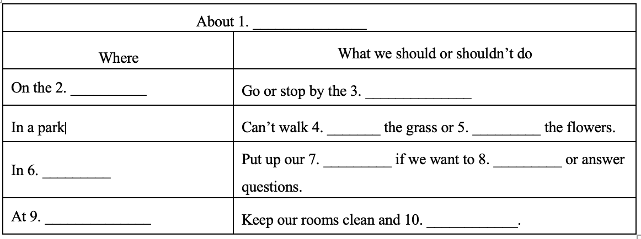
2.根据所听到的内容完成表格。（读两遍）(10分)
二、阅读理解（20分）
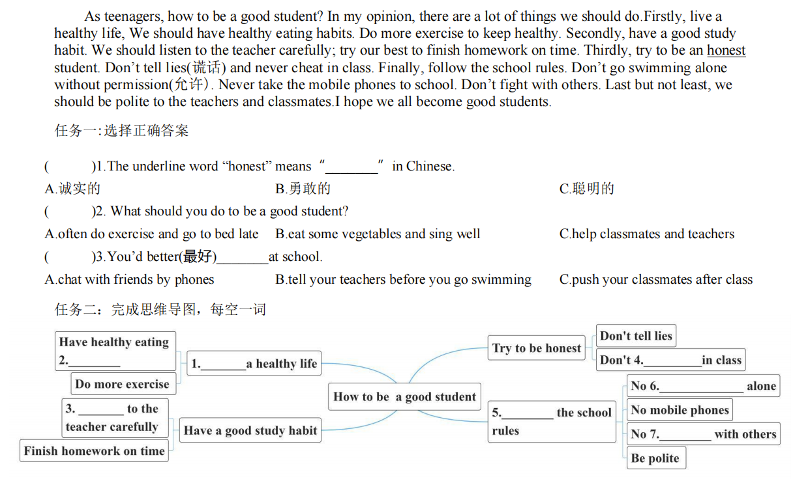
A) 阅读短文，将正确答案序号写在题前括号内。(10分)

B) 阅读短文，将正确答案序号写在题前括号内。(10分)
Welcome to our 7-day tour(旅行) in the UK. We’ll provide(提供) you with a nice experience(体验).
Day(s) | City | Activities
Day 1 | Arrive in London | Arrive in London→Meet the tour guide(导游) →Check in at the hotel
Day 2 | London | Visit the Windsor Castle→Move on to the London Eye
Day 3 | London | Visit the Great Britain Museum(with a lot of history and culture)
Day 4 | London-Cambridge | (After breakfast)Take a walk to the National Gallery→(After lunch)Take a train to Cambridge and check in at the hotel→Go shopping
Day 5 | Cambridge | Visit the Cambridge University→Walk around the King College→Go boating on the River Granta
Day 6 | Portsmouth | Take the train to Portsmouth→Visit the Pier(码头) and see a lot of war ships→Enjoy a buffet(自助餐) dinner
Day 7 | Return home | Take the plane from London Heathrow International Airport to Shanghai
( )1. How long will the tour take?
A. 7 days. | B. 8 days. | C.9 days.
( )2. What will the tourist(游客) visit in London?
A. The war ships. | B. The King College. | C. The Great Britain Museum.
( )3. When will the tourist go to Cambridge?
A. On the 5th day. | B. On the 4th day morning. | C. On the 4th day afternoon.
( )4. How will the tourist go from Cambridge to Portsmouth?
A. By plane. | B. By train. | C. On foot.
( )5. Where can the tourist enjoy a buffet dinner?
A. In London. | B. In Cambridge. | C. In Portsmouth.

三、书面表达（8分）
同学们，每个人都有梦想，请根据思维导图的提示，以My dream为题，写一篇小作文（不少于8句话）。要求：语句通顺，信息完整，意思连贯，书写规范、正确。
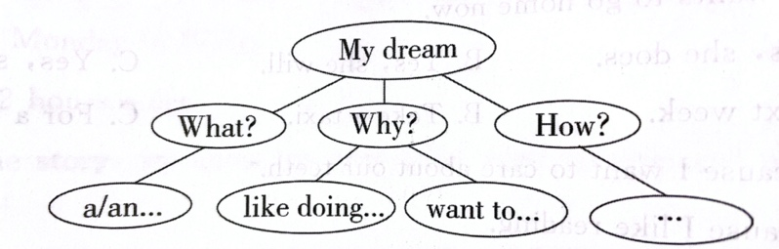
__________________________________________________________________________________________________________________________________________________________________________________________________________________________________________________________________________________________________________________________________________________________________________________________________________________________________________________________________________________________________________________________________________________________________________________________

录音文稿：
1(1)
W: Do you see the sign here? Please drive away your car!
M: I’m sorry.
Q: What’s the sign?

1(2)
W: Let’s have a picnic today, Mike.
M: I’d love to. But there is little rain in the sky now.
Q: What’s the weather like today?

2
Where do we have rules? Almost everywhere. Cars must follow the rules on the road. You should go or stop by the signs. In a park, we can’t walk on the grass or pick the flowers. We should put up our hands if we want to ask or answer questions in class. At home, we should keep our rooms clean and tidy. Rules help us live happily.

