Unit5 Look at me!教 学 设 计 方 案

课题 | 三上 Unit5 Look at me! |  | 教时 | 1 |  | 日期 | 2022年7月11日
一、教学目标
1. 学生能借助字母Aa的音素音自主拼读含有a的单词。
- 学生能在情境中了解字母组合oo和ir的发音，并尝试拼读含有oo和ir组合的单词，提高自然拼读的意识和能力。
- 借助主题“Party”，通过说唱、听读、表演等方式，学生能正确使用Look at …介绍服饰，并用It’s nice/great. How nice! Great!等称赞别人，提高语言交际能力。
- 学生能在情境中理解课文，并能正确朗读和表演。
- 学生能大胆地展示自己的服饰并给予对方得体适当的评价和赞美。

二、教材分析
三年级Unit 5 Look at me！的主题是服饰的展示与欣赏评价。本课是 Story time,是杨玲与妈妈关于服饰的简短对话。本课的教学内容是学生学会用Look at ...介绍服饰cap，jacket，skirt，T-shirt，并用It’s nice/great. How nice! Great!称赞他人，其中skirt、T-shirt的发音，look at的连读是难点。因此本课采用Story time与Phonics融合教学，借助“派对”话题，让学生自主运用拼读规律（a/ir/oo）尝试、验证、矫正发音，学习新词，理解文本、朗读、表演课文并想象创编，培养学生的综合语言运用能力，促使每个学生都有不同程度的提高。

三、学生分析
经过三个多月的英语学习（其中一个半月的phonics集中教学），学生有了一定的语言积累和拼读意识，绝大部分学生学习兴趣较浓，上课发言积极，愿意与他人进行合作交流。学生已经清晰的知道了字母Aa到Zz的字母音和音素音，并且掌握了与这些字母相关的单词和儿歌，但是字母组合ir/oo的发音，学生还是初次接触，有一定的难度。
学生已了解句型This is ... （第二周）Look at my ... It’s ...（第六周）,因此教师可以引导学生在介绍服饰时通过新旧知识的有机整合，学会表达展示服饰并评价赞美，适度加强对学生语言表达的纵向和横向的拓展。
学生对于如何展示服饰和评价赞美很感兴趣，但仍需要创设真实情景，在情景中体验、运用核心句式来表达。
教 学 过 程
教学环节 |  | 教 师 活 动 |  |  | 学 生 活 动 |  |  | 设 计 意 图
Warm-up |  | Sing Phonics songs. |  |  | Sing the songs together. |  |  | 通过说唱歌谣，激活有关Phonics的旧知,为新授做准备。
Pre-reading |  | Brook’s preparation for the party  - Introduce my friend, Brook.  Look,this is Brook.  He’s a cook.  Cooks nice cookies.  Good good good!  - Teach the pronunciation of “oo”.  - Play music and let Ss chant together.  4. Look and say.  T: Today, Brook has a big party. What can you see?  5.Encourage Ss to read the new words. |  |  | 1.Know the new friend “Brook”.  2. Ss try to read the words according to phonics: cook, cookies  3. Chant together  4.Look at the picture and answer the question.  Ss: I can see……  5. Try to read: ham, candy, sandwich. |  |  | 集中呈现字母组合oo的相关单词，通过拼读、说唱歌谣巩固发音, 并为新句型Look at my……的学习做好渗透和铺垫。  引入本课主情境Brook’s party。借助已知字母Aa的音素音/æ/，尝试自主朗读新词：ham, candy, sandwich
While-  reading |  | Yang Ling’s preparation for the party  T: Yang Ling will come to the party. She is preparing for it. What clothes does Yang Ling try on?  1. Teach the new words.  (1)Look, these are Yang Ling’s clothes. Can you try to read these words?  (2)Have the Ss read jacket, cap by the sound of /æ/  (3)Teach ir/ɜ:/  ir is pronounced /ɜ:/  ir→ skirt shirt T-shirt  The skirt of the girl is dirty, so is her shirt.  - Read and learn.  T: What clothes does Yang Ling try on? Boys and girls, let’s open our books, try to read Story time and know. If you meet the new words, never mind, try to read.  - Listen and check.  - Try to find:  How does Yang Ling introduce her clothes?  How does Mother praise her？  5. Read and act the story. |  |  | - Ss try to read the words:cap, jacket, skirt, T-shirt.  - Read in groups.  (2)Help each other.  (3)Learn the new words with ir, and read the sentence.  2. Read and learn.  Ss try to read nice/great and other new words and sentences.  3.Listen and check.  4.Find and know how to introduce the clothes and praise others.  5. Read and act the story. |  |  | 学生运用Phonics规则试读cap, jacket; 借助已学单词bird感知ir发音, 再通过一个有趣、朗朗上口的句子，巩固ir发音。  直接把文本抛给学生，让学生借助Phonics大胆尝试朗读生词并结合图片进行理解。  通过听录音验证，培养学生的语音意识和自主阅读的能力。  学生细读文本，发现并总结展示服饰和评价赞美的语言和方式，从而了解文本内涵，养成会话意识。同时通过图文匹配，加强学生对句型的理解和新词音、形、义的联系。
Post-reading |  | 1.Teach more words about clothes and make a chant.  T: If you were invited,what would you wear? Can you make a chant.  拓展词汇： hat, dress, ...  2.Encourage Ss to imagine and use the words and sentences they learned today.  Brook and Yang Ling are at the party, what would you say to them?  (1）Show the picture of Brook’s party.  T：If you were at Brook’s party, what would you say?  (2） Do a model with a student.  (3） Encourage Ss to work in pairs and give a show. |  |  | 1.Know more words about clothes and make a chant:  Look at my ...  Look at my ...  Look at my ... and look at me.  2. Work in pairs and give a show. |  |  | 延伸拓展其他服饰，让学生联系实际用儿歌的形式介绍服饰，巩固句型，拓展词汇，增加趣味。  创设情境，鼓励学生想象体验，强调学习过程的实践性。通过角色扮演，引导学生利用已学单词和句子在派对上介绍服饰并交流互动，培养学生的发散思维和语用能力。
Assign homework |  | 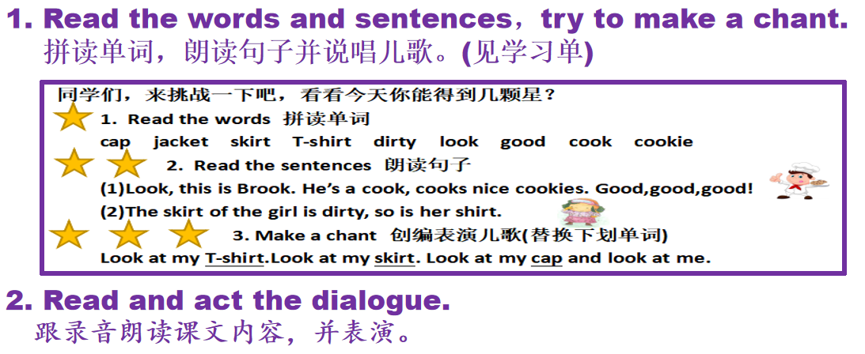 |  |  |  |  |  | 进一步巩固课堂所学，并鼓励学生在生活中运用所学。
板书设计 |  | Unit 5 Look at me!  Look at my cap. It’s nice. pretty oo/u/  Look, this is my T-shirt How nice! cool ir/ɜ:/  skirt It’s great. smart  coat Great! cute  sweater beautiful 学生生成资源  Look at me.

教学流程
Warm-up
歌曲热身，激活旧知

字母音的复习：Phonics songs

1.介绍Brook，利用chant教学字母组合oo
Pre-reading
创设情境，温故知新

2.导入Brook’s party, 在词中、句中复习巩固字母a的音素音

自主学习文中含有a的单词

Unit 5
Look at me！
1.杨玲挑选派对服饰，学习课文新词
学习字母组合ir，并尝试拼读文中新词
While-reading
自主学习，
拼读生词，
理解语篇

2.杨玲展示派对服饰，自主学习并理解语篇
自主阅读，理解大意
找出新词，尝试拼读
听读课文，朗读纠音

3.细读课文，总结归纳如何展示和赞美，跟读并表演课文
跟读课文并表演课文

Post-reading
迁移创新，想象表演
At Brook’s party，想象表演交流对话

延伸拓展其他服饰词汇，用儿歌介绍自己的服饰

