4月活动通知与通讯

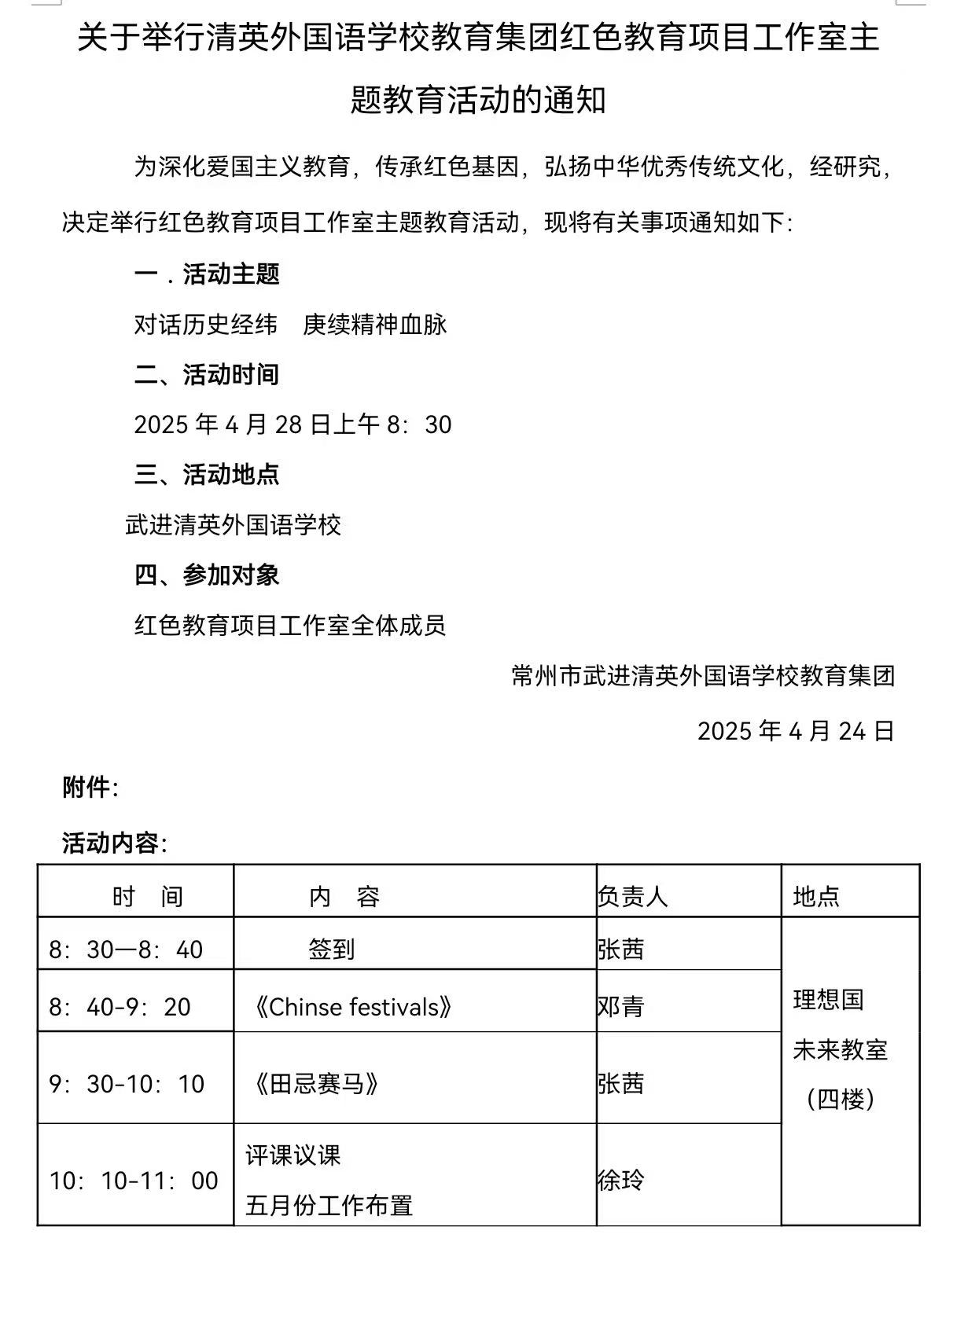

https://mp.weixin.qq.com/s/VWZ5bHKtNHOIn8TprbVkZw