四年级阅读素养比赛(30分）

一、将下列句子重新排序,组成一段通顺的对话。(6分)

A. Some purple skirts? How many would you like?

B. OK. Here's the money.

C. Good morning. Can I help you?

D. Forty yuan each. Four hundred and eighty yuan in all

E. Yes. 'd like some purple skirts.

F.Twelve. How much are they?

G. Thank you.

|  |  |  |  |  |  |  |
| --- | --- | --- | --- | --- | --- | --- |
|  |  |  | F |  |  |  |

二、阅读对话,给下列图片排序。(6分)

Sam & Bobby:Welcome to our talent show.

Sam: What can he do?

Bobby: He can play with three umbrellas.Sam:Look! He can play with many hand puppets(手偶).

Bobby: That's wonderful!What about you, Sam?

Sam:I can sing “Happy New Year”

Bobby:Oh，cool!

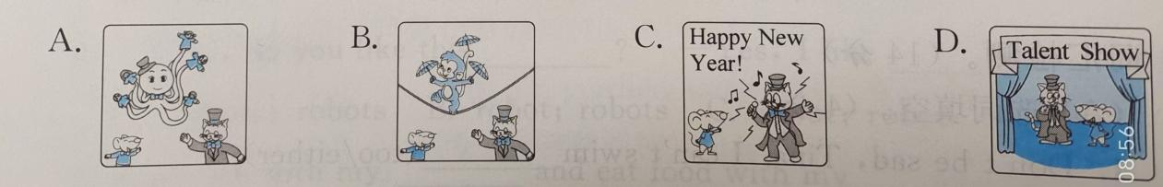

1. 2. 3. 4.
2. 根据 The Little Match Girl故事,给下列句子匹配对应的图片。（6分）

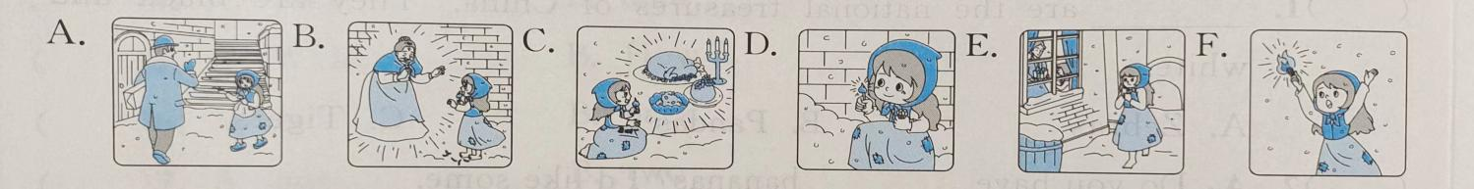

（ ）1.The little girl lights(点燃)a match(火柴)

（ ）2. The little girl sees a happy family through(通过)the window.

（ ）3. The little girl hugs(拥抱) her grandmother.

（ ）4. No one buys the little girl's matches.

（ ）5. The little girl wants delicious food.

（ ）6. Look! There are lots of matches.

四、楠楠在假期搬了新家,她拿出了新家的照片与大家分享喜悦。请根据图片或首字母提示完成短文。(8分)

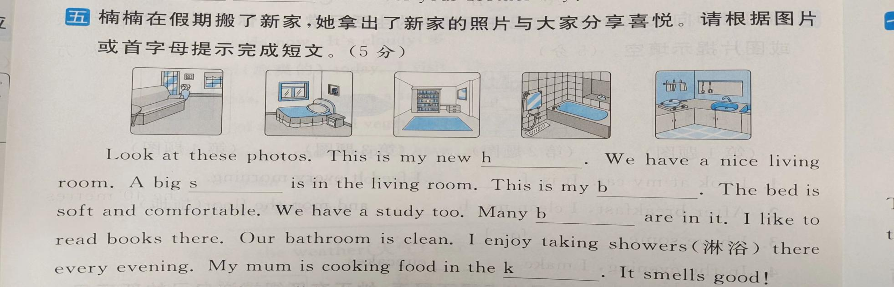

Look at these photos. This is my new h .We have a nice living room. A big s is in the living room. This is my b .The bed is soft and comfortable. We have a study too. Many b are in it. I like to r books there. Our bathroom is c . I enjoy taking showers(淋浴) there e evening. My mum is cooking food in the k . It smells good

五、阅读短文,判断正(T)误(F)。(5分)

I have a pet turtle named Rex. He has a funny look. On the top of his head, there is a pair of small eyes. They are as small as two mung beans(绿豆).He has stayed with me for four years. He is my good friend, and I always want to play with him. But he is very shy and he likes to hide in his shell. I feed him every evening. Then, he stretches out(伸出)his neck to get his food.But if I touch his shell gently, he will pull his head back so quickly.How funny!

( )1. My animal friend is a turtle named Rex.

( )2. The underlined word“pet”means“玩具”in Chinese.

( )3. Rex has a hard shell and small eyes.

( )4. I feed Rex once every two days.

( )5. The following sentences are all correct(正确的).

1. Rex is funny and shy.
2. Rex likes to hide in his shell.

③ My pet friend has stayed with me for 5 years.