**20250506| 中一班**



Daily life

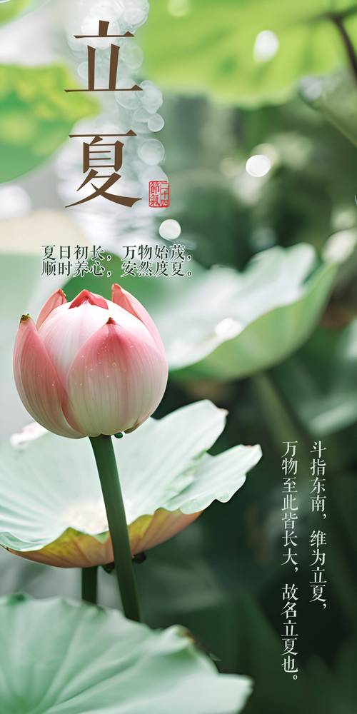

**「来园情况」**

今日星期二，共有20人来园，2人请假。

**「日常生活观察」**

|  |  |  |  |  |  |  |
| --- | --- | --- | --- | --- | --- | --- |
| **序号** | **姓名** | **午餐** | | | **午睡** | **备注** |
| **饭** | **菜** | **汤** |
| 1 | 韩昕怡 | √ | √ | √ | √ | 看护入睡 |
| 2 | 韩昕悦 | √ | √ | √ | √ |  |
| 3 | 吴清墨 | √ | √ | √ | √ |  |
| 4 | 陆晟涵 | √ | √ | √ | √ |  |
| 5 | 张梅伊 | √ | √ | √ | √ |  |
| 6 | 吴沐檀 | 请假 |  |  |  |  |
| 7 | 曹果 | √ | √ | √ | √ |  |
| 8 | 曹煜琪 | √ | √ | √ | √ | 看护入睡 |
| 9 | 蒋安乐 | √ | √ | √ | √ |  |
| 10 | 韩书华 | √ | √ | √ | √ |  |
| 11 | 顾言希 | √ | √ | √ | √ |  |
| 12 | 贾钧尧 | √ | √ | √ | √ | 看护入睡 |
| 13 | 杨宸 | √ | √ | √ | √ | 看护入睡 |
| 14 | 张予安 | √ | √ | √ | √ |  |
| 15 | 高瑞泽 | √ | √ | √ | √ |  |
| 16 | 张路翔 | 请假 |  |  |  |  |
| 17 | 谢咏呈 | √ | √ | √ | √ |  |
| 18 | 汤凌宇 | √ | √ | √ | √ |  |
| 19 | 韩以轩 | √ | √ | √ | √ |  |
| 20 | 冯煦晨 | √ | √ | √ | √ |  |
| 21 | 郑哲皓 | √ | √ | ⭕ | √ |  |
| 22 | 张致远 | √ | √ | √ | √ |  |

**「集体活动：拍花箩」**

《拍花箩》是一首极具中国民间特色的游戏儿歌，全文采用了问答调的格式，适合幼儿在拍手念唱中一问一答地快乐学习。它还是一首有趣的数字歌、数数歌，从“一”问起，答以“一”种动物活动的情景，以此类推（但“四”和“六”除外）。内容有趣简单，琅琅上口，插图的色彩明朗鲜艳，与游戏儿歌内容相辅相成的画面情境给孩子们带来想象的空间和无穷的乐趣，适合幼儿边念、边唱、边玩。

|  |  |  |
| --- | --- | --- |
| IMG_256 | 684c49e90bfe4e2e8833a9e3048d4b99 | 6ba2e82d597178792d58fd48ae3e496b |
| bd4aab3686d851fd05c56b72865d2b5b | 27d605f296671353c425918b07e5e810 | IMG_256 |

**「区域游戏」**

|  |  |  |
| --- | --- | --- |
| IMG_1471(2) | IMG_1467(1) | IMG_1460 |
| IMG_1468(1) | IMG_1465(1) | IMG_1457(1) |