**今日动态**

**第十一周 4月29日 星期二 晴**

**一、晨间入园**

1.出勤：今日来园19人

2.入园情况：今天早上宝贝们入园后能够大方打招呼、放水杯、选区域，非常棒哦！

**二、户外游戏活动**

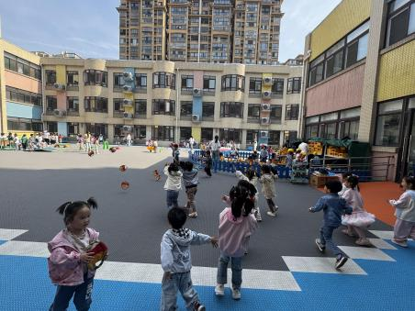早上来到就是户外游戏时间，今天我们玩的游戏是飞盘区。

|  |  |  |
| --- | --- | --- |
| /Users/jisha/Library/Containers/com.kingsoft.wpsoffice.mac/Data/tmp/picturecompress_20250430130547/output_1.jpgoutput_1 |  | /Users/jisha/Library/Containers/com.kingsoft.wpsoffice.mac/Data/tmp/picturecompress_20250430130612/output_1.jpgoutput_1 |
| /Users/jisha/Library/Containers/com.kingsoft.wpsoffice.mac/Data/tmp/picturecompress_20250430130625/output_1.jpgoutput_1 | /Users/jisha/Library/Containers/com.kingsoft.wpsoffice.mac/Data/tmp/picturecompress_20250430130645/output_1.jpgoutput_1 | /Users/jisha/Library/Containers/com.kingsoft.wpsoffice.mac/Data/tmp/picturecompress_20250430130655/output_1.jpgoutput_1 |

**三、集体活动**

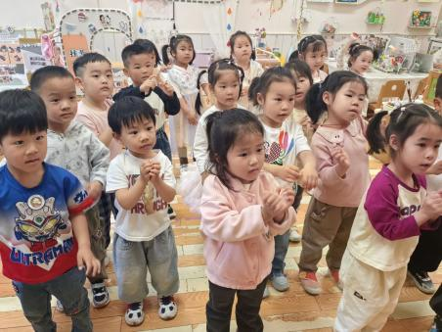今天我们集体活动带孩子们一起玩了律动游戏，孩子们兴趣浓厚，一个个积极参与其中，看看我们的活动吧！

|  |  |  |
| --- | --- | --- |
| /Users/jisha/Library/Containers/com.kingsoft.wpsoffice.mac/Data/tmp/picturecompress_20250430130709/output_1.jpgoutput_1 | 93c642b8689ffd884a161652dcfcd4e9 |  |

**四、区域游戏**

区域游戏时间开始啦！我们按照自己的喜好选择了喜欢的游戏内容，来看看我们快乐的游戏时光吧！

|  |  |  |
| --- | --- | --- |
| /Users/jisha/Library/Containers/com.kingsoft.wpsoffice.mac/Data/tmp/picturecompress_20250430130851/output_1.jpgoutput_1/Users/jisha/Library/Containers/com.kingsoft.wpsoffice.mac/Data/tmp/picturecompress_20250430130812/output_1.jpgoutput_1 | /Users/jisha/Library/Containers/com.kingsoft.wpsoffice.mac/Data/tmp/picturecompress_20250430130917/output_1.jpgoutput_1/Users/jisha/Library/Containers/com.kingsoft.wpsoffice.mac/Data/tmp/picturecompress_20250430130828/output_1.jpgoutput_1 | /Users/jisha/Library/Containers/com.kingsoft.wpsoffice.mac/Data/tmp/picturecompress_20250430130926/output_1.jpgoutput_1/Users/jisha/Library/Containers/com.kingsoft.wpsoffice.mac/Data/tmp/picturecompress_20250430130838/output_1.jpgoutput_1 |
|  |  |  |

**五、午餐时光**

今天的午餐是燕麦饭、糖醋排骨、上汤苋菜、丝瓜豆腐汤，宝贝们大口大口吃得香，一起来看看吧！

|  |  |  |
| --- | --- | --- |
| /Users/jisha/Library/Containers/com.kingsoft.wpsoffice.mac/Data/tmp/picturecompress_20250430131155/output_1.jpgoutput_1 | /Users/jisha/Library/Containers/com.kingsoft.wpsoffice.mac/Data/tmp/picturecompress_20250430131210/output_1.jpgoutput_1 | /Users/jisha/Library/Containers/com.kingsoft.wpsoffice.mac/Data/tmp/picturecompress_20250430131221/output_1.jpgoutput_1 |
| /Users/jisha/Library/Containers/com.kingsoft.wpsoffice.mac/Data/tmp/picturecompress_20250430131230/output_1.jpgoutput_1 | /Users/jisha/Library/Containers/com.kingsoft.wpsoffice.mac/Data/tmp/picturecompress_20250430131244/output_1.jpgoutput_1 | /Users/jisha/Library/Containers/com.kingsoft.wpsoffice.mac/Data/tmp/picturecompress_20250430131254/output_1.jpgoutput_1 |

**六、温馨提醒**

五一劳动节放假时间：

5月1日（周四）——5月5日（周一），放假5天。

4月27日（周日）调休，正常上课。

5月6日（周二）正常入园。