课题 | 三下 Unit5 Fruit (Story time)
年级 | 三年级 | 执教人 | 常州市武进区雪堰中心小学 李烨
教材 分析 | What：三下 Unit5 Fruit 第二课时story time语篇为劳动课上的日常对话，内容围绕制作和分享水果沙拉展开。劳动老师号召同学们制作水果沙拉，同学们通过互相询问了解彼此所带的水果，合作完成水果沙拉，最终大家一起分享美味的水果沙拉。  Why：本语篇呈现了劳动老师和同学们一起制作水果沙拉的情境，在学生熟悉的课堂场景中自然引出互相询问是否拥有某种水果和拥有何种水果的对话，有助于激发学生的学习兴趣，加深学生对语言的理解。故事结尾呈现老师邀请同学们一起分享水果沙拉的情境，引导学生学会合作与分享，并指出水果有益健康，引导学生养成健康的饮食习惯。文末的读后问题What do the students think of the fruit salad？引导学生在前一课时的基础上进一步思考单元主题意义，为回答本单元的big question奠定基础。  How: 本语篇是比较典型的课堂对话，涉及多种常见水果的名称，如orange, apple, mango, banana, grape；介绍自己拥有某种水果的句型，如“I have a/an ...” “I have some ...”; 询问对方所拥有水果的句型“What fruit do you have?” “Do you have a/an ...?”及其回答Yes, I do. /No, I don't.”。语篇情节简单，贴近生活实际，易于理解，具有现实教育意义。
课时 学情 分析 | 已有基础：从主题上来看，本单元主题为“Fruit”,属于“人与自我”主题范畴，涉及“身边的事物与环境”和“饮食与健康”两个子主题。从语言知识方面来看，句型Do you have...?及其否定回答在第一课时已经出现，学生有了一定的语言基础。但是What fruit do you have? 在平时课堂用语、 练习中也没有出现过。  兴趣点：学生都喜欢吃水果，水果也是生活中常见的事物，此话题紧贴学生生活。  难点：名词单复数在句子中的正确使用以及一般疑问句Do you have ...?及其回答的表达。
课时 教学 目标 | 通过本节课的学习，学生能够：  - 在看、听、读、说的活动中整体理解语篇内容，并梳理匹配人物和对应的水果。  - 通过分角色表演操练并掌握本单元核心语言,体会分享的乐趣,了解水果的益处。  - 在制作和展示水果沙拉计划的过程中，进一步谈论水果，表达自己对水果的认识和喜好，形成健康饮食的意识。  核心语言：  Make, an, orange, apple, banana, grape, good  What fruit do you have?  I have an orange/two apples/a mango/some grapes.  What about you?  Do you have a banana?  Yes, I do. / No, I don’t.

重难 点 | 1. Be able to read, understand and act out Story time and be able to know the benefits fruits can bring us.  2. Be able to talk about fruit from different aspects and make a plan about making a fruit salad.
整体 思路 | Step 1  Pre-reading |  |  |   在Pre-reading环节，通过I say you say 的chant激发学生 学习兴趣，并再现 Lead-in中相关chant，通过语段的输出来引导学生进行复习，再次聚焦本单元的Big question：Why do you like fruit？  1. I say you say  2. Let's review  3. Let's talk  1. Look and say  在While-reading，在文本的学习中，以劳动课上制作沙拉为主线，通过who,what的引导来带着学生理解文本，并关注核心语言：What fruit do you have? I have... 和Do you have...? Yes,I do./ No, I don’t.引导学生在情境中进行语言的理解和输出。  2. Watch and choose  3. Let’s learn  4.Listen and circle  5. Read and match  6. Let’s check  7. Do a role-play  8. Think and order  9 Think and say  - Listen and repeat  在Post-reading环节中，引导学生体会文本中的情感价值。通过同桌问答的形式来谈论自己拥有的水果。为之后写沙拉制作计划做好语言铺垫。  - Let’s think  - Let’s discuss  - Plan and write  - Let’s talk  在Pre-reading环节，通过I say you say 的chant激发学生 学习兴趣，并再现 Lead-in中相关chant，通过语段的输出来引导学生进行复习，再次聚焦本单元的Big question：Why do you like fruit？  【Must do】  1.Read Story time correctly and loudly.  2.Ask and answer with your classmates about fruit.  【Choose to do】  Make a fruit salad with the help of your parents.
Step 2
While-reading

Step 3
Post-reading

Step 4
Homework

教学 过程 | 教师活动 | 学生活动 | 设计意图
Step 1 Pre-reading | 1. I say you say  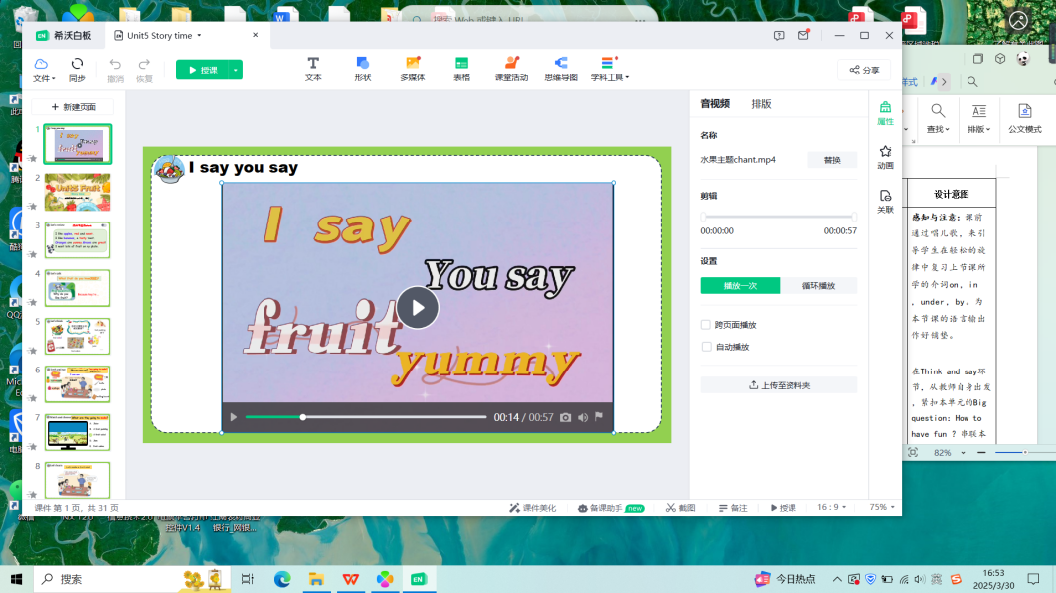  T:Today we’ll go on learning Unit4 Fruit. What fruit do you know?  2. Let's review  Review the chant in Period 1.  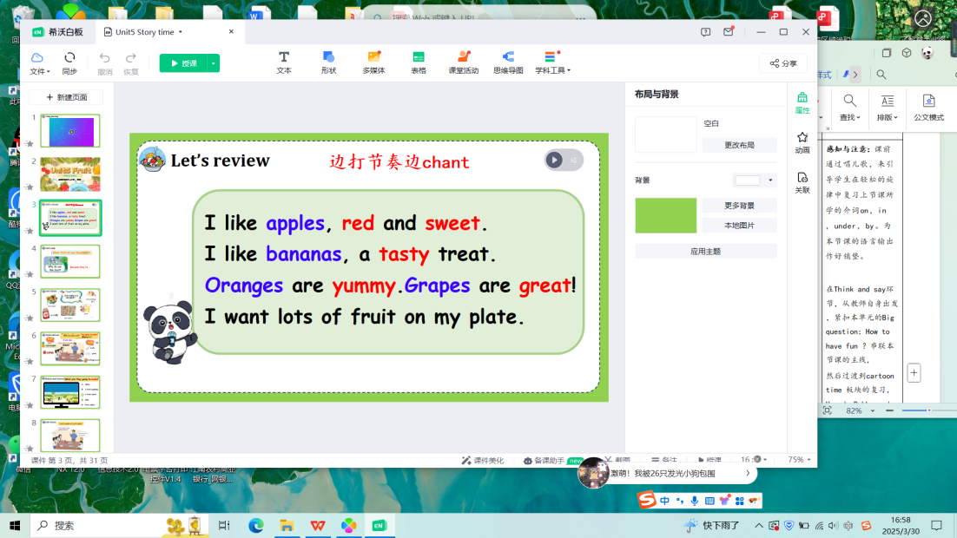  3. Let's talk  What fruit do you like? Why?  （colours，shapes,flavor）  Big question: Why do you like fruit?  T: Fruit has a good flavor. | 1.I say you say  Students chant with the teacher：  yummy, pink, red, yellow, orange, green, blue, purple  What fruit do you know?  apples, bananas, pears, oranges, watermelons, grapes, mangoes ...  2. Let's review  Review the chant in Period1.  3. Let's talk  I like ...s/es. Because they’re good/ great/ yummy/ juicy/ sweet/ tasty/ yellow/ red... | 感知与注意：课前通过chant，来引导学生在轻松的旋律中复习上节课所学的水果及一些颜色。为本节课的语言输出作好铺垫。  在review环节，复习Lead-in板块中的chant来为后面谈论学生喜欢的水果及理由作语言铺垫,足够的语言输入，才能保证接下来的语言输出。再引出本单元的Big question：Why do you like fruit？
Step 2 While-reading | 1.Look and say  Who can you see in the picture?  What else can you see on the table?  Guess: What are they going to make?  2.Watch and choose  What are they going to make?  - Juice  - A fruit pudding  - A fruit salad  - Jam  - Fruit cakes  3.Let’s learn  呈现Story time的小标题  Let’s make a fruit salad  4.Listen and circle  What fruit do the students have?  完成课中练习单  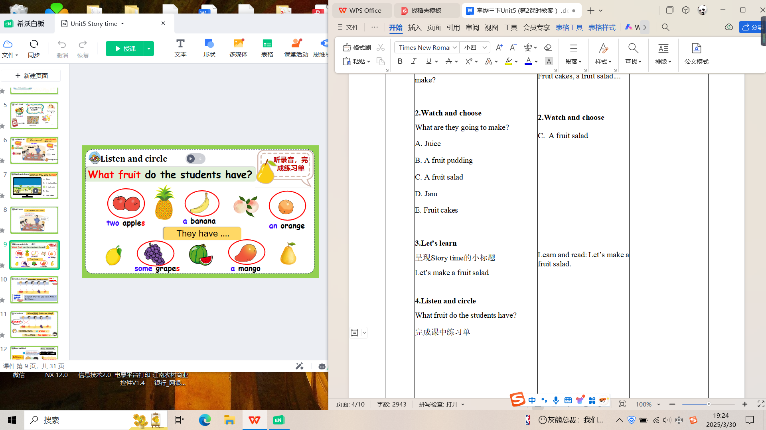  5.Read and match  Whose fruits are they?  1.Read the story and find out the key points. Then finish Part A on P48.  2.Choose one way you like to check the answers with your partner.  6.Let’s check.  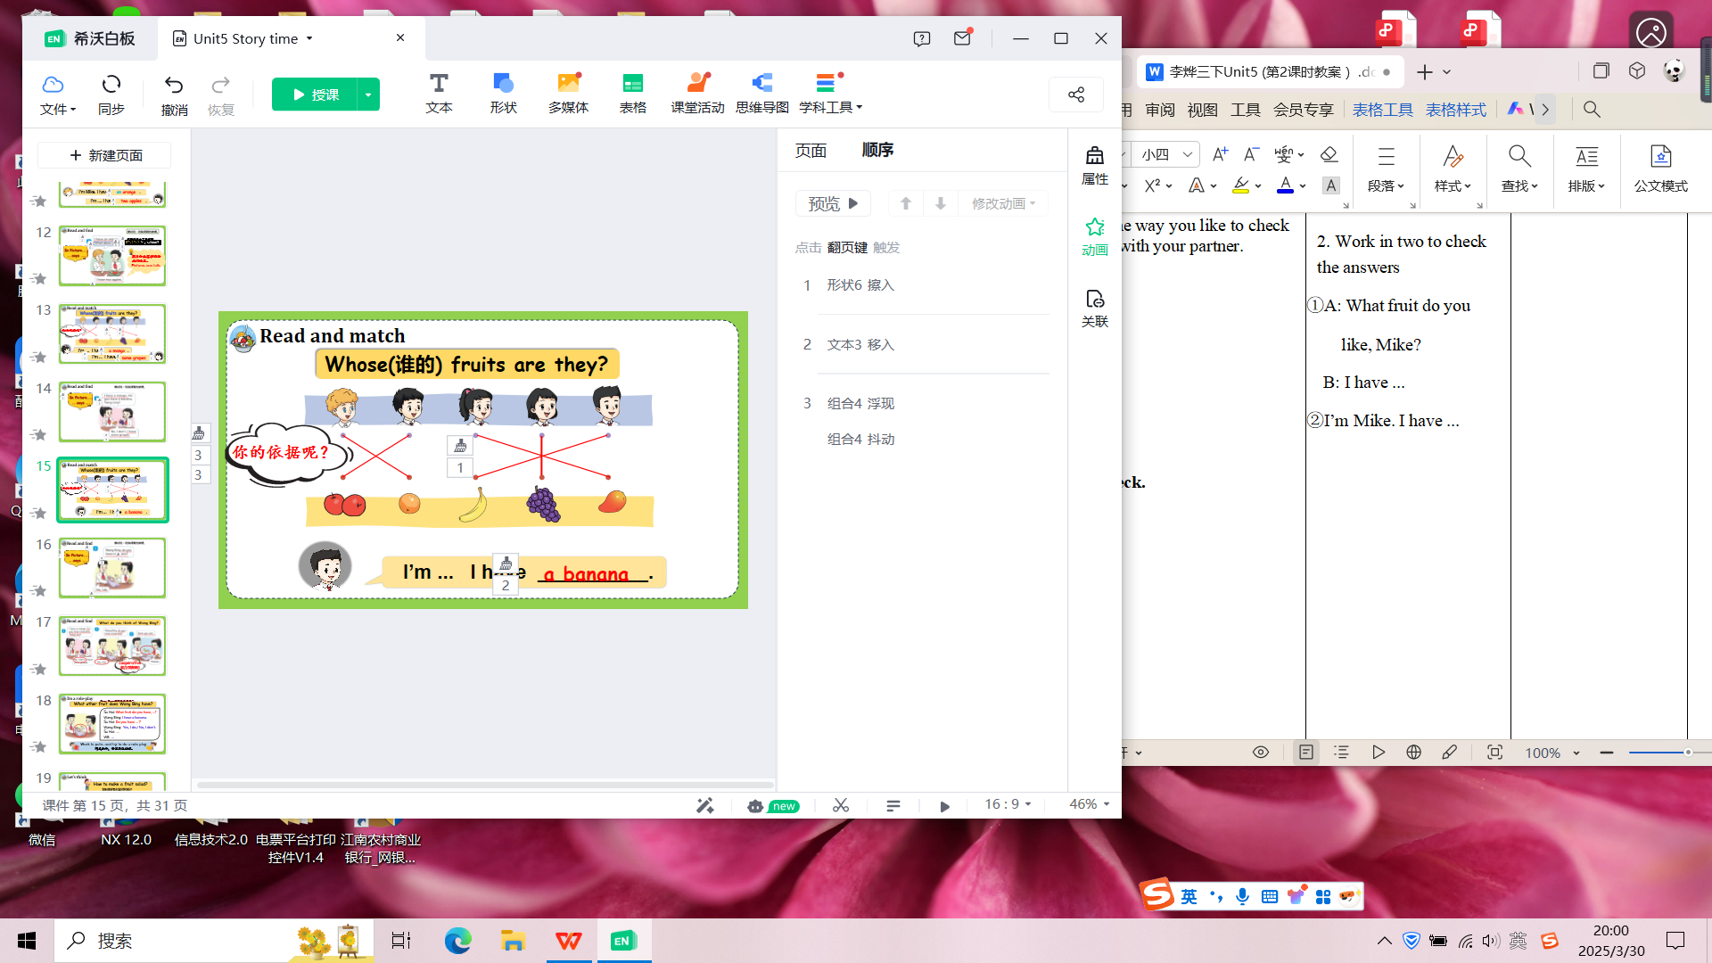  边校对答案边找出文中依据  Where else can you find the answer?  Tip: We can get information from the text and pictures. Pictures can talk.  What does “What about you?” refer to?  呈现Do you have...?句型及回答。  What do you think of Wang Bing?  7.Do a role-play  What other fruit does Wang Bing have?  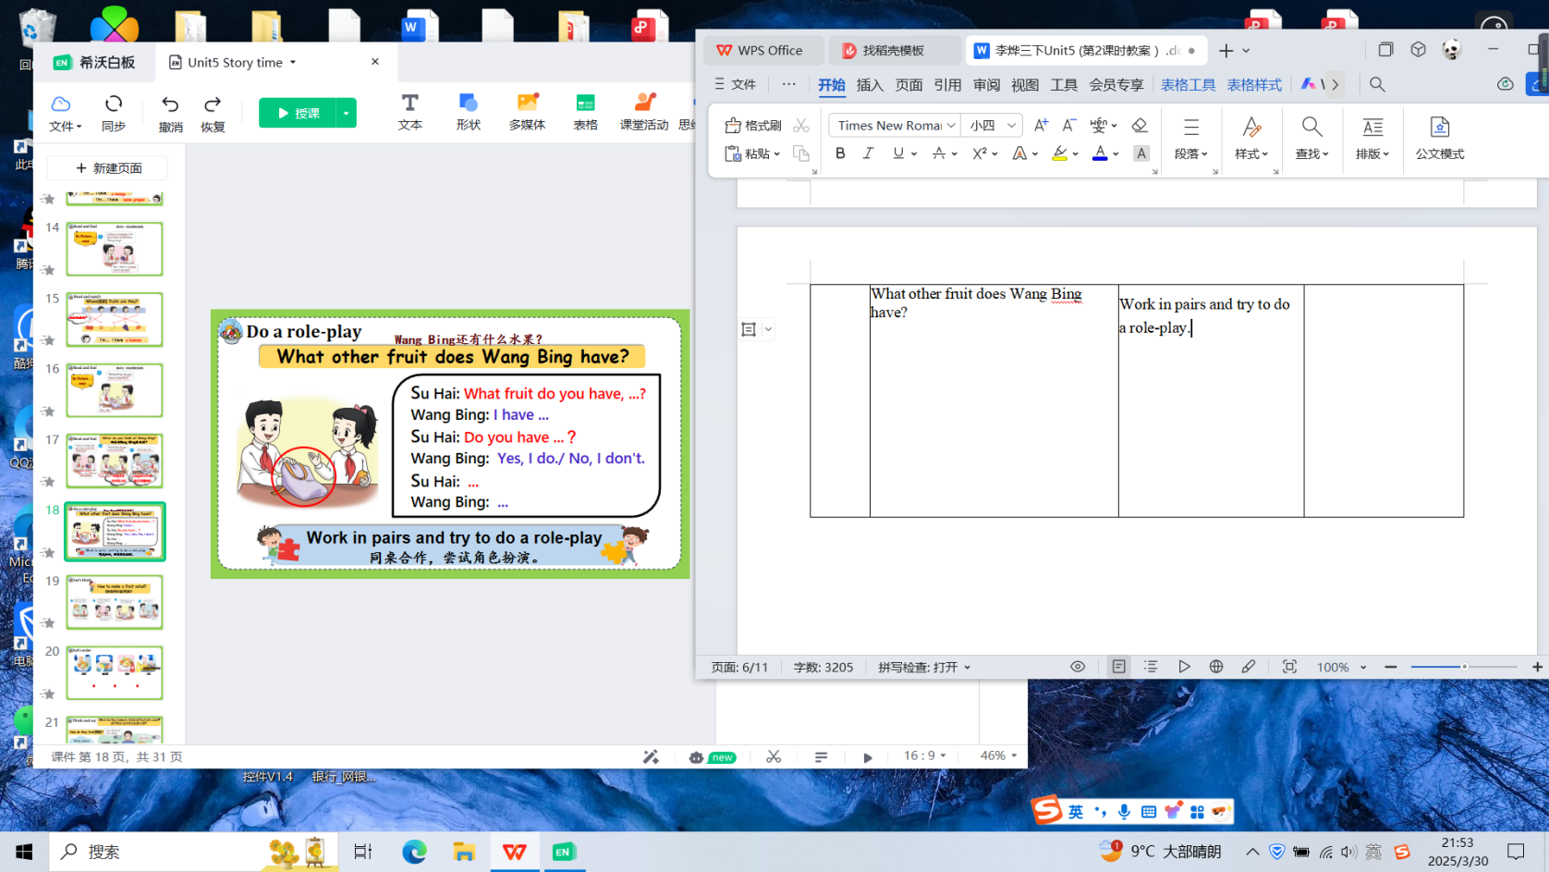  8.Think and order  How to make a fruit salad?  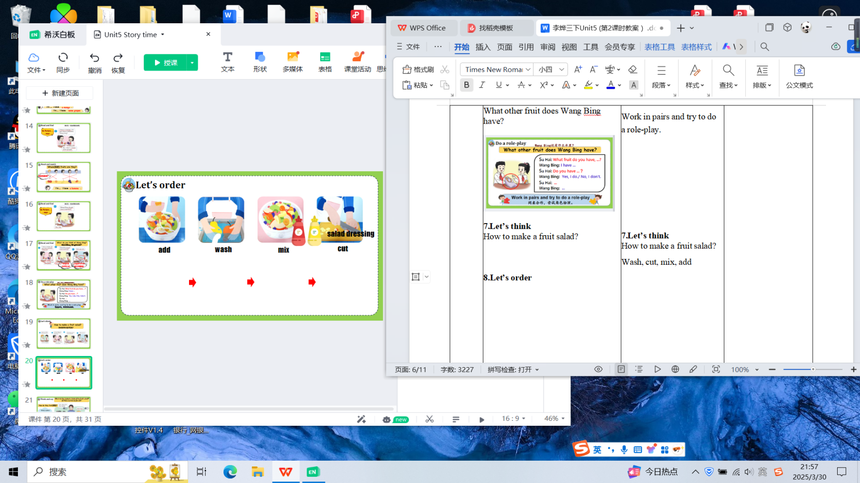  9.Think and say  What do the students think of the fruit salad?  What do you think of the salad?  How do they feel? Why?  Work makes people happy.  10.Listen and repeat  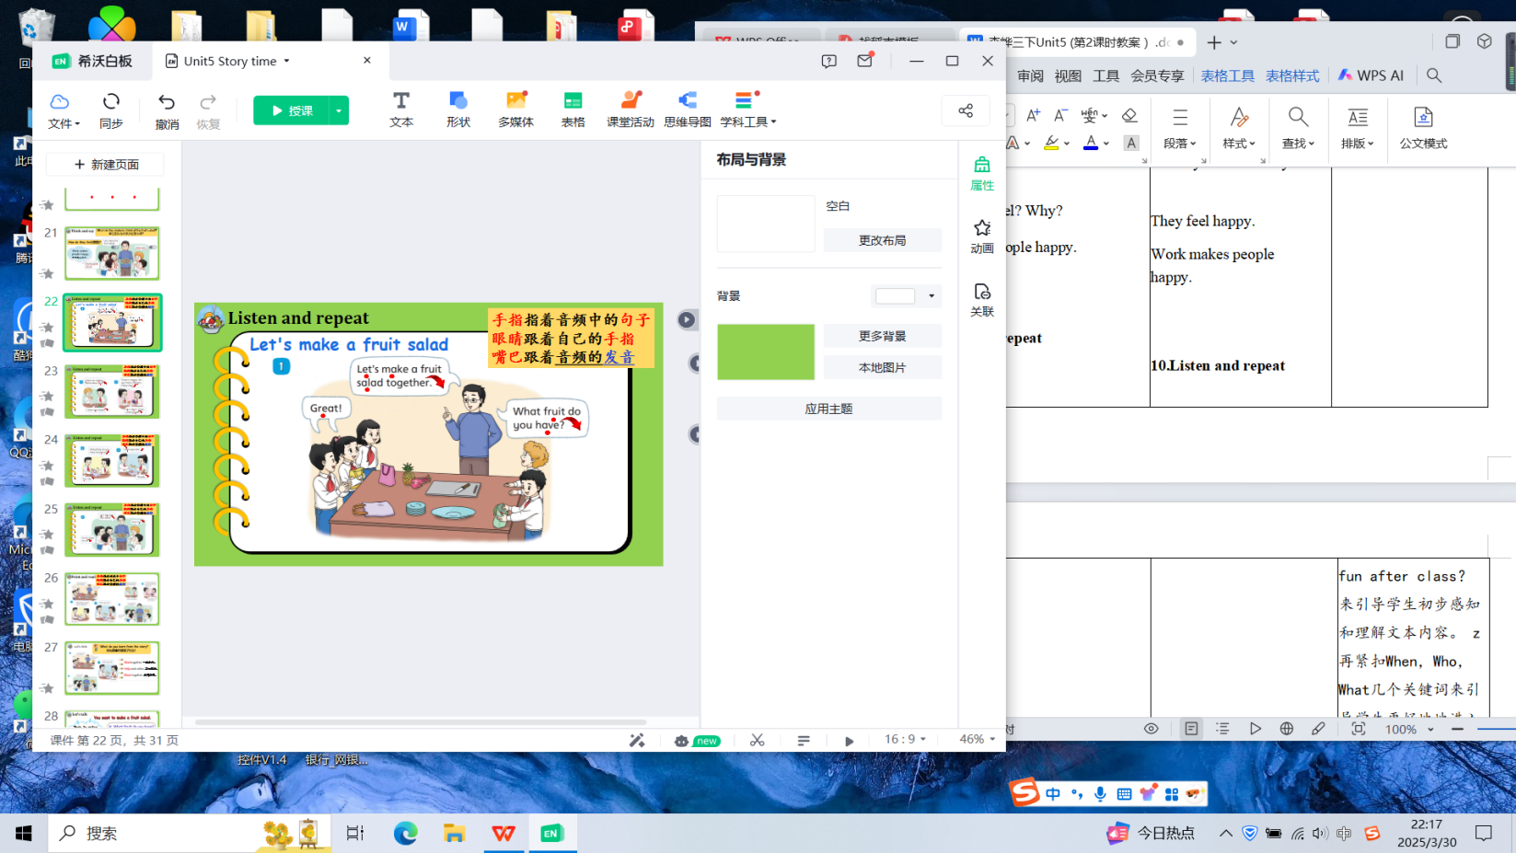  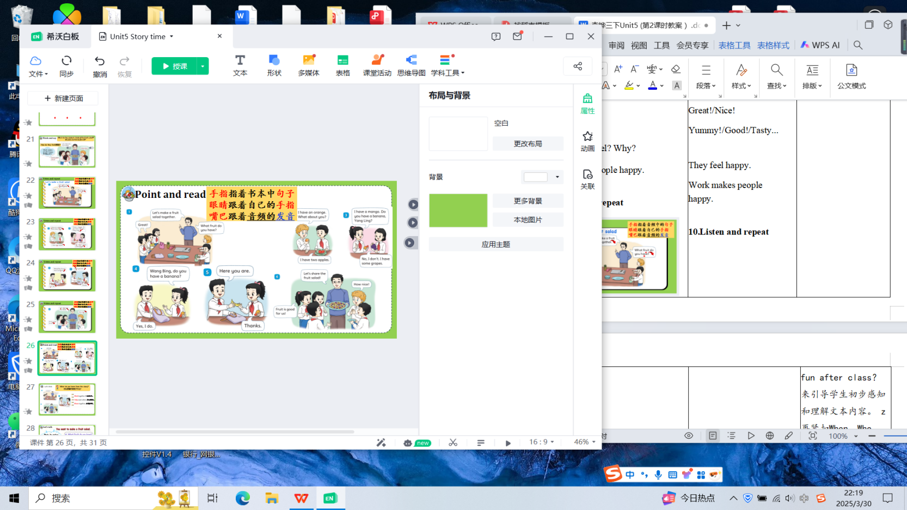 | 1.Look and say  Who: Wang Bing, Liu Tao, Su Hai, Mike, Yang Ling, the Labor teacher.  What: a pineapple, a pitaya, plates, knife, bags, cutting board.  Fruit cakes, a fruit salad....  2.Watch and choose  - A fruit salad  Learn and read: Let’s make a fruit salad.  4.Listen and circle  What fruit do the students have?  完成课中练习单  They have two apples.  They have a banana.  They have an orange.  They have some grapes.  They have a mango.  5.Read and match  Whose fruits are they?  1.Read the story and find out the key points. Then finish Part A on P48.  2.Work in two to check the answers  ①A: What fruit do you  like, Mike?  B: I have ...  ②I’m Mike. I have ...  6.Let’s check.  I’m Mike. I have an orange.  I’m Liu Tao. I have two apples.  依据:In Picture2, ...says...  From the picture.  What fruit do you have?  I’m Su Hai. I have a mango.  I’m Yang Ling. I have some grapes.  依据:In Picture3, ...says...  I’m Wang Bing. I have a banana.  依据:In Picture5, ...says...  Helpful, cooperative...  7.Do a role-play  Work in pairs and try to do a role-play.  8.Think and order  How to make a fruit salad?  Wash-cut-mix-add  9.Think and say  What do the students think of the fruit salad?  How nice!/  Fruit is good for us.  Great!/Nice!  Yummy!/Good!/Tasty...  They feel happy.  Work makes people happy.  10.Listen and repeat  指着屏幕上的句子跟读  指着书本上的句子跟读 | 呈现文中图片引导学生仔细观察图片，再紧扣Who和What几个关键词来引导学生更好地地进入文本的学习。  获取与梳理：利用课中练习单，听课文录音并圈出所听到的水果，让学生抓住核心水果词汇。  获取与梳理：通过完成书本课后练习A的连线，并找出相关依据，引导学生在情境中进行语言的理解和输出。在表达中，通过不同层次的任务设计和评价，关注不同能力学生的评价和发展，尊重个体差异。  获取与梳理：提供学生阅读策略，图片和文字都可获取信息以及联系上下文猜测句意。  课文后B部分的任务，让学生小组讨论，展开想象，Wang Bing的包里还有什么水果？巩固Do you have...?句型及其回答。  通过思考What do the students think of the salad?引出Fruit is good for us.为学生进一步回答Big question：Why do you like fruit? 做铺垫。  本环节能更好地体会人物情感，感受到劳动的乐趣，在文本朗读时能够准确地把握和表达情感，对于劳动课的意义有更好地理解。

Step 3  Post-reading | 1.Let's think  What do you learn from the story?  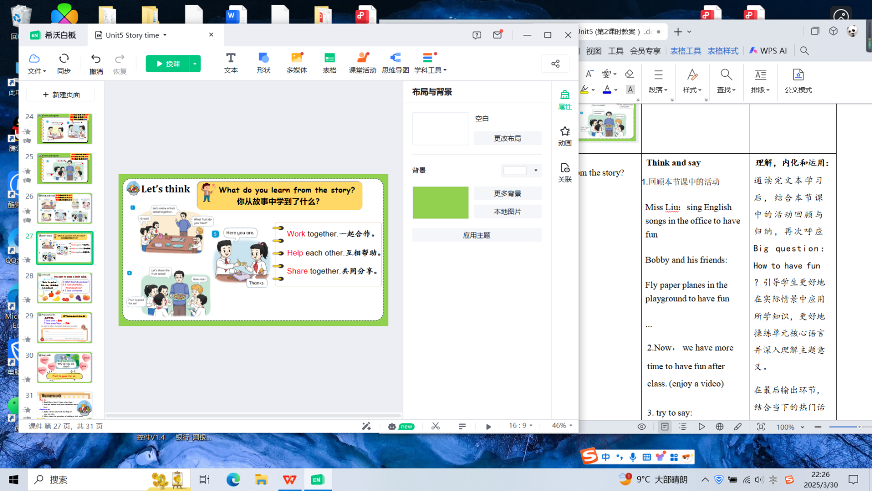  2.Let's discuss  You want to make a fruit salad.  Open the envelop. Have a look at what you have. Discuss what fruit you have with your partner.  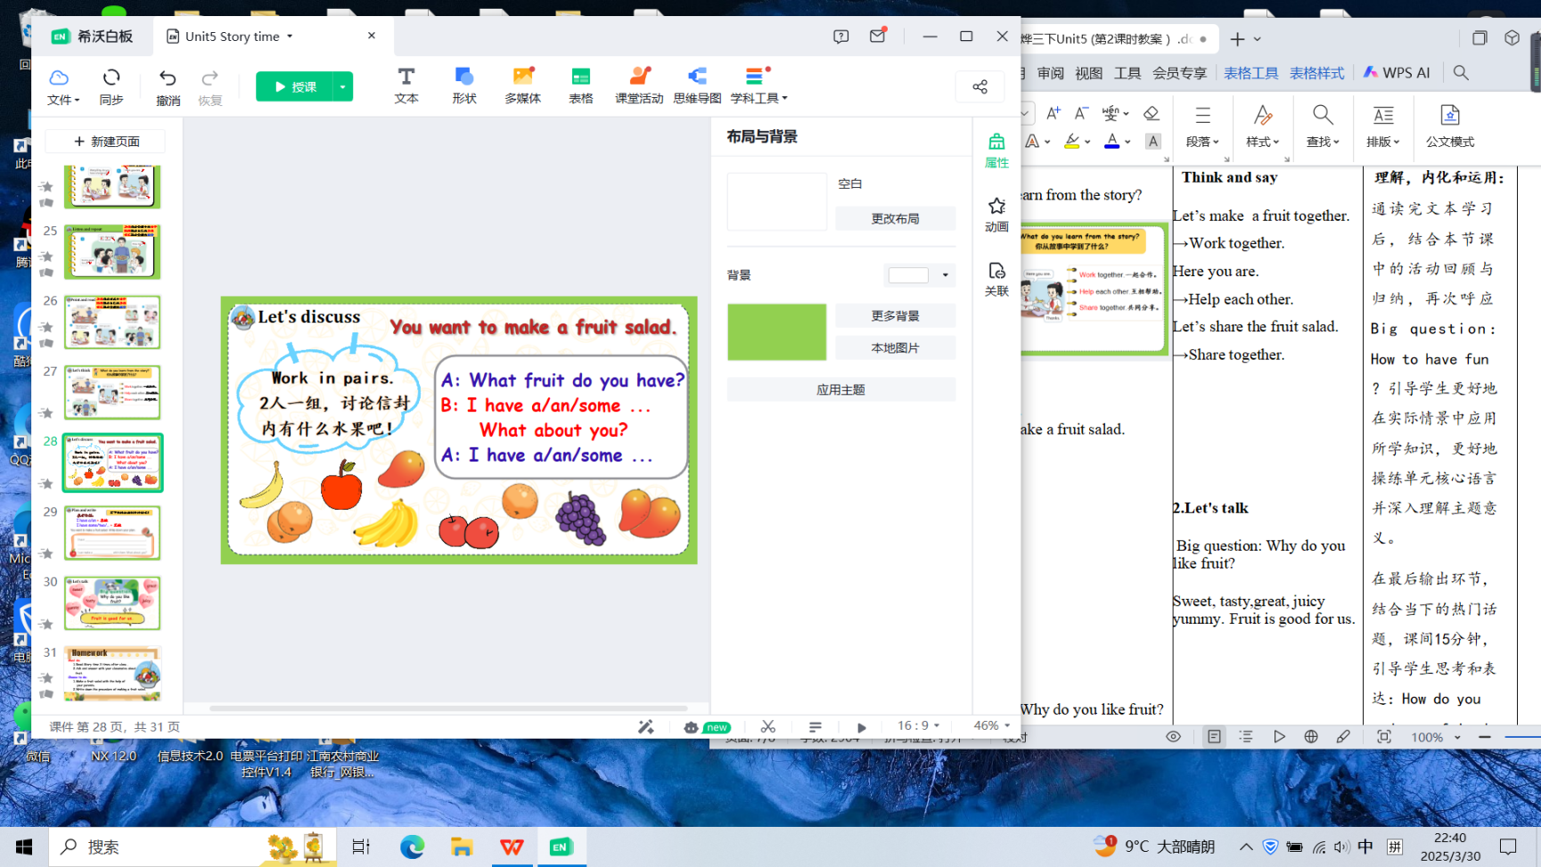  3.Plan and write  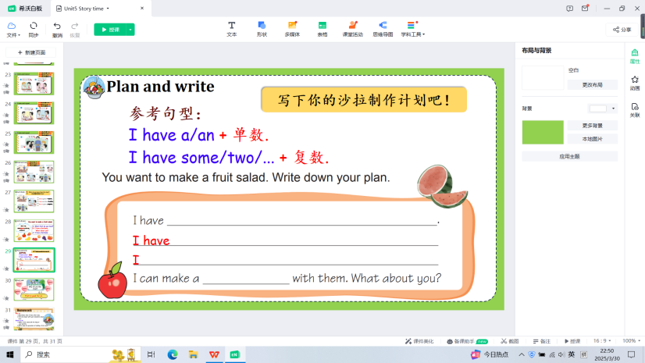  4.Let's talk  Big question: Why do you like fruit? | Think and say  Let’s make a fruit together. →Work together. Here you are. →Help each other. Let’s share the fruit salad. →Share together.  2.Let's discuss  A: What fruit do you have?  B: I have a/an/some ... What about you?  A: I have a/an/some ...  3.Plan and write  Finish the plan.  4.Let's talk  Big question: Why do you like fruit?  Sweet, tasty,great, juicy yummy. Fruit is good for us. | 理解，内化和运用：  通读完文本学习后，结合本节课中的沙拉制作过程回顾，引导学生体会文本中的情感价值合作与分享。  在最后输出环节，通过同桌问答的形式来谈论自己拥有的水果。为之后写沙拉制作计划做好语言铺垫。  再次聚焦本单元主题Big question: Why do you like fruit?引导学生进一步理解本单元的主题意义，水果有益健康，引导学生养成健康的饮食习惯。
Step 4 Home work | 【Must do】  (1) Read Story time correctly and loudly.  (2) Ask and answer with your classmates about fruit.  【Choose to do】  Make a fruit salad with the help of your parents.
板 书 | 