Unit 4 Have fun after school第四课时教学设计
课 题 | Unit 4 Have fun after school（Wrap-up time & Assessment time）
学 校 | 常州市武进清英外国语学校 |  | 执 教 | 胡佳慧
教学目标 | 通过本课时的学习，学生能够：  - 借助绘本情境复习并运用本单元核心语言，理解故事大意。  - 在任务情境中解决问题，完成说、读、写等方面的练习。  - 通过一系列hide-and-seek活动，融合说写介绍自己和朋友的游戏，并分享。
教学重难点 | - 在实际情境中准确运用表示方位的词语来描述物品所在位置。  - 能规范、准确、美观的进行“写”的表达。
教学流程 | 教学活动 | 学生活动 |  |  | 设计意图
Step1 Warm-up and lead in | - Chant and greet  T: Do you remember the chant in this unit? Let’s chant, OK?  T: What do they play in the chant?  S: Hide-and-seek.  - Lead in  T: Before class, I did a survey in my school. What do my students like best?  T: Do you like playing hide-and-seek? Let’s chant again and play together. OK?  T: We all like to hide-and-seek. But how to play? Can you find in the chant? | Ss look at the pictures and answer where the students are.  学生看图片和文字，说红色字体的部分  Ss: On, on, on the table.  Ss think and share  Chant again.  S: Run and hide. Don’t speak. |  |  | chant导入，激活思维。激发兴趣，快速复习。  呈现课前调查的结果，点出孩子们喜欢捉迷藏  感受游戏的趣味
Step2  Learn and practice | - Look and find  T: Let’s play with the children. Where are the children?  T: Who’s behind the tree? Where’s Yang Ling / ...?  - Listen and find  1）listen  T: The school things are hiding. Let’s listen and find.  T: Look! What can you see?  T: Let’s listen and write the numbers on the line. Here’s the listening tip. First, look at the picture carefully.  Think: What you may hear？  Now let’s listen.  - Read and find  1）课前预学单  T: The animals want to play too. Let’s read and find them.  Q:Where do the animals hide?  Q:Why do they hide?  T: They play together and have fun together.  2）Read and choose  T: Tiger wants to hide-and-seek with the animals, too. Let’s read and choose, to finish the dialogue. | 先看图回忆学生躲藏的位置，两两对话  再跟节奏将对话变成chant  学生看图说表格里的东西  学生看图、讨论图片信息，做好预测  学生借助课前预学单，理清楚故事的脉络，找到Where do they hide?和Why do they hide?  检查核对——表演 |  |  | 课课练40页B部分听力  出示听力tip，掌握听的技巧：1看2想3听  将课课练的练习和绘本内容结合起来，阅读完成对话，掌握阅读策略和答题技巧
Step3  Wrap-up | - Think and find（改错：大写、间距、标点）  T: Tiger and zebra also wants to hide. Where do they hide?  T: There are some mistakes. Let’s correct it. I ask my AI friend about writing English, it helps a lot. So you can follow the check list.  - Write  T: Do you want to play with the animals? Let’s join them.  - Share and check  Big question: How do you have fun after class? | 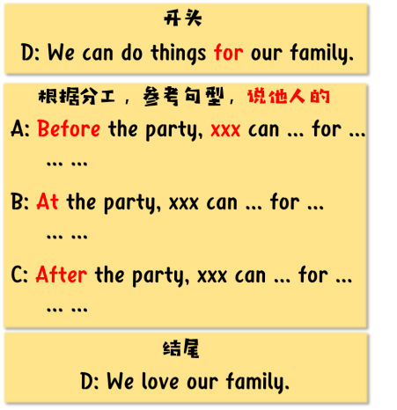  Write  Discuss in pairs and find.  学生根据check list与同桌讨论、找出文本中的格式错误  学生在仿写的过程中，关注格式  More activities.More fun.  More friends. |  |  | 帮助Zebra修改不规范的表达，增加活动的趣味性。同时为自主输出增加基础  结合三年级学生特征，将标准中的几个规范书写的要求设计成金币，助力仿写  综合运用本单元语言知识，规范写作
Step4  Homework | Need to do（必做）:  - Finish your writing and ask more friends to join you.  优化你的写作，邀请更多朋友参加。  - Assessment for Unit4 完成第四单元《课课练》  Choose to do（选做）：  Read or search the internet, know about activities in foreign countries.

