课题 | 三下 Unit4 Have fun after class (Lead-in & Cartoon time)
年级 | 三年级 | 执教人 | 常州市武进区横林实验小学 陶希
教学内容分析 | - Lead-in  Lead-in板块作为单元学习的起点，围绕Big question：”How do you have fun after class?”设置三个单元学习目标：谈论人和物品的位置、讨论如何在课后玩得开心以及找寻课后玩得开心的方式。单元主题图直观地展示了学生们在课后玩捉迷藏游戏的场景，整体呈现学习情境，以一首关于捉迷藏的韵律诗作为学习热身活动，引导学生看图片、听读韵律诗、探话题，初步感知单元主题。  - Cartoon time  【What】故事内容  本语篇讲述了课间休息时间Bobby、Sam和Billy进行纸飞机比赛的故事。他们的纸飞机飞得都很远，最终落在了不同地方，如桌子上和花丛中，而Bobby的纸飞机却落在了树上。  【Why】主题意义  本语篇通过展示有趣的课件活动，教授描述物品位置的核心语言，同时引导学生体会课间活动的乐趣。鼓励学生走出教室，参与户外活动，感受课间活动的乐趣。  【How】文本结构和语言修辞  本语篇教授谈论位置的句型“Where’s my plane?”和“It's on the table/in the flowers/in the tree.”等，配以生动的图片，帮助学生理解和记忆有关位置的表达。故事情节简单明了，语音生动有趣，符合小学生的认知水平和生活实际。
课时 学情 分析 | 已有基础：在主题意义方面，学生在学习了三下前三个单元后，对校园学习生活有了更深刻的理解，开始形成校园小主人的意识，享受美好校园的快乐时光。从语言知识方面来看，在三上U5的Lead-in板块的韵律诗中首次出现了Where的特殊疑问句:”Where are you?”，降低了学生理解卡通时间的难度；在学习了三下U1，U3语篇后，学生能运用地点介词in，on对地点进行描述，如 in the schoolbag ,in the classroom, in the library 等。在学习能力方面，学生已经具备初步的观察、模仿、记忆、想象和创新的能力，自学的能力也在不断发展，但他们的学习策略和方法相对简答，需要教师给予适当的引导。  兴趣点：故事内容贴近学生校园生活且风趣幽默，有利于学生朗读、表演、联想等活动的展开。  难点：理解Where’s....的含义，并根据实际利用in the flowers, behind the tree, by the tree, on the table,under the table等方位短语对地点进行描述；图文结合理解故事，体会人物心情，做到准确且有感情朗读课文，能够分角色表演对话。
课时 教学 目标 | 通过本节课的学习，学生能够：  1.在单元主题图的帮助下，通过看、听、说、读等活动认读核心词汇，初步感知韵律诗的节奏与含义。  2.在看、听、读、说的活动中获取、梳理Bobby，Sam和Billy的纸飞机的位置，并进行正确描述。  3. 能正确熟练地辨别、朗读辅音音素[ f ], [v ]，感知、发现并掌握字母f和v在单词中的发音。  4. 通过交流封面图和卡通人物的课余游戏生活，感受与朋友游戏活动的快乐，初步思考本单元 Big question。
重难 点 | 1.正确认读单元核心词汇，在理解的基础上流利朗读表演课文语篇。  2.能在综合语言活动中感知、理解并在语境中正确运用方位短语in/on/under/ by/behind...等核心语句”Where’s...?””It’s in/on/under/ by/behind...”等交流人或事物的方位。  3.基于文本内容推断信息，探究主题意义，进一步思考本单元 Big question。
课前 准备 | 学生在 前置性作业单的帮助下下预习Lead-in和Cartoon time.

整体 思路 |  |  |  | 通过Listen and sing，引起学生学习热情，同时引起学生对介词的感知。通过听读唱，使学生对 Lead in 内容进行整体梳 理 认知， 聚 焦场景人物的不同位置。  1. Greet the friends  2. Look and say  3. Check the answers  4. Make a new chant  - Listen and answer  - Look and say  - Listen and order  4. Listen and match  5. Read and check  6. Listen and imitate  7. Act out in groups  8. Think and say  学生能通过听看的方式掌握故事脉络，及核心句型与词汇。并借助指读的方式流利地朗读课文和对话，在不断思考中切身体会课中人物的感情并一步步探究主题意义。  让学生感知字母“f”“v”在单词中的发音，利用对比视频感知两个音素的发音区别；此外，借助连词游戏，提升学生学习兴趣，强化拼读意识。  1. Look and read  2. Read the words  3. Chant together  【Must do】  - Read Cartoon Time with your fingers and act it out for your family.  - Make a paper plane and fly it. Try to say where it is.  - Preview Story time and finish the exercise A on P38
  Step 1
  Lead-in
整体 思路
  Step 2
  Cartoon-time
整体 思路
  Step 3
  Sound-time
整体 思路
  Step 4
  Homework

教学 过程 | 教师活动 | 学生活动 | 设计意图
Step 1  Lead-in | 1. Warming up  T: Hello, boys and girls. Let’s sing and move.  T : We usually sing ,dance and act in English lesson.We can have fun in class. But how do you have fun after class?  (揭题： Unit 4 Have fun after class）  2. Look and say  T：Look！ The students are having fun after class. Who are they?  Check the exercise（Period 1课前学习单）  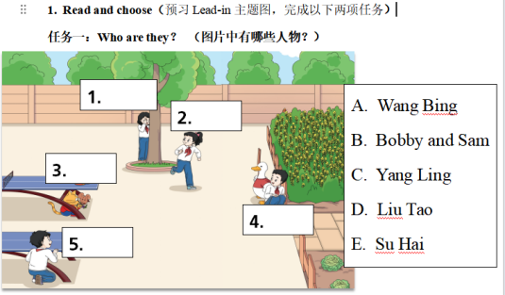  T: This time,let’s say good morning and check.  T: Well done. They are playing hide-and-seek. What game is it?  3.Check the exercise  T:Well，they run and hide. Let's find them together!  -Check the 1st exercise  look at the pre-class task sheet? Is it right?  (核对课前预学单2）  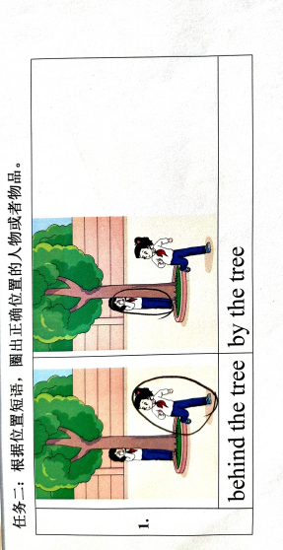  T:Well，Let's take a look at the picture from the book. Look! Who’s behind the tree?  Who’s by the tree?  （引导学生观察主题图的标识意思）  -Check the 2nd exercise  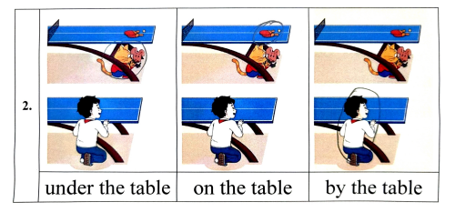  T: Who are under the table?  What is on the table?  Who is by the table.  -Check the meaning of words  T:So, can you find the meaning of them? This time, let’s play a game-little train.  4.Make a new chant  -Listen and chant  T:This time let’s chant and play with them?  (播放音频）  This rhyme has magic.Let's listen carefully again.Then tell me what you can find?  T:These are called the rhyme. It can help it easy to chant.  T: Let’s give the answers to the rhyme.Who’s behind the tree?  Can you see？ Can you see？  （引导学生能说出Who's by tree.）  T:This time,please work in two and make a new chant.（课中助学单1）  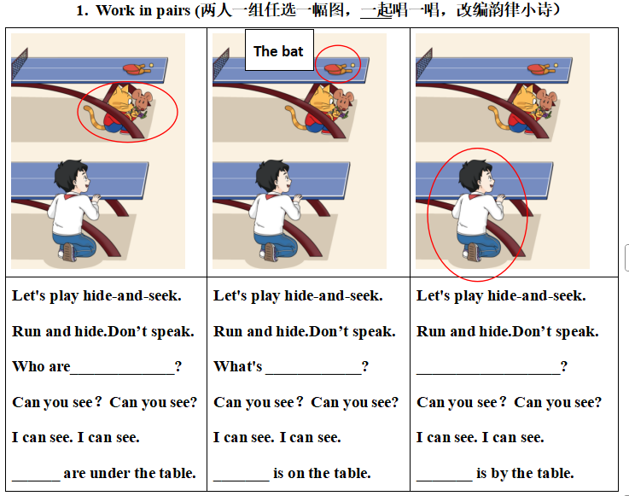 | Ss sing and do actions.  Ss:Good morning, Yang Ling/ Good morning,Su Hai....  S：B  Ss：No  Ss：behind是在……后面，by是在……前面。  Ss：Yang Ling  Ss: Su Hai.  S: Bobby and Sam are under the table.  ...  Ss:GO! Go Go!  (开火车，按顺序说出各个介词的意思）  Ss do the gesture.  Ss listen and chant  Ss listen and try to find the rhyme.  S2:I can see. I can see.  Yang Ling is behind the tree.  S3:I can see. I can see.  Su Hai is behind the tree. | 感知与注意：课前通过TPR，激发学生兴趣，使学生在朗朗上口的歌曲中感知本单元内容,与学生形成良好的互动。  利用课前学习单检验学生的预习成果，帮助学生对将要进行的学习有大致性地了解，为后续活动推进做铺垫。  通过阅读主题图、听读、创编韵律诗对Lead-in内容进行整体梳理和认识，聚焦文本人物的课间活动乐趣，引发学生思考本单元大问题。
Step2  Cartoon  time | 1.Listen and answer  (播放铃声，及音频“It’s break time.”)  T：Listen，who is speaking?  T: What’s the meaning of break time?  Guess：what is he going to do after class? Let’s listen and find the answers. (播放音频：Let’s play outside.)  T: Yes. He wants to play outside. Outside means out of the classroom.  2.Look and say  T：Look！Who are they? What are they playing with?  Whose planes are they?  (核对课前学习单）  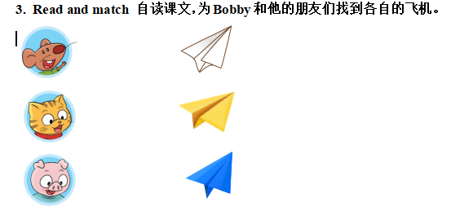  T:How do you find the answers?  3. Listen and order  T:From the story, we know the planes are in different places. Now let’s listen and order.(课中助学单2  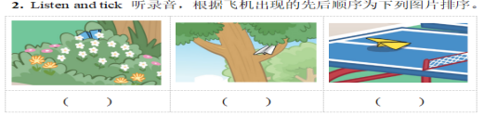  T：Your can get the key phrases.  4.Listen and match  T: where is Bobby’s plane? Let’s take a look where they are. (学生自读文本完成A部分练习）  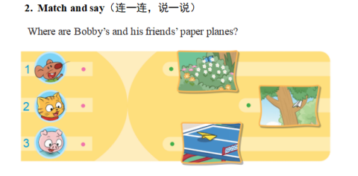  5.Read and check  T:Now,let’s read and check  T：Now，let's check.  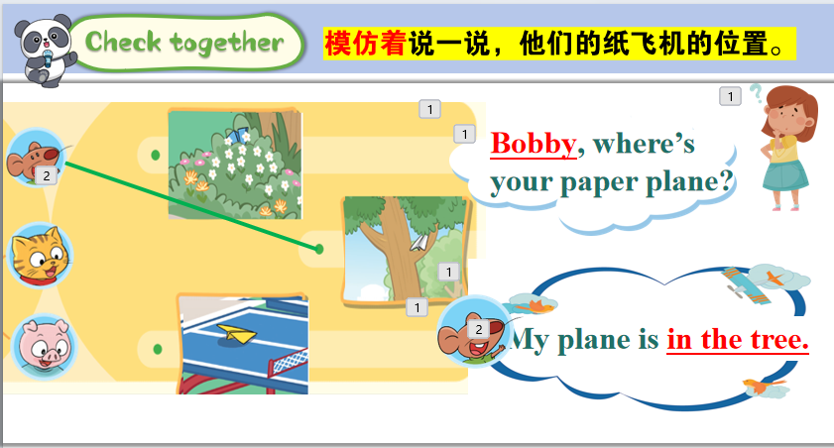  - Listen and imitate  - Act out in groups  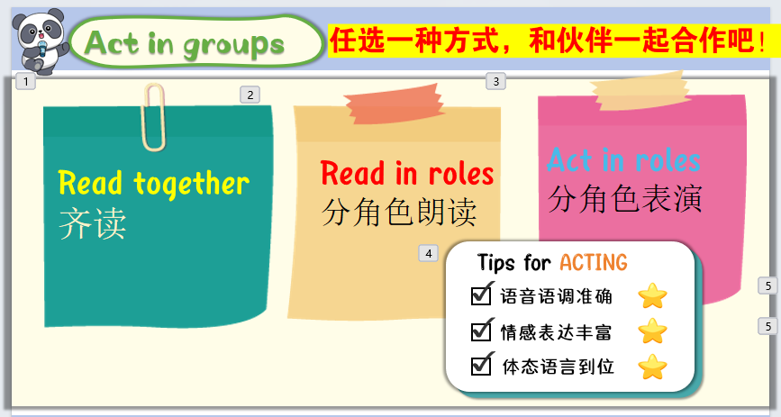  8.Think and say  Q: How do Bobby and his friends have fun after class? | S:Bobby.  S:A 下课  S:play.  S:Bobby, Sam and Billy. /paper planes.  S: I can read from the pictures.  Ss listen and order  S: This plane is in the flowers. This plane is in the tree. This plane is on the table.  S listen to the story and match it)  学生听录音，指读课文；在对话中核对连线是否正确。  Ss follow the tapes and read with emotion.  S1: They play with paper plane.  S2: They play outside.  S3:They play with friends....（言之有理即可） | 获取与梳理：通过Bobby玩的其他课间游戏，自然引入卡通部分。并通过看、听、读等多种形式，解决小问题: When? Where? Who?  图文结合的方式，让学生直观理解生词意思。结合生活体验，同时也鼓励更多的学生在课间能走出教室，享受户外乐趣。  在听录音，手指指尖跟着录音内容移动的过程中，整体感知故事内容，并在看图的过程中核对连线是否正确。  在不断听、读、模仿中复现本课时核心句型，同时在续编故事的同时，让学生理解方位介词。  运用核心语言，回顾已学,巩固语篇内容，体会课间活动的乐趣。

Step 3  Sounds in focus | - Listen and read  T：We also can have fun with our letters. Letter F and V come to have fun with us. Do you still remember the chant about them ?  What’s the sound of “f”&“v”?  Learn the sounds in the video.  - Chant and find  - T: Letter F and V like playing hide-and-seek.Can you find them all ?(核对课前作业单）  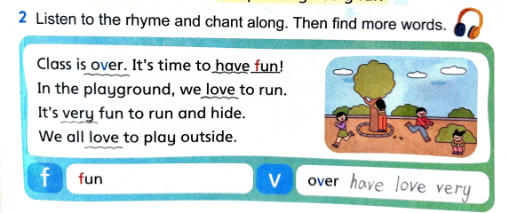  What do you find?  Now let’s follow the tape and chant together  - Read the words  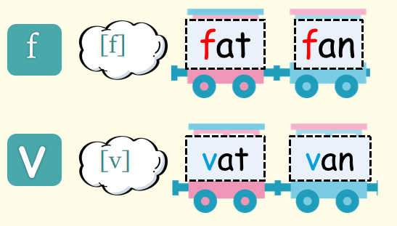  Summary: Class is going to be over.  How do you have fun after class? |  | 复习自然拼读小诗。  S:/f/ /v/  Follow the tape and feel the differences between them,  Fun,/over/have/love...  S:Chant together  Ss listen and find.  学生尝试读一读单词fat,vat,fan,van,再次感知并内化它们的发音区别。  学生交流How to have fun after class?，首次回应big question。 | 内化与运用：  自然引出字母f,v的发音，过渡到Sounds in focus。  让学生感知字母“f”“v”在单词中的发音，与学生形成良好的互动  在听、读、跟唱中内化单词的发音规律。含拼读有[f][v]的相似读音的单词中，考察学生是否了解“f”“v”在单词中的发音/f/ /v/,
Step 4 Home work | Must do（必做）:  - Read Cartoon Time with your fingers and act it out for your family.指读卡通时间，为 家人演一演。  - Make a paper plane and fly it. Try to say where it is.  - Preview Story time and finish the exercise A on P38
板书 |  | 