**20250221| 中一班**

Daily life

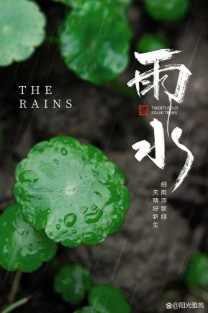

**「来园情况」**

今日星期五，全勤。

**今日餐点**

上午点心：鲜牛奶、自选饼干、腰果

午餐：黑芝麻米饭、香菇鸡腿、莴苣炒木耳小香干、鸡毛菜肉末汤

下午点心：思念小猪包、奶酪棒

水果：草莓、哈密瓜

**「日常生活观察」**

|  |  |  |  |  |  |  |
| --- | --- | --- | --- | --- | --- | --- |
| **序号** | **姓名** | **午餐** | | | **午睡** | **备注** |
| **饭** | **菜** | **汤** |
| 1 | 韩昕怡 | √ | √ | √ | √ |  |
| 2 | 韩昕悦 | √ | √ | √ | √ |  |
| 3 | 吴清墨 | √ | √ | √ | √ |  |
| 4 | 陆晟涵 | √ | √ | √ | √ |  |
| 5 | 张梅伊 | √ | √ | √ | √ |  |
| 6 | 吴沐檀 | √ | √ | √ | √ |  |
| 7 | 曹果 | √ | √ | √ | √ |  |
| 8 | 曹煜琪 | √ | √ | √ | 看护入睡 |  |
| 9 | 蒋安乐 | √ | √ | √ | √ |  |
| 10 | 韩书华 | √ | √ | √ | √ |  |
| 11 | 顾言希 | √ | √ | √ | 看护入睡 |  |
| 12 | 贾钧尧 | √ | √ | √ | 看护入睡 |  |
| 13 | 杨宸 | √ | √ | √ | 看护未睡 |  |
| 14 | 张予安 | √ | √ | √ | √ |  |
| 15 | 高瑞泽 | √ | √ | √ | √ |  |
| 16 | 张路翔 | √ | √ | √ | √ |  |
| 17 | 谢咏呈 | √ | √ | √ | √ |  |
| 18 | 汤凌宇 | √ | √ | √ | 看护未睡 |  |
| 19 | 韩以轩 | √ | √ | √ | √ |  |
| 20 | 冯煦晨 | √ | √ | √ | √ |  |
| 21 | 郑哲皓 | √ | √ | √ | √ |  |
| 22 | 张致远 | √ | √ | √ | √ |  |

**「户外活动」**

**今天我们在中操场的亿童建构区进行户外游戏，我们搭建了坦克、楼房、游乐园……**

|  |  |  |
| --- | --- | --- |
| **IMG_7161** | **IMG_7181** | **IMG_7187** |

**「区域游戏」**

**今天区域游戏时间，我们自己选择感兴趣的区域进行游戏，快来看看我们的作品吧。**

|  |  |  |
| --- | --- | --- |
| **cf1a9c0f76f58e6a3f1088acbabc80f1** | **bc4942411f39dfdc0d386e5e4548317f** | **28cadfe8e50181c3d5537ee39338ec3b** |

**「午餐活动」**

**今天我们吃的是黑芝麻米饭、香菇鸡腿、莴苣炒木耳小香干、鸡毛菜肉末汤。**

|  |  |  |  |  |
| --- | --- | --- | --- | --- |
| IMG_7189 | IMG_7190 | IMG_7193 | IMG_7192 | IMG_7194 |
| IMG_7195 | IMG_7196 | IMG_7197 | IMG_7198 | IMG_7199 |
| IMG_7200(1) | IMG_7201(1) | IMG_7202(1) | IMG_7204 | IMG_7205(1) |
| IMG_7206 | IMG_7207(1) | IMG_7209 | IMG_7208 | IMG_7210 |
| IMG_7214 | IMG_7215 |  |  |  |