**20250225| 中一班**



Daily life

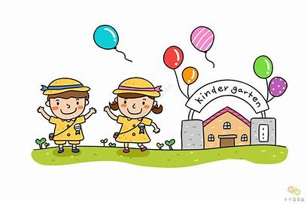

**「来园情况」**

今日星期二，共有20人来园，2人请假。

**「日常生活观察」**

|  |  |  |  |  |  |  |
| --- | --- | --- | --- | --- | --- | --- |
| **序号** | **姓名** | **午餐** | | | **午睡** | **备注** |
| **饭** | **菜** | **汤** |
| 1 | 韩昕怡 | √ | √ | √ | √ |  |
| 2 | 韩昕悦 | √ | √ | ⭕ | √ |  |
| 3 | 吴清墨 | √ | √ | √ | √ |  |
| 4 | 陆晟涵 | 请假 |  |  |  |  |
| 5 | 张梅伊 | √ | √ | √ | √ |  |
| 6 | 吴沐檀 | 请假 |  |  |  |  |
| 7 | 曹果 | √ | √ | √ | √ |  |
| 8 | 曹煜琪 | √ | √ | √ | √ | 看护入睡 |
| 9 | 蒋安乐 | √ | √ | √ | √ |  |
| 10 | 韩书华 | √ | √ | ⭕ | √ |  |
| 11 | 顾言希 | √ | √ | √ | √ | 看护入睡 |
| 12 | 贾钧尧 | √ | √ | √ | √ |  |
| 13 | 杨宸 | √ | √ | √ | ⭕ |  |
| 14 | 张予安 | √ | √ | √ | √ |  |
| 15 | 高瑞泽 | √ | √ | √ | √ |  |
| 16 | 张路翔 | √ | √ | √ | √ |  |
| 17 | 谢咏呈 | √ | √ | √ | √ |  |
| 18 | 汤凌宇 | √ | √ | √ | √ | 看护入睡 |
| 19 | 韩以轩 | √ | √ | √ | √ |  |
| 20 | 冯煦晨 | √ | √ | √ | √ |  |
| 21 | 郑哲皓 | √ | ⭕ | √ | √ |  |
| 22 | 张致远 | √ | √ | √ | √ |  |

**「户外活动」**

|  |  |  |
| --- | --- | --- |
| **IMG_9015** | **IMG_8977(1)** | **IMG_9002** |
| **IMG_9027(1)** | **IMG_9026(1)** | **IMG_9025(1)** |
| **IMG_9024(1)** | **IMG_9023(1)** | **IMG_9016** |