七年级上册 Unit5 Integrated skills
班级_____________________________ 姓名_____________________________
Activity 1. Learn about the festivals
Group1-4 Group 5-8 Group 9-12
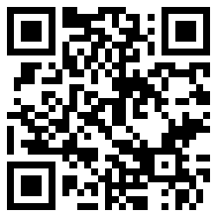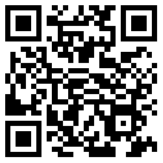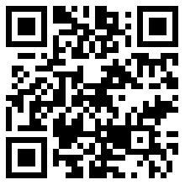
( ) People celebrate the festival ___________________.
A. for family reunion (家庭团圆)
Structures: It comes in …
People celebrate it to …
People usually…
B. to remember Qu Yuan
C. to pray or bless (祈福)

Activity 2. Learn more about the party
Listen and fill in the table (p.63) (scan the two codes)
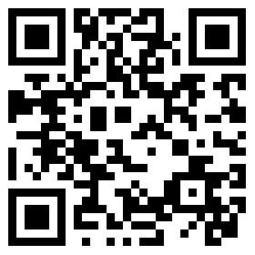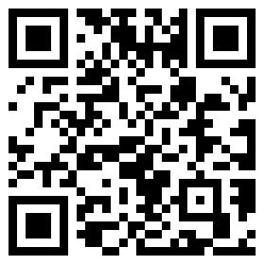

◆Reading criteria 朗读标准
Student 1 Student 2
Scores得分 | 1 point | 2 points | 3 points
Accuracy 正确性
Pronunciation 发音
Fluency 流利度
Scores得分 | 1 point | 2 points | 3 points
Accuracy 正确性
Pronunciation 发音
Fluency 流利度

Activity 3. Group work (choose ONE task you like)
Task 1 Task 2


