活动通知：
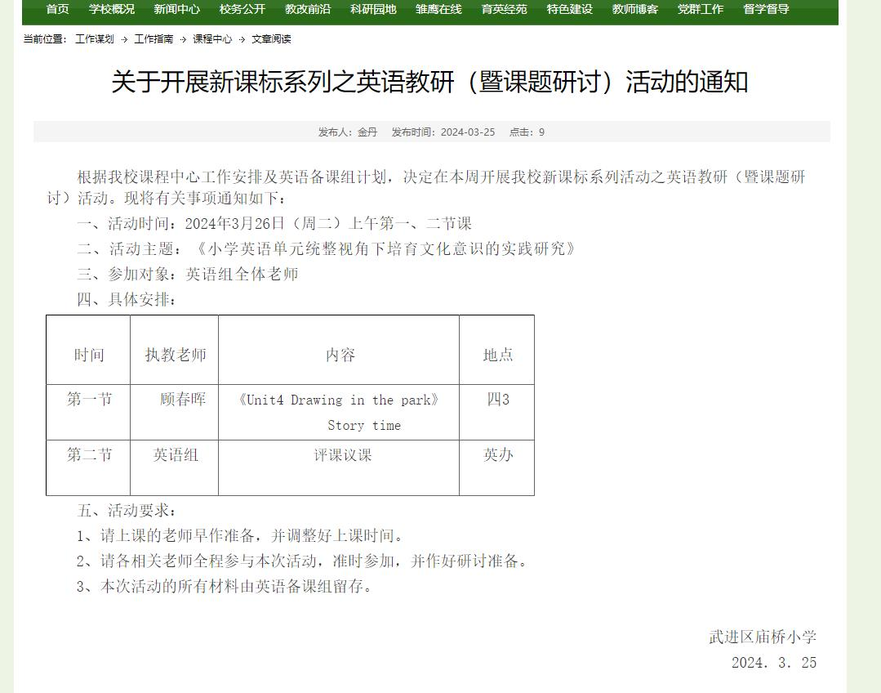
教学设计:
四下 Unit 4 Drawing in the park Period 1
Story time
Step 1 Free talk and introduction
T: Hello, boys and girls, Nice to see you again. I'm your English teacher. Do you want to know more about me?
T: OK. Let me introduce myself to you . Listen carefully.
T: I’m Miss... I like English. I can...
T；Can you try to introduce yourself to your partner. Here are the key sentences:
I’m__________.
I like_________.
I can__________.
This song is composed of sentences from poetry.
Step 2 Presentation
1 Play a game
T: Nice. All of you can do a lot of things. How about our friends? What can they do?
Let's play a game. Please look at the sentences and the picture. If they are the same. We can say: “Yeah,yeah, yeah.” If they are different, we can say “no, no, no”
- Can you swim? Yes, we can.
- Can you sing? No, we can’t.
- The woman can run.
- What can you do, little boy? I can play basketball.
- Can you draw pictures? Yes, I can. (呈现draw pictures, 进行教学）
2 Present the title
T: The girl can draw. Where can she draw?
S: ...
T: Yes, sometimes in the art room. . Sometimes in the park.
T:Look, Mike and his brother Tim are in the park. Look at the picture carefully. What would they like to do in the park?
呈现主要问句
S: draw pictures.
T: Yes, you are right. They like drawing in the park.
Present the title “ Unit 4 Drawing in the park”
3 Talk about the picture.
T: (继续讨论第一幅图) Look, they are in the park. What can you see in the park?
Present “trees, flowers, river, bridge, boat” (拓展教学bridge)
带读新句子和新单词
4 Watch and circle.
T: There are some many things in the park. What does Tim draw?T: （课件呈现主要问句） Let’s watch the cartoon and circle.
学生看视频，并在图片上圈出答案。教师给出提示性句型： Tim draws
5 Learn the picture 2-3
T: Can Tim draw the tree and the flowers well?T: Work in two. Read Picture 2-3 carefully and find the answer. (同桌读2-3 图，并寻找答案。）
S: Yes, he can. (下面讨论关键句）
分析： （1）Mike asks: Can you draw them? 圈出them，并用箭头直接指向上文的 the tree and the flowers. (learning tip: them 是“他们、她们、它们”的宾格形式，用于指代上文出现过的复数的人或物， 用在动词和介词的后面）
- T: Tim says: ...
S: Sure, it’s easy. Present “ easy”
T: How does Tim feel?
S: ...（可以说中文）
T: Yes，proud. Can you read it with right emotion? 引导学生读出骄傲的口吻。
- T: After he shows his picture. Mike says ...
S: Well done.
T: So we know: Tim can draw the tree and the flowers very well.
6 Learn the picture 4
T: Can Tim draw the boat well? T: Work in two. Read Picture 4 carefully and find the answer. (同桌读4图，并寻找答案。）
S: No， he can’t. (下面讨论关键句）
分析： （1）Mike asks: Can you draw it? 圈出it，并用箭头直接指向上文的boat. (learning tip: it 是“它”的宾格形式，用于指代上文出现过的单数的物， 用在动词和介词的后面）
（2）T: Tim says: ...
S: It’s difficult. But I can try. Present “ difficult”
T: How does Tim feel?
S: ...（可以说中文）
T: Yes，uncertain( 不确定的）. Can you read it with right emotion? 引导学生读出不确定的口吻。
7 Read and imagine
T: Boys and girls，can you guess which is Tim’s picture?
S: ...
T: Yes, you’re right. Mike asks: “Is this a boat? “ That means Tim's boat doesn't look like a boat. 把这个句子引申一下然后再来谈。
Q1: How does Mike feel? Can you imitate?
Q2:Then, what else will Mike say？
T: So Tim will go on learning how to draw.

Step 3 Consolidation
1 Listen and repeat.
2 Read in groups
3 Let’s go to the park and draw pictures.
4 Summary
（1） 如果你想邀请别人在这画画，你会怎么说？
（2）如果你赞同别人的建议，你会怎么说？
（3）如果你觉得很容易，你会怎么说？
（4）如果你想问对方能否看见河上的小船，该怎么问？
（5）如果你觉得很难，但你还想试一试，你会怎么说？

Step 4 Homework
1 Read and try to act the story out.
2 Go to the park and talk about with your friends in English.

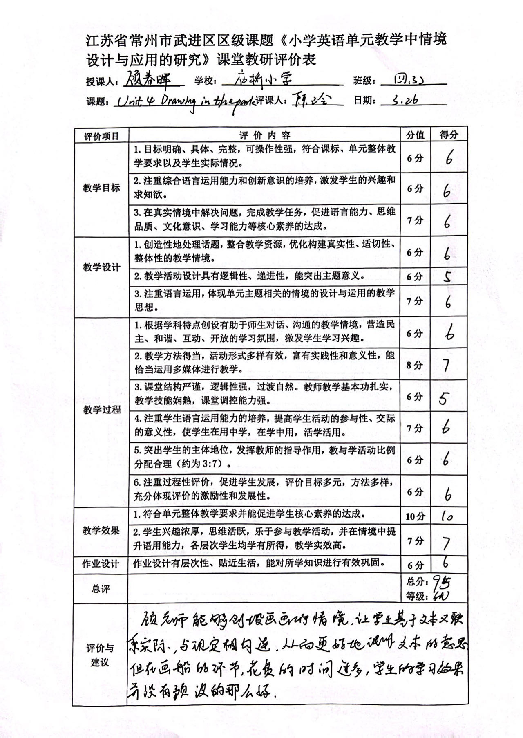
教学评价：

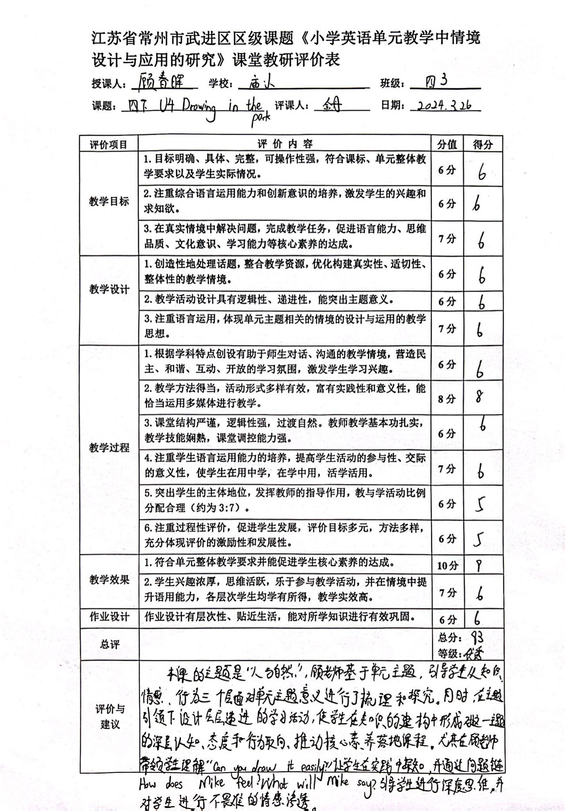

教后反思：
Unit4《Drawing in the park》教学反思
本单元的主要学习内容是用I can see …的句型描述公园里的事物。教学中，我利用图片、幻灯片以及电脑课件引导学生观察和理解所学的语言。
多媒体借助完成以后，大多数学生对于所学的概念有了一定程度的理解，但是还不够深刻。所以我又利用简笔画的形式，补充的降本单元出现的几个名词对应的简笔画呈现在黑板上，帮助学生加深理解。同时，可以借助黑板上的简笔画，对于生说Can you draw …?自然的引出本课的重点句型。通过对花的单数的描述，以及树的复数的描述，让学生体会代词 it 和them之间的区别。
但是在教学中也存在一定的问题，学生对于draw easy difficult 的发音理解和朗读起来有一点的困难。仍然需要结合以后的内容在课堂上加强训练。
同时我也发现，多媒体课件以及简笔画的使用，可以使课堂上的氛围活跃不少，并且可以弥补传统的班级教学中存在的不足与缺陷。让学生虽不在现场也可以由身临其境的感觉，更好的体会文章的内容以及主人翁的语言环境，能够更好的接受自己的所学知识，并且能够学以致用，真正做到学英语、用英语。

活动报道：