一、课题研讨课通知
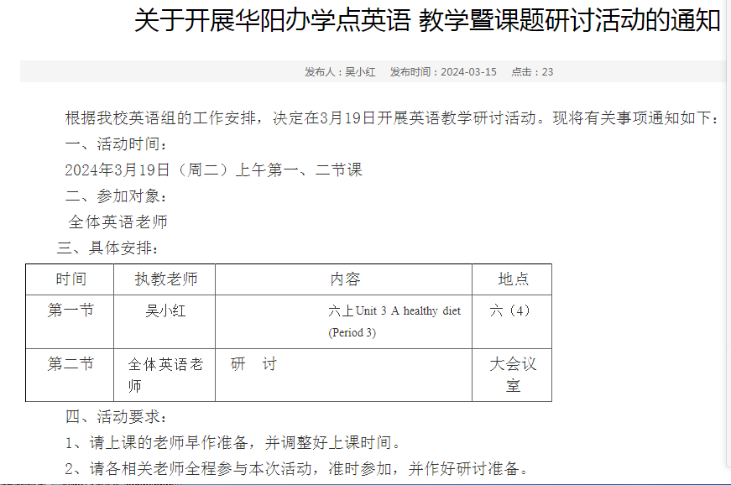

- 教学设计
Unit 3 A healthy diet
一、教学内容 Sound time Culture time &cartoon time
二． 教学目标
1.能理解并体会字母组合ou在单词中的发音。
2.能理解culture time的内容并适当拓展。
3.能在前两课时的基础上正确并熟练地掌握a little , a few , some 和a lot of 并且可以正确使用。
三．教学重点
1.能理解culture time的内容并适当拓展。
2.能在前两课时的基础上正确并熟练地掌握a little , a few , some 和a lot of 并且可以正确使用。
四、教学难点
能在前两课时的基础上正确并熟练地掌握a little , a few , some 和a lot of 并且可以正确使用。
五、教学准备
图字卡， 课件多媒体， 《补充习题》
六、教学过程：
Step 1 Review Let’s talk
T: In a healthy diet, what should we have for meals?(列出金字塔)
Step 2 Culture time
1.T: There are many differences between Chinese and western food culture
（屏幕列举）
What about breakfast?
What do our Chinese people often have for breakfast?
S: They often have some porridge, eggs and steamed buns for breakfast.
(ppt: some porridge ,steamed buns 学生学习生词)
T: How about Western people, do they often have porridge or steamed buns for breakfast?
2.学生阅读Culture time 部分
S:No, they often have cereal, bread, eggs and sausages for breakfast.
(ppt: some cereal, bread, sausages学生学习生词)
师生读单词，请学生带读这些词。
3.介绍常见的中式早餐和西式早餐食物及中西方餐具的不同。
4.T：Different diet styles show us different culture.
Step 3 Sound time
T: We all know healthy diet means a lot to us. Look, Mrs Li is in the kitchen to prepare a good and healthy meal for her family. (呈现Sound time 插图) What happened to Mrs Li?
Look! There is a little mouse in her house.
T: Give you some time to read.
1.学生先自读句子，请学生读再齐读
2.总结字母组合ou 的发音发/ au /
3.请学生找出字母组合ou 发/ au / 的单词
Ss: trousers/ loudly/ proud...
4.教师出示一些字母组合ou的单词，学生齐读。
Step 4 Cartoon time
We have a mouse friend—Bobby. What does Bobby ’friend Sam like eating ?
1）T: There is not much food in the fridge. What food do they buy?
S: Cola, fish and rice.
T: Can Sam drink too much cola? (文中划出重点句子)
S: No, he can’t.
2）复习 should shouldn’t
3) They buy so many things. Is Sam happy at last(最后）?
S: I think he is sad at last.
4) 跟读全文
5）四人小组选择一种喜欢的方式读一读。（分角色读，齐读，一人领读，其余跟读）
6）Summary：They have a healthy diet. They have healthy bodies.

七、作业设计：
1.Do the survey with your classmates after class.
2.Find more differences between Chinese and Western diet.

八、板书设计：
Unit 3 A healthy diet Date
What do you often have for breakfast?
I have… ( some/ a few/ a lot of/ a little…)

三、教学评价
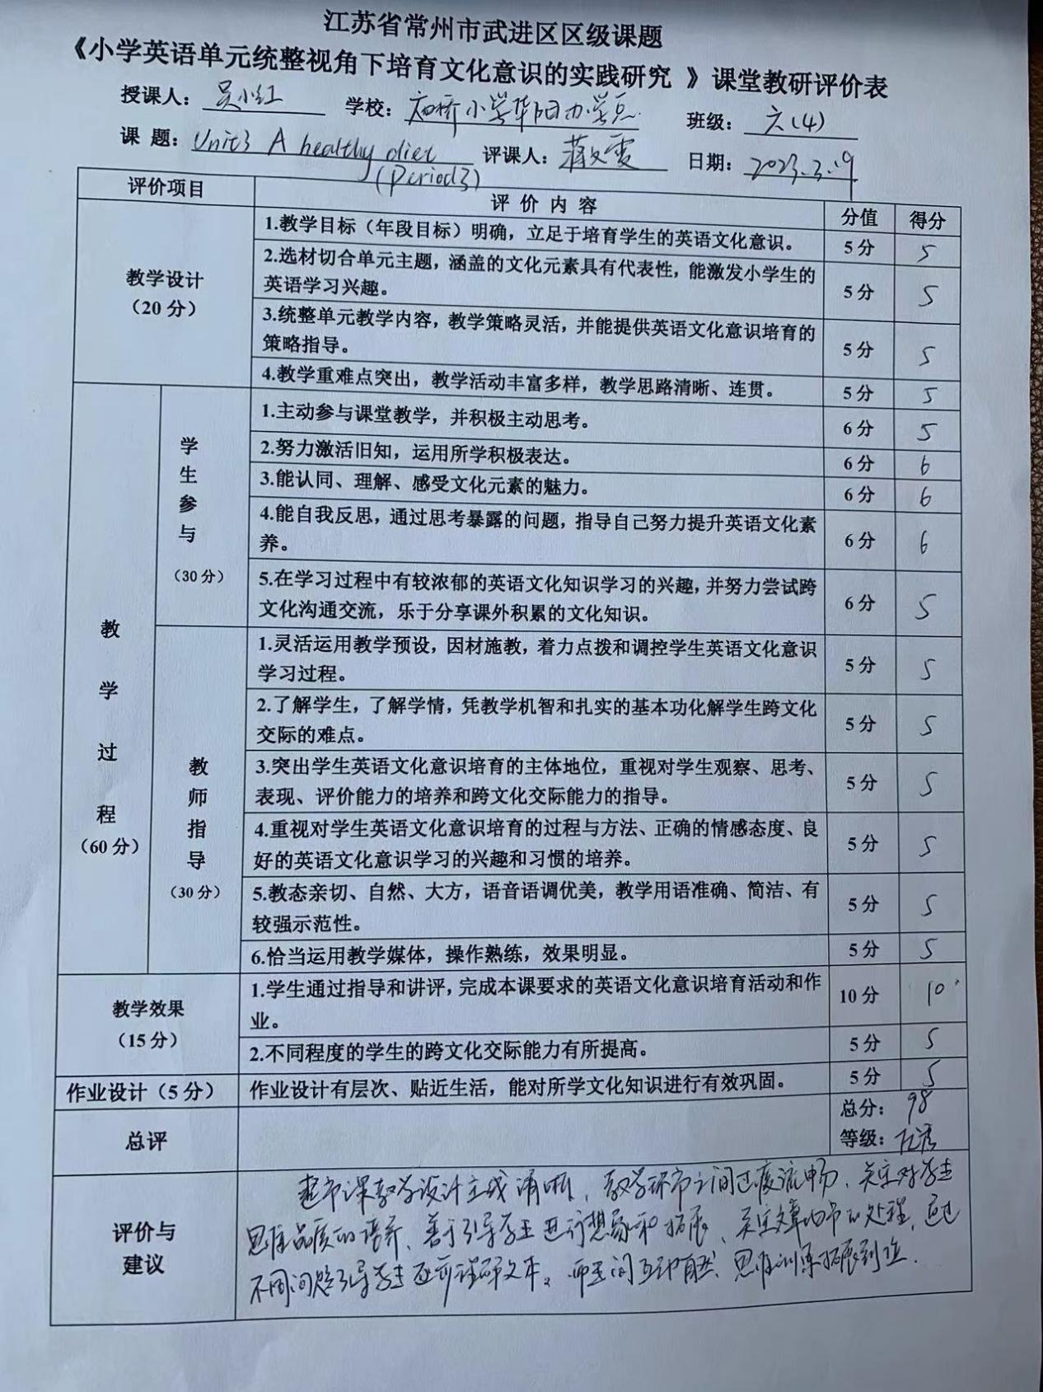

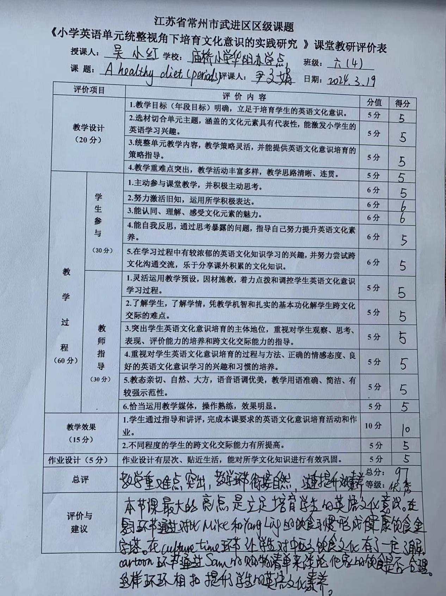

四、教学反思
Unit 3 A healthy diet（Period 3）
这是一个综合版块的教学，内容包括语音，文化，及卡通部分的教学。这一内容相对于Story time 和 Grammar time来说，单词量较少，更具趣味性和延伸性，是很好的阅读材料。要确保确保综合版块教学的实效，我们要认清不同版块教学内容的特点，发挥各板块的功能和作用，强化巩固前两课时的重点和难点，加强对学生语言运用能力的培养。
本节课我以healthy diet 为主线，让学生在谈论自己的一日三餐后，马上引入中外饮食文化的不同。除了介绍书本上的早餐外，我与学生还探讨了Chinese people like drinking tea. Western people like drinking coffee. Chinese people use chopsticks. Western people use forks and knives.
紧接着我出示Mrs Li is in the kitchen. Maybe she is cooking breakfast for her family.在厨房这一情景中，学习ou 的发音。并让学生进行补充单词。
由对话中的little mouse引出Bobby 和Sam，进而进入Cartoon time 的学习。在学习的过程中，我抓住what food do they buy? How much do they buy? 最后讨论Do they have a healthy diet? 并且要求学生们都能有a healthy diet ,a healthy body.
以上是我对于综合板块教学的自我实践，通过教学，我发现虽然我创设了一个合理的相适应的情景，将各板块串联了起来，但是其中的过度还是比较生硬的，语言的衔接有些不到位。在今后的教学中，除了传授语言知识和技能，还应注重发展学生的思维能力、想象力、创新精神、协作能力、培养学生的阅读能力。
五、新闻报道
