**钟子莲老师《Unit6 Is he your grandpa?第一课时》公开课材料**

1. 安排表

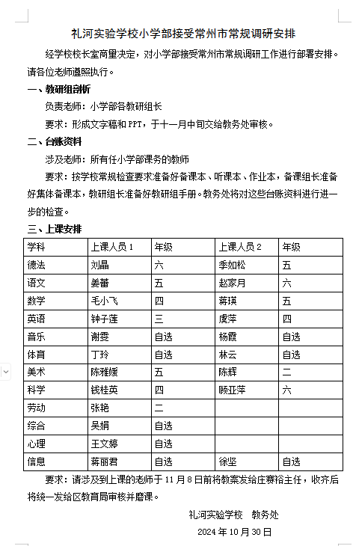

1. 教案

**Unit 6《Is he your grandpa?》**

**（Lead-in&Cartoon time）教学设计**

**礼河实验学校 钟子莲**

**一、教学目标**

（一）知识目标

1. 能听懂、会说、会读单词 grandfather/grandpa、grandmother/grandma、uncle、aunt、cousin、cool、me。

2. 能听懂、会说、会读句型Is he your...? Yes, he is. Who’s...? He’s...This is me!

（二）技能目标

1. 能够准确地发音本课的单词。

2. 能够听懂、理解并表演 Cartoon time 的内容。

（三）情感目标

1. 培养学生对家庭的热爱和尊重，增强家庭观念。

2. 培养学生的合作意识和交流能力，鼓励学生积极参与课堂活动。

3. 启发学生发现西方国家家族中重名的文化现象，培养学生的跨文化意识。

**二、教学重难点**

（一）教学重点

1. 掌握单词grandfather/grandpa、grandmother/grandma、uncle、aunt、cousin，并学习一首有关于家庭成员的儿歌。

2. 能够听懂、理解并表演 Cartoon time 的内容。

（二）教学难点

1. 能够准确地运用句型“Is he/she your...?”“Yes, he/she is. / No, he/she isn't.”进行询问和回答。

2. 理解并表演 Cartoon time 的内容。

**三、教学准备**

1. 教师准备

多媒体课件、教学图片、单词卡片、人物头像。

2. 学生准备

预习本课的内容，了解一些关于家庭成员的词汇。

**四、教学过程**

**Step 1 Lead-in**

1. **Let’s enjoy**

Before class, enjoy a song.

T: Just now we enjoyed a song. What’s the song about?

Ss: Family.

T: Right. Today we are going to learn more about family. The title is Unit6 Is he your grandpa? Read after me.

1. **Let’s review**

T: First let’s review Liu Tao’s family. Can you act Liu Tao and introduce family members? You can refer to these sentence structures.

参考句型：

Hello! I’m …

Come and meet my family.

This is my…

He’s/She’s...

1. **Let’s say**

T: Look, where are they now?

S1:刘涛家里。

T: How many people can you see? Please count.

S1: 十个。

T: Yes. Can you read this word?（用自然拼读法读出Ten）So Liu Tao has a big family.

1. **Let’s listen**

Who else are in Liu Tao’s big family? Let’s listen and find.

T: Boys and girls, who is Liu Tao’s grandpa? Who can come here and point? (学生到讲台前指认)

S1: He’s grandpa.

T: Great! (teach: grandpa)

|  |
| --- |
| grandpa=grandfather 祖父/外祖父 |

T: Who’s Liu Tao’s grandma?

S2: She’s Liu Tao’s grandma.

T: Good! (teach: grandma)

|  |
| --- |
| grandma=grandmother 祖母/外祖母 |

T: Great! Who’s he? Who’s she?

S3: He’s Liu Tao’s uncle. She’s Liu Tao’s aunt.

T: Good job! Look at Liu Tao’s father and him. They look the same. So he is father’s brother. He’s Liu Tao’s uncle. (teach: uncle, aunt)

T: Look at these two girls. Are they Liu Tao’s sisters?

Ss: No.

T: They are Liu Tao’s cousins. They are the daughters of Liu Tao’s uncle and aunt. (teach: cousin)

T: Now let’s help Liu Tao make a family tree. Can you put them into right places? (请一个学生到前面将人物头像放置于正确的位置，帮助刘涛制作家庭树)

1. **Let’s chant**

T: Now, you know Liu Tao’s family very well. Let’s try to say the chant together!

Teach: We all love each other! We are happy together!

T: Now let’s chant together.

Ss:...

Now I have a big question for you: What do you think of Liu Tao’s big family?

Ss: 温暖的，热闹的，快乐的……

T: Yes, warm, lively, happy.

**Step 2 Cartoon time**

1. **Let’s think**

T: Look at this picture. What other old friends can you see?

Ss: Bobby and Sam.

T: Today Sam invites Bobby to his home. This is the living room. Look, what’s on the wall?

S1: 照片。

T: Yes. There are some photos of Sam’s family members on the wall.

1. **Let’s guess**

T: Who are they? Let’s guess. You can use “Is he Sam’s...?” to guess.

S: Is he Sam’s...?

1. **Let’s watch**

T: Now let’s watch the video and find who they are.

T: Now let’s look and say.

S1: He's Sam’s__grandpa/grandfather__.

S2: He's Sam’s__father___.

S3: He's Sam’s__cousin___.

S4: He’s Sam.

**4. Let’s tick**

T: Look at the picture. What’s the title of Cartoon time?

S1: He’s John too.

T: Who is John? Please read fast by yourselves and finish part A. Open your books and turn to page 53.

T: OK, boys and girls, who is John? Is he John? （指第一幅图）

S1: Yes.

T: Yes, he is. From which picture do you know?

S1: 第一幅图。

T: Yes, picture 1. Which sentence?

S1: He’s my grandfather John.

(以相同方法验证下面三张画像。)

**5. Let’s chant**

T: Great! You know Sam’s family members well now. Here’s a chant about Sam’s big family. Please fill in the blanks. Work in pairs, ask and answer. Pay attention to the intonation. Look at picture a, I’m Bobby, who can be Sam?

T: Is he John?

S1: Yes!Yes!Grandpa John. （师生示范）

T: OK, it’s your turn. Please finish b, c and d with your partner.

1. **Let’s listen**

T: Now, it’s time for you to listen and imitate the whole story. Pay attention to your pronunciation and intonation.

Ss:...

T: (teach cool) What does “cool” mean? Guess.

S1: 酷的。

T: Right.

1. **Let’s think**

T: Now, let’s think: why does Bobby say “John” in picture 4?

S2:...

T: Yes. The first three are all named John, so Bobby thinks the last is also John.

T: Grandpa John, Father John, Cousin John. Why are their names all John? Because Chinese names and English names are different. How are they different? In China, when parents give the children names, we don’t use the same name as our grandparents or parents. It’s a kind of respect. But in western countries, they usually use the same name as their grandparents, parents or relatives to show respect and love. So this is the culture difference.

T: Are you clear? So what do you think of Sam’s big family?

Ss:...

T: I think there are many Johns in Sam’s big family. It’s fun.

1. **Let’s read**

T: Now it’s our reading time. First, let’s read together. Please read correctly, loudly, fluently and emotionally. Now let’s read in roles. Boys you are Sam, girls you are Bobby. Now exchange.

1. **Let’s act**

T: Now let’s act out the story. You can choose read in roles or act in roles. You can add some sentences. Let’s start.

**Step4 Homework**

**Must do（必做）:**

1. Say the chant to your family. (把儿歌说给家人听)

2. Read Cartoon time.（跟读卡通时间）

3. Preview Story time. Listen and repeat 3 times.

（预习故事时间，听读3遍）

**Choose to do（选做）：**

Make your own family tree.（制作你自己的家庭树）

1. 评议表

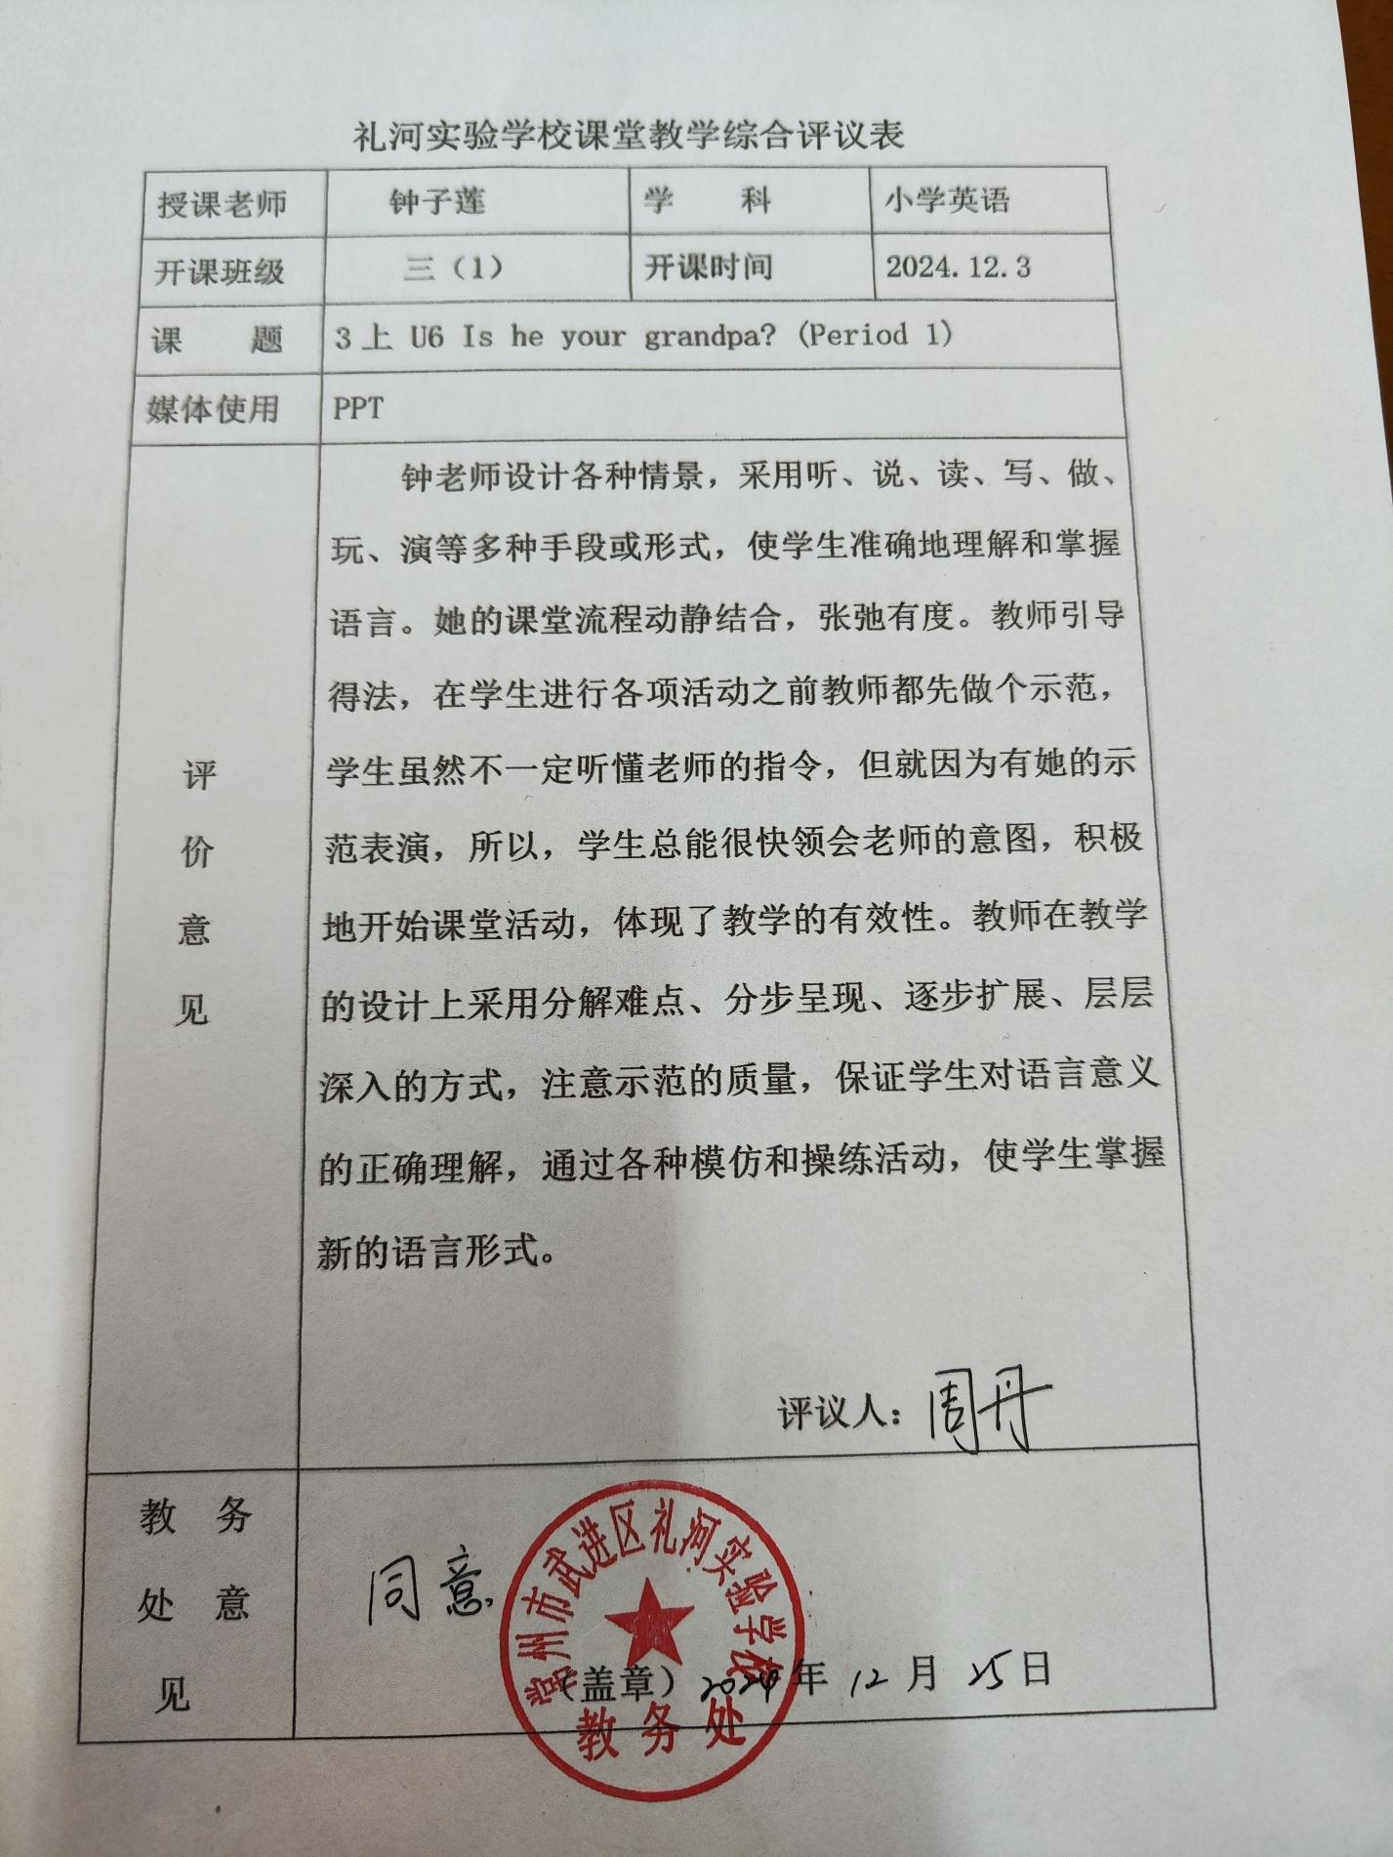

1. 照片

