**周丹老师英语学科**

**三上U4《This is my friend》公开课材料**

1. 安排表

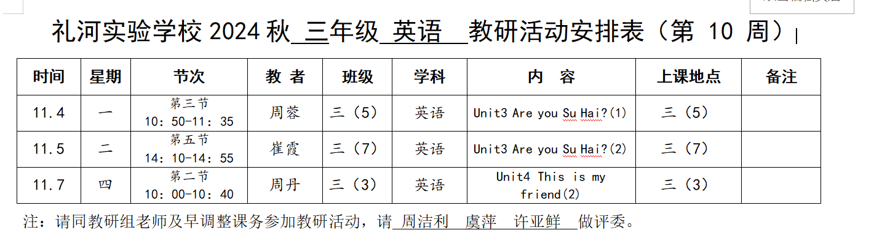

1. 签到表

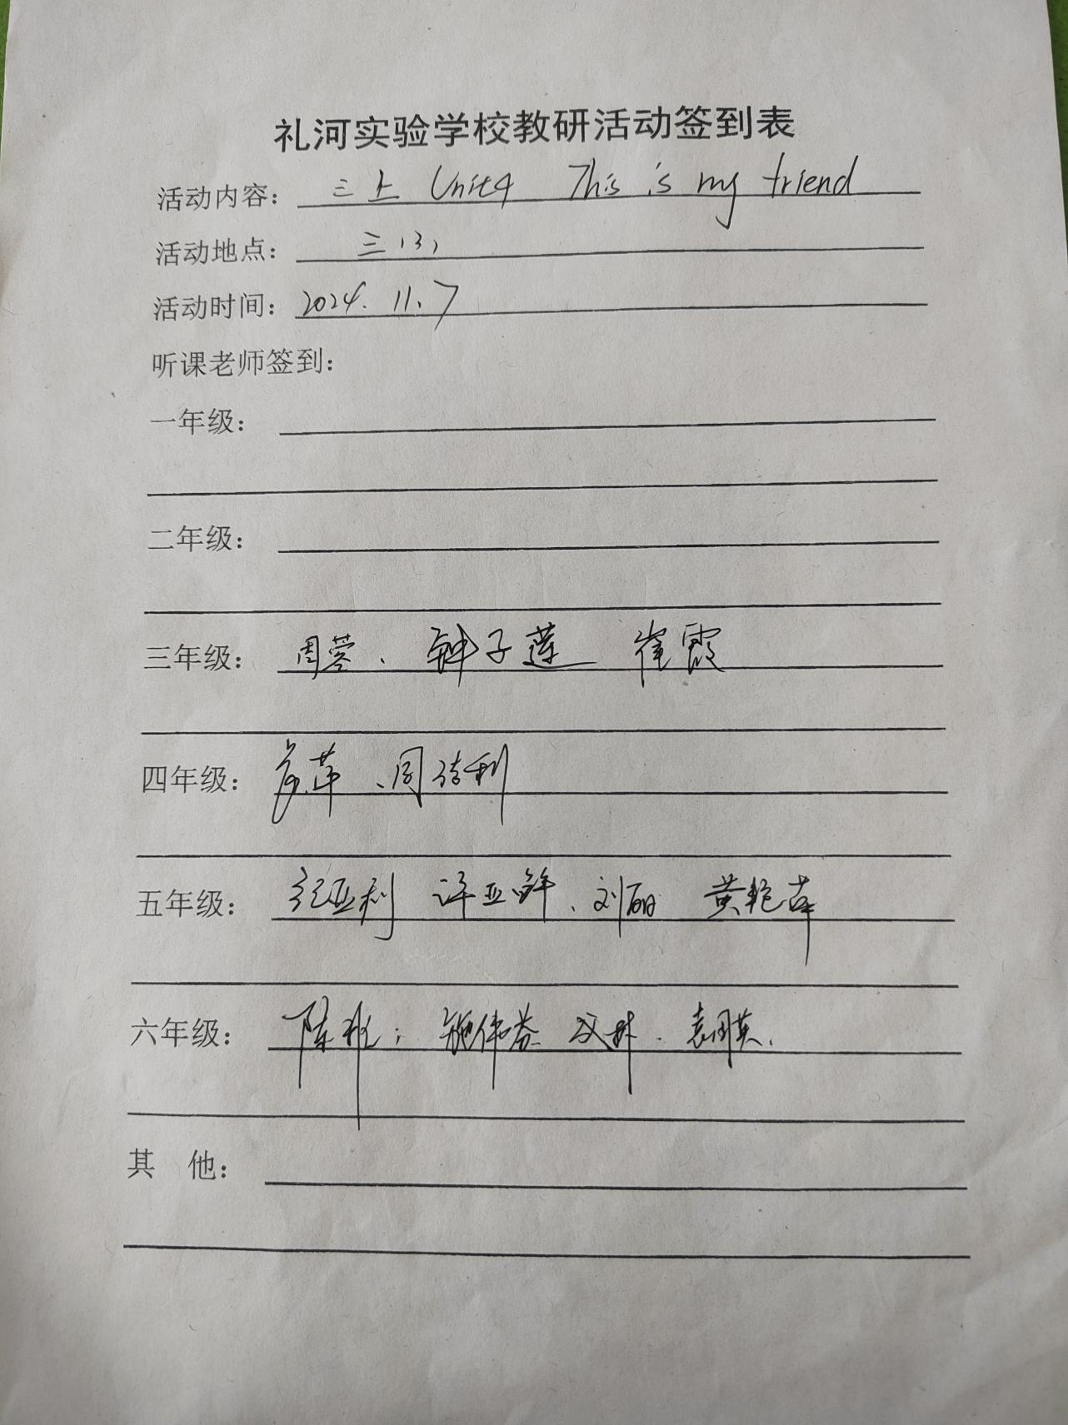

1. 教案

|  |  |
| --- | --- |
| **三上Unit4 This is my friend. Story time** | |
| 教学目标： | 1.能够用英语介绍自己的朋友Yhis is...；  2. 学生能够理解并使用基本的问候语和自我介绍。  3. 学生能够通过游戏和活动提高英语口语能力。 |
| 教学目标： | 学生能够理解并使用基本的问候语和自我介绍。 |
| 教学难点： | 学生能够通过游戏和活动提高英语口语能力。 |
| 教学具准备： | 1. 教师准备：录音，图片，PPT，人物头饰，板书 2. 学生准备：预习Story time |
| 教学过程： | **Step 1 Warm up and revision**  1 Free talk  2 Play a game  T: Hello, boys and girls. Let's play a game. Do you remember who they are? I will show different parts of them and please tell me who they are.  T: Bobby wants to introduce Sam, Willy, and Max to Tina.  课件呈现： Bobby 要向Tina介绍Sam、Willy和Max，可以站到台前来，指着屏幕上的人介绍哦。  T: Now boys and girls, please act Bobby and Tina, choose one child to make different dialogues .  可以让学生站到台前来表演的时候，借助于黑板上的三个人物头像。  3 Summary  T:Yes, boys and girls. Do you remember the small question: How does Bobby introduce his friend to Tina? 课件呈现第一课时中出现的Big question 和第一层small question.  S: This is Sam, he is my friend.  T: Yes, you’re right. And today we will have other different to introduce friends.  **Step 2 Presentation**  1Talk about Picture 1  T: Look, the boys and girls are in the classroom. This is Calligraphy. In this picture who are talking now?  课件呈现问题：Who are talking谁在交流？  学生可以根据图片和气泡框的回答出是Wang Bing和Liu Tao  T: Wang Bing and Liu Tao are going to introduce their friends.  T: Let's watch the cartoon and try to find the answers  Who is Liu Tao's friend? and Who is Wang Bing’s friend?  播放卡通回答这两个问题  Q: Who is Wang Bing's friend? is Wang Bing's friend.  Q: Who is Liu Tao’s friend? is Liu Tao’s friend.  注意第一题： 回答有两个人： Zhang Hua Liu Tao  第二题： 回答为： Su Hai  2 Talk about Picture 1 and 2  课件呈现课本1-2图。  T： Now boys and girls，Look carefully. (课件呈现三个小男孩的头像。） In this part, Wang Bing will introduce Zhang Hua to Liu Tao. And he will introduce Liu Tao to Zhang Hua too. Let’s read this part in two, and underline the key sentence about introduction.  同桌合作： 读一读课文1-2图，找出介绍Zhang Hua 的句子用“ ”，介绍Liu Tao 的句子用“ ”画出。并比较。  根据学生回答呈现出两句话：  This is my friend, Zhang Hua.  This is Zhang Huan，he is my friend.  T:Can you say the difference between them?  S: ....人名、身份在前后的区别。  Then read the sentences after the teacher跟着老师读这两个句子  3 Play a game.  T: Now do you remember these two ways to introduce your friend? Let’s help Bobby to say the different sentences.  这里做一个快速的转换游戏。将第1课时出现的波比介绍的句子来进行转换，贴出人物头像并进行转换，一共是三句话   1. 贴出Sam的头像，呈现句子This is Sam. He’s my friend. = 2. 贴出Max的头像。呈现句子This is my friend, Max.= 3. 贴出Willy的头像。呈现句子This is Willy, He’s my friend.=   回到课文的123幅图这一面。提问after introduction在互相介绍之后，两位新朋友之间可以说些什么呢？  4 Talk about Picture 1 and 2again  课件回到课文1-2幅图  T: After introduction, what can the new friends say to each other?  介绍之后，新朋友们之间可以说什么呢？  学生找出句子  S: Hello. Hi. Nice to meet you. Nice to meet you too.  T: Yes, they can greet each other.  S: It’s good.  T: Yes, praise somebody or something. 圈出句子。 tip： it’s=it is 它是  边做竖起大拇指的动作边说句子。  Learning tips:  当我们结识了新朋友，我们可以对新朋友说哪些话呢？   1. 我们可以互相打招呼、问好。 2. 我们可以适当的表扬对方的外貌、穿着或者你看得到的他的好的行为或者作品等。   这些都可以拉进彼此之间的距离。  5 Talk about Picture 4  课件呈现课文第4幅图。只有三个人物  T: Now, a girl is coming. She is ....  S: Su Hai.  T: Look, Liu Tao is going to introduce Su Hai.  Can you try to imagine and act it out in three?  （学生在表扬中如果用错了she’s,教师口头带过指正一下就行，不用可以停下来纠正）  学生表演过后，呈现书上的句子。  T: Look， what does Liu Tao say? (呈现图四的所有内容）  学生读出句子  划出This is Su Hai. She’s my friend. 并圈出 She’s 呈现she’s=she is (她是）  带读并教学这个句子。  T: We can introduce a girl like this : 我们可以这样介绍一个女孩子  =  What else does Liu Tao say?Liu Tao 还说了什么？  S: I have many friends in my class.  教学这句话，情感升华：We all have many friends in our class. We should help each other. We should encourage each other . 我们在班级里都有许多朋友，我们应该互相帮助，互相鼓励。  T:They greet each others. If you are Zhang Hua, what else can you say?  如果你是张华，你还可以说什么？  “It’s good too.””Nice to meet you too.”  6 Discuss  课件呈现本单元的大问题的页面，提出追问的第二个问题  Small question: How do Wang Bing and Liu Tao introduce their friends?  S: ..  根据学生回答，整理  This is...He’s / She’s my friend. 先人名，后身份。  This is my friend,... 先身份，后人名。  **Step 3 Consolidation**  1 Listen and repeat  2 Dub in four  3 Match and say (Exercise A)  T: In this lesson, there are some students in the classroom. Look at these  Can you match the name and the picture? Then introduce like this: This is Liu Tao.  根据学生回答，课件呈现答案。  4 Game Get on the boat of the friend ship  屏幕上呈现一艘友谊船  T: Now boys and girls let's go traveling with the friends on the boat of the friendship. How to invite your friends? You should introduce your friends to others in right ways . If they say “ Hello” to him/her, he/she can get on the boat.  课件展示： 同学们快来邀请你的好友一起乘船旅行吧，请你向大家正确的介绍你的好友，同学们向他打招呼，你的好友就可以上船了。（设置背景音乐和背景图片）  操作方式：老师做船头，第1个邀请一个小朋友，然后这个小朋友继续邀请他的好友，一个个接龙。等10-15个孩子上船了，就可以开船了。围着教室转圈圈，音乐结束就结束。  情感升华：友谊是什么？  Step 4 Homework  Must do: 1 Recite Story time.  2 Make and say  (制作一张朋友卡片，画上你的两位朋友，并写上名字。使用正确句型进行介绍，下一节课课上表演。）  Choose to do:  如果你的朋友不是你们班级的，可以了解一下是哪个班级的，写在卡片上，这样你明天的介绍会更加丰富哦。 |
| 板书设计： | Unit4 This is my friend |

4.评议表

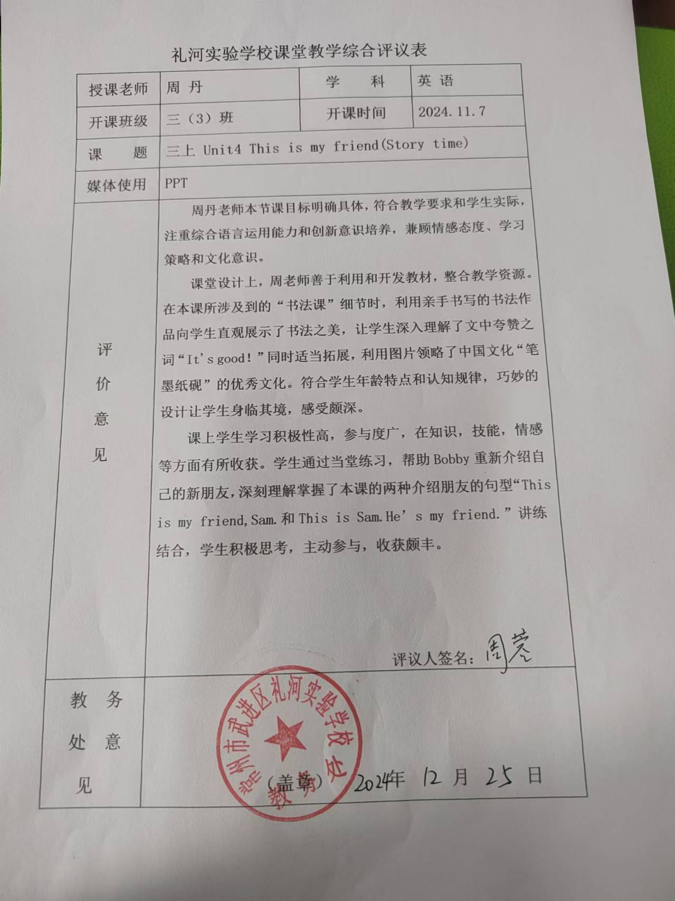

5.照片

