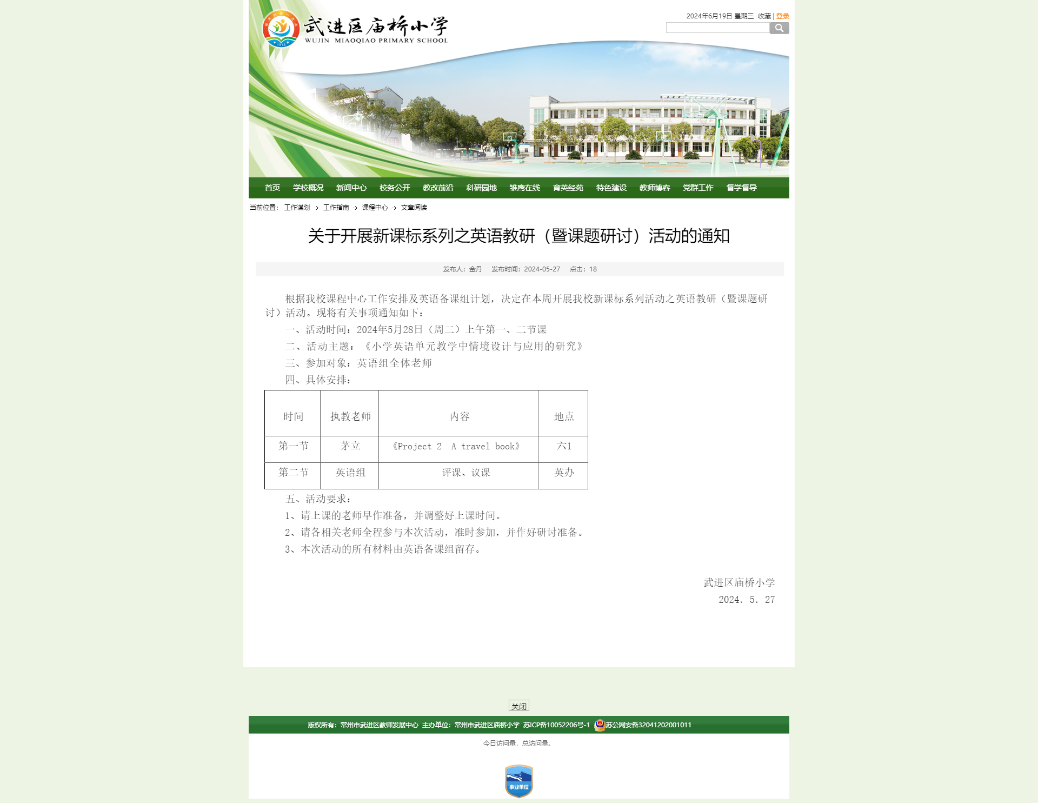

Project 2 A travel book
Step 1 Lead-in
- Watch a video
T: Before we begin our class, let’s enjoy a video. Watch it carefully. I will ask you some questions.
- Free talk
Just now we watched a video about Yangzhou. Do you like Yangzhou?
S1: Yes, I do.
T: What interesting places do you know in Yangzhou?
S: ....
T: Did u go there with your parents?
S: Yes, I did.
T: Did you eat yummy food there?
S: Yes
T: What did you eat?
...
T: Good job! Boys and girls, you watched the video very carefully. But I still have one last question. At the beginning of the video we saw a lady with a book. What book is it?
S: A travel book.

Step 2 Presentation
- What’s a travel book about?
T: Yes, a travel book!贴标题，让孩子跟读。
T: Look! Here are some travel books. People can read the travel books before they visit some places. What information can we get from the travel books?
提示孩子用we can find.....in the travel books.
We can find the information of weather...... Interesting places etc.
T: So travel books are important for the visitors. There are a lot of interesting cities in the world. Among them, my favorite one is Toronto.(学生跟读，往黑板上贴图片)and I want to make a travel book before I go there.
First, I will draw a beautiful cover. What do you think about it? Is it beautiful?
Then, I will find the information of weather, interesting places, food and special transportation.(跟读)
- Listen and complete
T: Now I want to know the weather in Toronto. Let’s listen to the weather broadcast and pay attention to the key words.(点击录音机播放听力，播放两次。)
T: What’s the weather in summer?
S1: It’s hot in summer.
T: That’s right. How do you know?
S1: Eat ice cream
T: Good job.
T: Next, let’s listen to another weather broadcast and complete the sentence.
S1：It’s cold and snowy in winter.
T: Great! How do you know? What key words did you hear?
S1:It snows heavily.
S2: Put on more clothes.
T: Now we can write hot in summer, cold and snowy in winter here.
(Who can help me stick the information on the blackboard.)
T: What interesting places are there in Toronto? I will ask my e-friend for help.
PPT呈现图片学生跟读。
让学生将这几个景点词组粘贴到黑板上！
T：Now we know some interesting places in Toronto. What about the food? Let’s watch a short video.(播放高以翔介绍多伦多食物视频)
T：What food did you see in the video?
S1：Hamburger.
S2: Beef.
S3:...
PPT呈现食物，并粘板书贴。
T: We know the weather, some interesting places and some yummy food in Toronto. What about the special transportation? Let’s surf the Internet to find some information.
(让学生读找到的资料然后在黑板粘贴这两个交通工具）
T：Boys and girls, thanks for your help. I get some information about Toronto now. Now can you help me write something to introduce Toronto?
Toronto is a b__________ city. It is c______ and s_______in winter. There are many i_________ p________ in Toronto. You w___see Niagra F____, CN T_____ and Casa Loma C_____. You will eat a lot of y______food there, such as, hamburger, b______, salad and s________. You can take the s______ car and the f_______ here. W________ to Toronto!

T: With some information, some pictures and introduction, I can make a travel book about my favourite city like this! Can you make a travel book about your favourite cities?
2.How to make a travel book?
T: Before class, I asked you to prepare a paper book, draw a beautiful cover and collect some information about your favourite city. Did you do that? If you do, put up your hands.
（在课前将学生分组，每组折叠好一本旅行手册，画上封面，在背面贴上软磁铁，因为最后需要粘贴到黑板上，并准备好自己喜欢的城市的图片，打印裁剪好，并写好信息卡）
T：Good job. So which is your favourite city?
S1:...
T: What’s the weather like in...?
S2:...
...
T: Boys and girls, are you serious about your deskmates’ favourite cities?
S: Yes.
T: You can ask them some questions.
(学生两两一组互相提问)
T：Now you’ve got some information about your favourite city. Can you write something to introduce it?
（让学生在小卡片上写上对自己最喜欢的城市的介绍）
T：Boys and girls, it’s your turn to make your travel book. Work in a group of four. Stick the pictures and cards on it.
T: Have you finished? I can’t wait to see your travel book. You have two ways to show your travel book. Which one will you choose.
(学生展示自己的旅行手册，喊两组学生，展示好了之后就将他们的旅行手册粘贴到黑板上，其他小组的旅行手册请每组一个代表粘贴到黑板上。）
T: Wow, a lot of interesting cities! Do you like travelling?
S：Yes!
T：Me too! From travelling, we can be relaxed. We can learn much knowledge. We can make more friends. However, because of the coronavirus pandemic, it’s not easy for us to go travelling now.
T： It doesn’t matter! You can read the travel books you made this class, then you can know a lot about some interesting cities. When the epdemic is over, you can choose one city to visit! Okay?
Step 3 Homework

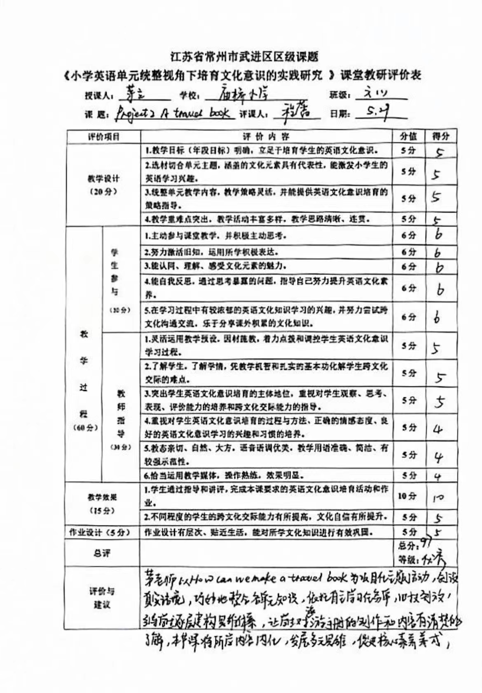

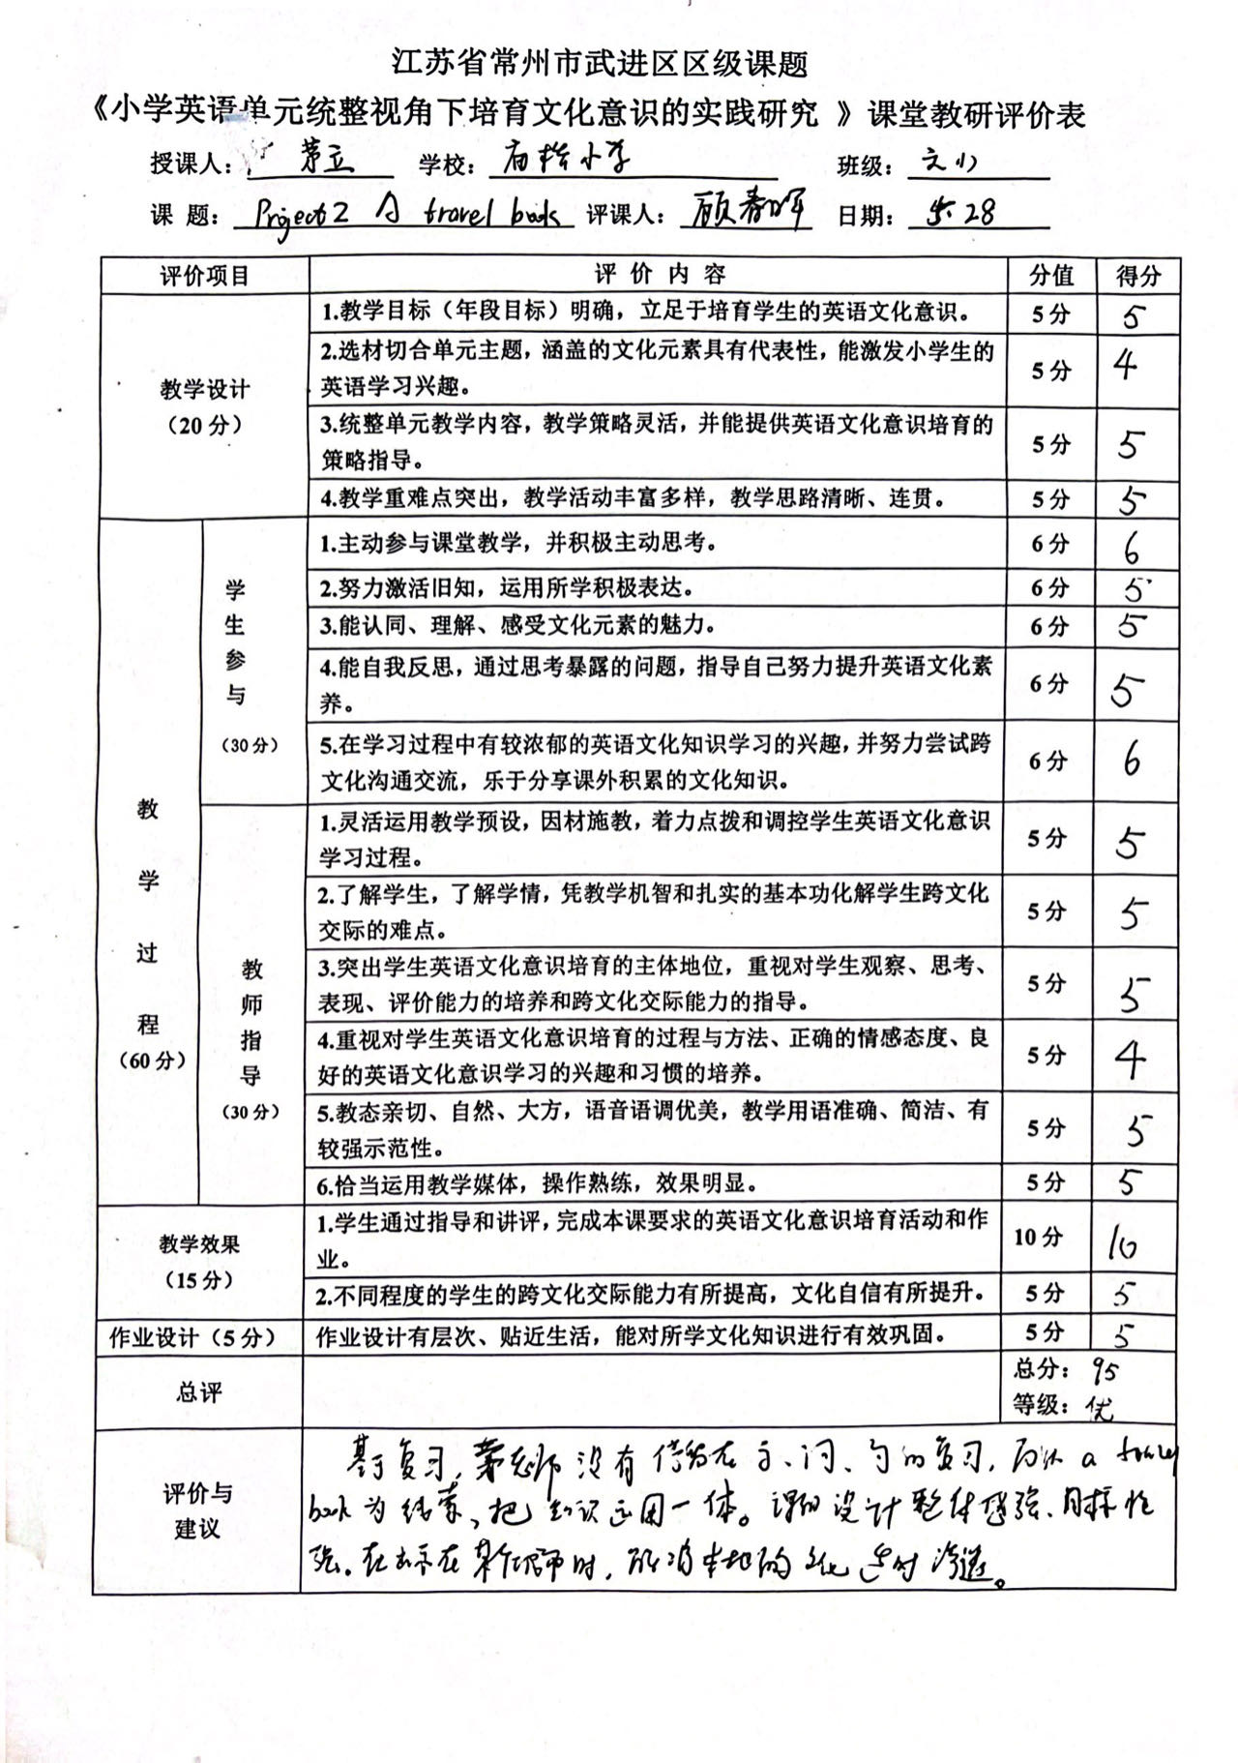

六下Project 2 A travel book 教学反思
武进区庙桥小学 茅立
一、以话题为主线，于情境运用中整合知识内容
本单元是project2板块，融合了以前所学过的所有知识点和语用功能，教师在教学中必须把握知识内容的整合和串联，而不是按部就班地按照书上板块一个点一个点的累赘繁琐的教学。基于此认识，我在free talk中通过小语段的输出引导学生谈论介绍自己，I’m...I’m ...years old. I like ...I like ...ing and ...ing...I always ...at weekends. At Christmas,I usually...通过一个小语段将各个方面的知识信息串联起来了，将枯燥的语言板块罗列变成了结合学生已有知识经验的“自我介绍”语言运用，顿时语言功能变得鲜活而丰富，大大激发了学生运用语言介绍自己的兴趣，提高了语言输出的质量，降低了综合输出的难度，使得班级的每个孩子愿意大声说，增强了孩子无形中的自信。
二、以重组为策略，于文本再构中串联知识内容
按照教材编写的指导思想，我采取对教材的重构和重组，使得零散的板块知识系统化、单薄的文本内容厚实化，使得我们的教学内容逐步丰富化。本节课安排学生采用问答对话的方法来了解对方的朋友信息（your friend）,在问答中巩固复习每个单元的主话题词汇，包括favourite subjects,hobbies,parents’ jobs,weekend activities,Christmas activities,巧妙地将第一人称和第三人称的转换串联起来，将What does he do at weekends?what does he do at christmas?what does he like doing?等主要句型操练充分。
三、以优化为目标，在文本拓展延伸处运用知识内容
本节课是复习课，旨在巩固复习每个单元的重点语言词汇，句型和基本的语法结构和新的情境中的语言运用，从而达到温故知新的目标，因此复习课中我要求学生的语言输出以优化为目标，有一定的拓展延伸性。如在谈论职业时，学生可以这样介绍My father is a doctor.He helps sick people. He works in Renmin Hospital. My mother is a cook. She usually cooks nice food for me. I’m a student. I want to be a policeman. I should study hard from now on.如在谈论圣诞节的活动时，学生可以这样介绍朋友My friend usually buys presents for his family and friends. He also buys a Christmas tree. He often puts some pretty things on the Christmas tree.He also puts some presents under the tree. He sometimes makes christmas cards and sends them to all his friends.这样来进行语言输出，使得教材内容运用更加连贯，语言量更加丰富，更好地体现了复习中的螺旋上升的温故知新的目标。
知识的整合是一门艺术，在教学中我们应该根据教材特点和实际的学情，采取适宜的方式串联知识，整合文本，在故事情境中，在语言综合输出时，在情感推进中，在知识链接处，在文本再构中，在环节和环节之间，课时和课时之间将各个板块整合重组，让教学充满智慧，使得知识不零碎，促进学生对知识的记忆和提取，更好地实现知识的整体学习和深入运用。
