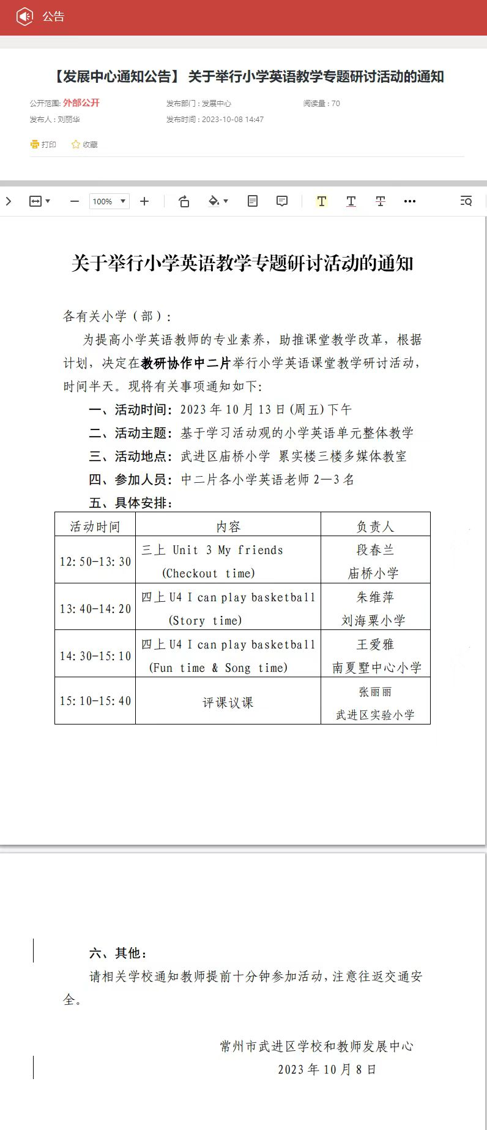

**三上Unit 3 My friends (Checkout time)教案**

武进区庙桥小学 段春兰

**Step 1 Warm up**

1. **Sing a song**

T:Boys and girls,do you like singing?

Ss:Yes.

T:Let’s sing a song together. And think, what's the song about?

S1:It’s about friends.

1. **Introduce myself (Rap介绍)**

T：Yes,we all have friends. I want to be your friends.Here’s something about me. Hello, everyone.I'm Miss Duan, I teach English. I like reading English books. Look, she's Vera. She's my friend. She's nice. He's Jack. He's my friend, too. He's cool.

T:Do you want to be my friends?

Ss:Yes.

T:Wonderful. Now can you tell me something about you and your friends?

Ss:Yes.

T:Please work in four. Introduce you and your friends.

**3.Students introduce their friends**

预设：

S1：I’m ...He’s...He’s my friend.She’s... She’s my friend.

T:Nice to meet you,... You are nice/cool. Hope we can also be friends./Can we be friends?

S2:I don’t have any friends.

T:Don't worry. Let's be friends.

S2:Great.

T:As friends, let's have a secret code. “Friends, friends,where are my friends? ”

Ss:Here, here, here I am.

**Step 2 Presentation**

**1.Letters’ friends**

T:We know friends are in our daily life, friends are everywhere. Today we will find s letters’ friends, meet Liu Tao’s friends,praise Ben’s friends and introduce our friends.

A.Play a game with a frog

T:First,Let's play a game with our letter friends. Look,this ia a frog. Please say the letters aloud where the frog is.Are you ready?

Ss:Yes.

B.Match the letters

T:(课件播放哭声)Listen，who is crying?谁在哭？ Let’s have a look.擦除希沃蒙层，出现HIjK. T:Oh,some letters,why are you crying?

PPT音频：I lost my friends.

T:Can you help them?

Ss:Yes.(S1,S2,S3,S4上台操作希沃配对游戏)

T：(课件播放笑声)Boys and girls, you're so kind.You Help the letters find their friends.

C.Introduce letters’ friends

T:Look,our letter friends come. They are Aa...

Ss:Aa,Bb,Cc,Dd,Ee,Ff,Gg,Hh,Ii,Jj,Kk.

T:手持字母卡片Aa. This is letter Aa.So I can say:Hello, I’m Aa. Bb is my friend.

手持字母卡片Bb. Hello. I’m Bb. Aa is my friend. Cc is my friend too.Now it’s your turn. Please work in four. Try to introduce your letter friends.

**2.Liu Tao’s friends**

T:Excellent. We know our letter friends. Do you still remember Liu Tao’ s friends?

T:Now please look at this picture. Who are they?

Ss:Yang Ling, Mike, Su Hai.

T:What will Liu Tao’s father say? can you guess?

S1:Who's she? Who's the girl?

S2:Who’s he? Who's that boy?

T:Very good guessing.Now let’s listen to the tape and find it out.

T:If you were Liu Tao,how will you introduce your friends?

S1:She’s/He’s...She’s/He’s my friend too.

T:Now please work in five,try to act the dialogue.(show 2 groups)

1. **Ben’s friends**

A.Watch and find

T:Boys and girls,let’s say goodbye to Liu Tao’s friends.

Ss:Goodbye.

T:Then we will meet a new friend. He’s Ben. Can you greet him?

Ss:Nice to meet you,Ben.

T:I think Ben will say:Nice to meet you too.

T:Then who is Ben’s friends?Let’s watch a cartoon.

S1:Kris./Ida./Hanson./Judy.(师板贴)

T:What’s the firstletter of their names.

S1: “K,I,H,J”.

B.Chant Ben’s friends

T:Ben makes a chant about his friends.

C.Watch and choose

T:We know Ben has four good friends. Then why can they be friends?Let’s watch and choose.

S1:Kris is cool../Ida is nice./Hanson is kind./Judy is smart.(师板贴品质词，教kind/smart)

T:Yes,they have something in common. So they can be friends.

D.Introduce Ben’s Friends

T:Now let’s retell the story together.

T:Now you are Ben, can you introduce one of your friends?

Ss:Yes.

1. **Our friends**

T:Now boys and girls,we know Ben’s friends well. Can you introduce your friends just like Ben?

Ss:Yes.

T:First, let me introduce my friends to you.This is Vera. She is my friend. She is nice. This is Jack. He’s my friend too. He is cool. I love my friends.(show 2-3 groups)

T：“Friends, friends,where are my friends? ”

Ss:Here, here, here I am.

T:Would you like to talk about your new friend,Miss Duan?

S1:Yeah.This is Miss Duan. She’s my friend.She’s nice and kind. I love my friend.

T:You are so sweet. I love you too,my friends. Boys and girls,all of us have friends,why do we need friends?

Ss:We can play/study/share together.

T:Yes. Let’s enjoy a video about friends.

T:So friendship is the great pleasure in life. we should learn to love each other and share with each other.

**Step3 Homework**

1. Introduce your friends to your family.

用英语把你的朋友介绍给你的家人。

2. Chant Ben's friends with your friends.

和你的朋友一起唱一唱Ben的朋友。

**板书：**

蝴蝶状

Unit3

My friends

Our friends

Ben’s friends

Liu Tao’s friends

nice

cool

smart

kind

He’s/She’s/This is...

He’s/She’s my friend.

He is /She is...

Letter’s friends

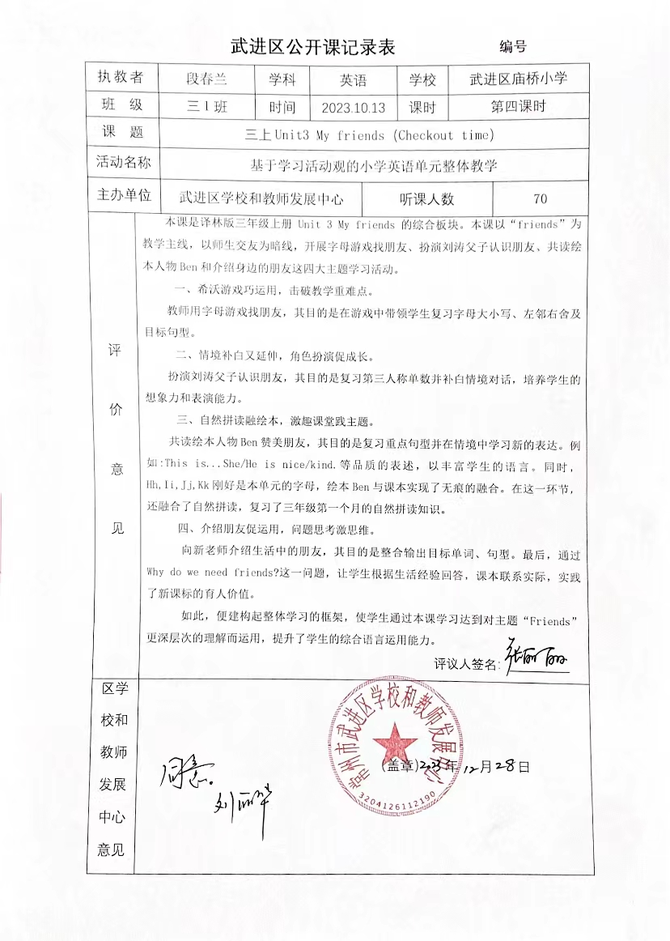

**三上Unit 3 My friends (Checkout time)教学反思**

段春兰

本节课以My friends为主题，旨在帮助学生掌握如何介绍自己朋友的方式的同时，懂得友谊的重要性，明白要珍惜自己的朋友。在设计这堂课时，我从学生的生活实际出发，以“friends”为教学主线，以师生交友为暗线，开展字母游戏找朋友、扮演刘涛父子认识朋友、共读绘本人物Ben和介绍身边的朋友这四大主题学习活动。

在第一板块的字母游戏找朋友环节，我利用希沃游戏，积极调动了学生的积极性，在游戏中带领学生复习字母大小写、左邻右舍及目标句型。在第二板块，学生通过补白刘涛父子对话，复习了本单元的重点句型：She’s/He’s...She’s/He’s my friend.第三板块是本堂课的重要环节，在这一板块融入了自然拼读和课外绘本资源。不仅帮助学生复习的自然拼读知识，在绘本教学环节更拓展了体现人物美好品质的词汇：kind,nice,cool,smart,与目标句型“He’s/She’s...”充分融合。课堂最后，我以开放性问题Why do we need friends ? 收尾，引导学生进一步理解朋友的重要性，懂得珍惜自己的朋友。

整堂课流程板块较为清晰，但是也发现了一些问题。第四板块学生在向老师介绍生活中的朋友时，稍有困难，课堂还应多给学生练习的时间，以便学生可以有更好的语言输出。在开放性问题Why do we need friends ?提出后，学生脑洞大开，问题回答精彩纷呈。但此时也是考察教师基本功的时候，教师要随机应变，适时接住学生的话茬。在课堂上学生说到“当不开心时，和朋友相处会很愉快。”当时的我没有很准确的理解学生的意思，所以备课时还应多预设，让师生交流更加自然顺畅。



