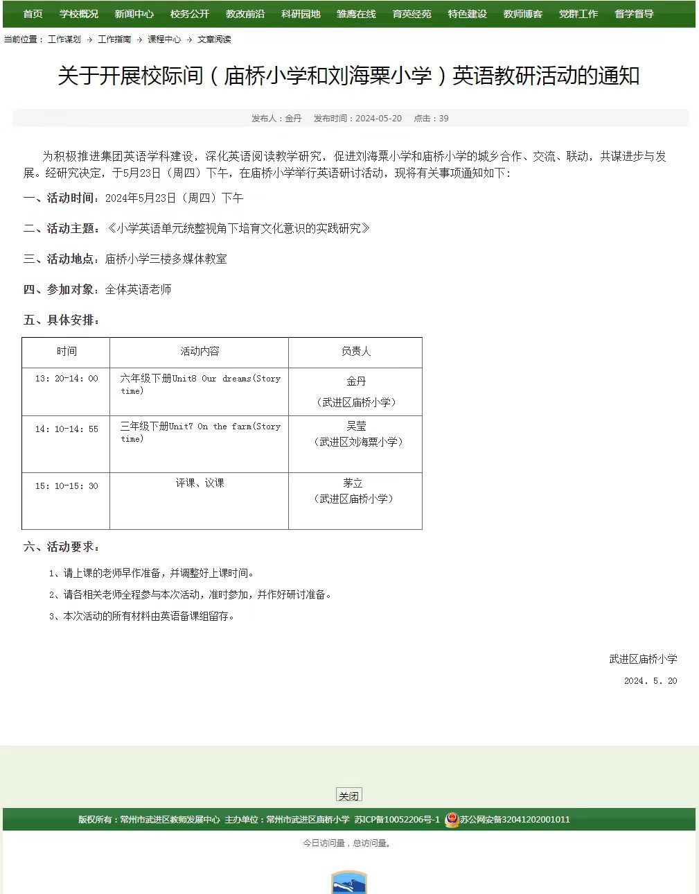
Unit 8 Our dreams (Story time)
武进区庙桥小学 金丹
一、教学目标：
（一）知识目标
1.能够学会并使用单词dream, future, spaceship以及表示职业的单词：dancer, writer, football player, pianist, dentist, astronaut.能够理解并运用词组：come true, in the future, care about.
2.能用句型a. …want to be… b. He wants to… c. …make…谈论梦想以及理由。
3.通过文本学习，提高学生捕捉目标信息的能力，以及对输入的材料进行内化的能力。
4.通过丰富的语言输入，学生能在主题情境中构建话语体系，转化成自己的语言并加以输出和运用。
5.通过文本学习和课堂实践，让学生感受梦想的魅力和意义，理解为实现梦想而践行的重要性，从而产生积极的情绪体验。
（二）德育目标
1.通过欣赏华为手机的英文宣传曲《Dream it possible》视频，引导学生结合已有语言储备自由表达观点，拓展学生的思维，为学生思考自己的理想职业作出正面引导。
2.以文本为依托，在教师的指导下学习男生的理想职业，跟着文本体会这些职业的不平凡之处，并把这种情感内化为自己的体验，再以小练笔的形式把每位学生自己的梦想，自己对这种职业的情感写出来，最后老师以励志的图片总结提升学生对梦想力量的认识，再次提升学生的情感、态度、价值观。
（三）能力目标
通过文本学习，发展学生用英语解决问题的能力和用英语思维的能力。从而不断丰富自己的生活经历。
- 教学过程。
Step1 Pre-reading
1. Enjoy the song: Dream it possible.
T: Now boys and girls, let's enjoy a song.(课前放)
T: Are you ready for class?
T: Before class, let’s enjoy a song first. It's about a little girl. Can you say something about her according to the video?
T: Let’s say sth. about her story.
S: The girl probably likes playing the piano. /Her grandpa taught her how to play the piano.
(S: she played the piano hard and finally she become a great pianist.)T: So her hobby was playing the piano. First, her grandpa taught her. Then she learned from her teacher. Then she played and practiced a lot. Finally, she became a very famous pianist. And her dream came true.
2.So it’s a nice song about dreams. Today,our topic is Our dreams.(揭示课题)
PPT出现 Our dreams T: Follow me: Our dreams(读两遍)
Step2 While-reading
1.Look and say
T: Look, who are they ? You know them very well.
S: Miss Li and her students.
T: What are they doing?
S:They are talking about their dreams.
T: And Miss Li is asking the students about their dreams .(出示句子)
T:Let's listen:What do you want to be in the future? (板书句子)
T:Ss say together .
T: Here “in the future” means
- many years later B. Many years ago
T: Together.
2.Watch and answer
T: So what do they want to be in the future? Let’s watch and answer.
S1: Liu Tao wants to be a football player in the future.
T:He likes playing footba1l.
S2:Wang Bing wants to be an astronaut....
T. This is a new word. Let's listen and repeat.(reach: astronant)
Yang Ling wants to be a pianist. She likes playing the piano. Piano/pianist
(师板书:Pianist
I: Do they have the same pronunciation(音)? Who’s the famous pianist in China?
Mike wants to be a dentist.
Sun Hai wants to be a dancer
3. Read and learn
T: Why does Mike want to be a dentist? Let’s read.
S: Many children don’t care about his teeth. He’d like to help them.
T:Maybe there is another reason we have learned before. In Grade 5,do you remember?
S: He likes eating sweet food very much. He wants to see the dentist./He had a toothache.
T: Yes, he has the dream also because of his experience.Do you care about your teeth? T: How do you care about your teeth?
S1: I brush my teeth in the morning and before bedtime.
T:Mike has some questions for you.
We should brush our teeth for 3 minutes each time. Mike says please brush all of your teeth.
T: Please care about our teeth in our daily life.
4.Read and underline
7: What about them? Why do they have these dreams ?
T:This time, Please open your book to Page 78, read and underline the reasons.
自主阅读78页,划出关于梦想原因的句子。
T: Ok, most of you have finished. let's check together.
5.Check and learn.
T: Look at Wang Bing. Why does he want to be an astronaut ?
S: Because he wants to fly a spaceship to the moon.
T: What is this?(space-spaceship) Who are they? What do they do?(Study the space)
Let’s enjoy a video. 2024
T: The astronauts drove Shenzhou 18 Spacecraft to study the space in 2024.
T: So do you know:Why does WB want to fly to the Moon some day?
Have Chinese astronauts flied to the Moon before? But have Chinese astronauts landed on the Moon before?
S: So Maybe they are going to fly to the moon in 2030. So flying to the moon is not only Wang Bing’s dream, but also China’s space dream. So you see Wang Bing is very proud of his great dream. Let’s listen and repeat.
T:What about this boy?(Liu Tao)
S: Liu Tao wants to be a football player. He wants to play in the World Cup some day.
T:Do you know something about World Cup? Can you say something in English?
S:The World Cup is a very famous football match in the world.We can watch the World Cup every four years.
T: Have Chinese football players played in the World Cup before? (Yes./No) It was in 2002, only once. So playing in the World Cup is not only Liu Tao’s dream but also China’s great football dream. There is also another reason why Liu Tao have the dream. Do you still remember?
S: He likes playing football. He’s good at it.
T: He has the dream because of his talent.Please look at these boys' dreams what do you think of them ?
S: Their dreams are ... good/great / cool...
- What does Miss Li think? Let’s listen: (出示句子: Your dreams are great!) Together.
T:What should they do to make their dreams come true?
S1:Perhaps they should study hard and read more book, practice a lot.
S2: First they should do sports every day. Health is the most important.
S3:Maybe they can't make their dreams come true quickly, but they shouldn't give them up easily.
6.Work in groups. 小组合作，自主学习。
(1)Finish the form.
T: What about the girls' dreams? Now I'd like you to read and fill in the form.
Who What Why
Su Hai Nancy Yang Ling
(请学生将相关答案贴在黑板上)
T:From the passage ,we know “Dancing makes people healthy and beautiful."and“Music makes people happy.” What about reading?
S1: Reading makes children clever.
S2: Reading makes children happy.
S3:Reading makes children brave and strong.
T:Why do Yang Ling and Su Hai have their dreams? Do you still remember we have learnt them before?
T:Yes, their dreams come from their hobbies.
7.Read after the tape.跟读课文，模仿录音。
T:OK,that’s the whole story, now read and imitate. Ss:(跟读，教师指导)
8.Try to say.巧用追问，拓展文本。
T:What’s Miss Li’s dream?
Ss: She wants to see her students’ dreams come true.
T: Why does she have this dream?
S1: Maybe her dream was to be a teacher when she was a little girl. And now her dream came true.
S2: Miss Li loves her students. So she hopes their dreams will come true some years later.
S3: If the students' dreams come true, Miss Li will be very happy.
Step3 Post-reading
- Let’s talk
T:Now boys and girls, we known Miss Li and her students' dreams. Do you have a dream? What’s your dream? We’ll hold a China dream show. Please work in pairs and talk about your dream with partner.
2.Show T’s dream card
T:I also want to say: Everybody has his or her own dream. You see I have a dream when I was a little girl.This is my dream card. Do you know my English name?
T: Let's read my dream card together.
Hello, I'm Tina.
I want to be an English teacher. I like English and I'm good at it.
To make my dream come true, I should read and speak English every day and study hard.
I believe: Where there is a will, there is a way.
T: Then my dream came true. I'm an English teacher now. Yes ?
Ss: Yes.
3.Write and share
T: So you may have your own dreams.How to write it? Look,this is the beginning. For the body part, you can write:What is your dream? Why do you have the dream ? How to make your dream com true? Maybe your dreams come from your hobbies, talent, experience or other's influence. Don’t forget your ending.
T: This time, please take out this paper,please choose one to finish your dream card, then share in groups.
T: Who can share your dream with us?
T: You please. Let's listen to him. who else?
T:What's his/her dream? What should he/she do to make the dream come trme?
T: Time is limited. You can share your dreams with your family after class.
3.Enjoy some pictures.
Now boys and girls. We have different dreams. We are all dream chasers. We believe Practice makes perfect.We believe: No pairs, no gains.
我们都是追梦人.我们坚信.熟能出巧。
我们信:一份耕表,一份火获。
T: My dream, your dream, China dream, if we never stop, study hard and help each other.It will be easier to make our dreams come true.

板书设计

T:Come on. boys and girls!
Step 4 Homework
1.Know more about celebrities’(名人) dreams.
2.Talk about your dreams with your family.

板书设计

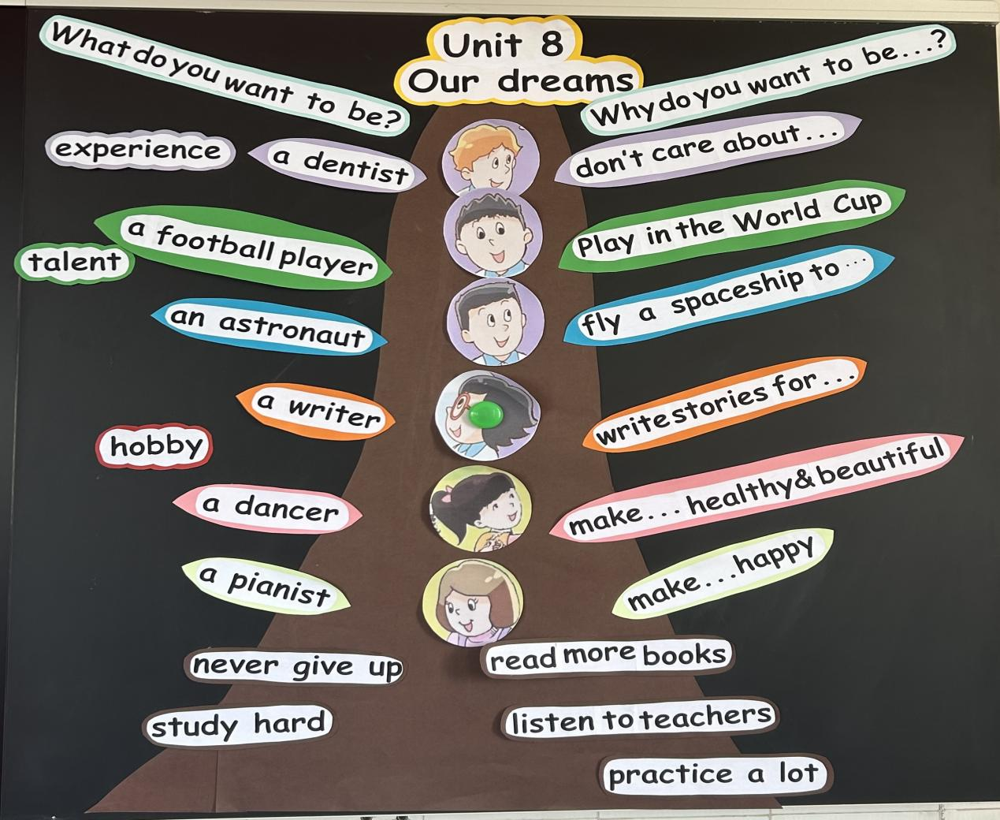
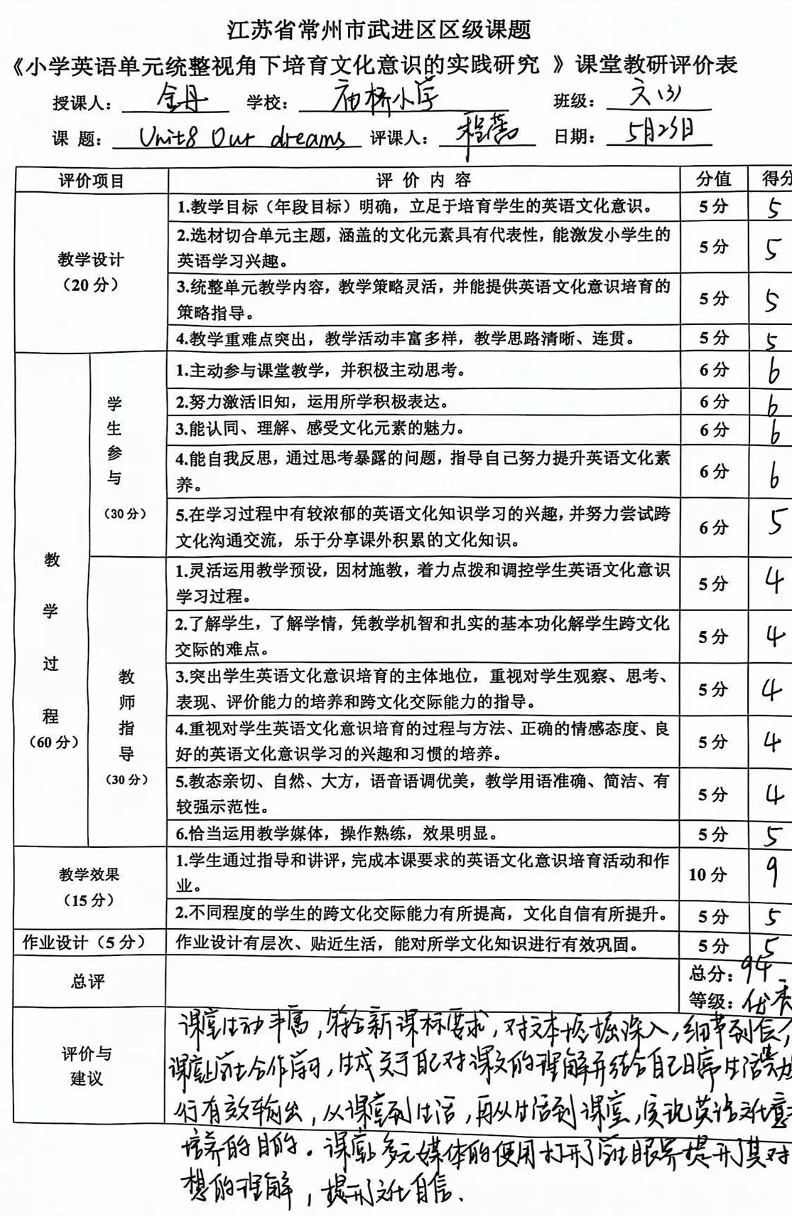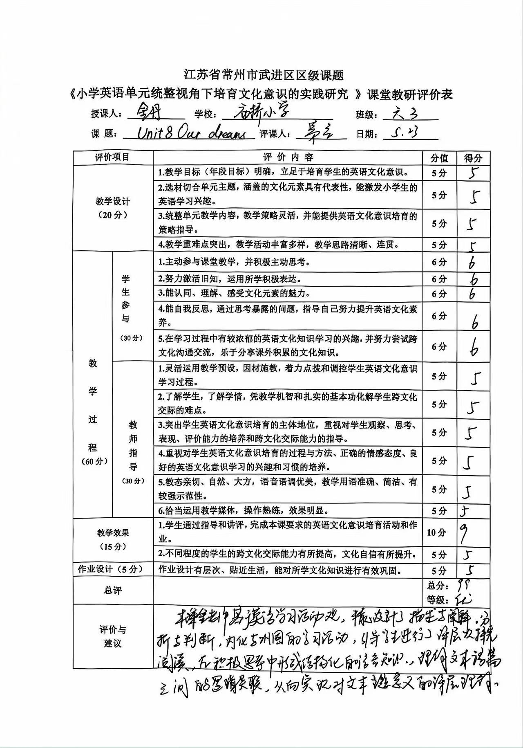

六下 Unit 8 Our dreams 教学反思
武进区庙桥小学 金丹
本单元话题是“我的梦想",旨在通过此话题讨论，引导学生树立正确的价值观，心怀梦想并为实现自己的梦想努力奋斗。
课堂伊始，教师通过欣赏华为手机的英文宣传曲《Dream it possible》视频，引导学生结合已有语言储备自由表达观点，拓展学生的思维，为学生思考自己的理想职业作出正面引导。
呈现部分，以文本为依托，在教师的指导下学习男生的理想职业，引导学生进行深层次探究阅读，在积极思考中形成结构化的语言知识，并跟着文本体会这些职业的不平凡之处，并把这种情感内化为自己的体验，再让学生选择一种框架结构，从兴趣、经历、特长等角度，以小练笔的形式把自己的梦想以及自己对这种职业的情感写出来，实现分层教学。最后老师以励志的谚语总结提升学生对梦想力量的认识，从而实现让学生对文本主题意义的深层理解，培养学生的核心素养。
整堂课中，老师充分运用音频，神舟十八升空视频以及世界杯图片等一些媒体教学手段，使课堂生动而具象，给学生以深刻的体验。除学习单给出的一些职业外，还可以调查一些学生喜欢的符合时代背景的一些职业，并让孩子有更多的了解。

