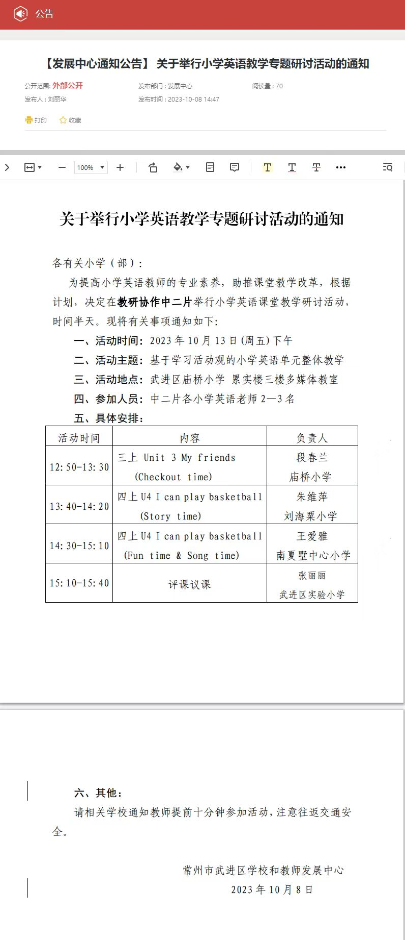
三上Unit 3 My friends (Checkout time)教案
武进区庙桥小学 段春兰
Step 1 Warm up
- Sing a song
T:Boys and girls,do you like singing?
Ss:Yes.
T:Let’s sing a song together. And think, what's the song about?
S1:It’s about friends.
- Introduce myself (Rap介绍)
T：Yes,we all have friends. I want to be your friends.Here’s something about me. Hello, everyone.I'm Miss Duan, I teach English. I like reading English books. Look, she's Vera. She's my friend. She's nice. He's Jack. He's my friend, too. He's cool.
T:Do you want to be my friends?
Ss:Yes.
T:Wonderful. Now can you tell me something about you and your friends?
Ss:Yes.
T:Please work in four. Introduce you and your friends.
3.Students introduce their friends
预设：
S1：I’m ...He’s...He’s my friend.She’s... She’s my friend.
T:Nice to meet you,... You are nice/cool. Hope we can also be friends./Can we be friends?
S2:I don’t have any friends.
T:Don't worry. Let's be friends.
S2:Great.
T:As friends, let's have a secret code. “Friends, friends,where are my friends? ”
Ss:Here, here, here I am.
Step 2 Presentation
1.Letters’ friends
T:We know friends are in our daily life, friends are everywhere. Today we will find s letters’ friends, meet Liu Tao’s friends,praise Ben’s friends and introduce our friends.
A.Play a game with a frog
T:First,Let's play a game with our letter friends. Look,this ia a frog. Please say the letters aloud where the frog is.Are you ready?
Ss:Yes.
B.Match the letters
T:(课件播放哭声)Listen，who is crying?谁在哭？ Let’s have a look.擦除希沃蒙层，出现HIjK. T:Oh,some letters,why are you crying?
PPT音频：I lost my friends.
T:Can you help them?
Ss:Yes.(S1,S2,S3,S4上台操作希沃配对游戏)
T：(课件播放笑声)Boys and girls, you're so kind.You Help the letters find their friends.
C.Introduce letters’ friends
T:Look,our letter friends come. They are Aa...
Ss:Aa,Bb,Cc,Dd,Ee,Ff,Gg,Hh,Ii,Jj,Kk.
T:手持字母卡片Aa. This is letter Aa.So I can say:Hello, I’m Aa. Bb is my friend.
手持字母卡片Bb. Hello. I’m Bb. Aa is my friend. Cc is my friend too.Now it’s your turn. Please work in four. Try to introduce your letter friends.
2.Liu Tao’s friends
T:Excellent. We know our letter friends. Do you still remember Liu Tao’ s friends?
T:Now please look at this picture. Who are they?
Ss:Yang Ling, Mike, Su Hai.
T:What will Liu Tao’s father say? can you guess?
S1:Who's she? Who's the girl?
S2:Who’s he? Who's that boy?
T:Very good guessing.Now let’s listen to the tape and find it out.
T:If you were Liu Tao,how will you introduce your friends?
S1:She’s/He’s...She’s/He’s my friend too.
T:Now please work in five,try to act the dialogue.(show 2 groups)
- Ben’s friends
A.Watch and find
T:Boys and girls,let’s say goodbye to Liu Tao’s friends.
Ss:Goodbye.
T:Then we will meet a new friend. He’s Ben. Can you greet him?
Ss:Nice to meet you,Ben.
T:I think Ben will say:Nice to meet you too.
T:Then who is Ben’s friends?Let’s watch a cartoon.
S1:Kris./Ida./Hanson./Judy.(师板贴)
T:What’s the firstletter of their names.
S1: “K,I,H,J”.
B.Chant Ben’s friends
T:Ben makes a chant about his friends.
C.Watch and choose
T:We know Ben has four good friends. Then why can they be friends?Let’s watch and choose.
S1:Kris is cool../Ida is nice./Hanson is kind./Judy is smart.(师板贴品质词，教kind/smart)
T:Yes,they have something in common. So they can be friends.
D.Introduce Ben’s Friends
T:Now let’s retell the story together.
T:Now you are Ben, can you introduce one of your friends?
Ss:Yes.
- Our friends
T:Now boys and girls,we know Ben’s friends well. Can you introduce your friends just like Ben?
Ss:Yes.
T:First, let me introduce my friends to you.This is Vera. She is my friend. She is nice. This is Jack. He’s my friend too. He is cool. I love my friends.(show 2-3 groups)
T：“Friends, friends,where are my friends? ”
Ss:Here, here, here I am.
T:Would you like to talk about your new friend,Miss Duan?
S1:Yeah.This is Miss Duan. She’s my friend.She’s nice and kind. I love my friend.
T:You are so sweet. I love you too,my friends. Boys and girls,all of us have friends,why do we need friends?
Ss:We can play/study/share together.
T:Yes. Let’s enjoy a video about friends.
T:So friendship is the great pleasure in life. we should learn to love each other and share with each other.
Step3 Homework
1. Introduce your friends to your family.
用英语把你的朋友介绍给你的家人。
2. Chant Ben's friends with your friends.
和你的朋友一起唱一唱Ben的朋友。

板书：
蝴蝶状
Unit3
My friends
Our friends
Ben’s friends
Liu Tao’s friends
nice
cool
smart
kind
He’s/She’s/This is...
He’s/She’s my friend.
He is /She is...

Letter’s friends

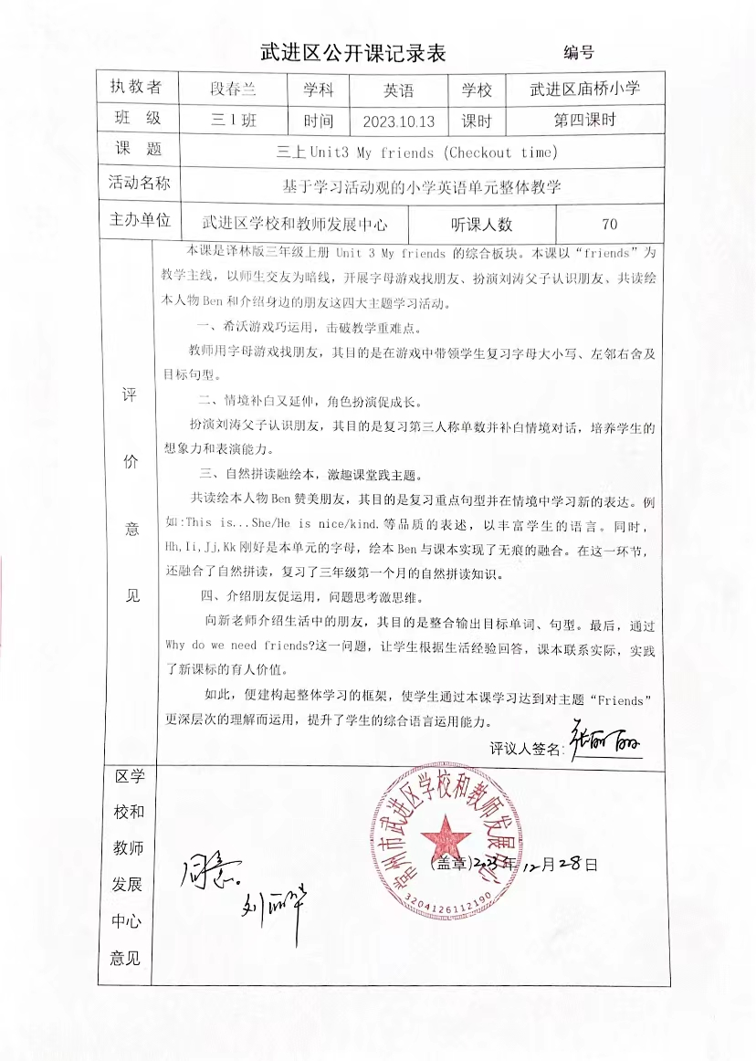

三上Unit 3 My friends (Checkout time)教学反思
段春兰
本节课以My friends为主题，旨在帮助学生掌握如何介绍自己朋友的方式的同时，懂得友谊的重要性，明白要珍惜自己的朋友。在设计这堂课时，我从学生的生活实际出发，以“friends”为教学主线，以师生交友为暗线，开展字母游戏找朋友、扮演刘涛父子认识朋友、共读绘本人物Ben和介绍身边的朋友这四大主题学习活动。
在第一板块的字母游戏找朋友环节，我利用希沃游戏，积极调动了学生的积极性，在游戏中带领学生复习字母大小写、左邻右舍及目标句型。在第二板块，学生通过补白刘涛父子对话，复习了本单元的重点句型：She’s/He’s...She’s/He’s my friend.第三板块是本堂课的重要环节，在这一板块融入了自然拼读和课外绘本资源。不仅帮助学生复习的自然拼读知识，在绘本教学环节更拓展了体现人物美好品质的词汇：kind,nice,cool,smart,与目标句型“He’s/She’s...”充分融合。课堂最后，我以开放性问题Why do we need friends ? 收尾，引导学生进一步理解朋友的重要性，懂得珍惜自己的朋友。
整堂课流程板块较为清晰，但是也发现了一些问题。第四板块学生在向老师介绍生活中的朋友时，稍有困难，课堂还应多给学生练习的时间，以便学生可以有更好的语言输出。在开放性问题Why do we need friends ?提出后，学生脑洞大开，问题回答精彩纷呈。但此时也是考察教师基本功的时候，教师要随机应变，适时接住学生的话茬。在课堂上学生说到“当不开心时，和朋友相处会很愉快。”当时的我没有很准确的理解学生的意思，所以备课时还应多预设，让师生交流更加自然顺畅。

