|  |  |  |  |  |  |  |  |  |  |
| --- | --- | --- | --- | --- | --- | --- | --- | --- | --- |
|  | |  |  |  |  |  |  | | |
| **译林（三起） 三年级英语上册单元分层作业设计（** Unit 4 This is my friend)**）** | | | | | | | | | |
| Class:  Name: | |  | | | | 自我评价:  教师评价： | |  | |
|  | **一．字谜大挑战， 请根据给出的单词提示，完成方框中的单词填写同时按规范书写抄写在四线格中， 看看谁完成最好，最棒**!   |  | | --- | | **Down（竖）**  1.sister  2.grandma 3.grandpa  6.me |  |  | | --- | | **ACROSS（横）**  4.brother  5.family  7.father |   1.  2.  3.  7.  4.  6.  5. | | | | | | | |  |
| |  | | --- | | **二．**Look and write.**同学们我们一起来认识一下** Mike’s family**，根据图片提示填写适合的单词。**  .  .  Tim  5.This is  1.This is  He’s my  2.This is  He’s my  3.This is  He’s my  4.This is  He’s my  He’s my  .  .  D. Good afternoon. Tim.  .  .  .  **三．**Look and choose.**同学们一起选一选。**  1.Good evening, Su Hai.  .  2.Hi, are you Liu Tao?  B ·  .  3.Goodbye, Sam.  4.This is my brother, Mike.  .  5.Good afternoon. | | | | | | | | | | |

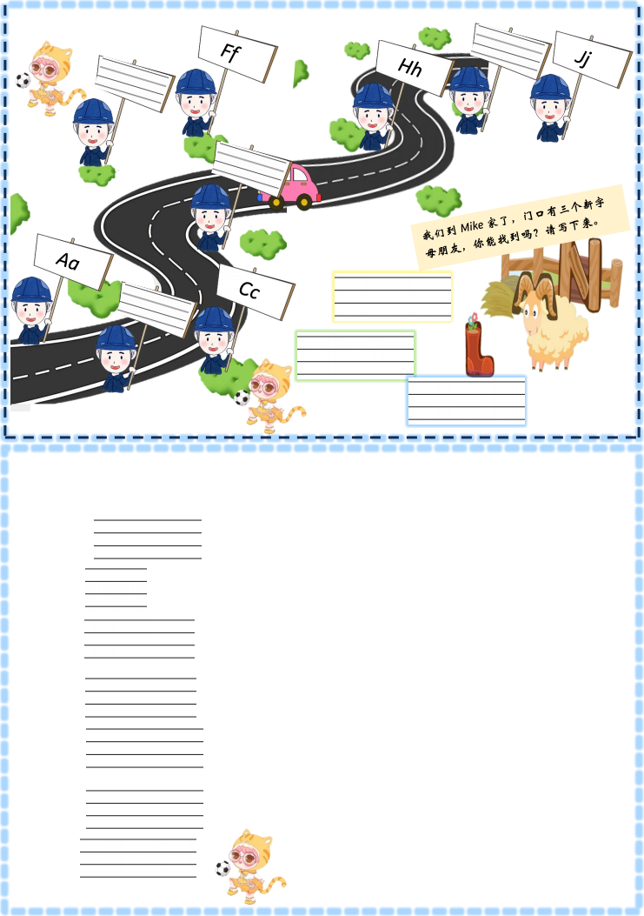

|  |  |  |  |
| --- | --- | --- | --- |
| **四．**Look and write. **我们现在要去** Mike **家，这条路是必经之路，你能写出路边的字母吗？（字母的左邻右舍）**   |  | | --- | |  |   .  in my family.  .  .  .  .  .   |  |  | | --- | --- | | **五．**Draw ,write and color .**今天是 Mimi 家庭日，她的父母邀请一名绘画师给她的家人设计一幅与众不同的全家福，如果你是，**  **你会怎么设计及介绍你的家人。（选做）**   |  | | --- | | Hello! I am  There are  This is my  This is my  This is my  This is my  I love my | | |