**译林版小学英语3A 第六单元** **作业创新与分层设计**

**第一部分：基础性作业**

**1.Fill in the blanks(根据课文内容填空)**

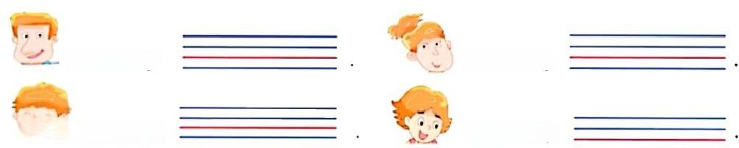

**This is my**

This is my

**This is my**

△**This is my**

**2.Make Mike's family tree(制作一个Mike 的家谱)**

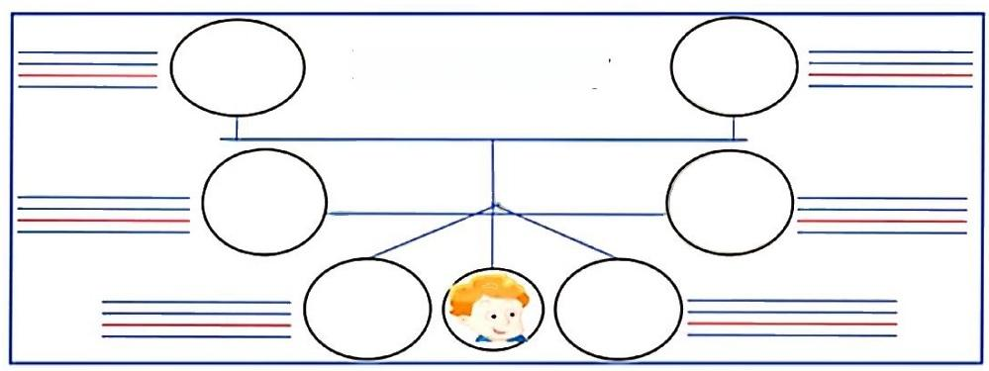

**Mike's family**

**第二部分：拓展性作业** **1.Draw yourfamily tree(画**一幅你的家谱吧!)

|  |
| --- |
|  |

**第三部分：综合实践性作业**

1.Introduce your family tree(介绍一下你的家谱吧!)



This is  .This is .Thisis



This is .This is me.I love my family.