常州市雕庄中心小学

校本课程操作手册

课程名称： Happy English

任教教师: 黄静华

二0二五年一月

雕庄中心小学校本课程规章制度

一、活动前
1．教师提前3分钟到达上课地点，队员准时、坚持参加每次活动。
2．教师做好每次活动的考勤，请假的队员要及时与该生的班主任联系，搞清去向。
3．教师做好课前准备，学生带好所需的学习用品。

二、活动时
1.队员要遵守纪律，按时、认真完成学习任务。
2.队员之间要团结合作、互帮互助、友好相处。

三、活动后
1．要做好教室的清洁打扫。请各校本课程再结合各自的特点，师生共同补充制定具有个性化的制度，其中校本课程岗位设置、优秀社员评选标准不可少。
2.制度定好后，请上传至校园网“学生成长——校本课程工作”栏目

常州市雕庄中心小学校本课程开发纲要
开发的课程名称 | Happy English | 教师姓名 | 黄静华
实施对象 | 五（2）班学生 | 班级规模 | 42人
展示形式 | £ 视频展示  R 作品展示  £ 现场展示  £ 其他形式：
课程目标 | - 通过社团活动，进一步激发学生学习英语的兴趣。2．通过专题作文培训，拓展学生的英语知识、开拓学生的思路。3．通过课内与课外相结合、课本与课外读物相结合的方式，使学生能更好地理解课本知识，提高解决实际的能力。
课程内容  及实施 | 两课时为一主题，用英语作文结合简笔画来介绍。  第一主题：Goldilocks and the three bears  第二主题：A new student  第三主题：Our animal friends  第四主题：Hobbies  第五主题：What do they do?  第六主题：My e-friend  第七主题：At weekends  第八主题：At Christmas
课程评价 | 教师综合学生的表现给予奖励，也可分为一二三等奖，一二三等奖可以获得物质奖励。
请同时将电子稿上传至“学生成长——校本课程工作”栏目

授 课 计 划
序号 | 周次 | 授课内容安排
1 | 二 | Goldilocks and the three bears（1）
2 | 三 | Goldilocks and the three bears（2）
3 | 四 | A new student(1)
4 | 五 | A new student(2)
5 | 六 | Our animal friends(1)
6 | 七 | Our animal friends(2)
7 | 八 | Hobbies(1)
8 | 九 | Hobbies(2)
9 | 十 | What do they do?(1)
10 | 十一 | What do they do?(2)
11 | 十二 | My e-friend(1)
12 | 十三 | My e-friend(2)
13 | 十四 | At weekends(1)
14 | 十五 | At weekends(2)
15 | 十六 | At Christmas(1)
16 | 十七 | At Christmas(2)
17
18
19
20
请同时将电子稿上传至“学生成长——校本课程工作”栏
学生出勤情况统计
序号 | 姓名 | 1 | 2 | 3 | 4 | 5 | 6 | 7 | 8 | 9 | 10 | 11 | 12 | 13 | 14 | 15 | 16 | 17 | 18 | 19 | 20
1 | 季顾芯雨 | √ | √ | √ | √ | √ | √ | √ | √ | √ | √ | √ | √ | √ | √ | √ | √
2 | 唐冰莹 | √ | √ | √ | √ | √ | √ | √ | √ | √ | √ | √ | √ | √ | √ | √ | √
3 | 仲慕颜 | √ | √ | √ | √ | √ | √ | √ | √ | √ | √ | √ | √ | √ | √ | √ | √
4 | 纪雨萱 | √ | √ | √ | √ | √ | √ | √ | √ | √ | √ | √ | √ | √ | √ | √ | √
5 | 朱慕子夕 | √ | √ | √ | √ | √ | √ | √ | √ | √ | √ | √ | √ | √ | √ | √ | √
6 | 陶若萱 | √ | √ | √ | √ | √ | √ | √ | √ | √ | √ | √ | √ | √ | √ | √ | √
7 | 孙紫涵 | √ | √ | √ | √ | √ | √ | √ | √ | √ | √ | √ | √ | √ | √ | √ | √
8 | 方诗妍 | √ | √ | √ | √ | √ | √ | √ | √ | √ | √ | √ | √ | √ | √ | √ | √
9 | 周涵琪 | √ | √ | √ | √ | √ | √ | √ | √ | √ | √ | √ | √ | √ | √ | √ | √
10 | 周晨晨 | √ | √ | √ | √ | √ | √ | √ | √ | √ | √ | √ | √ | √ | √ | √ | √
11 | 徐梦琪 | √ | √ | √ | √ | √ | √ | √ | √ | √ | √ | √ | √ | √ | √ | √ | √
12 | 何思雨 | √ | √ | √ | √ | √ | √ | √ | √ | √ | √ | √ | √ | √ | √ | √ | √
13 | 韩为婷 | √ | √ | √ | √ | √ | √ | √ | √ | √ | √ | √ | √ | √ | √ | √ | √
14 | 张苏平 | √ | √ | √ | √ | √ | √ | √ | √ | √ | √ | √ | √ | √ | √ | √ | √
15 | 李小念 | √ | √ | √ | √ | √ | √ | √ | √ | √ | √ | √ | √ | √ | √ | √ | √
注：出勤打√，缺勤打×，迟到打 ，旷课打○。
学生出勤情况统计
序号 | 姓名 | 1 | 2 | 3 | 4 | 5 | 6 | 7 | 8 | 9 | 10 | 11 | 12 | 13 | 14 | 15 | 16 | 17 | 18 | 19 | 20
16 | 张 雨 | √ | √ | √ | √ | √ | √ | √ | √ | √ | √ | √ | √ | √ | √ | √ | √
17 | 鲍梓萌 | √ | √ | √ | √ | √ | √ | √ | √ | √ | √ | √ | √ | √ | √ | √ | √
18 | 张馨语 | √ | √ | √ | √ | √ | √ | √ | √ | √ | √ | √ | √ | √ | √ | √ | √
19 | 汪 涵 | √ | √ | √ | √ | √ | √ | √ | √ | √ | √ | √ | √ | √ | √ | √ | √
20 | 吴思宇 | √ | √ | √ | √ | √ | √ | √ | √ | √ | √ | √ | √ | √ | √ | √ | √
21 | 王博涵 | √ | √ | √ | √ | √ | √ | √ | √ | √ | √ | √ | √ | √ | √ | √ | √
22 | 张景泽 | √ | √ | √ | √ | √ | √ | √ | √ | √ | √ | √ | √ | √ | √ | √ | √
23 | 葛振航 | √ | √ | √ | √ | √ | √ | √ | √ | √ | √ | √ | √ | √ | √ | √ | √
24 | 牛梓洋 | √ | √ | √ | √ | √ | √ | √ | √ | √ | √ | √ | √ | √ | √ | √ | √
25 | 董 彪 | √ | √ | √ | √ | √ | √ | √ | √ | √ | √ | √ | √ | √ | √ | √ | √
26 | 方俊轩 | √ | √ | √ | √ | √ | √ | √ | √ | √ | √ | √ | √ | √ | √ | √ | √
27 | 郭善水 | √ | √ | √ | √ | √ | √ | √ | √ | √ | √ | √ | √ | √ | √ | √ | √
28 | 周锦博 | √ | √ | √ | √ | √ | √ | √ | √ | √ | √ | √ | √ | √ | √ | √ | √
29 | 邹宇阳 | √ | √ | √ | √ | √ | √ | √ | √ | √ | √ | √ | √ | √ | √ | √ | √
30 | 孙煜腾 | √ | √ | √ | √ | √ | √ | √ | √ | √ | √ | √ | √ | √ | √ | √ | √
注：出勤打√，缺勤打×，迟到打 ，旷课打○。
学生出勤情况统计
序号 | 姓名 | 1 | 2 | 3 | 4 | 5 | 6 | 7 | 8 | 9 | 10 | 11 | 12 | 13 | 14 | 15 | 16 | 17 | 18 | 19 | 20
31 | 韩 斌 | √ | √ | √ | √ | √ | √ | √ | √ | √ | √ | √ | √ | √ | √ | √ | √
32 | 胡崇治 | √ | √ | √ | √ | √ | √ | √ | √ | √ | √ | √ | √ | √ | √ | √ | √
33 | 丁子舜 | √ | √ | √ | √ | √ | √ | √ | √ | √ | √ | √ | √ | √ | √ | √ | √
34 | 毛瑾祎 | √ | √ | √ | √ | √ | √ | √ | √ | √ | √ | √ | √ | √ | √ | √ | √
35 | 王子木 | √ | √ | √ | √ | √ | √ | √ | √ | √ | √ | √ | √ | √ | √ | √ | √
36 | 杨梓博 | √ | √ | √ | √ | √ | √ | √ | √ | √ | √ | √ | √ | √ | √ | √ | √
37 | 黄皓轩 | √ | √ | √ | √ | √ | √ | √ | √ | √ | √ | √ | √ | √ | √ | √ | √
38 | 李俊杰 | √ | √ | √ | √ | √ | √ | √ | √ | √ | √ | √ | √ | √ | √ | √ | √
39 | 盛晨阳 | √ | √ | √ | √ | √ | √ | √ | √ | √ | √ | √ | √ | √ | √ | √ | √
40 | 翟雨萌 | √ | √ | √ | √ | √ | √ | √ | √ | √ | √ | √ | √ | √ | √ | √ | √
41 | 卞泽铭 | √ | √ | √ | √ | √ | √ | √ | √ | √ | √ | √ | √ | √ | √ | √ | √
42 | 苏欣怡 | √ | √ | √ | √ | √ | √ | √ | √ | √ | √ | √ | √ | √ | √ | √ | √
43
44
45
注：出勤打√，缺勤打×，迟到打 ，旷课打○。
教学设计
序号 | 1 | 时间 | 2.26 | 周次 | 二 | 课题 | Goldilocks and the three bears （1）
教  学  设  计 | Step1 Warm up  Show teaching aims  In this lesson, we’ll have some learning aims. Look at the learning aims. First, I can understand “Cinderella”. Then, I can use “Why” and “Because” to ask and answer questions.  Ss read after T.  Step2 Presentation  Task1. Ask and answer  T: Look at the picture of Cinderella. What questions can you raise? For example, Who’s the girl? Can she go to the party? Why? You can ask like this in groups.  Task 2 .Who’s the best story teller?  Now, first, let’s come to the first aim. Can you understand “Cinderella”?  Step 3: Consolidation  课外阅读：Lily's Adventure  1. T给出图片，引导学生思考Lily都会问哪些问题。  2. Lily的奇幻之旅中发生了怎样的故事呢？ I can use “why” and “because” to ask and answer questions.全班根据练习完成情况自评。
教  学  效  果 | 学习了Lily's Adventure ,学生在自己能力的基础初步构思My Goldilocks，作文全篇应该如何构思，如何写作，为下一课时做准备。
序号 | 2 | 时间 | 3.4 | 周次 | 三 | 课题 | Goldilocks and the three bears （2）
教  学  设  计 | 1.Greetings  2.Imitation  Task1  1.Check the answers.  2.ask and answer  Why is Cinderella sad?  Why can’t she go to the party?  Task2  1.lead-in：Cinderella is a fairy tale. 2.Listen. What does Mike like reading? What does Yang Ling like reading?  3.what fairy tales do you know in China? How about the fairy tales in Western countries?  Task23  Show some pictures:  1.Look and say  2.Write it down  3.Summary: why, because
教  学  效  果 | 学生完成了Goldilocks and the three bears 的小作文，并附上自己的简笔画，简单高效，用自己的英文话语输出介绍自己喜欢的童话，对英语综合语用能力有很大的提升。
教学设计
序号 | 3 | 时间 | 3.11 | 周次 | 四 | 课题 | A new student（1）
教  学  设  计 | Step 1  1.Sing a song “ The wheels on the bus”  2. Say a chant  You go to work by bike.  He walks to school with Mike.  She comes here by plane.  They go there by train.  We are busy on weekdays.  Let’s be early as always.  Review the cartoon time:  How does Bobby want to go to school?  Can Sam go to school by bike?  Let’s act it.
教  学  效  果 | 利用谈话开始上课，学生很快进入状态，通过练习检查学生是否掌握所学内容。
教学设计
序号 | 4 | 时间 | 3.18 | 周次 | 五 | 课题 | A new student（2）
教  学  设  计 | 1、Free talk  Can you go to school by bike?  How do you go to school?  What about your family?  What about your friend?  Think and write  Finish P25  I live ….  It is near …  I go to school …  My father/ mother goes to work …  My friend … lives …  It is near …  He/ She goes to school …  His/ Her father/ mother …  2、Checkout time  What about them?  1.Look and finish.  2.Look and say.  Read together.
教  学  效  果 | 情感教育时注重引导学生用英语表达，教师要给予适当的帮助。通过表演进一步巩固所学的内容。课本结合实际来操练，帮助学生提升语言运用能力，提升他们在实际中解决问题的能力。
教学设计
序号 | 5 | 时间 | 3.25 | 周次 | 六 | 课题 | Our animal friends（1）
教  学  设  计 | 1.Free talk  2.Retell Cartoon time (PPT呈现该板块四幅图，引导学生根据关键词提示复述该故事。）  Key words：Bobby and Tina want to ... First, they ... Next, they ... Then, they ... Finally, they ...  3.Give Bobby and Tina some good ideas to get to the cinema in time.  （1）Discuss in pairs.  （2）Check.  4. Review “Sound time”  Help Sharon get to the shoe shop. (将Sound time的图与Checkout time的图重组，在Checkout time 的Point and say 板块线路图中加入shoe shop。）  Meet the new friend(呈现Sharon图，从Cartoon time过渡到Sound time)  T: You’re helpful. Here’s a new friend, Sharon. She needs help, too. (让学生尝试读出女孩的名字。shoe--sharon）  S：...  Sharon: Hello, everybody. I’m Sharon. I like shiny shoes. I would like to go to the shoe shop and buy a new pair. (提前录音，做在课件里。）  --L: shiny
教  学  效  果 | 引导学生根据情境复述文章，鼓励进行适当创新，拓展内容。把shoe shop安排在怀特路的公园旁边，有两条合理的路线，培养学生仔细观察的品质和运用语言解决实际生活中问题的能力，将语言回归生活。
教学设计
序号 | 6 | 时间 | 4.1 | 周次 | 七 | 课题 | Our animal friends（2）
教  学  设  计 | 1. Talk about the map of the streets.  2. Play the game about asking and telling the way. (翻牌游戏）  （1）T: We can ask and show the way in English well now. Shall we play a game about it?  How do you get to these places from your school?  Ss: ...  （2）Model: （T和一生玩，看一轮的结果。）  （将写有地点的单词卡反扣在桌上，让一生任选一张，然后根据单词卡向另一生问路。问对，答对都可以获得一颗星，看看谁是游戏赢家。）  （3）Play it in pairs.  1.Model1: The T’s way to school (Ss问，T答。然后PPT呈现如下语篇。）  I live in Tianmu Garden(小区/新村名. It is on Tianmu Road. It is near No. 2 People’s Hospital. I often come to school by bus. First, I get on the bus at No. 2 People’s Hospital. Then I get off the bus at No. 1 People’s Hospital. Then, I walk to school./ I’m on Beida Street. I go along Beida Street Then I turn right at the 1st traffic lights. The school is on my left.  - Talk in pairs(让生拿出昨天家作准备的路线图。  Check 1group  A: Where do you live?  B: I live in__________(新村名). It is on ___________ Street/ Road. It is near _________.  A: How do you get to school?  B: I come to school ____________ ...  4. Write down on P35.  Check 1 passage.
教  学  效  果 | Draw and write板块本身设计有问题，图中相对固定了家与学校的方位，这是不符合现实的；其次对于五年级学生，如果住的离学校太远，很难准确地绘制或表达途径的街道和站点名称；如果住的较近，步行上学又用不着First, I ... Then, I ... 因此在辅导学生写话时应根据学生的现实情况，适当简化，改变写话形式和内容。

教学设计
序号 | 7 | 时间 | 4.8 | 周次 | 八 | 课题 | Hobbies（1）
教  学  设  计 | Greetings.  T:1. What’s wrong with Su Hai? What should she do?  What’s wrong with Mike? What should he do? What should not he  教师出示图片  T:There are five pictures here. Please guess What’s wrong with them?  (1)学生猜测，并用英语说出答案  例如：Picture 1:He is very hot.教师引导：What should he do?学生说出答案。  (2)教师让学生观察其余的四幅图，并完成相应的练习。  (3)教师检测答案，并作出评价  (4)教师让学生预习Listen and choose板块的三个问题，带着问题来听录音。  (5)教师播放录音，学生根据复述录音内容并校对答案。
教  学  效  果 | 阅读故事，然后邀请学生以Bobby或者第三人称为视角。叙述动物们就医的经过。然后教师可以找出关键词并板书在黑板上，帮助学生进行复述。
教学设计
序号 | 8 | 时间 | 4.15 | 周次 | 九 | 课题 | Hobbies（2）
教  学  设  计 | Free talk  (1)教师出示图片并提出问题，引导学生讨论who where what,然后聚焦在Bobby在四幅图里的活动，要求学生用What’s wrong with the rabbit/elephant/monkey/giraffe描述。  The rabbit’s ear hurts.  The elephant’s nose hurts.  The monkey’s arm hurts.  The giraffe’s neck hurts.  (2)教师播放录音，要求学生跟读模仿，并要求学生注意兔子，猴子，长颈鹿和大象的语气。教师可以设计如下的阅读任务，以检查学生的理解情况。  例如：  How does the rabbit feel now?  How does the rabbit feel now?  How does the rabbit feel now?  Can Bobby help the giraffe at last? Why?  (3)复述故事
教  学  效  果 | 要求学生阅读故事，然后邀请学生以Bobby或者第三人称为视角。叙述动物们就医的经过。然后教师可以找出关键词并板书在黑板上，帮助学生进行复述，在学生复述熟练的基础上，可以安排四人一小组用头饰进行角色表演，注意语气语调和任务表情。
教学设计
序号 | 9 | 时间 | 4.22 | 周次 | 十 | 课题 | What do they do? (1)
教  学  设  计 | Step 1 Greeting  Step 2 Sound time  1.Free talk  T: Do you remember the title of this unit?  Ss : Helping our parents  T: How to pronounce “ ing ”? First, you read the word “helping” again.  教师再示范读。  2.给出动词让学生变成动名词后大声朗读。  Do, clean, cook, eat, help, wash, watch…..  学生回答。  3.出示sound time图片。  T: What can you get?  Ss talk about the picture.  4.教师出示单词 bring, morning, sing, spring.  学生试读并带读。  5. Listen to the tape
教  学  效  果 | 自己读单词感知发音规律，并总结发音，加深对本课语音版块理解，培养语音意识，提升语言能力。
教学设计
序号 | 10 | 时间 | 4.29 | 周次 | 十一 | 课题 | What do they do? (1)
教  学  设  计 | Step1 Checkout time  1.Look and write  T: What are the children doing?  （1）直接出示图片，同桌一问一答。  （2）教师指名回答。  （3）男生问女生答。  （4）将答案写在书上，同桌互查。  2. Listen, number and say.  (1)Show the pictures. ss discuss what are they doing.  (2)Listen to the tape.  (3)Listen again and number.  (4)Have a check  (5) Read after the tape.  (6)Say in group.  Helen is in…., she’s…..  (7) 小组展示  Step 4 Song time  <Polly, put the cattle on>
教  学  效  果 | 播放视频，让学生更直观感受西方文化，对比中外文化差异。学生对于现在进行时的应用还要加强练习。
教学设计
序号 | 11 | 时间 | 5.6 | 周次 | 十二 | 课题 | My e-friend (1)
教  学  设  计 | T: Good morning, class. Nice to see you.  Here are our learning goals, Let’s read it.  1. I can name some food.  2. I can ask and answer “Yes/No” questions about actions.  3. I know the sound of ‘qu’  1.Look and say (review the story)  (PPT present the pictures of story time)  What are they doing? (Liu Tao’s father and mother )  What is Liu Tao looking for?  What is Liu Tao eating?  2.Ask and answer: (PPT呈现P66 图)  A. Group work to ask and answer about the picture.  Is he/she...? Yes, he/she is. No, he/she isn’t.  Are ...? Yes, they are. /No, they aren’t.  B. show time  Five groups to ask and answer the picture  3.Work in pairs.  Ticking time: I can ask and answer “Yes/No” questions about actions.同桌互评
教  学  效  果 | 本课是第四课时，所以开始上课时，首先带领学生一起简要回忆前三课时学习了什么，并提出本单元最让人感兴趣的地方是因为它由一个又一个的故事构成。在此基础上,引出本课结构: 讨论书本上的故事-阅读欣赏身边的故事-写出并分享自己的故事.
教学设计
序号 | 12 | 时间 | 5.13 | 周次 | 十三 | 课题 | My e-friend (2)
教  学  设  计 | 4.Look and guess (PPT呈现冰箱的图片)  T：What’s this? Can you guess: What’s in the fridge? Please use the following sentence structure to talk about the picture.  There is…in the fridge.  There are…in the fridge.  5. Look and say  T：Let’s have a look. Oh, there are many food in the fridge. How many kinds of food are there in the fridge? What are they?  6. Look and write  Good job. Now let’s write down these sentences:  Check the answer and read these sentences  What can you find from these sentences?  Ticking time: I can name some food
教  学  效  果 | 这故事想要告诉我们什么，你学到了什么。请学生思考，对于老师列举的道理，自己最赞同哪一点，为什么。句子写完交流展示。
教学设计
序号 | 13 | 时间 | 5.20 | 周次 | 十四 | 课题 | At weekends（1）
教  学  设  计 | Step 1 Greeting  Step 2 Sound time  1.T: Look, it’s a tree. Can you guess What’s in the tree?出示一张大树的图片  Ss try to guess.  S1….  S2….  T: There are some birds in the tree.出示鸟。  T: How many birds are there? Let’s count together.  Ss :One ,two……thirty-three.  T: You are right. Follow me again: thirty-three.  Ss: Thirty-three.  T: Pay attention to the pronunciation of “th”.  T: What are the birds doing?  Ss: They are singing.  T: Yes. They are singing to mike. Because today is his birthday.引导学生说出单词birthday.  Ss read “birthday” again.
教  学  效  果 | 自己读单词感知发音规律，并总结发音，加深对本课语音版块理解，培养语音意识，提升语言能力。
教学设计
序号 | 14 | 时间 | 5、27 | 周次 | 十五 | 课题 | At weekends（2）
教  学  设  计 | Look at these words: mouth, thank, thin, think. What does “th” pronounce?  Ss try to read and say.  T: Can you give more words?  教师将学生说的单词写在黑板上。  6. I have some new words, try to read them.(PPT呈现新单词)  Step 3 Culture time  1.出示一个普通的南瓜。  T: It’s a pumpkin, right? Look, is it a pumpkin too? 出示南瓜灯  Ss: No, it’s a pumpkin lantern.  T: Great! What holiday is it ?  Ss: It’s Halloween.帮助学生回答，出示中文。  T: When’s Halloween? Who knows anything about the festival?  可让了解的学生讲讲。  教师给学生具体的讲一下万圣节。  Step 4 Checkout time  1. Ask and answer  T: Look, here are four cards. First, let’s read.  Next, you try to ask some questions according to the card..  We do it one by one.  出示第一个图片，师问生答。  Work in pairs.  Have a check.  T: Just now we learnt Halloween, can you make a card like these four?  将一组学生制作的信息卡展示给学生们看，然后以相同的方式问一些问题进行拓展。  2. Think and write  T: We know there are so many festivals. Which one do  you like best? And tell us why.  3分钟时间学生准备。  出示think and write 信息表。  T: You can say like this. Who wants to share?  点名3、4个学生。  抽取一名学生的festival 大家可齐读。  组内说说。  教师可介绍自己的最喜爱的节日。
教  学  效  果 | 播放视频，让学生更直观感受西方文化，对比中外文化差异。学生写完最喜欢的节日后交流分享，效果较好。
教学设计
序号 | 15 | 时间 | 6.3 | 周次 | 十六 | 课题 | At Christmas （1）
教  学  设  计 | 1：Greetings  1. T: How many people are there in your family?  S1: There are ….  T: What does your father do?  S1: He is a ….  T: Is your mother tall?  S1:…  2. T: What about Helen’s parents? Look at the picture.  Listen to Helen carefully.播放录音。  3. Follow the tape.  4. Say the chant in pairs.  5. Sum up.  T: T: Look at these words: this, that, father, mother. What does “th” pronounce？  Ss try to read and say.  T: Can you give more words?  教师将学生说的单词写在黑板上。  6. I have some new words, try to read them.
教  学  效  果 | 自己读单词感知发音规律，并总结发音，加深对本课语音版块理解，培养语音意识，提升语言能力。
教学设计
序号 | 16 | 时间 | 6.10 | 周次 | 十七 | 课题 | At Christmas（2）
教  学  设  计 | T: What will you get on birthday?  Ss: Presents.  T: When you open your presents?  T: Let’s watch a video.(西方国家过生日的视频)  T: Are Chinese and people in the west same?  Ss: No.  T: 出示culture time中的句子总结。  学生自读或齐读。  1. Listen and choose  师放录音，学生回答。  2. Make and say  T: What can you do for your parents and friends on their birthday?  S1…  S2…  S3…  T: Make a card is meaningful. But how ?  回顾五上第八单元at Christmas 制作卡片的过程。  First, fold a card  Next, write some message.  Then, draw some pictures  Finally, write your name.  小组合作制作卡片。  小组展示。  3.Write and say  T: When’s your birthday?  S1…..  T: When are your parents birthdays?  S1….  T: What do you do on these days?  S1…..  Work in pairs.  Write on the sheet.  指名说说。  教师展示自己的信息卡。
教  学  效  果 | 播放视频，让学生更直观感受西方文化，对比中外文化差异。作文写完以后交流分享，效果比较好。

雕庄中心小学 2024-2025 学年第 一 学期
Happy English 校本课程成果展示（照片形式贴于下方）

教师： 黄静华
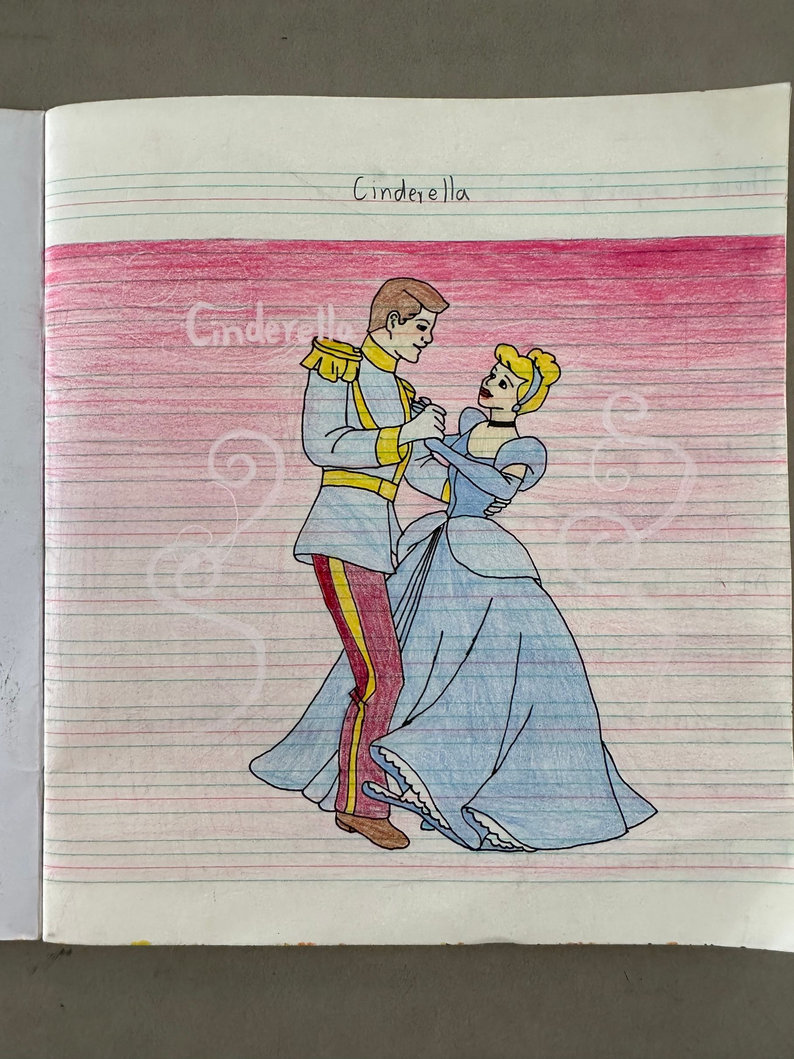
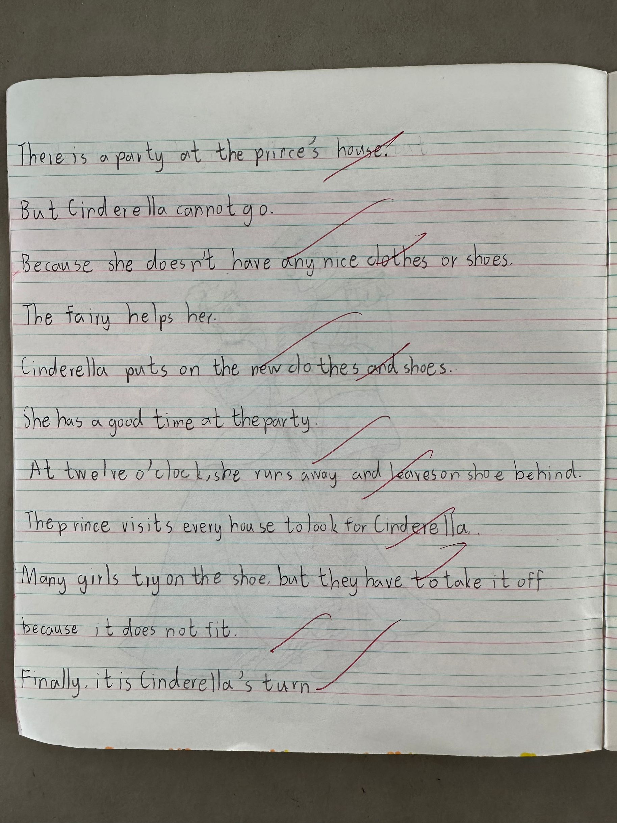

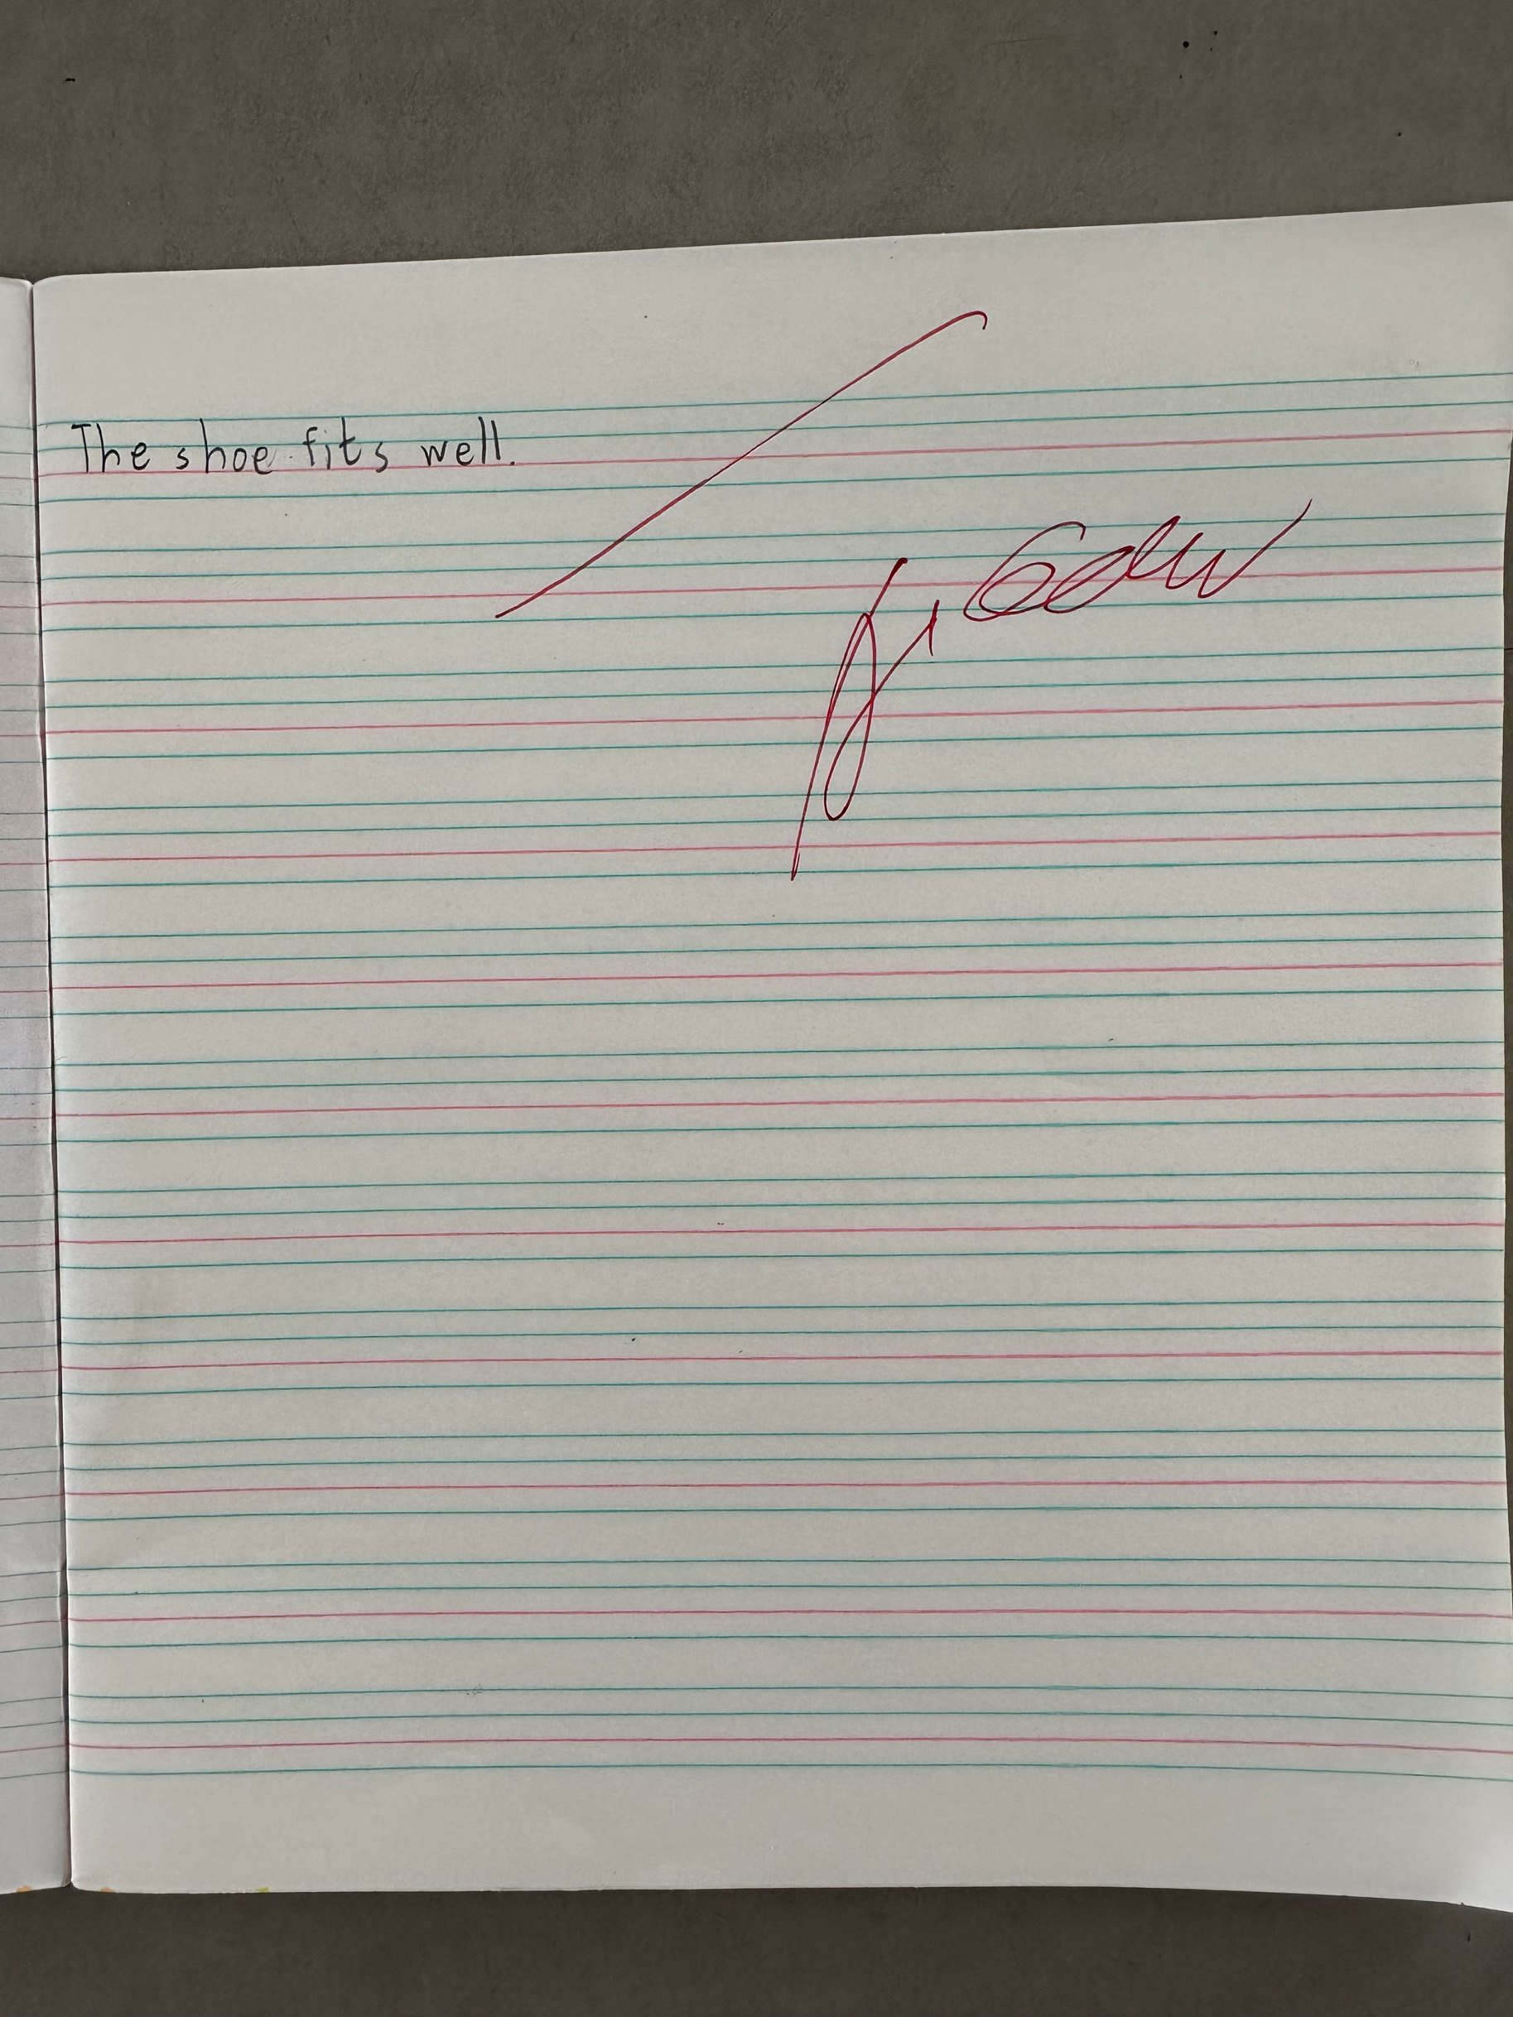

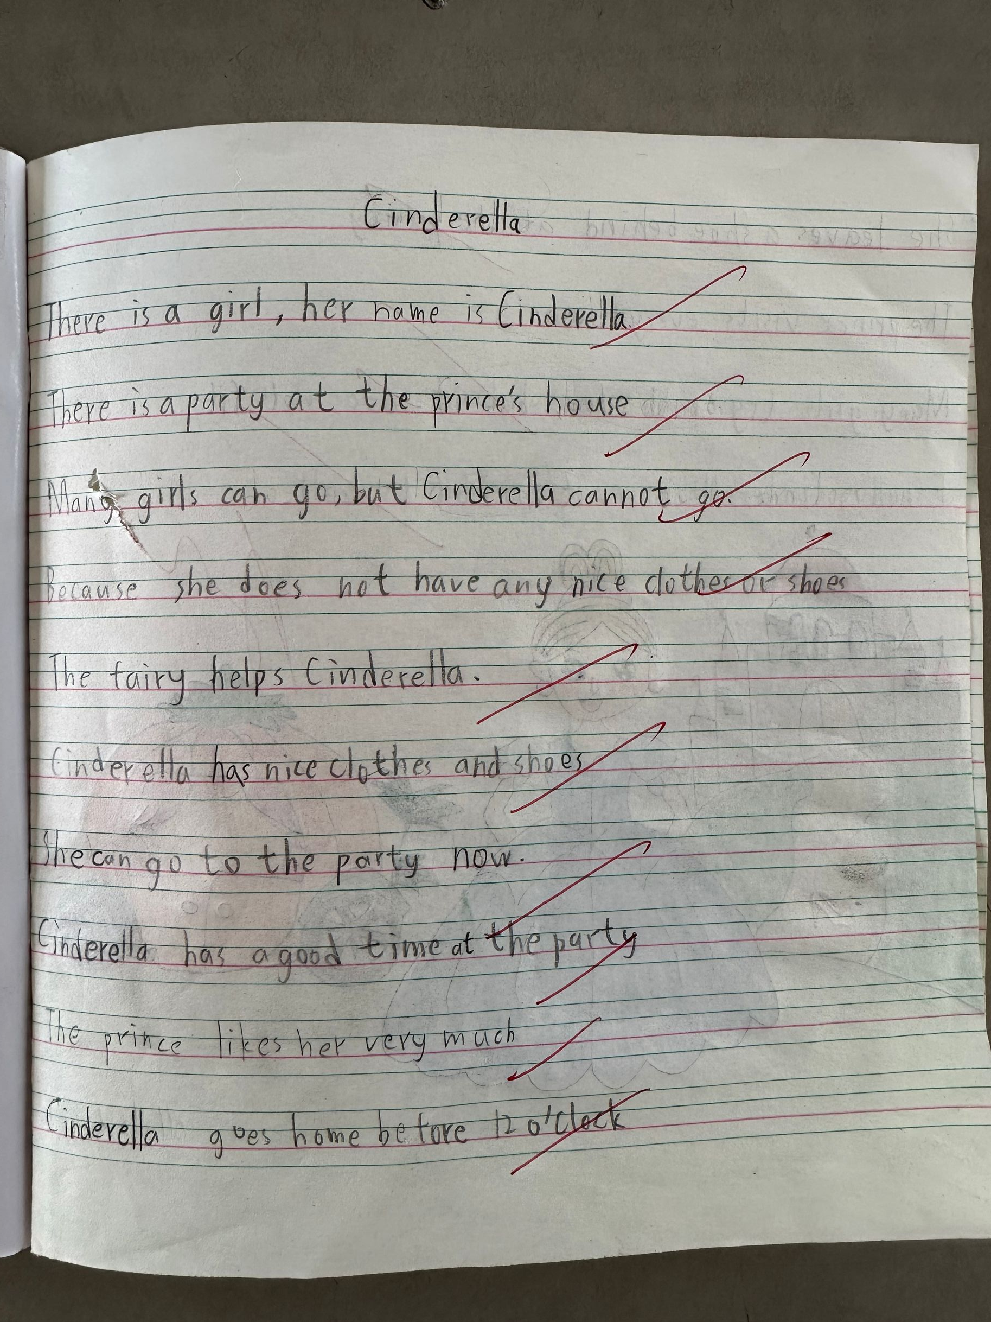
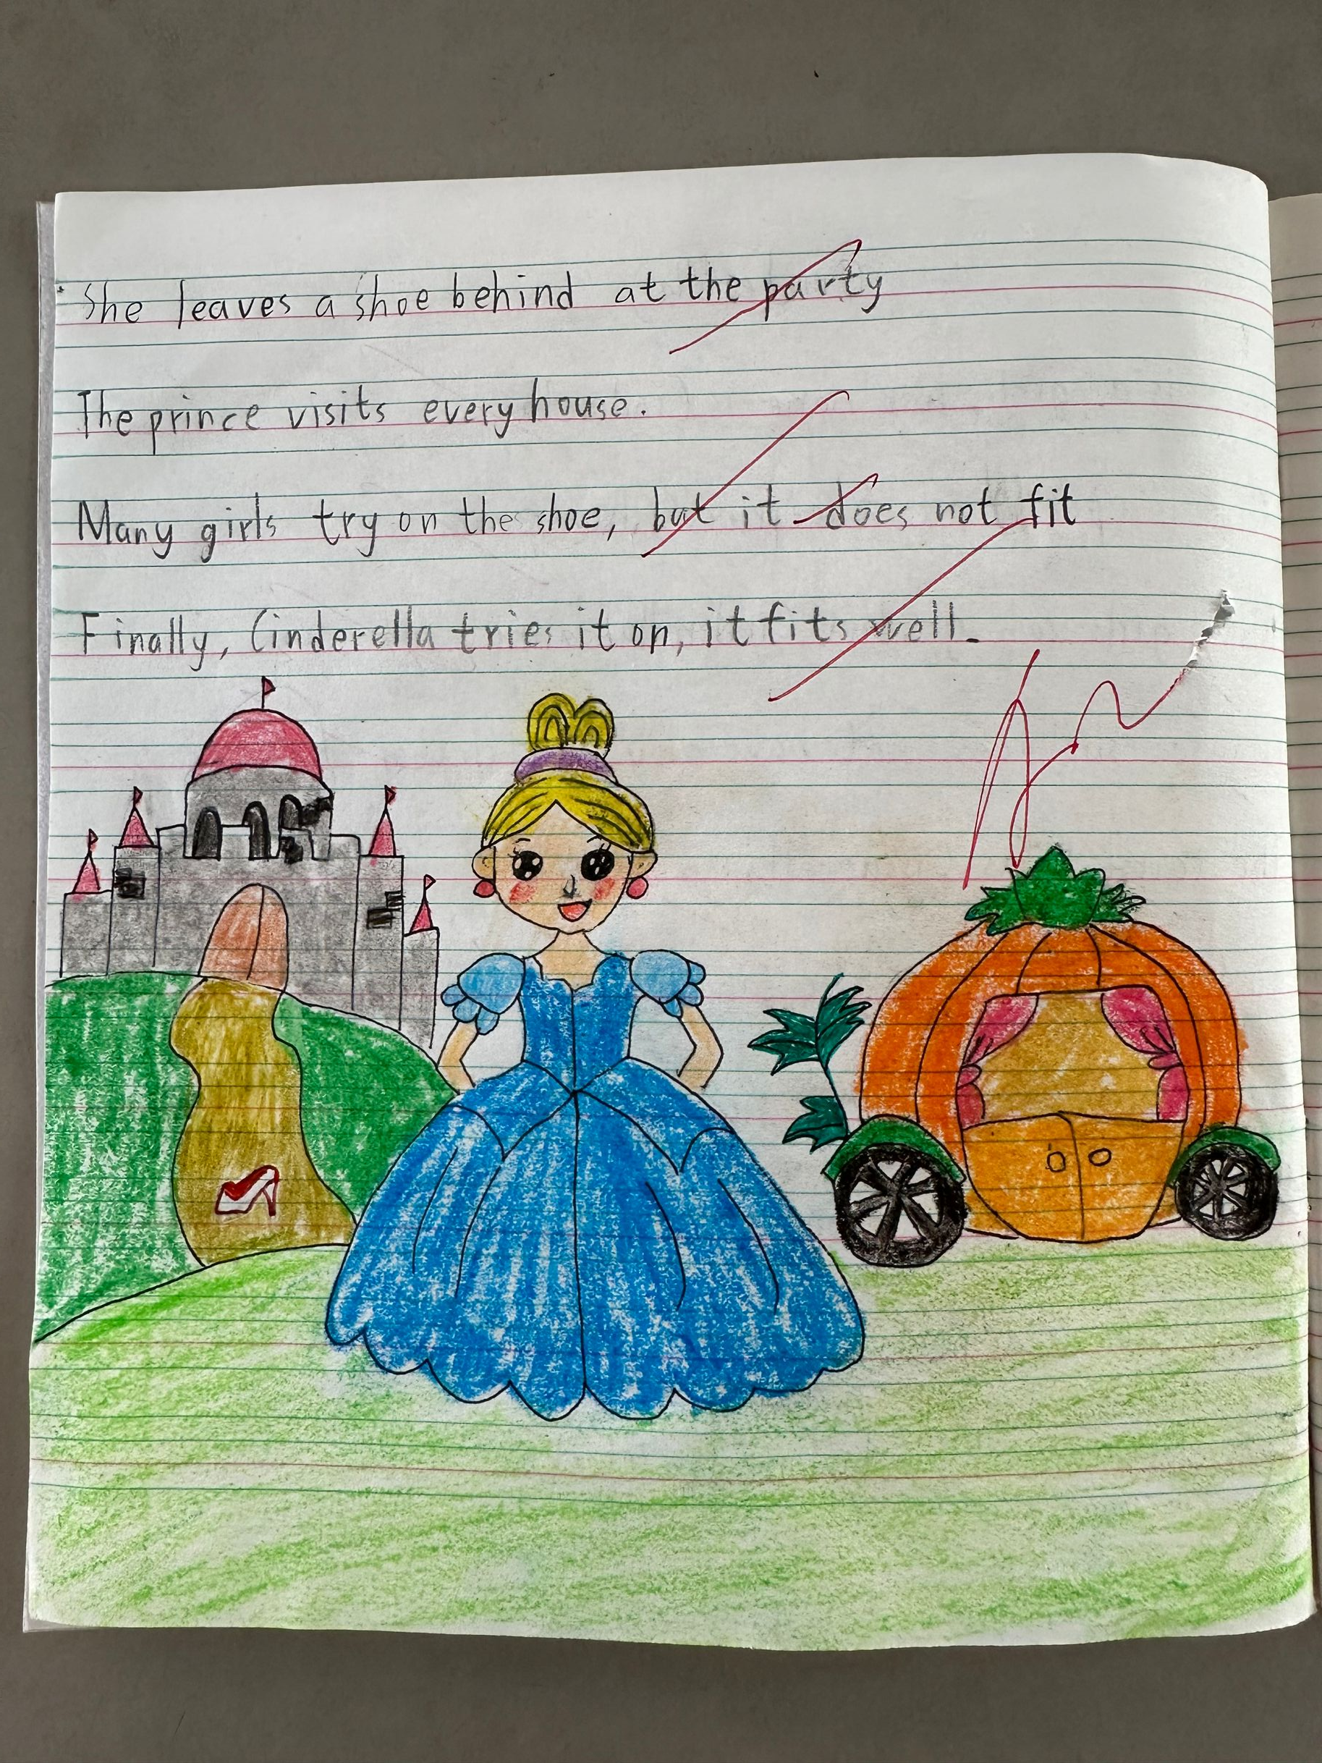

请同时将电子稿上传至“学生成长——校本课程工作”栏目
优秀社团成员名单：合计 人

序号 | 班级 | 姓名 | 简 评
1 | 五2 | 丁子舜 | 上课认真，作文优美
2 | 五2 | 周涵琪 | 上课认真，成绩提升
3 | 五2 | 纪雨萱 | 上课认真，学以致用
4 | 五2 | 仲慕颜 | 语句通顺，插图优美
5 | 五2 | 王子木 | 学习努力，上课认真
6 | 五2 | 吴思宇 | 上课认真，作文优美
7 | 五2 | 牛梓洋 | 上课认真，成绩提升
8 | 五2 | 唐冰莹 | 上课认真，学以致用
9 | 五2 | 孙煜腾 | 语句通顺，插图优美
10 | 五2 | 徐梦琪 | 学习努力，上课认真
优秀校本课程学员人数不超过总人数的30%，期末由指导教师在优秀成员学生护照上评定盖章。
请同时将电子稿上传至“学生成长——校本课程工作”栏目。

