**20241216| 中一班**

Daily life

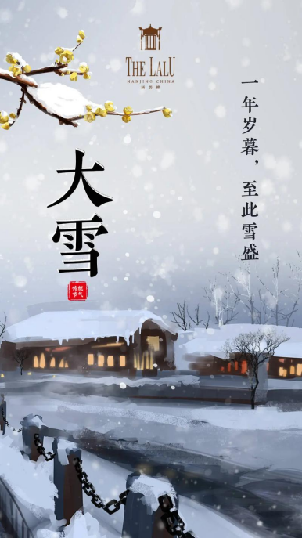

**「来园情况」**

今日星期一，共有21人来园，1人请假。

**「日常生活观察」**

|  |  |  |  |  |  |  |
| --- | --- | --- | --- | --- | --- | --- |
| **序号** | **姓名** | **午餐** | | | **午睡** | **备注** |
| **饭** | **菜** | **汤** |
| 1 | 韩昕怡 | √ | √ | √ | √ |  |
| 2 | 韩昕悦 | √ | √ | √ | √ |  |
| 3 | 吴清墨 | √ | √ | √ | √ |  |
| 4 | 陆晟涵 | √ | √ | √ | √ |  |
| 5 | 张梅伊 | √ | √ | √ | √ |  |
| 6 | 吴沐檀 | √ | √ | √ | √ |  |
| 7 | 曹果 | √ | √ | √ | √ |  |
| 8 | 曹煜琪 | √ | √ | √ | √ |  |
| 9 | 蒋安乐 | √ | √ | √ | √ |  |
| 10 | 韩书华 | √ | √ | √ | √ |  |
| 11 | 顾言希 | √ | √ | √ | √ |  |
| 12 | 贾钧尧 | √ | √ | √ | 看护入睡 |  |
| 13 | 杨宸 | √ | √ | √ | 看护入睡 |  |
| 14 | 张予安 | √ | √ | √ | √ |  |
| 15 | 高瑞泽 | √ | √ | √ | √ |  |
| 16 | 张路翔 | 请假 |  |  |  |  |
| 17 | 谢咏呈 | √ | √ | √ | √ |  |
| 18 | 汤凌宇 | √ | √ | √ | 看护入睡 |  |
| 19 | 韩以轩 | √ | √ | √ | √ |  |
| 20 | 冯煦晨 | √ | √ | √ | √ |  |
| 21 | 郑哲皓 | √ | √ | √ | √ |  |
| 22 | 张致远 | √ | √ | √ | √ |  |

**「户外活动」**

|  |  |  |
| --- | --- | --- |
| **E2E990042F1C3ECC3D977A558448A85F** | **7C1EE61CCFC6C934A1FC641CB0C91F3B** | **A7074F45C2C5D5CB4B124DB856E82DA6** |
| **6451FEA11799BAD3D623E5289FAA14FB** | **23376453E43569925A74D3CCA3D9DE6C** | **4C84DE3B93AFC60ADC449FAF524FB7B3** |