**20241205| 中一班**

Daily life

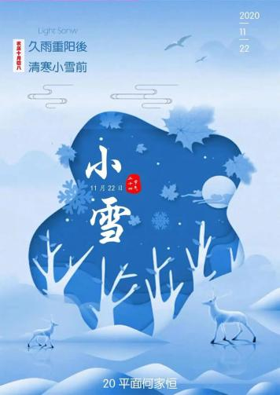

**「来园情况」**

今日星期四，20位幼儿来园，2位幼儿请假。

**「日常生活观察」**

|  |  |  |  |  |  |  |
| --- | --- | --- | --- | --- | --- | --- |
| **序号** | **姓名** | **午餐** | | | **午睡** | **备注** |
| **饭** | **菜** | **汤** |
| 1 | 韩昕怡 | √ | √ | √ | √ |  |
| 2 | 韩昕悦 | √ | √ | √ | √ |  |
| 3 | 吴清墨 | 请假 |  |  |  |  |
| 4 | 陆晟涵 | √ | √ | √ | √ |  |
| 5 | 张梅伊 | √ | √ | √ | √ |  |
| 6 | 吴沐檀 | √ | √ | √ | √ |  |
| 7 | 曹果 | √ | √ | √ | √ |  |
| 8 | 曹煜琪 | 请假 |  |  |  |  |
| 9 | 蒋安乐 | √ | √ | √ | √ |  |
| 10 | 韩书华 | √ | √ | √ | √ |  |
| 11 | 顾言希 | √ | √ | √ | √ |  |
| 12 | 贾钧尧 | √ | √ | √ | √ |  |
| 13 | 杨宸 | √ | √ | √ | √ |  |
| 14 | 张予安 | √ | √ | √ | √ |  |
| 15 | 高瑞泽 | √ | √ | √ | √ |  |
| 16 | 张路翔 | √ | √ | √ | √ |  |
| 17 | 谢咏呈 | √ | √ | √ | √ |  |
| 18 | 汤凌宇 | √ | √ | √ | √ |  |
| 19 | 韩以轩 | √ | √ | √ | √ |  |
| 20 | 冯煦晨 | √ | √ | √ | √ |  |
| 21 | 郑哲皓 | √ | √ | √ | √ |  |
| 22 | 张致远 | √ | √ | √ | √ |  |

**「集体活动」**

这是一节偏向于科学知识性的综合活动。动物世界种类繁多，但它们都有各自的名称、外形特征、生活习性等。本节活动采用经验分享法，让孩子讲述自己所知道的动物，并乐意倾听同伴讲述，增加对动物的了解，满足幼儿的愿望和需求。

|  |  |  |  |
| --- | --- | --- | --- |
| **0CDDE79CE039B5F47F428F4B994D8F5E** | **5BB93AEDD235E7BB9FEBAEFBFA952765** | **5BC62E75CD1E02093FC462FD57086B00** | **5FDBD7363A7D0C20E8C5B0C51C042030** |
| **5E0593DCDBD57D3C72F05A1D7277F699** | **6B6F027613C20EE1204FB09431A7C3E0** | **26347A48372F06426EE4E9A2514204E5** | **6DF78D056F7459AA74976CE95DB5CBE1** |