六 年级 英语 学科 《Protect the Earth》单元整体作业设计
- 作业设计说明
教材分析
What: 本单元教学内容为译林版《英语》六年级上册第七单元Protect the Earth，主题是保护地球，该单元属于“人与自然”主题范畴下的“环境保护”子主题。Story time通过四个方面：节约用水、节约能源、保护树木、少用塑料，提出了保护地球的一些建议；Grammar time呈现了use...to...和情态动词should的用法；Fun time展示了“变废为宝”的活动；Sound time呈现了oo字母组合的发音规律；Culture time介绍了两个有关环境保护的公益日：地球日和世界环境日；Cartoon time讲述了Bobby，Sam以及Billy为了让大家了解保护地球的重要性，一起制作了一张宣传海报的故事；Checkout time呈现了不同类型的破环环境的行为，写作练习以“保护”地球为主题。
Why: Story time旨在引导学生明确地球上一些资源的用途及使用情况，了解保护地球的措施，提高保护地球的意识；Grammar time旨在让学生能在主题语境中运用目标语言交流使用、节约资源的方式；Fun time旨在认识到节约资源、重复利用资源的重要性，倡导绿色生活；Sound time旨在让学生体悟每天在优美的校园环境中学习是非常开心、快乐的；Culture time旨在让学生进一步了解保护地球、爱护环境是全人类共同的目标；Cartoon time旨在引发学生深层理解环保的意义；Checkout time旨在引导学生在实践运用中内化所学语言和文化知识，加深理解和应用，并以实际行动践行爱护环境、保护地球。
How: Story time语篇结构清晰，包含用途、现状及措施，能为学生后续的写作搭建基本框架，提供素材；Grammar time, Fun time和Sound time由图表、游戏和小诗歌三个语篇组成，学生观察归纳核心语言并在语境中运用；Culture time和Cartoon time分别是配图文字和一项海报设计活动；Checkout time由六组配图小短文和一个写作小练习组成，帮助学生从should和shouldn’t两个方面梳理保护地球的方式。
单元及课时教学目标
单元教学目标 | 语篇 | 课时目标
1. 能阅读、理解、概括文本信息，提炼出“保护地球”语篇关键信息，完成思维导图，并能基于思维导图和关键词，运用目标语言复述文本内容。  2. 能基于结构化知识，运用目标语言探讨我们的责任“保护地球”，并能够结合图片，运用目标语言描述我们应该如何保护地球。  3. 通过“做一做、说一说”的活动，学生能用情态动词should 表达出保护地球的实际行动。学生激活已知，内化、巩固所学语言和文化知识，加深理解和应用。  4. 通过听、读，模仿语调朗诵诗歌、创编诗歌，掌握字母组合oo的发音，即/u:/。  5. 通过查阅书籍、浏览网络等方式，学生了解更多保护地球的方式和节日，争当保护地球的小达人。  6. 通过图片和文本提取、分析、整合关键信息，学生理解卡通故事的幽默之处，引发学生思考垃圾桶的点睛之笔，在现实生活中应该不随手丢垃圾，保护环境。  7. 通过看、读，能从图片中获取信息，将语篇信息补充完整，并能以小组合作方式介绍语篇中人们应该和不应该做的事情。  8. 基于文中所给框架，学生能设计写作提纲，合理架构文章。 | Story time  （1课时） | 1. 能听懂、会说、会读、会写下列单词：project, Earth, save, useful, waste, reuse, energy, most, come from, coal, wood, cut down, too many, plastic, too much, project, poster, gate  2. 能听懂、会说、会读、会写下列句型：We should/We shouldn’t...  3. 能阅读、理解、概括文本信息，提炼出“保护地球”语篇关键信息，完成思维导图，并能基于思维导图和关键词，运用目标语言复述文本内容。
 | Grammar time&Fun time  （1课时） | - 能基于结构化知识，运用目标语言探讨我们的责任“保护地球”，并能够结合图片，运用目标语言描述我们应该如何保护地球。  2. 通过“做一做、说一说”的活动，学生能用情态动词should 表达出保护地球的实际行动。学生激活已知，内化、巩固所学语言和文化知识，加深理解和应用。
 | Sound time, Culture time&Cartoon time  （1课时） | - 通过听、读，模仿语调朗诵诗歌、创编诗歌，掌握字母组合oo的发音，即/u:/。  2. 通过查阅书籍、浏览网络等方式，学生了解更多保护地球的方式和节日，争当保护地球的小达人。  3. 通过图片和文本提取、分析、整合关键信息，学生理解卡通故事的幽默之处，引发学生思考垃圾桶的点睛之笔，在现实生活中应该不随手丢垃圾，保护环境。
 | Checkout time  （1课时） | 1. 通过看、读，能从图片中获取信息，将语篇信息补充完整，并能以小组合作方式介绍语篇中人们应该和不应该做的事情。  2. 基于文中所给框架，学生能设计写作提纲，合理架构文章。
单元作业整体设计思路
1.选择适当的题目类型，注重培养学生用语言做事的能力
综合决定主观题和客观题所占比例，保证作业质量。
2.选择优质素材是关键
尽可能选择与实际生活有关的语篇，语篇题材要符合学生的年龄特点和生活经历，语篇的长度要适宜，要与学生日常所接触的语篇长度基本一致，语篇的内容包含可以用来考察理解的考点，难度应与相应学段学生语言能力相当。
3.要从考察知识的积累与记忆转向考察学生核心素养表现
作业内容要有意义，有语境，引导学生在真实或近似真实的情景中用语言做事，题目体现互动及学生与情境任务的互动，调动学生的参与积极性和参与感，使学生体验用语言做事的意义和成就感。
- 详细作业设计（立足单元整体进行设计）
课题 | Protect the Earth | 第一课时 | Story time
分层作业模式 | 作业内容 |  | 设计意图
夯实基础  （必做） | - Read and imitate  同学们，通过本课时的学习，你能流利朗读课文了吗？请以正确的语音语调，朗读课文：  - 听录音跟读两遍  - 自己完整朗读一遍  - Read and write  同学们，你能根据课文内容完成思维导图吗？  Save_____ : We should__________.  We should not________.  Save_____ : We should ___________.  We should not________.  Protect the Earth Save_____ : We should___________.  We should not________.  Don’t_____: We should___________.  We should not________.  - Review and write  同学们，还记得本课所学吗？请用所给词的适当形式填空。  - --There ________ (be) a lot of paper on the desk just now. But now there ________ (be) many paper bags on it. Why?  --Because Nancy ________ (use) the paper ________ (make) these bags.  - Mr White (use) the telephone (call) people.  - My father (use) a mobile phone (call) (I) just now.  - Who can make a sentence (use/with) this new word?  - They (use/with) paper to make a T-shirt. |  | 听录音跟读课文，加深对课文内容的记忆，强化正确的语音语调。  利用思维导图帮助学生掌握整体教学内容，提升学生理解、记忆能力，激活学生的语言思维，培养了学生的核心素养。  强化本单元的核心知识点及易错点：use sth to do sth以及可数、不可数名词的用法。
能力提升  （选做） | - Think and write  同学们，想一想，除了课文中所提及的，地球还存在哪些环境问题呢？参考语句：...make(s)... dirty/ messy/ noisy/...  Problems about the environment:  _________________________________________  _________________________________________  _________________________________________  - Think and write  同学们，我们还能做些什么来保护地球呢？请结合U6所学，写一些吧。  _________________________________________  _________________________________________  _________________________________________ |  | 结合实际生活，联系旧知，写一写其他环境问题，引起学生对环境保护的重视。  激活学生思维，知识勾连，锻炼综合语言运用能力。
作业评价 | 同学们，请给自己的作业评评分吧，你能得到几颗星星？也给父母分享你的作业，请他们也评价一下吧！  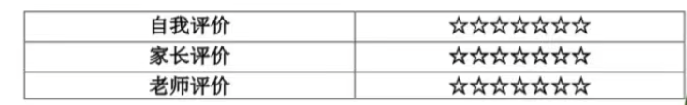
课题 | Protect the Earth | 第二课时 | Grammar &Fun time
分层作业模式 | 作业内容 |  | 设计意图
夯实基础  （必做） | - Brainstorm  同学们，生活中的很多东西都可以被利用，我们可以利用以下物品做什么呢？你能再举个例子吗？（使用use...to...）  We__________wood___________________________.  We__________water___________________________.  We__________plastic___________________________.  We__________________________________________.  - Think and match  同学们，以下生活妙招你知道吗？试着匹配吧！  ( ) 1. There’s too much greasy（油腻的）dirt on the dishes. How can we clean them?  ( ) 2. How to save water?  ( ) 3. What can we do to reuse water?  ( ) 4. How can we reuse paper?  ( ) 5. To save energy, what can we do?  - We can take a bus or bike for a short trip.  - We can reuse it to make a box or fashion clothes.  - We can use the paper to clean the dishes first and then use water to wash them.  - Turn off the tap（水龙头）when washing the face.  - We can sweep the floor after washing vegetables.  - Read and choose  同学们，针对塑料瓶的回收，我们做了个调查统计，一起来看一看吧。  The students of Grade 6 collect empty(空的) bottles. In January, they are going to take them to a recycling centre(回收中心). They're going to sell(卖) the bottles and buy some books for the school library.  Kate has made a graph(图表) to show the number(数量) of the bottles they have collected. This is the graph.  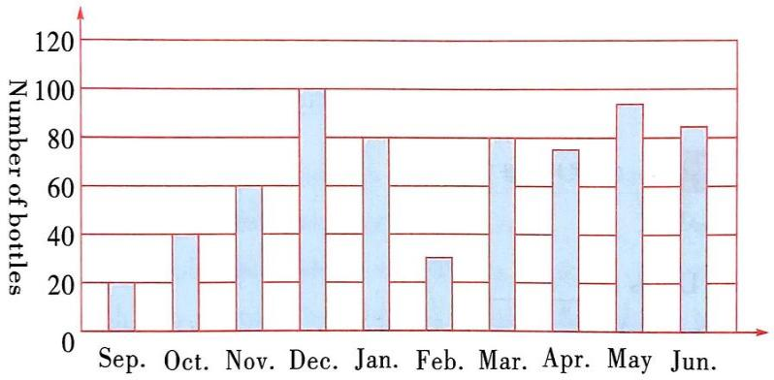  Mar. Apr. May Jun. Jul. Aug. Sept. Oct. Nov. Dec.  ( )1. In September, students collected ____ empty bottles.  A. 80 B. 60 C. 40  ( ) 2. The students collected ________ more(更多) bottles in June than(比······) in July.  A. 10 B. 20 C. 30  ( ) 3. From the graph, we know that the students collected the same number of bottles in _____ and ______.  A. November;June B.September; July C.August; March  ( ) 4. The students are going to take the bottles ________.  A. to the library B. to the recycling center C. home  ( ) 5. The students collected the bottles ________.  A. for a year B. every month C. for 10 months  ( ) 6. Why do the students collect empty bottles?  A. Because they want to do something for their school.  B. Because they like empty bottles very much.  C. Because they want to play with the bottles. |  | 本题是一道开放型题目，旨在让学生开动脑筋，运用本课时核心知识点use sth to do sth进行填空，并提示学生联系生活举例，内化知识并运用。  本题考察了学生的生活常识，提供了一些生活妙招和生活中的具体环保措施，旨在让学生明白从生活中的小事做起，保护环境。  阅读理解主题与Fun time主题reuse相关，培养了学生提取关键信息和数据对比的能力。
能力提升  （选做） | - Think and write  同学们，生活中还有哪些物品可以再回收利用呢？试着写一些吧！  I can reuse ________ to ______________.  I can reuse ________ to ______________.  I can ______________________________.  - Have a try  同学们，尝试用你的巧手再利用身边的物品进行创造吧，把你的作品拍成照片粘贴在这吧！ |  | 能力提升的两题分别为书面和实操，以书面形式表达自己的想法，再将自己的想法付诸行动，这种形式的作业考察了学生的综合能力，发展了学生的核心素养。
作业评价 | 同学们，请给自己的作业评评分吧，你能得到几颗星星？也给父母分享你的作业，请他们也评价一下吧！
课题 | Protect the Earth | 第三课时 | Sound, Culture& Cartoon time
分层作业模式 | 作业内容 |  | 设计意图
夯实基础  （必做） | - Think and write  同学们，本课时我们学习了oo字母组合的发音/u:/，你能写一些oo字母组合发/u:/的单词吗？  oo/u:/ _________________________________________  你能仿照Sound time能用上几个词编个chant吗？  _________________________________  _________________________________  _________________________________  _________________________________  - Read and write  同学们，Bobby和Sam正在进行保护地球的课题研究，你能帮助他们搜集到正确的资料吗？  There are many d________ things we can do to protect the Earth. Everyone should k______ something. When you visit a park, take away what you bring there—keep r________ in a bag until(直到) you can put it in a b______. To keep the a_____ clean, we can p_____ more trees and f________. There are some important d______ about protecting the environment every month, such as E_____ day in A_____, World E_________ Day in J_____, etc. We can make some p_____ to let all the students know.  If everyone pays more attention to protect the environment, the w______ will become more b________.  - Read, choose and answer  同学们，认真阅读文章，得到一些新的思考和收获吧。  Earth Day is coming. “What are you going to do to protect the Earth, class?” asked Mrs Conner.  “I’m going to 1 polar bears!” said Eigen. “I’m going to plant a forest!” said Katie. “These are big ideas,” said Mrs Conner. “What other 2 can you think of?”  When Emma went back home, she was 3 and said to her dad, “I can’t help the Earth. I don’t have any big ideas.” “But we can start with 4 things,” said her dad.  All that week, Emma and her dad did a lot of things to help the Earth. Emma reused the water to clean the floor. They 5 up rubbish on the way. They sorted cans and bottles. They went out by 6 , not by car.  “Emma’s small ideas are very big,” said Mrs Conner. “The Earth is 7 in your hands.”  ( )1.A.find B.help C.see  ( )2.A.ideas B.animals C.projects  ( )3.A.happy B.sad C.clever  ( )4.A.big B.same C.small  ( )5.A.cut B.picked C.looked  ( )6.A.bike B.taxi C.plane  ( )7.A.safe B.little C.fast  From this passage, I know____________________________  _________________________________________________. |  | 本题旨在回顾本单元oo字母组合的发音，学生通过本题头脑风暴，举例更多有关单词并创编小诗，培养学生的创造性和思维的灵活性。  本题糅合了Culture time及Cartoon time的主要内容，考察学生在语境下对于知识点的运用，培养学生上下文联系的能力。  本篇阅读理解与本课时主题相关，但又蕴含新的意义点，旨在让学生明白保护地球从身边小事做起即可，开放性问题考察学生的语言组织能力和阅读理解能力。
能力提升  （选做） | - Let’s make  同学们，请以Sam的海报为例，绘制一幅图文并茂的海报，号召小伙伴们一起保护地球吧！ |  | 本题是一道学科融合题，将美术与英语相结合，对学生来说是一个挑战，充分考验学生的综合语言运用能力，学生可以联系实际生活加以创设。
作业评价 | 同学们，请给自己的作业评评分吧，你能得到几颗星星？也给父母分享你的作业，请他们也评价一下吧！
课题 | Protect the Earth | 第四课时 | Checkout time
分层作业模式 | 作业内容 |  | 设计意图
夯实基础  （必做） | - Think and write  同学们，请从方框中选择合适的内容并用适当形式填空。  reuse old things coal and oil cut down  make beautiful clothes do a project  - Two men ____ the dead tree in the garden yesterday.  - We shouldn’t use animal fur to ___ .  - Wind energy is cleaner than .  - —Do you like collecting old things?  —Yes. I often .  - It is three o’clock in the afternoon. Liu Tao and his friends  about Labor education（劳动教育）.  - Read and judge  同学们，读一读，判断下列行为是（T）否（F）环保？  ( ) 1. Mr Black works near his home. He goes to work by car every day.  ( ) 2. When Bobby brushes his teeth, he often leaves the tap running.  ( ) 3. Mrs Jones is a housewife. When she goes to the supermarket, she usually takes her own cloth bags.  ( ) 4. Amy buys coffee every morning. But she usually uses her own glass bottle to drink coffee. She thinks it is a good way to reduce the use of paper.  ( ) 5. Mr Brown washes his clothes by himself. He doesn't use the washing machine very often, because he wants to save energy.  - Read and fill  同学们，请阅读短文，完成下面的表格。  Good environment can make people feel happy. To keep the environment clean and nice, we can do many things. First of all, we should put rubbish in the bin. We should also stop factories from pouring dirty water and rubbish into rivers. Second, we should plant more trees. We should not cut down too many trees. Third, we should save energy. We should not drive too much. We can go to work or school by bus or on foot. Last but not least, we should reuse everything that can be reused. We can reuse paper and plastic bags. We shouldn't use too many disposable(一次性的) things. By doing these things, we can make the world a better place.  Do Do not  Rubbish put rubbish in the bin pour 1. ________ water or rubbish into rivers  Trees 2. ________ more trees 3. ________ down too many trees  4. ________ go to work or school by bus or on foot 5. ________ too much  Reusing 6. ________ some things use too many disposable things  - Think and write  同学们，想一想，地球现在存在哪些问题，我们该采取什么措施保护地球呢？请你写一写吧！  The air in the city is dirty now. Smoke from cars and factories  makes it. To keep it clean, we can______________________  _________________________________________________  _________________________________________________  _________________________________________________  _________________________________________________. |  | 本题旨在考察学生对于知识点的综合运用能力，对于时态和句意的理解都要精准。  本题联系实际生活，考察学生对于本单元主题意义的理解，并能在理解后学以致用。  短文与本单元主题相关，考察学生的阅读理解能力和提取关键信息，转换信息的能力。  本题为话题写作，学生通过已有经验与本单元所学，综合运用知识，进行书面写作，培养了学生的写作能力。
能力提升  （选做） | - Read and finish  同学们，请阅读下列绘本并积累一些关于环保的词汇和句型，参照模板完成好书推荐卡，可以试着做得更精美哦！  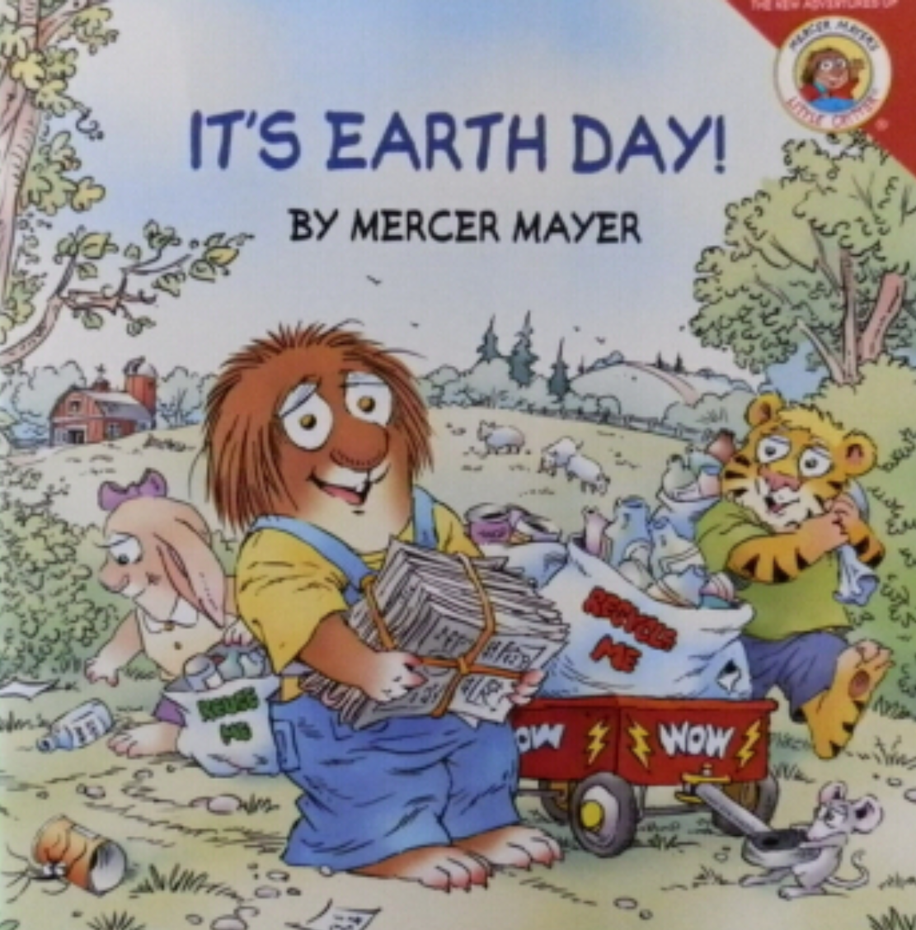  Title: _____________________  Writer: ____________________  Words: ____________________  Sentences: _________________  Reason: ___________________ |  | 绘本阅读，拓展视野，积累词汇语句，提升学生的阅读理解能力，并以好书推荐卡的形式外显读书成果。
作业评价 | 同学们，请给自己的作业评评分吧，你能得到几颗星星？也给父母分享你的作业，请他们也评价一下吧！

