五 年级 英语 学科 《At weekends》单元整体作业设计
- 作业设计说明
1.课程目标
五年级上册Unit 7 At weekends的单元主题是周末活动，这一话题与学生的日常生活密切相关。通过学习，学生能够熟练地用一般现在时介绍自己和他人的周末活动，并从中体验到丰富多彩的周末活动给人们带来的乐趣，从而让他们明白要合理地安排自己的周末活动，树立积极乐观的生活态度，以此来提高自我的价值感、成就感和幸福感。在本单元的教学中，教师可以灵活运用图片、视频、游戏等多模态的视听形式，引导学生了解周末活动的内容和频率，正确地运用一般现在时和相关频率副词对周末活动进行描述。在话题的导入和延伸上，教师可以结合四年级下册Unit 2 After school和五年级上册Unit 4 Hobbies有关业余活动和兴趣爱好的背景知识，在情境应用中综合提升语言能力和思维品质。
本单元的教学重难点是运用句型What do/ does... do at weekends? I / They / He / She always / usually / often / sometimes...询问介绍周末活动，掌握频率副词always、usually、often、sometimes的区别和用法，能将表述周末活动的语言知识在情境中准确、灵活地使用，并能在实践中迁移创新。教师可以通过对话、讨论、小组问卷、汇报等活动形式，引导学生在听、说、读、看、写中来介绍、分享彼此的周末活动并能科学合理安排周末活动。

2.教材分析
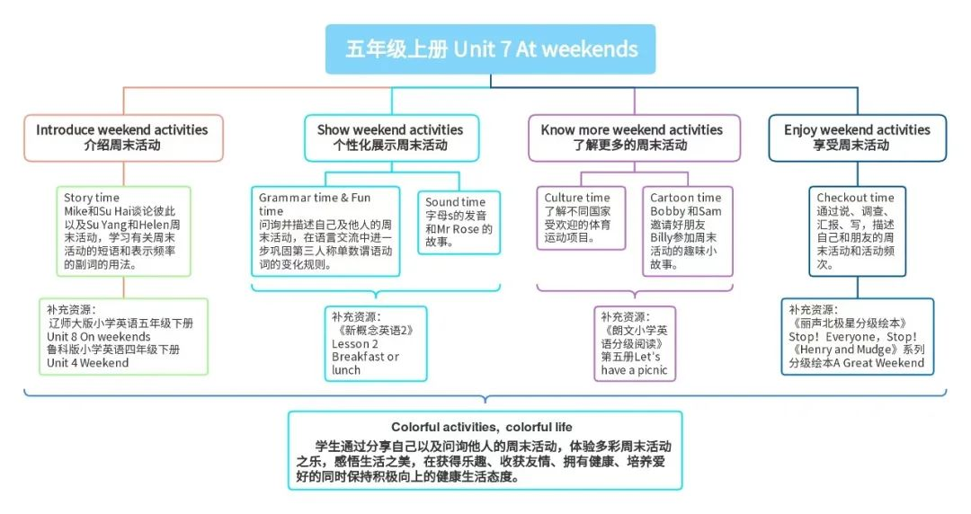
本单元的学习内容是“周末活动”，主题语境为“人与自我”、“人与社会”，与朋友畅谈周末活动是学生比较感兴趣的话题内容。各语篇与单元主题之间、各语篇之间相互关联，构成如下主题体系：通过确立“多样活动，多彩生活”的大观念，依托儿童的直观思维，确立分课时的小观念。各课时围绕单元主题和子主题展开，课时之间相对独立，又紧密关联，主要分为：认识不同的周末活动，询问他人的周末活动，了解更多的周末活动，分享自己及朋友的周末活动，以此统整本单元教学内容，促进学生思维品质的螺旋上升，同时关注学生文化意识的建构，渗透育人价值，引导学生科学合理安排周末活动，参与多样周末活动，感受周末活动的乐趣，享受美好的生活。

3.学情分析
五年级的学生活泼好动、善于思考、勇于挑战，已经形成一定的自主学习意识，在已有的语言知识和技能的基础上可以简单地表达自己的想法和意愿，学习积极性和主动性也逐渐增强。本单元的话题是周末活动，这一话题和学生的生活密切相关。学生已经具有日常活动和业余爱好方面的词汇积累，并能够用恰当的语言I like…进行表述；在译林版小学英语教材四年级上册第4单元、四年级下册第2、3单元以及五年级上册的第4单元中还有体育运动类、日常活动类以及兴趣爱好类词汇的渗透，在这样的语言知识铺垫下，我们将依托教材、创设丰富的活动，让学生学会准确地介绍自己和他人的周末活动，并从中体验到丰富多彩的周末活动给人们带来的乐趣。通过本单元的学习，学生能更好地理解周末活动与兴趣爱好之间的联系（Unit4Hobbies），也能对自己的周末生活做更好的安排。
4.作业类型
基础巩固作业、语言运用作业，拓展提升作业。

- 详细作业设计（立足单元整体进行设计）
同学们，你们喜欢周末吗？你们又是怎么度过周末的呢？最近学校正在举办“多彩周末”的设计活动，让我们一起去看看吧！

一、口语部分
看，下面是Mike和Su Hai在谈论他们的周末活动！
(一）、正确朗读以下句子。（基础巩固作业）
1.What do/does you/she do at weekends?
2.I usually visit my grandparents and play with their cat at weekends.
3.I often chat with them on the Internet.
4.She sometimes go to the cinema with my friends on Sunday.
5.She always has dancing lesson at weekends.
(二）、正确的谈论Mike和SuHai的周末活动。(语言运用作业)
A:What does...do at weekends?
B:He/She always/usually/often/sometimes.....
- 、正确的谈论自己的周末活动。(拓展提升作业)
My name is ....I have ....weekends.I always/usually/often./sometimes......
二、听力部分
听，下面是一些同学在谈论自己的周末活动！
- 听录音，选择你所听到的内容。（基础巩固作业）
1、A. chat B. friends C. cat D. friend
2、A. lesson B. dance C. dancing D. listen
3、A. weekends B. worker C. walkman D. works
4、A. cinema B. picture C. picnic D. visits
5、A. come in B. come to C. come out D. come on
- 听录音，选择正确的应答句(语言运用作业)
1.A. In the bag. B. At five. C. At school.
2.A. She likes dancing. B. She often dances. C. She wants to dance.
3.A. Here you are. B. Thank you. C. OK.
4.A. He likes watching TV. B. She doesn’t like watching TV. C. She likes watching TV.
5.A. She likes animals. B. Dogs. C.Yes,she does.
（三）听短文，选择正确的答案。(拓展提升作业)
1.Is Linda twelve?
A. Yes, she does. B. Yes, she is. C. No, she isn’t.
2.Do Linda and Mary study in the same class?
A. No, they don’t. B. Yes, they do. C. Yes, they are.
3.What’s Mary’s mother’s hobby?
A. She likes cooking. B. She likes eating bread. C. She likes making clothes.
4.Does Linda’s father like eating rice?
A. Yes, he does. B. Yes, she is. C. No, he doesn’t.
5.What’s Linda’s mother’s job?
A. A doctor. B. A worker. C. A housewife.
三、笔试部分。
同学们，你的周末活动是什么样的呢？现在，请你也来规划一下你的周末活动，并完成以下题目吧！
- 选择划线部分相同发音的单词填空。（基础巩固作业）
1.I __________ buy some _________ at weekends.(sometimes,fruits,roses）
2._____ sister and I usually _______ a kite in the park.(lovely, fly, my)
3.The ______ is ________.I like playing with it very much.(cat, nice, cute)
（二）单选题
1.The fat boy eats _____ e very evening.
A.a lot of B.a lot C.lots of
2.My father _____ at home at the weekends.
A.isn’t B.doesn’t C.don’t
3.Billy _____ his weekends at home.
A.always spend B.spend C.doesn't spend
4.We often have dinner _____ our grandparents.
A.for B.and C.with
5.She _____ go to the park at weekends.
A./ B.don't C.doesn't
6.My e - friend lives in _____.
A.the UK B.UK C.the uk
7.A: _____ does Jim's father do at home? B: He _____ TV.
A.Which; watch B.What; watches C.What; watch
8._____ any water in the bottle?
A.Are there B.Is there C.Has
9.I_____ an apple, but my brother _____ three pears. ()
A.have; have B.has; has C.have; has
10.A: Let's go _____, Billy. B: No. I don't like _____.
A.swim; swim B.swimming; swim C.swimming; swimming
（三）根据所给单词的适当形式填空。
1.I often _____ (go) swimming at weekends.
2.They _____ (do) their homework every Sunday.
3.My family and I _____ (watch) TV together on Saturdays.
4.She sometimes _____ (play) football with her friends.
5.We _____ (have) a picnic last Sunday.
6.My brother likes _____ (read) books at weekends.
7.They usually _____ (visit) their grandparents on Sundays.
8.I don't often _____ (cook) dinner, but my sister does.
9.Does your brother _____ (go) to the cinema at weekends?
（四）句型转换
1.I often play football at weekends. (改为一般疑问句)
_____ you often _____ football at weekends?
2.They usually go shopping on Sundays. (改为否定句)
3.They _____ usually _____ shopping on Sundays.
4.She sometimes watches TV in the evening. (对划线部分提问)
_____ _____ she sometimes _____ in the evening?
（五）翻译句子。
1.我总是拜访我的祖父母。
I _______ _______ my grandparents.
2.他有时周末在公园放风筝。
He _______ _______ kites in the park at weekends.
3.他有时在周末去公园。
He _________ _________ to the park at weekends.
4.我们有时候在周日去参观农场。
We ____________________________.
5.海伦有时候去公园。(汉译英)
____________________________
（六）将下列句子排成一段通顺的对话。(语言运用作业)
( ) Great! Let’s go and have a picnic now.
( ) How about autumn?
( ) What do you usually do in spring, Su Hai?
( ) Sorry. I can’t go out. I have to do my homework firs t.
( ) I usually fly a kite with my sister Su Yang.
(4) I sometimes have a picnic with my family.
（七）根据上下文，补全短文。
Mr Smith l__24__ in a nice house in a small town with his f __25__ . From Monday
t__26__ Friday he works in an office n__27__ his house. He is free on Saturdays
a__28__Sundays. He has a nice garden b__29__ his house. He likes growing f __30__ and he o__31__works in the garden at weekends. The flowers are v __32__ beautiful. Mr Smith likes them very m __33__.
（八）阅读选择
Sam is good at school, but he is very dirty. His face and hands are o ften dirty. He washes them with water only. He does not use soap.
Sam has an uncle. One day his uncle goes to see him. He looks at him and says, “Sam, I know what you ate for breakfast this morning.”
“What?” Sam looks at his uncle and says.
“Eggs” says his uncle, "Your face and mouth tell me that.
“You are wrong, uncle!” says Sam, “Not today or yesterday, but the day before yesterday!”
1.Who is Sam?
A.He is a teacher. B.He is not at school. C.He is a student.
2.What does “dirty” mean?
A .脏的 B.干净的 C.坏的
3.What’s on Sam’s face and mouth? ()
A.Eggs. B.Soap. C.Water.
40.Which of these is not wrong? ()
A.Sam doesn’t wash his face and hands every day.
B.The uncle thinks the boy ate eggs last morning.
C.Sam doesn’t like eggs at all.
41.What do you think of Sam? ()
A.He is a good boy. B.He is a clever boy. C.He is not clean.

（九）书面表达。
Write a short passage about your weekends. Include the following information:
- What you usually do at weekends.
- Who you do these things with.
- How you feel about your weekends.
- One thing you want to do differently next weekend.
__________________________________________________________________
__________________________________________________________________
__________________________________________________________________
__________________________________________________________________
__________________________________________________________________

三、作业设计特色说明
1.创新性：作业设计打破传统模式，尝试新的题型和呈现方式，如设计一些开放性练习、长链条作业等，引导学生从不同角度思考问题，培养学生的创新思维。
2.实用性：（1）作业内容紧密结合教材内容，有助于学生巩固课堂所学知识，提高实际应用能力。（2）作业设计注重与生活的联系，如通过描述自己的周末活动、讨论他人的周末计划等，培养学生的实际运用能力。
3.趣味性：（1）作业设计富有趣味性，如设计一些游戏化的练习形式，激发学生的学习兴趣，让学生愿意主动参与完成作业。（2）通过多样化的练习形式，如角色扮演、小组讨论、情景对话等，让学生在轻松愉快的氛围中学习。
4.个性化：（1）作业设计根据学生的不同特点和需求进行个性化设计，如提供不同难度的练习、不同形式的作业等，以满足学生的个性化需求。（2）鼓励学生根据自己的兴趣和爱好进行拓展阅读和学习，培养学生的自主学习能力和创新精神。

四、作业评价设计
1、评价标准：
（1）根据新课标中“学业质量描述”的具体要求，制定评价标准，如语音语调、语言表达的准确性和流畅性、阅读理解能力和书面表达能力等。
（2）评价标准注重全面性和客观性，既关注学生的知识掌握情况，又关注学生的能力发展和情感态度。
2、评价方式：
（1）采用多种评价方式，如教师评价、同伴评价、自我评价等，以全面了解学生的学习情况。
（2）教师评价注重及时性和针对性，对学生的作业进行及时批改和反馈，指出学生的优点和不足，提出改进建议。
（3）同伴评价和自我评价注重培养学生的自主学习能力和合作精神，鼓励学生互相学习、互相帮助、共同进步。
3、评价反馈：
（1）及时反馈学生的作业情况，鼓励学生继续努力，提高自信心和学习动力。
（2）针对学生的不足之处，提供具体的改进建议和指导，帮助学生不断进步。
（3）通过展示优秀作业和进步较大的作业，激励学生积极向榜样学习，提高整体学习效果。
通过以上练习设计和作业评价设计，旨在帮助学生更好地掌握译林版五年级上册Unit 7 At Weekends单元的知识点，提升学生的英语核心素养和综合能力。同时，全面提升学生的语言能力、文化意识、思维品质和学习能力等核心素养，为学生的全面发展打下坚实的基础。

