作业练习
课程基本信息
课题 | Unit 7 Happy Birthday! (Lead-in & Cartoon time)
作业练习
Need to do:
- Read the cartoon fluently and act it with your family.（流利地读一读课文，并和家人演一演。）

2. Practice writing letters “Uu”, “Vv” and “Ww”.（练习书写字母Uu、Vv、Ww。）
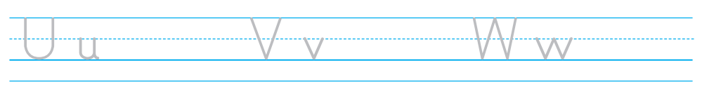

Choose to do:
Find more numbers in our daily life, write them down and think about their meanings.（寻找生活中常见的数字，写下来并思考其含义。）

_______——___________________________；

_______——___________________________；

_______——___________________________。

练习答案
Need to do:
- Read the cartoon fluently and act it with your family.（流利地读一读课文，并和家人演一演。）

答案：略。
方法指导：可借助学习任务单中推荐的“江苏省中小学语音学习系统”，通过模仿和跟读，熟练朗读课文。根据该系统中的打分结果，对朗读进行改进和完善。

2. Practice writing letters “Uu”, “Vv” and “Ww”.（练习书写字母Uu、Vv、Ww。）

答案：略。
方法指导：可借助课本61页“Letters in focus”练习中的第三项描红并书写字母，注意笔划书写顺序。

Choose to do:
Find more numbers in our daily life, write them down and think about their meanings.（寻找生活中常见的数字，写下来并思考其含义。）

答案（供参考，不唯一）：120——中国大陆急救电话号码；
110——中华人民共和国公安部门报警电话；

5G——第五代移动通信技术。

作业练习
课程基本信息
课题 | Unit 7 Happy birthday! (Story time)
作业练习
- Do a survey about your friends and try to make a mind map to share it.
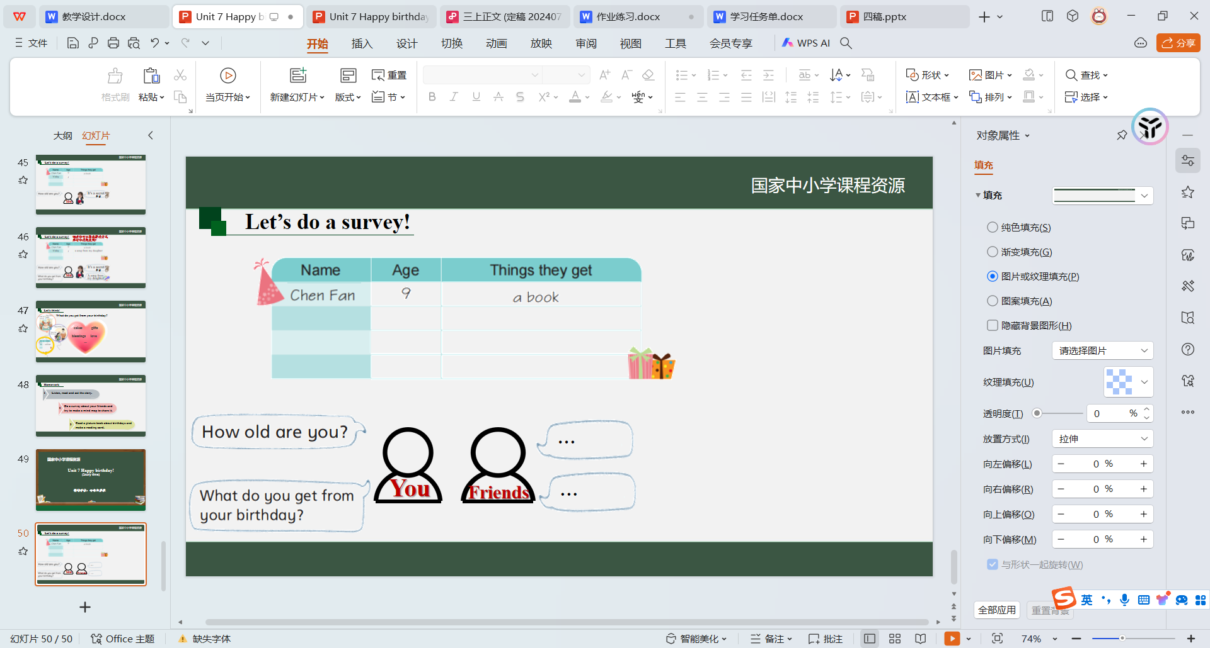
请借助课堂所学，课后询问、调查身边同学或朋友的年龄以及生日所获，并绘制思维导图。

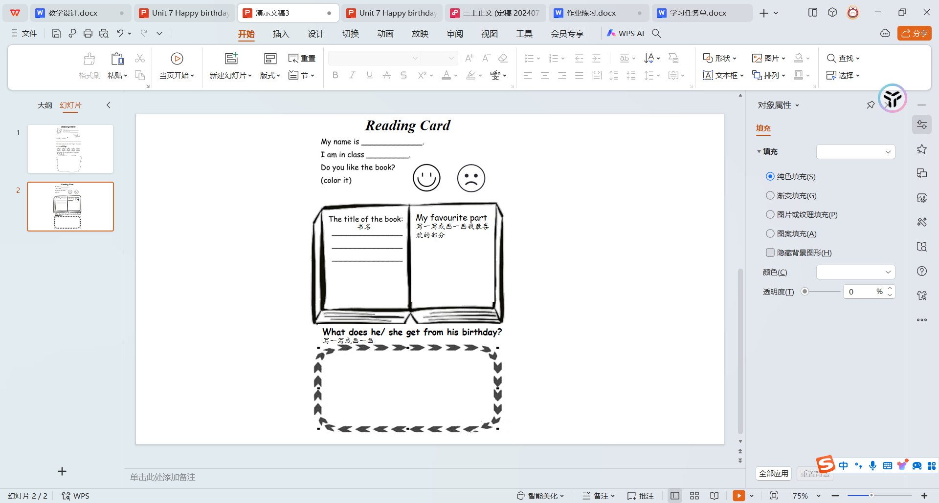
- Read a picture book about birthdays and make a reading card.
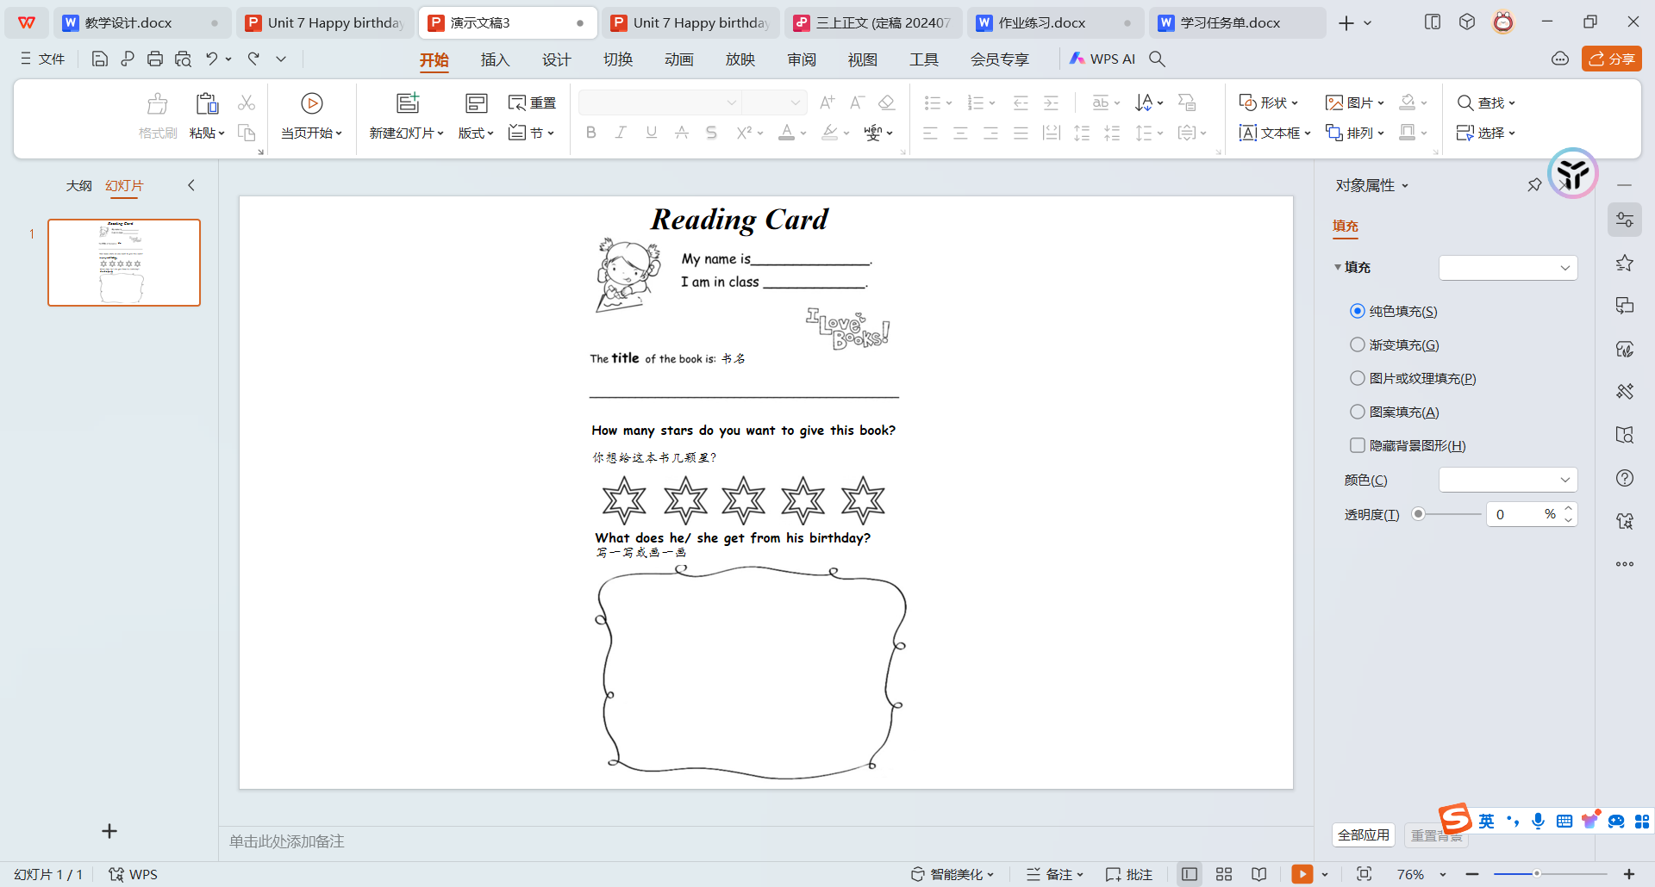

...

练习答案
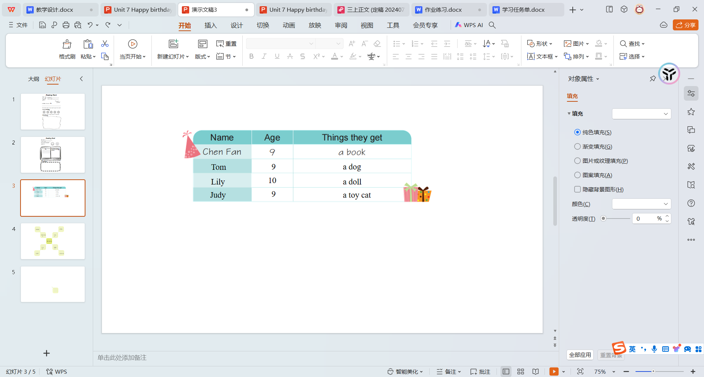
1. Do a survey about your friends and try to make a mind map to share it.

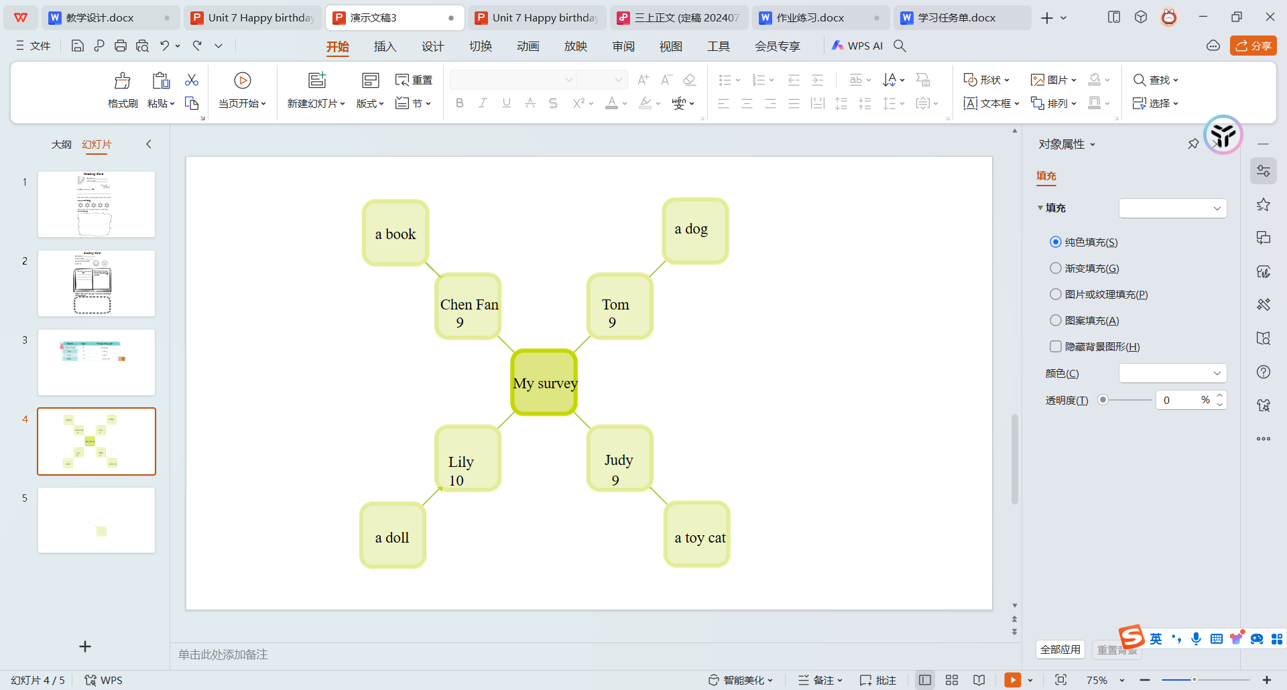

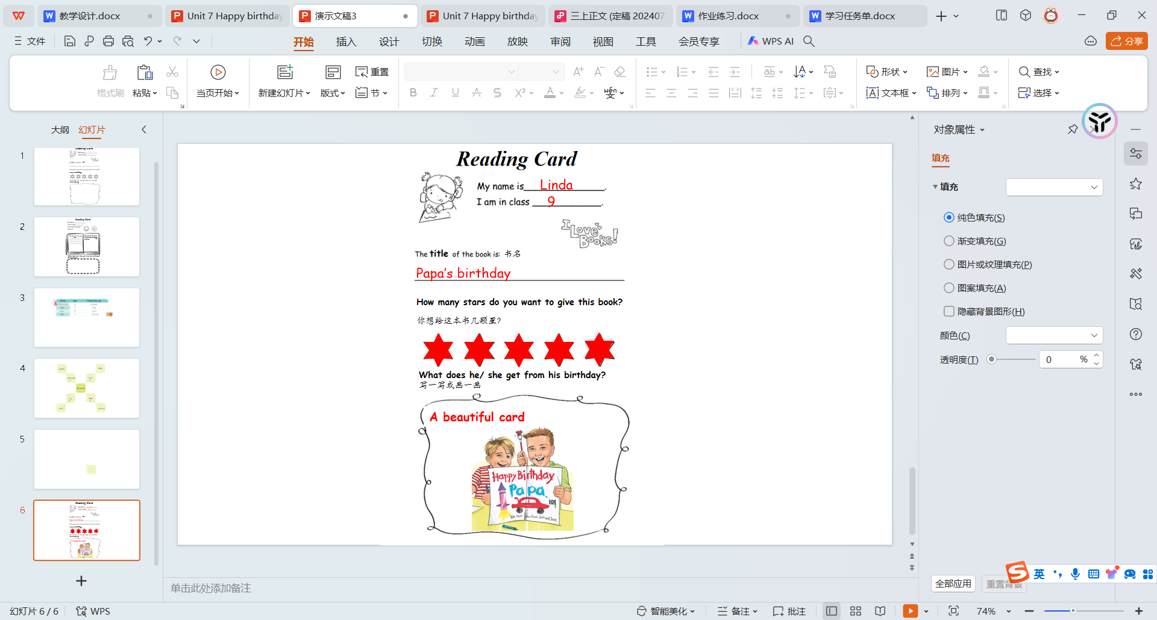
2. Read a picture book about birthdays and make a reading card.

作业练习
课程基本信息
课题 | Unit 7 Happy Birthday! (Wrap-up time & Assessment time)
作业练习

Beautify your birthday card and talk about your happy birthday moments with your family and friends.

美化你的生日分享卡并与家人朋友分享你生日的幸福时刻。

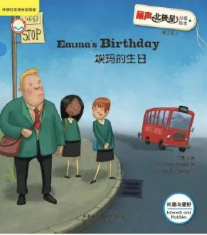
- Read Emma’s Birthday and try to answer some questions.
读英文绘本Emma’s Birthday并尝试回答问题。
a. Does Emma get any gifts from her dad and mum at home? Is she happy?
b. Does Emma get a gift from her best friend Alice? Is she happy?
c. Where does Emma’s mother take her after school?
d. What does Emma get from her birthday?

练习答案

1.美化你的生日分享卡并与家人朋友分享你生日的幸福时刻。（答案供参考）
参考词汇和句型：
a flower/a dress/a card/a dog ...
I want a ... for my father/mother/brother/sister ...
I want to sing (唱歌)/dance (跳舞)/cook (做饭) ... for my father/mother/brother/sister ...

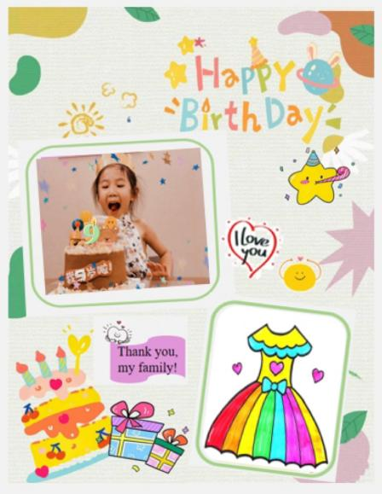
分享示例：

Hello, I’m Anna. I’m nine. I get a nice cake from my mother on my birthday.
I’m happy. I want a dress for my mother on her birthday.

2.读英文绘本Emma’s Birthday并尝试回答问题。（答案供参考）
a. Does Emma get any gifts from her dad and mum at home?
Is she happy?
No.
No, she is sad.
b. Does Emma get a gift from her best friend Alice? Is she happy?
No.
No, she is unhappy.
c. Where does Emma’s mother take her after school?
The Ping-pong Club.
d. What does Emma get from her birthday?
A big birthday cake. She also gets blessings and love from her parents and friends.

