学 校 | 常州市经开区横山桥中心小学 | 执教教师 | 卢静
教学内容 | 五下Unit5 Helping our parents  (Cartoon time) | 执教时间 | 2024.4.25
教学内容分析：
本单元 Cartoon time 板块的主题是“Helping”，属于人与社会的主题范畴。本单元Cartoon time 板块很适宜读者剧场课型的开展。它的故事幽默，对话丰富，很适合用来进行剧场课型的剧本创编，排练和表演。本节课讲述了Bobby在花园种葡萄，开心葡萄丰收之际却被害虫抢吃，生气愤怒的时候来了瓢虫的帮助，赶走害虫，Bobby正当感激却发现瓢虫不是真的帮助他，而是为了吃葡萄叶而来，赶走了狼却引来了虎，Bobby不知所措，未完待续的故事。在本节课上学生能正确理解、朗读Cartoon time中的故事，能读懂其中的趣味之处，能在教师的指导下续编故事，在剧场氛围中有序排练，积极表演完整的故事，并结合评价标准给小组评分。
教学目标：
- 借助预习，分析、整合Cartoon time图文信息，找准剧场故事的主角，场景和话题等剧本要素。

能正确理解、梳理故事情节并朗读Cartoon time中的故事，能读懂其中的趣味之处。
3.能续编故事，排练故事，进行剧场模式的表演。

教学重难点：
基于故事情境，培养学生的剧场意识，让学生体会剧本创编的乐趣，逐步养成剧场表演的习惯。
教学过程：
Step1 Lead-in
1.T:Do you like reading ? Ss:Yes.
What books do you like reading ? Ss: I like read …
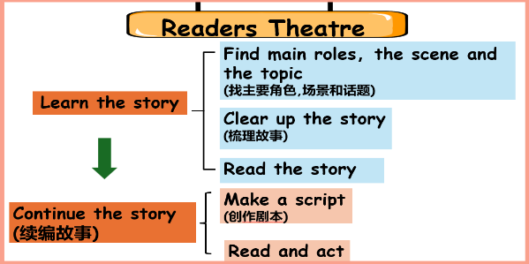
Do you want to be a good reader?
2. Readers theatre
We should follow these steps to be a good reader .
（快速进入剧场模式，明晰本节课学习步骤。）

Step 2 Learn the story
1.Look and guess
T: Please look at the pictures and find out main roles,
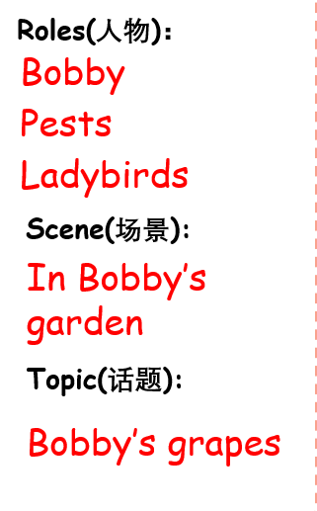
the scene, and the topic.

2. Watch and order
T: watch the cartoon then put these four pictures in right orders.

Read and fill
Read the sentences and fill the blanks.
Bobby grows in his .
There are some on the grapes.
Then , some come.

The go away, but the do not.
Ss read and fill the sentences.
T: These are the outline of the story.（描述图片相关的句子，理解故事大纲）

They’re always read by the narrator(旁白).(渗透剧场的角色分配理念)
4. Read and answer

T:Read their dialogues(台词). How does Bobby feel ? (植入剧场概念，梳理故事细节，体会人物语调变化和心情起伏，学生在跟读模仿中理解人物。)
Ss: First , Bobby is happy , next Bobby is … then … finally…

T: Yes , Bobby is proud ,next he is angry/ surprised ,then he is thankful ,finally he is disappointed.(尽量使用多类型的单词，拓展词汇量。)
T: Listen and imitate Bobby’s tone.

5.Think and say
T: The pests and the ladybirds are both bad for the grapes, but what’s the difference?

Ss: The pests eat grapes; the ladybirds eat the leaves. / They have different colors. / The ladybirds have spots, but the pests don’t.
T: Yes, this kind of ladybird have ten spots. They are bad for the plants. But in our daily life, there’s another ladybird we known that is seven spots ladybird. （辨析害虫，瓢虫，十星瓢虫和七星瓢虫，为接下来的续编做准备。）

6. Read and imitate
T: To be continued. What will happen then? Can Bobby protect his grapes?

Ss: Yes. Maybe Sam will help him/ Maybe Tina will help him. /…(让学生谈论会发生什么，拓展想象，为接下来的故事续编铺垫。)
Step3 Continue the story.

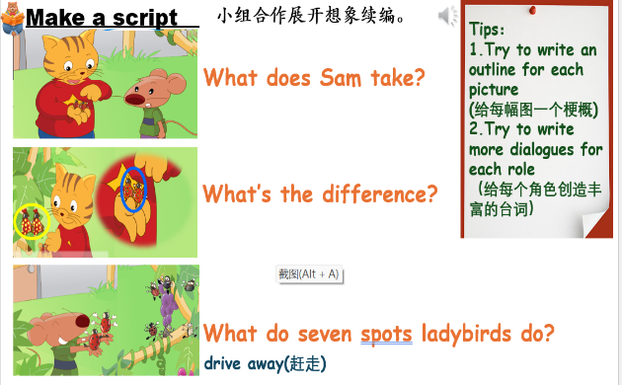
1.Talk about the pictures
（根据老师提供的图片，谈论故事的细节，引导学生观察图片，为续编故事准备。）

2. Make a script.
Ss work in the group of six, write the story.

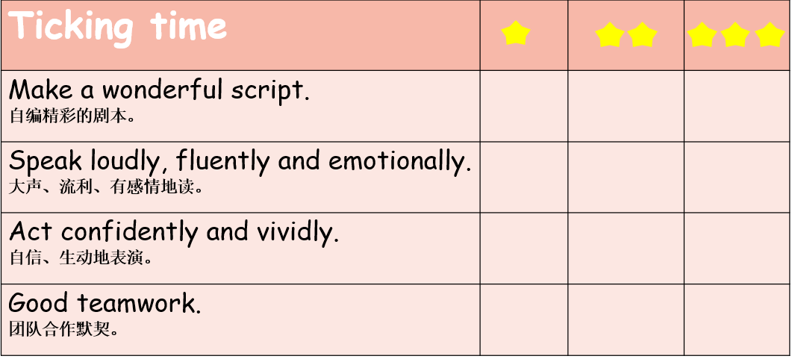
Step4 Rehearsal Time

T shows the standers , Ss practice in groups.
Step 5 Readers Theatre

Ss act out the story , others watch and score their performance 观看并根剧标准给与小组评价与建议
Step 6 Talk and think

T:You’re all good readers. You can learn the story clearly, continue the story and act it excellently . which role do you like ? Why ?
Ss: I like … because …

T:This unit is ‘Helping our parents’, can you give our story a title?
Ss: Helping Bobby /…

T: Yes ,we should help our friend ,help our teachers, help each other.（深化本单元主题Helping ，从帮助家人到朋友到互相帮助。）
Step 7 Homework

1. Refine your scripts

（完善你们的剧本）

2.Continue rehearsing ,make your theater better.

（继续排练，使你们的剧场更好。）

