**20241016| 中一班**



Daily life

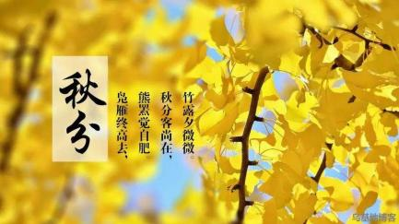

**「来园情况」**

今日星期三，共有22人来园。

**「日常生活观察」**

|  |  |  |  |  |  |  |
| --- | --- | --- | --- | --- | --- | --- |
| **序号** | **姓名** | **午餐** | | | **午睡** | **备注** |
| **饭** | **菜** | **汤** |
| 1 | 韩昕怡 | √ | √ | √ | √ |  |
| 2 | 韩昕悦 | √ | √ | √ | 看护入睡 |  |
| 3 | 吴清墨 | √ | √ | √ | √ |  |
| 4 | 陆晟涵 | √ | √ | √ | √ |  |
| 5 | 张梅伊 | √ | √ | √ | √ |  |
| 6 | 吴沐檀 | √ | √ | √ | √ |  |
| 7 | 曹果 | √ | √ | √ | √ |  |
| 8 | 曹煜琪 | √ | √ | √ | 看护入睡 |  |
| 9 | 蒋安乐 | √ | √ | √ | √ |  |
| 10 | 韩书华 | √ | √ | √ | 看护入睡 |  |
| 11 | 顾言希 | √ | √ | √ | 看护入睡 |  |
| 12 | 贾钧尧 | √ | √ | √ | √ |  |
| 13 | 杨宸 | √ | √ | √ | 看护入睡 |  |
| 14 | 张予安 | √ | √ | √ | √ |  |
| 15 | 高瑞泽 | √ | √ | √ | √ |  |
| 16 | 张路翔 | √ | √ | √ | √ |  |
| 17 | 谢咏呈 | √ | √ | √ | √ |  |
| 18 | 汤凌宇 | √ | √ | √ | √ |  |
| 19 | 韩以轩 | √ | √ | √ | √ |  |
| 20 | 冯煦晨 | √ | √ | √ | √ |  |
| 21 | 郑哲皓 | √ | √ | √ | √ |  |
| 22 | 张致远 | √ | √ | √ | √ |  |

**「区域游戏」**

|  |  |  |
| --- | --- | --- |
| IMG_4458(1) | IMG_4455 | IMG_4454(1) |

**「户外活动」**

|  |  |  |
| --- | --- | --- |
| IMG_4500(1) | IMG_4478(1) | IMG_4501(2) |
| IMG_4510 | IMG_4504 | IMG_4490 |

**「社会：我的家乡常州」**

常州是一座有着3200多年左右历史的文化古城，其境内风景名胜、历史古迹较多，有春秋淹城、文笔塔、天宁寺等，常州特产有萝卜干、麻糕、芝麻糖、银丝面等。多年来常州建筑业和旅游业各方面的发展都很快，建设速度突飞猛进，双子楼、传媒大厦等建筑物，中华恐龙园、嬉戏谷等主题公园和天目湖、南山、太湖湾等自然风景区远近闻名， BRT、环城高架等建设使常州的交通更加便利。

|  |  |  |
| --- | --- | --- |
| IMG_4527(1) | IMG_4528 | IMG_4529 |