**Teaching Design**

**Teaching Content:**

7A U8 Reading: The Fashion Show

**Teaching Aims:**

By the end of the lesson, students should be able to:

1. describe different styles of clothes in detail, including their colors, materials and functions.

2. get familiar with the procedures and terms of a fashion show.

3. understand what real fashion is and how to find real beauty.

**Teaching Aids:**

PPT, video, blackboard

**Key and Difficult Points:**

Key point: to learn different names, colors, materials and functions of clothes

Difficult point: to learn the procedures and terms of a fashion show

**Teaching Procedures:**

Step1: lead-in (8min)

1. Teacher presents the app. Show the style of dopamine.

Step2: pre-reading (8min)

1. Students listen to the tape and choose the type of the passage: script. Teacher explains the meaning of “script”.

2. Students find out the structure of the passage:

At the beginning of the show para1

During the show para2-5

At the end of the show para6

3.Students read para1 and summarize what the host says at the beginning of the show. Then teacher shows that para1 is consisted of “greeting” “self-introduction” and “lead-in”.

5. Students read para6 and summarize what the host says at the end of the show. Then teacher shows that para6 is consisted of “summary” and “thanks”.

Step3: while-reading (15min)

1. Students list the five models in order: Millie, Simon, Amy, Daniel and Sandy.

2. After self-reading, students underline the sentences for telling the order.

3. Millie (para2):

①Students read para2 together and tell what Millie is wearing: sports clothes and a pair of trainers. Teacher points out that “trainers” are from British English while “sneakers” are from American English.

②Students fill in the blanks based on the content. Teacher highlights the meaning of “light”: not heavy.

③Students discuss about the occasion of wearing sports clothes: work out in the gym, do morning exercises, take PE lessons.

4. Simon (para3):

①Students read para3 together and tell what Simon is wearing: a pair of grey trousers, a purple shirt, and a red and grey tie.

②Students fill in the blanks based on the content. Teacher highlights the meaning of “smart”: neat and tidy.

5. Amy and Daniel (para4):

①Students read para4 together and tell what Amy and Daniel are wearing: a blue scarf, a yellow cotton skirt, a blue T-shirt, blue jeans.

②Students fill in the blanks based on the content. Teacher highlights the usage of “both”.

6. Sandy (para5):

①Students read para5 together and tell what Sandy is wearing: a black wool skirt, a pair of red boots

②Students fill in the blanks based on the content. Teacher highlights the meaning of “modern”: fashionable.

7 Practice: hold a fashion show in our class.

Step4: post-reading (10min)

1. Teacher asks the question: How to be a good designer?

Apart from designing clothes fit for the occasion and our identity, we should also design clothes friendly to the environment.

3. Students watch a video about “how to deal with old clothes” made by the brand Patagonia and take some notes.

Show different ways of making old clothes into new ones: make jeans into shorts, make blouses into handbags, make sweaters into cushions, etc.

Step5: summary

1. Teacher raises the question: What is fashion?

Fashion doesn’t mean wearing beautiful or cool clothes.

①Fashion means the clothes we wear should be fit for the occasion and our identity.

②Fashion means the clothes we wear should be friendly to the environment.

③All in all, fashion is not about the outside, but about the inside. It is a positive way of living.

**Homework:**

Have to do:

1. Read the article aloud twice and recite the important words and phrases.

2. Finish the exercises after class.

Try to do:

1. Learn more about the brand Patagonia and write an article about your design of clothes out of old ones.

**Blackboard Design:** 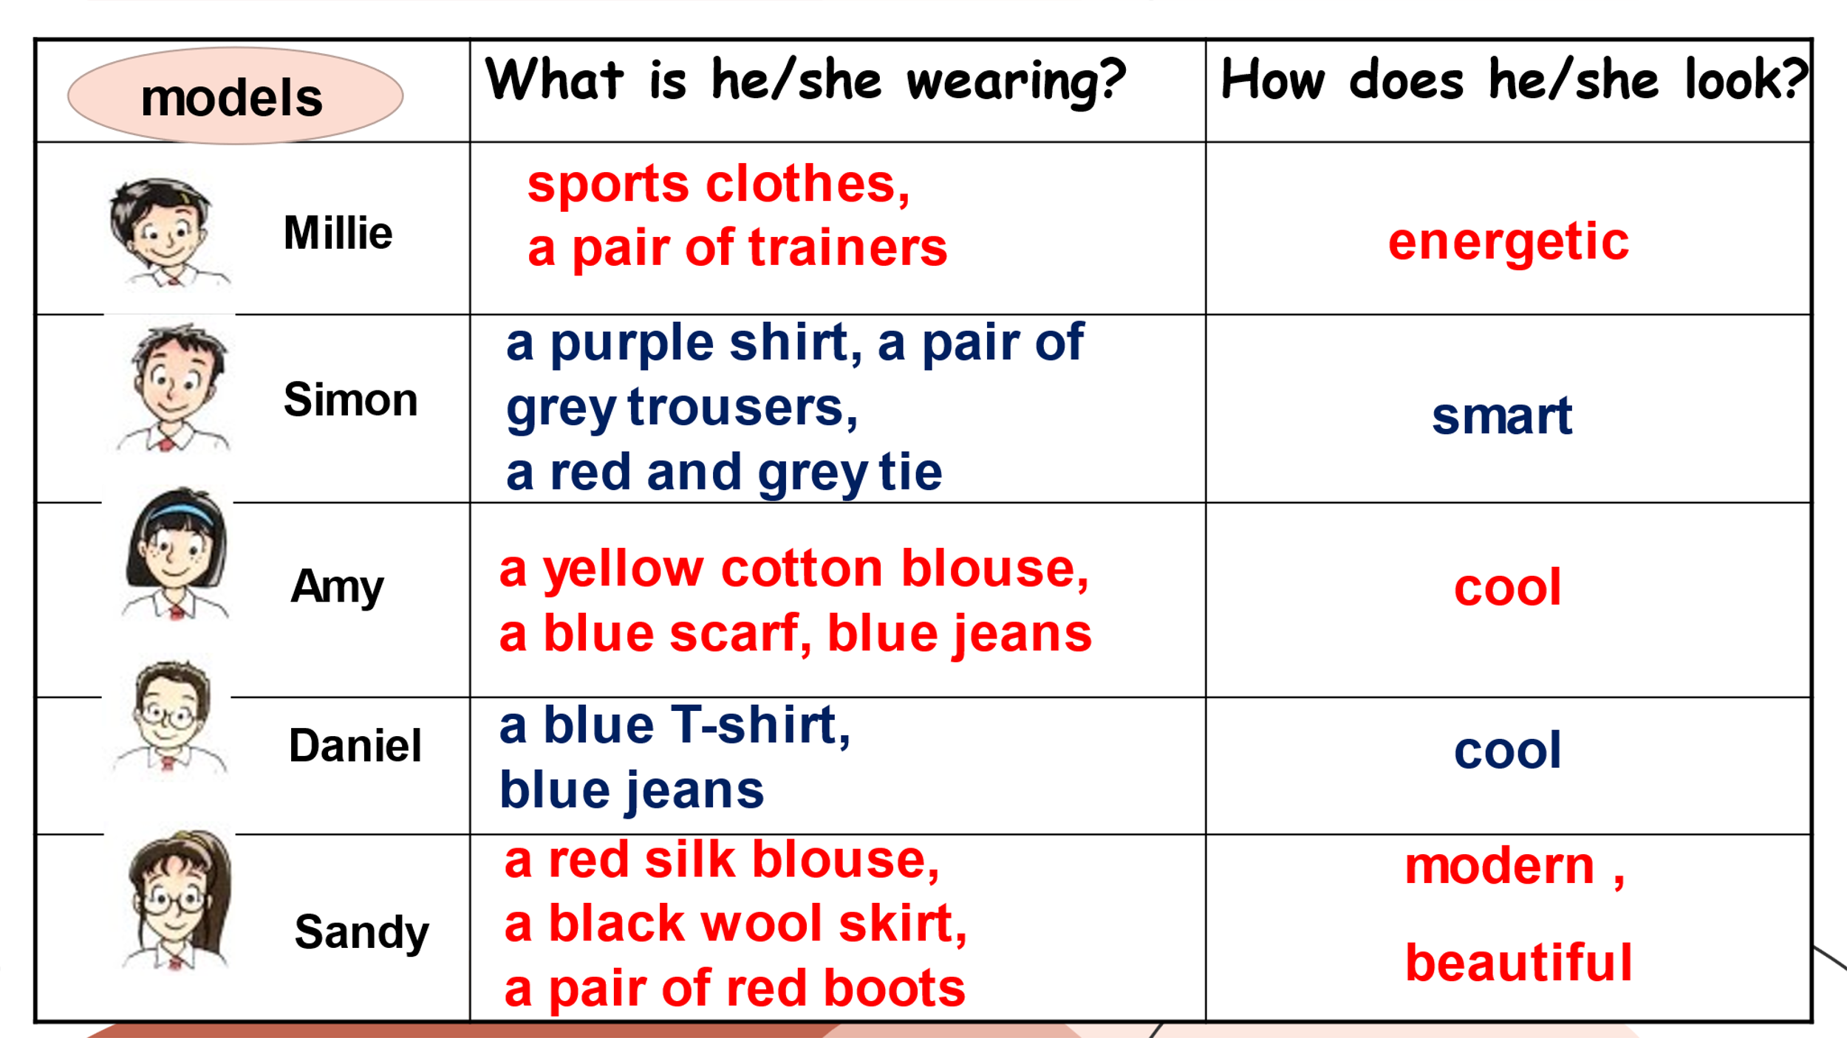

**Reflection**

The lesson is quite complete and fluent, and it involves lots of interaction between the teacher and students. If time is limited, more group work can be added, such as having a class fashion show on the stage. In this way, the lesson can become more active and lively.