**中考复习专题——书面表达教案**

常州市武进区雪堰初级中学 钱芳 2024.06

Teaching aims:

At the end of the class, Ss will be able to:

1. Master the seven steps of writing;
2. Appreciate some good expressions in sample writing;
3. Learn to master ‘hamburger writing method’ and apply it to real practice.

Teaching procedures:

Step 1: （呈现写作标准）

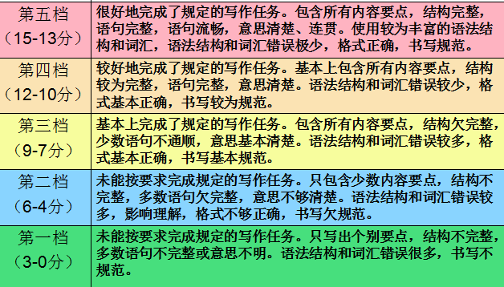

Show different articles written by students and assess them one by one by giving different points. Meanwhile, appreciate wonderful articles.

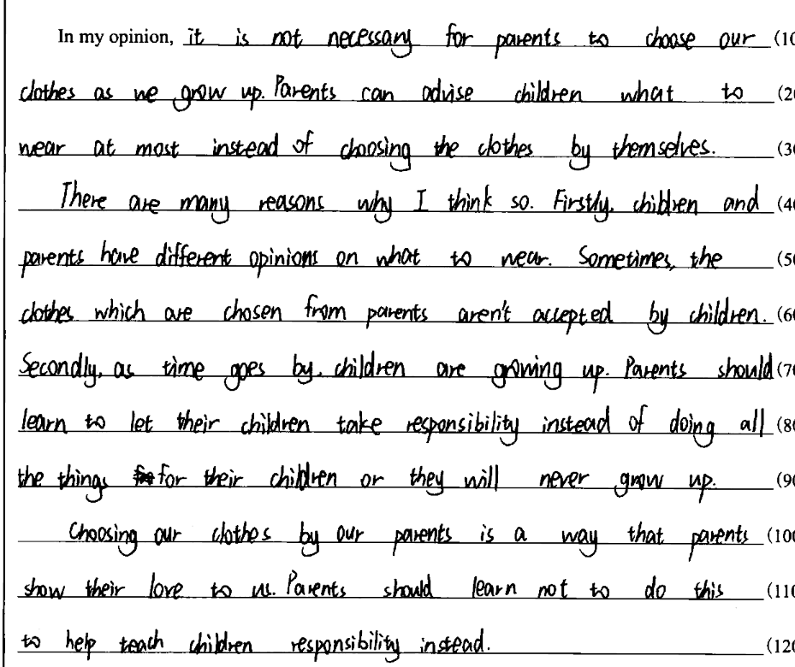

Step 2: （写作七步骤）

1. Introduce seven steps of writing

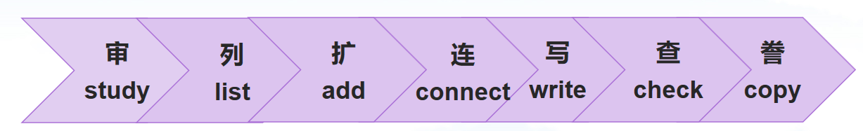

1. Study
2. Introduce ‘hamburger writing method’

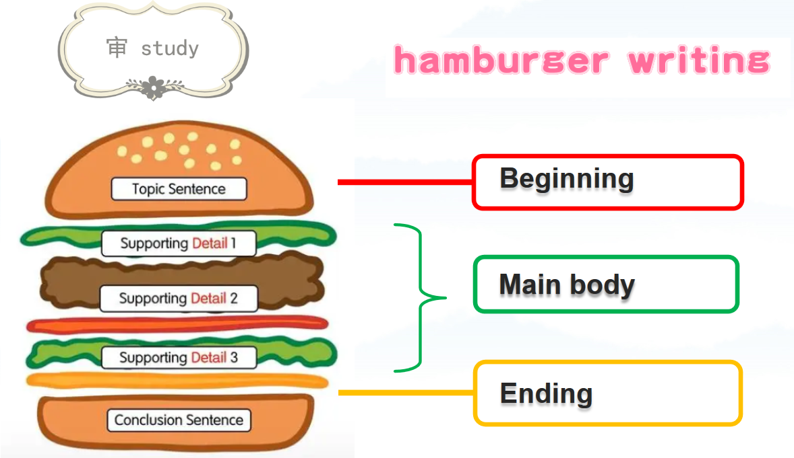

1. Try to study what they wrote about and figure out the structure of the article.

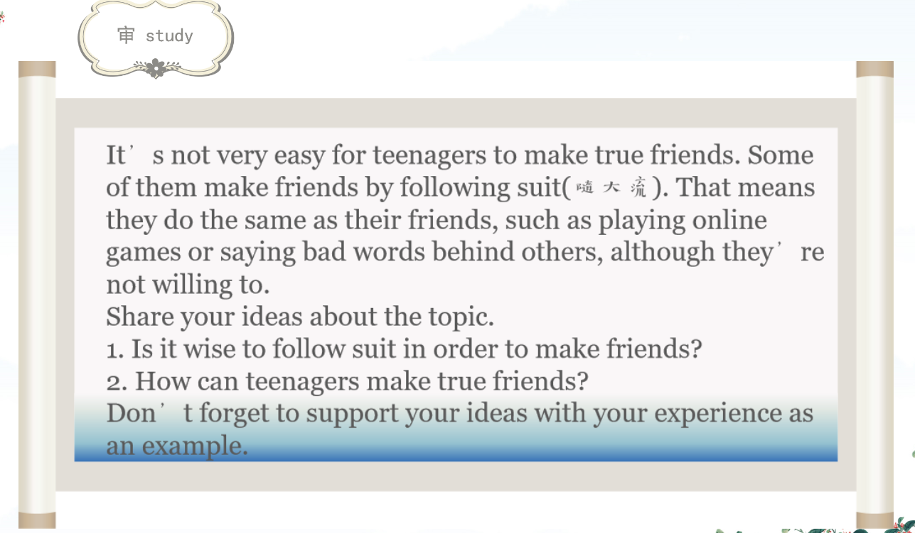

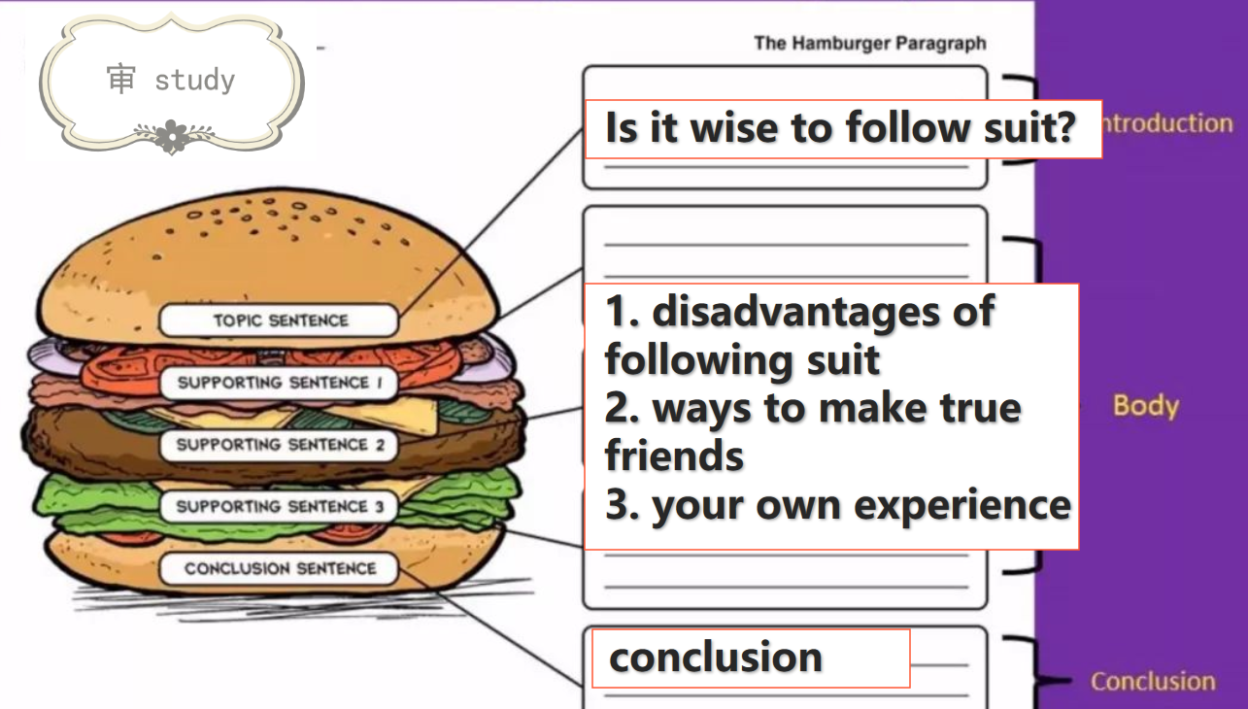

1. List

List main points of the main body by recalling what they have learned. Try to finish the mindmap or story map to help them to organize their ideas before writing, which helps Ss be aware of the importance of the usage of tools.

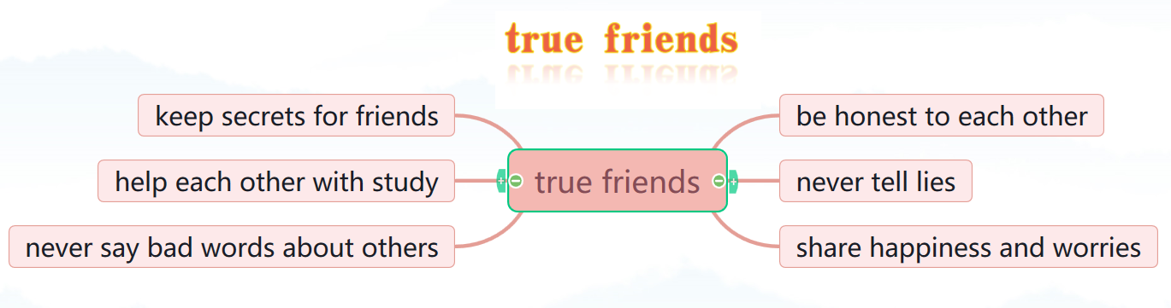

1. Add
2. Ways to rewrite sentences in a more complete way.

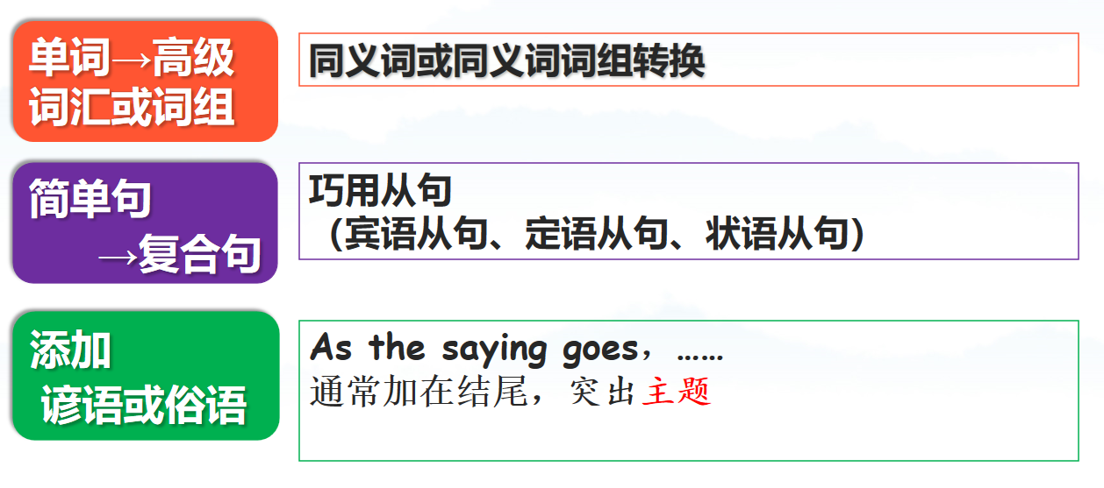

1. Finish some exercises by expressing in a more advanced way, such as words, phrases, clauses and so on.

Step 3: (赏析文章)

1. Read an article written by a student.
2. Enjoy the sample one.
3. Take some notes if necessary to put good expressions into practice.

Step 4: (实战演练)

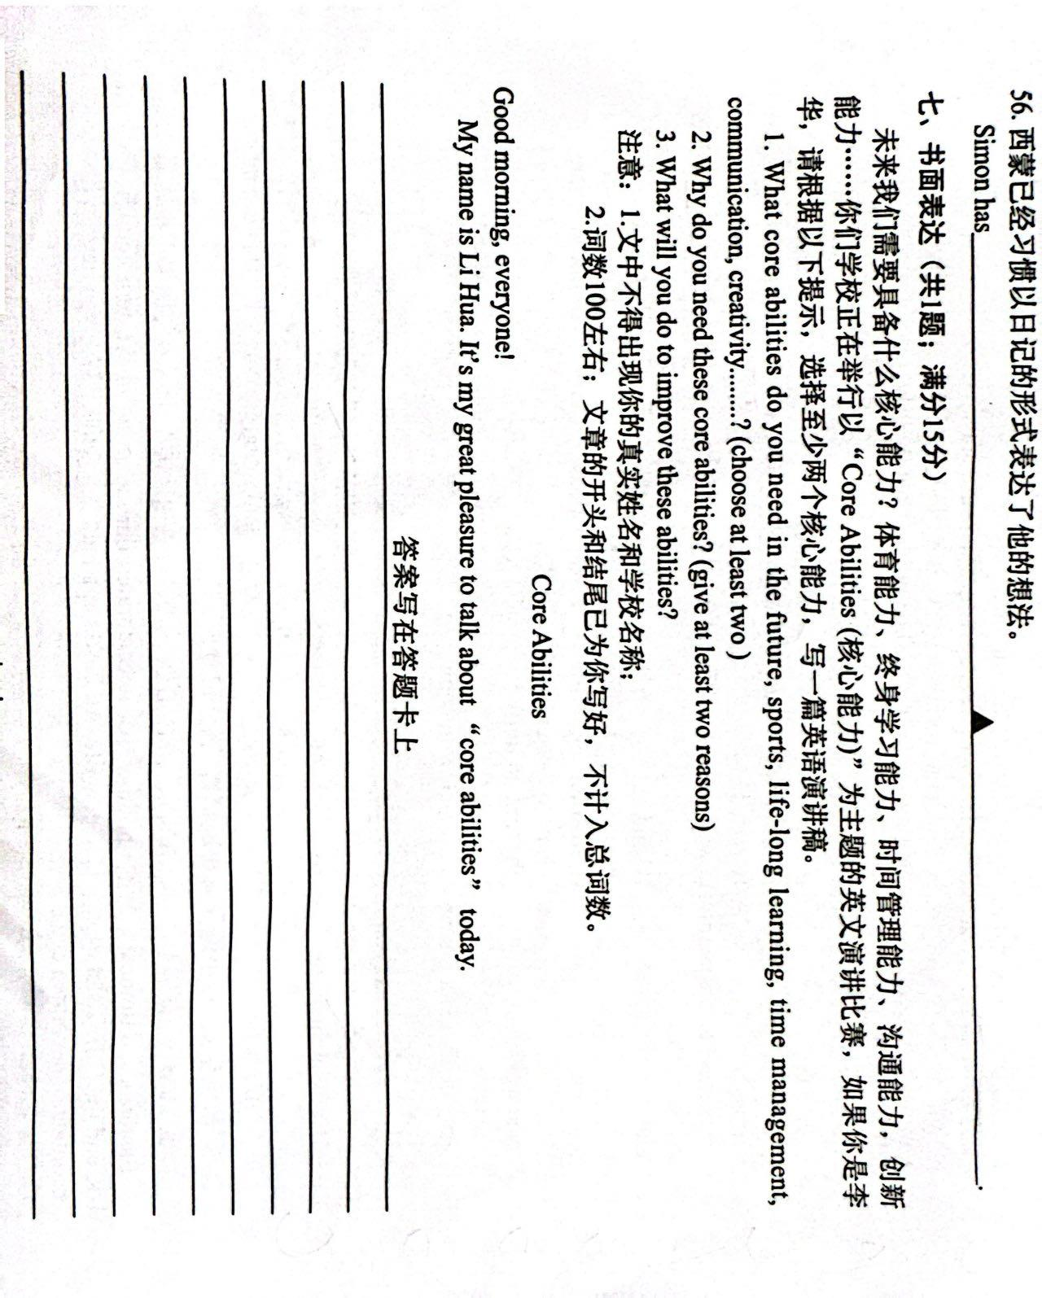

1. Study
2. List

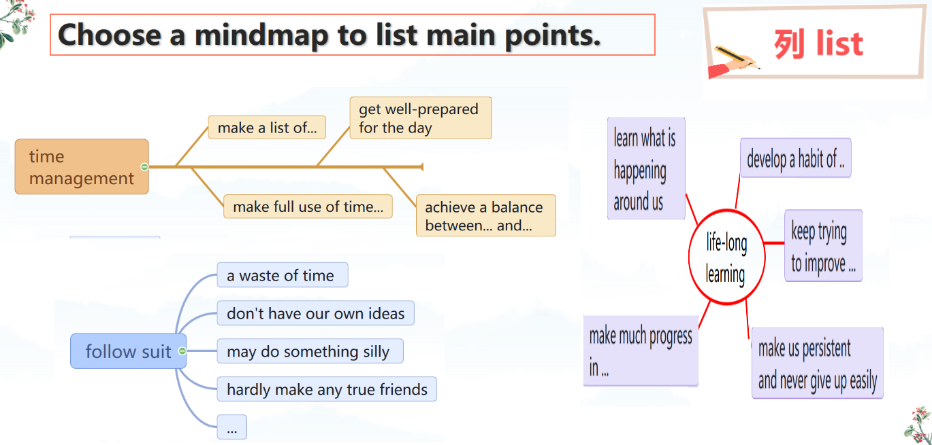

1. Add

Step 5: Homework

Finish the writing article.