**202409019| 中一班**

Daily life

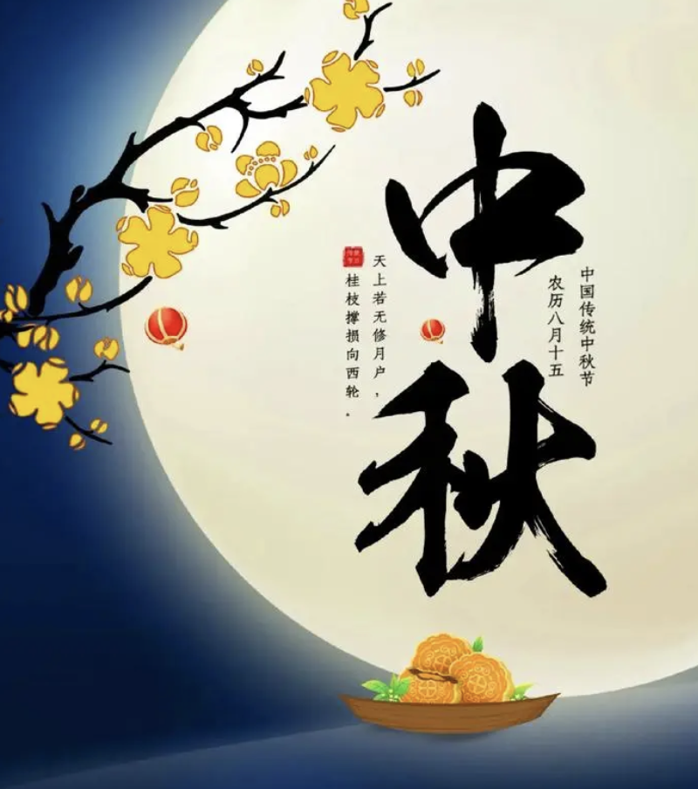

**「来园情况」**

今日星期四，共有21人来园，1人请假。

**「日常生活观察」**

|  |  |  |  |  |  |  |
| --- | --- | --- | --- | --- | --- | --- |
| **序号** | **姓名** | **午餐** | | | **午睡** | **备注** |
| **饭** | **菜** | **汤** |
| 1 | 韩昕怡 | √ | √ | √ | √ |  |
| 2 | 韩昕悦 | √ | √ | √ | √ |  |
| 3 | 吴清墨 | √ | √ | √ |  |  |
| 4 | 陆晟涵 | √ | √ | √ | √ |  |
| 5 | 张梅伊 | √ | √ | √ | √ |  |
| 6 | 吴沐檀 | √ | √ | √ | √ |  |
| 7 | 曹果 | √ | √ | √ | √ |  |
| 8 | 曹煜琪 | √ | √ | √ | √ |  |
| 9 | 蒋安乐 | √ | √ | √ | √ |  |
| 10 | 韩书华 | √ | √ | √ | √ |  |
| 11 | 顾言希 | √ | √ | √ | √ |  |
| 12 | 贾钧尧 | 请假 |  |  |  |  |
| 13 | 杨宸 | √ | √ | √ | 看护入睡 |  |
| 14 | 张予安 | √ | √ | √ | √ |  |
| 15 | 高瑞泽 | √ | √ | √ | √ |  |
| 16 | 张路翔 | √ | √ | √ |  |  |
| 17 | 谢咏呈 | √ | √ | √ | √ |  |
| 18 | 汤凌宇 | √ | √ | √ | 看护入睡 |  |
| 19 | 韩以轩 | √ | √ | √ | √ |  |
| 20 | 冯煦晨 | √ | √ | √ | √ |  |
| 21 | 郑哲皓 | √ | 蔬⭕ | √ | √ |  |
| 22 | 张致远 | √ | √ | √ | √ |  |

**「户外游戏」**

**今天户外活动时间，我们来到了大型亿童建构区，我们找到合作的小朋友，一起建构了属于自己的城堡。**

|  |  |  |
| --- | --- | --- |
| IMG_1208 | IMG_1209 | IMG_1215 |
| IMG_1219 | IMG_1229 | IMG_1231(1) |

**「午餐活动」**

**今天中午我们吃的是：五彩虾仁、娃娃菜油面筋和小米米饭。**

|  |  |  |
| --- | --- | --- |
| IMG_1233(1) | IMG_1234(1) | IMG_1235(1) |
| IMG_1237(1) | IMG_1238(1) | IMG_1239 |
| IMG_1240(1) | IMG_1241 |  |