**钟子莲老师《Unit3 Is this your pencil?第一课时》公开课材料**

1. 安排表

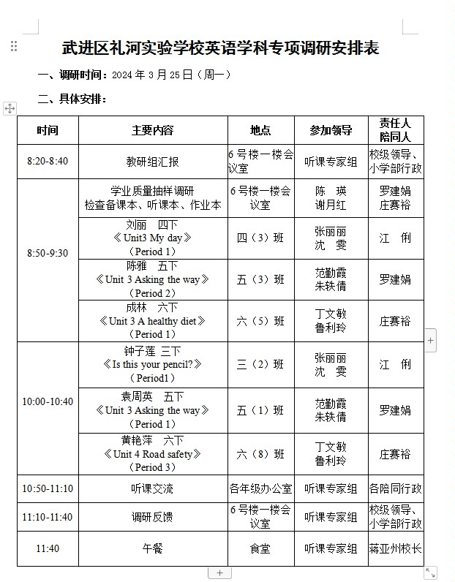

1. 教案

|  |
| --- |
| **Unit3 Is this your pencil? （第一课时）** |
| **教学目标：**   1. 能听懂，会说，会读，会运用词汇：school bag,pencil,pen,ruler,crayon,rubber,pencil case. 2. 能听懂，会说，会读,会运用句型：Is this/that your...? Yes,it is. No, it isn’t. 3. 学生能学习并懂得乐于助人的优秀美德。 |
| **教学重难点：**   1. 能听懂，会说，会读，会运用词汇：school bag,pencil,pen,ruler,crayon,rubber,pencil case. 2. 能听懂，会说，会读,会运用句型：Is this/that your...? Yes,it is. No, it isn’t. |
| **教学活动设计：**  **Step1 Lead in**   1. Free talk. ：(Greetings) 2. Game：Brain storm   T: Boys and girls. Do you like games? Now let’s play a game---Brain storm.  Look, here is a magic closet. There are many clothes in it. Can you guess what’s this?  You can use the sentence “ Is this a/an ...？” to ask.  学生用句型来猜测，教师回答Yes,it is.或No,it isn’t.  ① A Magic Box : a ball, a doll, a robot,a toy bus.  ② A Magic Schoolbag: a pen, a pencil, a crayon, a ruler, a rubber, a pencil case.  **Step2 Presentation**  **过渡：**Oh so many things, Do you like this magic school bag? Yes, I like it too. Whose bag is this? Oh, it’s Mike’s.  （书包旁边呈现，Mike人物，引出主人公。）   1. Look and say.   T: Whose bag is this? （这个书包是谁的？）  S: It's Mike’s. （麦克的）   1. Guess and say.   T: Yes, but Mike is sad today, because he lost one thing.  Can you guess what is he looking for?  You can use “ Is that a...?” 引导学生去猜测。   1. Watch and find.   T：Now，Let's watch the video and find What is Mike looking for？  Q: What is Mike looking for? 麦克在找什么？   1. pen B .pencil√   Yes, he is looking for his pencil.   1. 图片环游（逐图细化）   **Picture1**： Look at Mike. How does he feel? worried.（担心的）  “This isn’t my pencil.” 带感情朗读  isn’t= is not  过渡：Oh, Mike can’t find his pencil.Who helps him? Liu Tao and Yang Ling.    **Picture2~3**: 图二图三为了对比，一起呈现。  Look at their questions. What’s the difference?   |  | | --- | | 知识卡片：this 这个（用于离说话人较近的东西。）  that 那个（用于离说话人较远的东西。） |   T：Now we know the differences.Who can read these sentences？  How does Mike feel？ sad （伤心的）  No, it isn’t. 带感情朗读  **Picture 4:** Look at the picture.Where is the pencil?  T：It’s under the desk.  Mike find his pencil. How does he feel? happy  “Oh, that’s my pencil.” 带感情朗读  **Picture 5：**  T：What does Yang ling say? Who can read?  S: Is that a pencil?  Q：How does she feel? puzzled（疑惑的）,  Q：Why? Because the pencil is too special.  T：The pencil is like a frog.  Mike answers—— Yes, it is. It’s a pencil. （proud)自豪的 带感情朗读   1. Let’s read!   （Choose one way you like to read ）   1. Read after one B.Read together C.Read in roles 2. Let's act!   T: You are good actors! Mike find his pencil with the help of Yang Ling and Liu Tao.They are nice and helpful!  情感教育：乐于助人是一种美德哦！  **Step3 Consolidation**   1. **Stationary Show文具展览秀**   Well we know Mike has a special pencil. Here I got more special stationary for you. Can you guess what are they? You can use the sentence to ask.  **句型： Is this/that ...? Yes, it is. No,it isn’t.**   1. **了解更多的文具英文说法。**   Besides these things. There are some other stationary we need to know. Now Let’s enjoy!  pencil sharpener 卷笔刀；bookmark书签；notebook 记事本；  ball pen 圆珠笔；glue胶水；scissors 剪刀 |
| **Step4 Homework**   1. Read and recite story time. 2. Talk about your stationary with your friends. |

1. 评议表

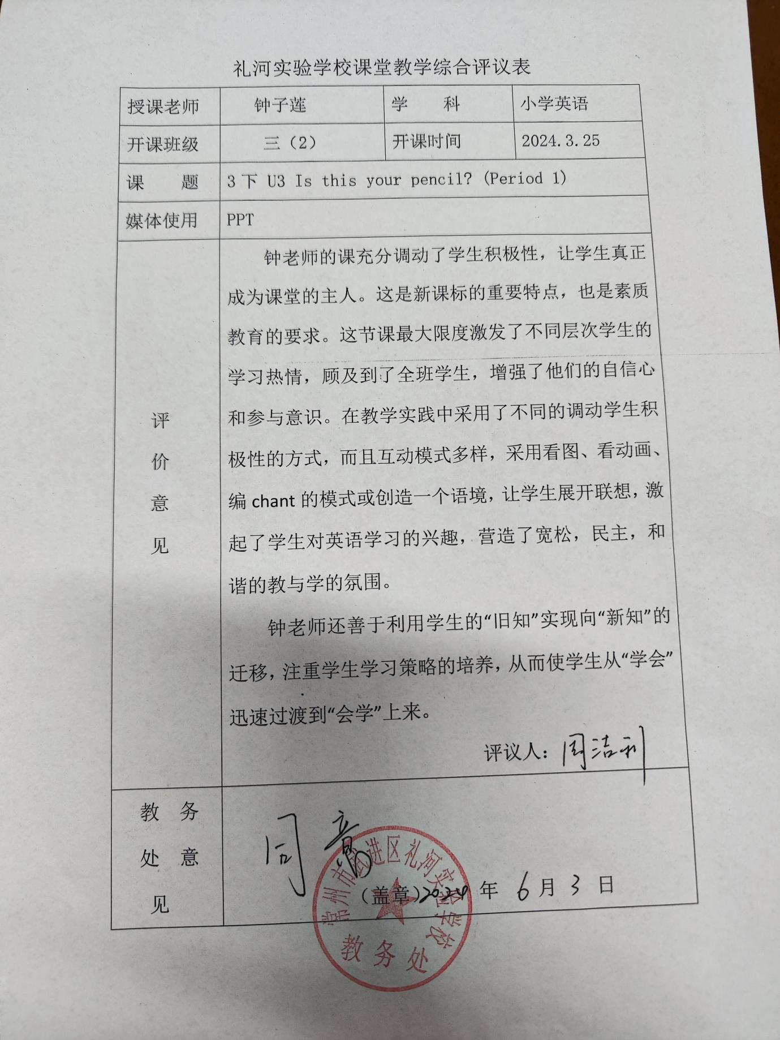

1. 照片

