六年级（下）英语口语交际
单元 | 语用交际话题 | 语用类型
Unit2 Good habits | 1、用上频率副词谈论自己和朋友的好习惯和坏习惯。  2、尝试说说好习惯带来的好处，以及坏习惯带来的危害。  参考句型：  Hello,I’m... I have ...good habits. I (always/usually/...)...  But I have ... bad habits, too. I.... I should/shouldn’t... This is my friend,... He/She has...good/bad habits.  He/She (always/usually/...)...  He/She should/shouldn’t...  例：  Hello,I’m Lily. I have some good habits. I always go to bed early and never go to bed late.Because it’s good for my health.I often put my things in order.It helps keep my room clean and tidy. But I have some bad habits, too. Sometimes I read in bed.It’s bad for my eyes.  This is my friend,Tom. He has some good habits.He usually brushes his teeth in the morning and before bedtime.He always finishes his homework early.  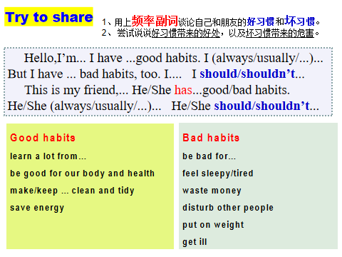 | 语境、特定意图、礼貌、评价
Unit3 A healthy diet | 请为Mike或者YL设计一份你认为更健康的饮食金字塔，并在组内说一说！  参考句型：  ________'s healthy diet  This is ...’s healthy diet.  In the morning, ...has/eats/drinks... We should eat a lot for breakfast.  At lunch time ,...has/eats/drinks... We should eat richly（吃得丰盛）for lunch.  For dinner,..has/eats/drinks...We should eat less(少吃) in the evening.It’s good for our health.  ... often ... ...also...It’s good for...  Healthy diet, healthy life！  例：  In the morning, She has a lot of noodles and drinks some milk.She eats some eggs every week.We should eat a lot for breakfast.  At lunch time ,She has a lot of rice,some meat and fish.She also has a little sweet food. We should eat richly（吃得丰盛） for lunch.  For dinner,She eats some meat and a lot of vegetables. We should eat less(少吃) in the evening.It’s good for our health.  She often has a lot of fruit. She also drinks a lot of water in a day.It’s good for her.  Healthy diet, healthy life！ | 特定意图、礼貌、表达得体、清晰
Unit4 Road safety | Mike and Yang Ling want to be a little policeman. They’re talking about the rules on the road now.两人一组讨论。  参考句型：  Yang Ling: Road safety is so important.  What must you do on the road?  Mike: We must....Because it’s safe.  Yang Ling: What must you not do on the road?  ....  Mike: We mustn't...  Because it’s not safe.  ....  例：  Yang Ling: Road safety is so important.  What must you do on the road?  Mike: We must stay on the pavement.Because it’s safe.  Yang Ling: What must you not do on the road?  Mike: We mustn't listen to music and play the skateboard.  Because it’s not safe.  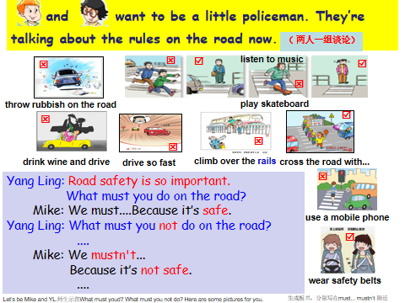 | 特定语境、礼貌、表达得体、清晰
Unit 7 Summer holiday plans | 通过制定自己的暑假计划，学生互相交流，能够正确地运用will和be going to引导的一般将来时的陈述句，有条理地、详细地介绍同桌的假期计划。  参考句型：  My deskmate and I have different plans for the summer holiday.  I'll...  He'll/She'll...  ...  例：  My friend Jack will go to Shanghai this summer. He will get to Shanghai by train. He will stay there for a week. He will go to the Bund and the Shanghai Museum. He will play with his friends there. He will live in his aunt's house. I think his travel will be very interesting.  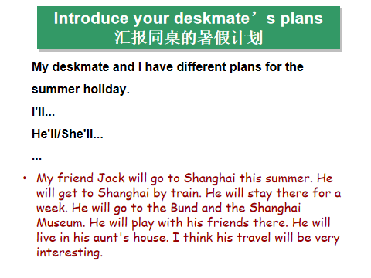 | 计划语境、礼貌、表达得体
Unit8 Our dreams | Our dreams采访你的同学的梦想。  参考句型：  1. What is your dream?  2. What do you want to be when you grow up?  3. Why do you want to be a/an...?  4. How do you make your dream come true?  5.To make your dream come true, what will you do?  例：  S1:What is your dream?  S2:Everyone has a dream. And I want to be a doctor when I grow up.  S1:Why do you want to be a/an...?  S2:Do you know why? Because I want to help sick people. And I’m good taking care of my baby sister. Helping people makes me happy.  S1:How do you make your dream come true?  S2: To make my dream come true,I will study hard. I often  listen to the teachers carefully in class and finish homework  quickly, so I can have more time to read Medical books and magazines. I will also ask my aunt. Because she is a doctor and I can learn from her. I hope I will go to Medical school one day so I can practice a lot there.  S1:To make your dream come true, what will you do?  S2: I think if I try my best, my dream will come true!  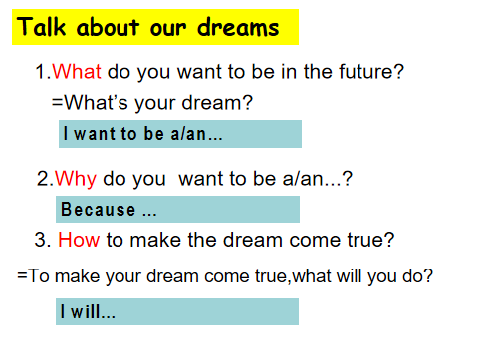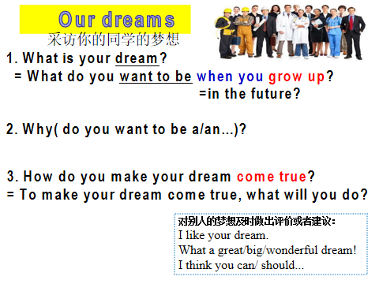 | 采访语境、礼貌、文化  表达清晰

