四年级口语交际材料

1、星期天，你和父母一起去动物园，看到许多可爱的动物，有些是你不认识的，你会跟父母会说什么呢？
参考句型：Let’s go to the zoo. Look at these animals.
What’s this/that? It’s…What are these/those? They’re
What a nice/cool….!They’re cute/big/lovely/cool/fat/thin…
Do you like…?Yes, I do/No, I don’t
What do you like? I like…..

2、英语俱乐部的时候，老师让同学们每人都带了很多玩具动物来，比一比谁的玩具动物最受欢
参考句型：Look at my…This is/That is/These are/Those are my…..
It’s/They’re cute/big/lovely/cool/fat/thin…
Do you like my…?Yes, I do/No, I don’t.
What a nice/cool….! I like your/his /her..…..

3、这个学期的实践活动，同学们参观了一个水果园，里面有好多品种的水果，而且可以免费品尝，他们会说些什么呢？
参考句型：Look at… It’s /They’re red/purple/yellow/sweet…
I like….very much. What do you like? Do you like….? Me ,too.
What would you like? I’d like…..
Would you like..?/What about…?Yes, please/No, thanks.
Do you like….? What do you like?
How many …would you like?
How nice/ What a nice…./It’s/They’re yummy.
Are you happy? Yes, we are .

4、班队课上，同学们带了很多水果，要一起去水果沙拉，同学们都很开心，他们会说些什么呢？
参考句型：I have…It’s They’re red/purple/yellow/sweet…
What do you have?/Do you have a /any…?Yes, I do /no, I don’t.
How many …do you have? I have…..
I like….very much. Do you like….? What do you like?
Would you like..?/What about…?Yes, please/No, thanks.
How many …would you like?
Let’s make a fruit salad. How nice/ What a nice…./It’s yummy.
Are you happy? Yes, we are .

5、星期日，你的小伙伴来你家做客，你有很多玩具，现在你正向你的小伙帮展示你的玩具。试着说一说吧。
参考句型 ：Welcome to my home…
What’s this/that? What are these/those?
Look at my … It’s/They’re … How… What a nice …!
What do you have ? How many …s do you have?
Can I have a look?/Can I have one?
I like this/your … Me,too.

6、今天是六一节，你和小伙伴们带来了很玩具，现在你们正在展示你们的玩具。
参考句型： Look at the … It’s/They’re … How …! What a nice/cool …!
I have … What do you have?
How many …s do you have?
Do you like …s?
What do you like? Look at my …
They’re …
Can I have a look? /Can I have one?
I like this/your … Me,too.

7、今天学校开展运动会，你和你的小伙伴谈论你们的擅长的运动。
参考句型: Look at … He’s cool/nice/happy …
What can …do? Can Mike ….?
I can … What can you do ?
Can you …?
I can ….well.
Have a try.
Let’s go and … Great./All right./…

8、图片上的同学正在做运动。你能和你的小伙伴谈谈他们吗？
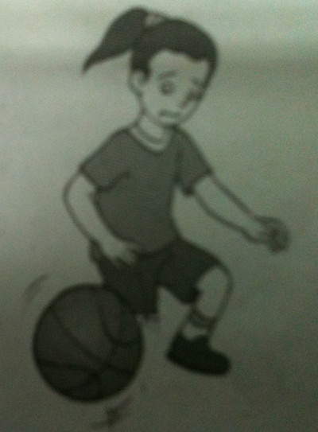
参考句型： Look at … He’s cool/nice/happy …
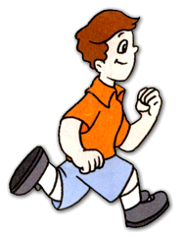
What can …do ?
Can he ….?
What can you do ?
Can you …？
Have a try.

9、星期一的早晨，是上学时间了，可是你找不到你的衣服、文具，妈妈过来帮助你了，你们会说些什么呢？
参考句型：What time is it? It’s… It’s time for…
Where’s/Where are my …? It’s / They’re in /on under /behind.
Is it…? Are they…?
Yes, it is./No, they are not.
Come and look, your…
Oh, I’m late….

10、你搬新家了，邀请了你的好朋友来到你的家里参观，你会怎样介绍你的新家呢?试着和小伙伴演一演吧。
参考句型：May I come in ? Come in, please.
Welcome to my new home. Thank you.
Look at my…
How nice!/It’s beautiful/cool/lovely/… Wonderful/Great!/What a…!
Where’s/ Where are your..?
Would you like…?

11、你来到一家小吃店，店里有许多美食，请你和你的小伙伴扮演顾客和服务员，表演点餐的情景吧。
参考句型：Welcome to .. Thank you. Wow. It’s nice and clean./big./..How…/…
What would you like?
I’d like…. /…., please.
Anything else? Would you like …/What about…?
Here you are./Here’s your…
How much ? …yuan, please.

12、今天是你的生日，你的好朋友来到你的生日聚会，你们很开心地庆祝你的生日，你会怎么招待他呢？想一想，和好朋友演一演吧。
参考句型：Happy birthday ! This … is for you.
Look at my …. Wow! It’s …/How…! /What a …!
Let’s have a big lunch.
What would you like? I ‘d like …
Would you like…? What about …?
It’s yummy. /How nice!

13、苏海妈妈来到商店，她想要买一条短裙和一双鞋，营业员热情地招待了她。请你和你的小伙伴扮演她们编个对话吧。
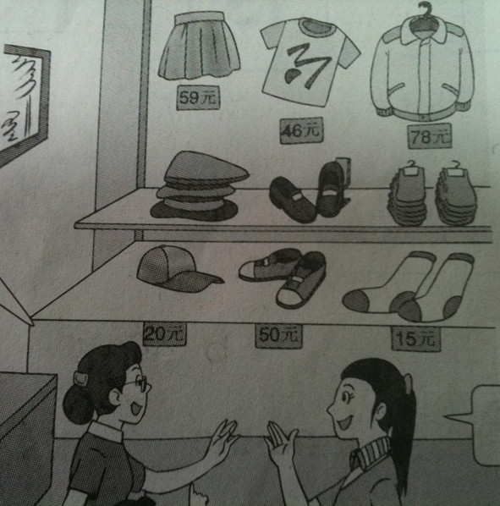
参考句型：Welcome to the shop.
Can I help you?/What would you like?
What colour do you like?
What about the …one(s)?
Do you like this …one?
This …skirt is nice.
These shoes are cool.
How much is it/are they?

14、学校举行一次大型义卖活动，有好多好看有趣的东西，大家快来看看吧！
参考句型：What’s this/that? It’s… What are these/those? They’re….
The…is /are nice/cool…What a ….!
Can I help you?/ What would you like? I’d like…..
Would you like..?/What about…?Yes, please/No, thanks.
Do you like….? What do you like?
How many …would you like?
How much is it/are they? It’s /They’re…

15、这里有两个可爱的娃娃，两人一组来讨论一下。
参考句型：Look at our /this doll. It’s .. How …! What a nice/cool/…!
His/Her ears/eyes/hair/mouth/nose…..big/small/fat/thin/..
Do you like this doll? Yes,I do/No, I don’t.
Can I have a look? I like this doll. Me, too.

16、这里有三个可爱的娃娃，试着用一段话来表述一下吧。
参考句型：She is a girl. She is ….She is not….Her eyes are…Her ….are small, too, but her hair/nose is…..
Her….is long. He is a robot. He is ….His eyes are…His….are/is…..
