**20240418| 小一班**

Daily life

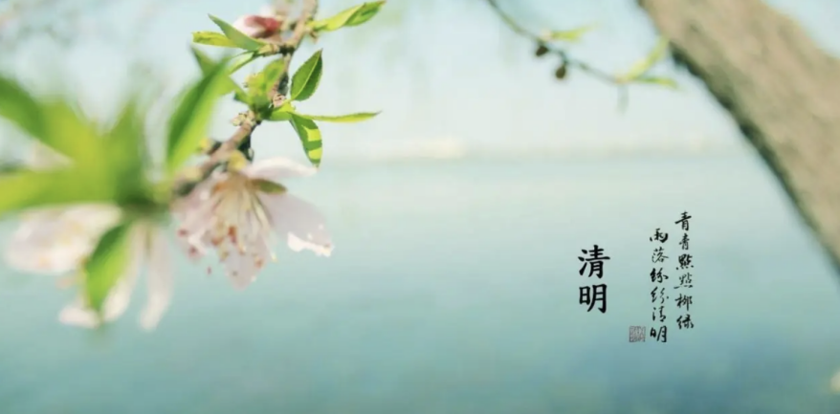

**「来园情况」**

今天星期四，21名幼儿来园，1名幼儿请假。

**「日常生活观察」**

|  |  |  |  |  |  |  |  |  |
| --- | --- | --- | --- | --- | --- | --- | --- | --- |
| **序号** | **姓名** | **入园情绪** | **早点** | **午餐** | | | **午睡** | **午点** |
| **饭** | **菜** | **汤** |
| 1 | 韩昕怡 | √ | √ | √ | √ | √ | √ | √ |
| 2 | 韩昕悦 | √ | √ | √ | √ | √ | √ | √ |
| 3 | 吴清墨 | √ | √ | √ | √ | √ | √ | √ |
| 4 | 陆晟涵 | √ | √ | √ | √ | √ | √ | √ |
| 5 | 杨雨涵 | 请假 |  |  |  |  |  |  |
| 6 | 张梅伊 | √ | √ | √ | √ | √ | √ | √ |
| 7 | 吴沐檀 | √ | √ | √ | √ | √ | √ | √ |
| 8 | 曹果 | √ | √ | √ | √ | √ | √ | √ |
| 9 | 曹煜琪 | √ | √ | √ | √ | √ | √ | √ |
| 10 | 蒋安乐 | √ | √ | √ | √ | √ | √ | √ |
| 11 | 韩书华 | √ | √ | √ | √ | √ | √ | √ |
| 12 | 顾言希 | √ | √ | √ | √ | √ | √ | √ |
| 13 | 贾钧尧 | √ | √ | √ | √ | √ | √ | √ |
| 14 | 杨宸 | √ | √ | √ | √ | √ | √ | √ |
| 15 | 张予安 | √ | √ | √ | √ | √ | √ | √ |
| 16 | 高瑞泽 | √ | √ | √ | √ | √ | √ | √ |
| 17 | 张路翔 | √ | √ | √ | √ | √ | √ | √ |
| 18 | 谢咏呈 | √ | √ | √ | √ | √ | √ | √ |
| 19 | 汤凌宇 | √ | √ | √ | √ | √ | √ | √ |
| 20 | 韩以轩 | √ | √ | √ | √ | √ | √ | √ |
| 21 | 冯煦晨 | √ | √ | √ | √ | √ | √ | √ |
| 22 | 郑哲皓 | √ | √ | √ | √ | √ | √ | √ |

**【美食节活动】**

**今天我们制作小花馒头，这是一个有趣且富有创意的活动。通过制作小花馒头，孩子们不仅可以学习到简单的烹饪技巧，还可以发挥想象力，制作出独一无二的美食作品。**

|  |  |  |
| --- | --- | --- |
| IMG_5383 | IMG_5384 | IMG_5385 |
| IMG_5386 | IMG_5387 | IMG_5388 |
| IMG_5389 | IMG_5390 | IMG_5391 |
| IMG_5393 | IMG_5397 | IMG_5400 |