**乔乔 辅导学生获奖 目录**

|  |  |  |  |
| --- | --- | --- | --- |
| **序号** | **奖项** | **级别** | **时间** |
| 1 | 第十六届“小数报杯·小小数学家”优秀指导奖 | 省级 | 2023.08 |
| 2 | 小数报第十六届“寒假快乐思维营”学生获奖证书若干 | 省级 | 2023.02 |
| 3 | 小数报第十七届“寒假快乐思维营”学生获奖证书若干 | 省级 | 2024.02 |

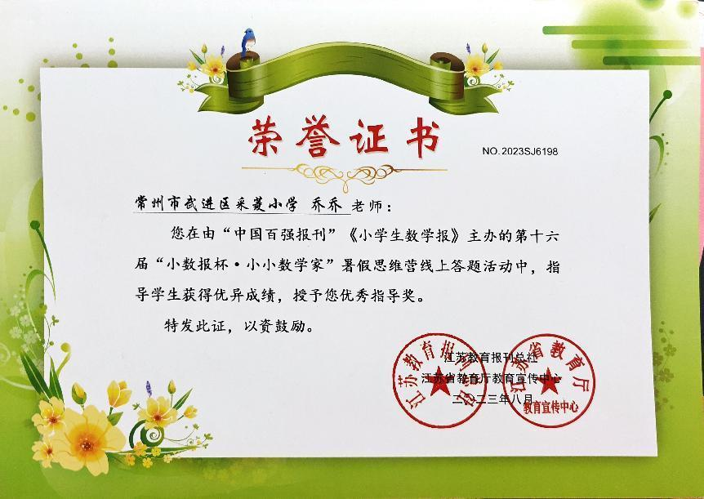

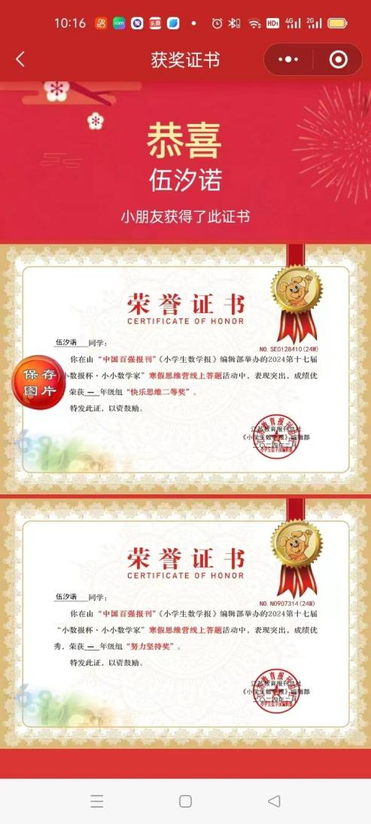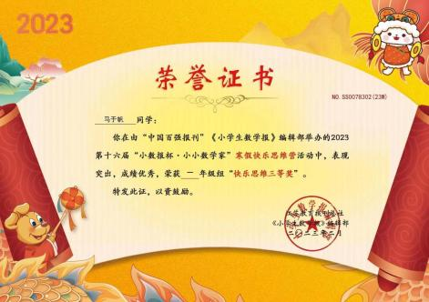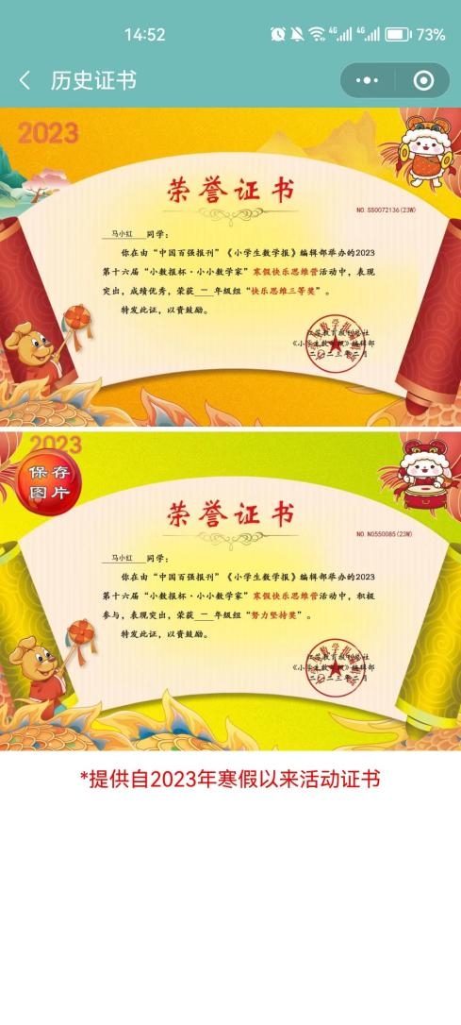

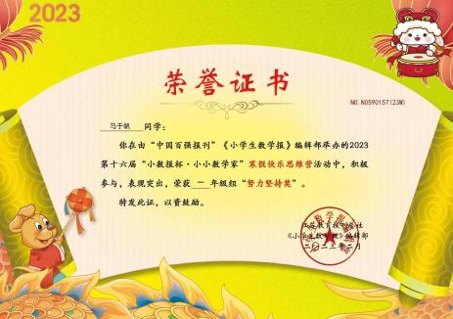

|  |  |  |
| --- | --- | --- |
| b38ff6e8d2348e7e4c73721d08071ee | 7aeccd7946c7ec1405afb02106f14dc | 6a6c3788cef01f33bf126cec454bc8d |
| 8b7b6a33c49b3f95f43f832d6f7c8d7 | c57e0b2c7ce81fe1b7184ebf7e4ef56 | dc83cd3d748c427ef58d5526c774cf2 |
| e1db97f8ac7ddcc34ed7b7409f42488 | 6762a13535cf8fb637ee618e1eb58dd | 2d8edd6781f5fa4f8f80a9d0b6bdc7e |
| 62aaa5ebd0c9ef182867047b14d29b2 | 21cfc051edb89f686b83e06d1038a6d | 310d1a82849a4ea9438ffe121ec218f |
| 1d8364f1616718dcd604487ed6e9e98 | 48904de894b1f05c1cc51be991b87ca | f09d27de4ba4f667c13693738ed2d52 |
| 071aa452690f0b158a2a37c4180328d | eb492999ce30872c0e05af82ed9055a | d980b212e1930043ebb06a291da4125 |