**绘本阅读无声教学（无声演课） 《丽声北极星分级绘本》**

绘本导图

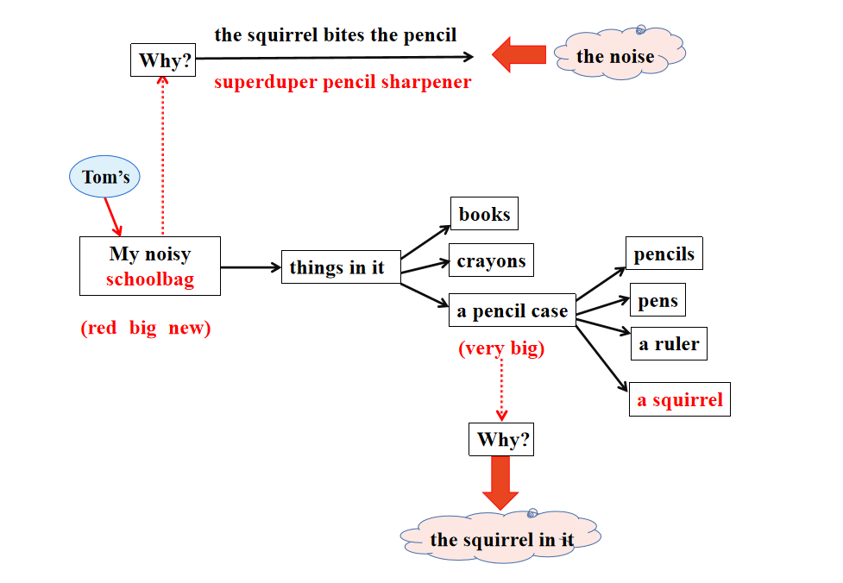

情感线： Why？

故事线：What？ How? Is this/that...?推进 抓住关键词big, very big

让学生读一读，演一演，猜一猜。

*Warm up activity*

Quick guessing about teacher and Stationery supplies(随机搜集的学生的学习用品）

*Pre- reading*

Read my story about Tom’s schoolbag. （遮挡 Noisy一词，读完再揭题）

*While- reading*

1. Page 2 : read together. How is the schoolbag?
2. 读图Read picture 2 carefully What else can you see in the picture? Do you like squirrels? What can the squirrel do? Where is Tom going to?(学生看图都能get到，不一定需要老师问，老师帮助引导回答）

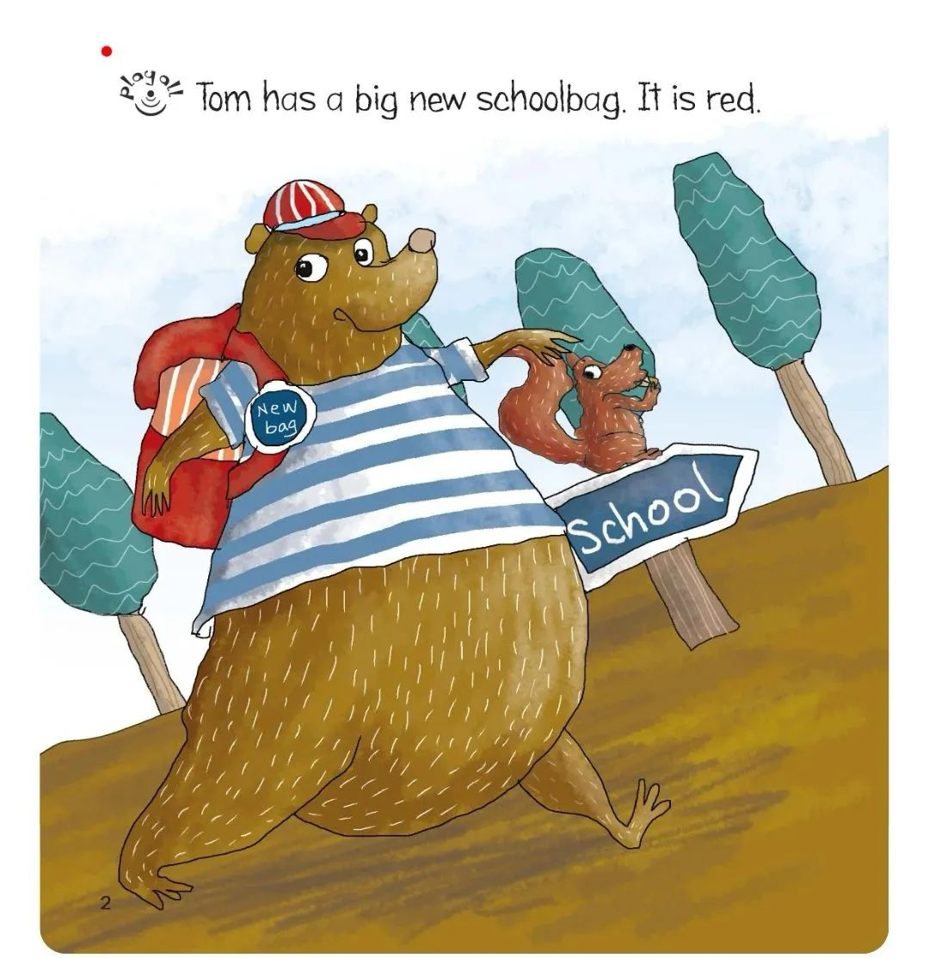

1. Be Tom to act it out.(扮演Tom增加台词： I’m going to school now. Look at my schoolbag. It’s .... I like it. I’m happy...)
2. Page (3-5) things in schoolbag

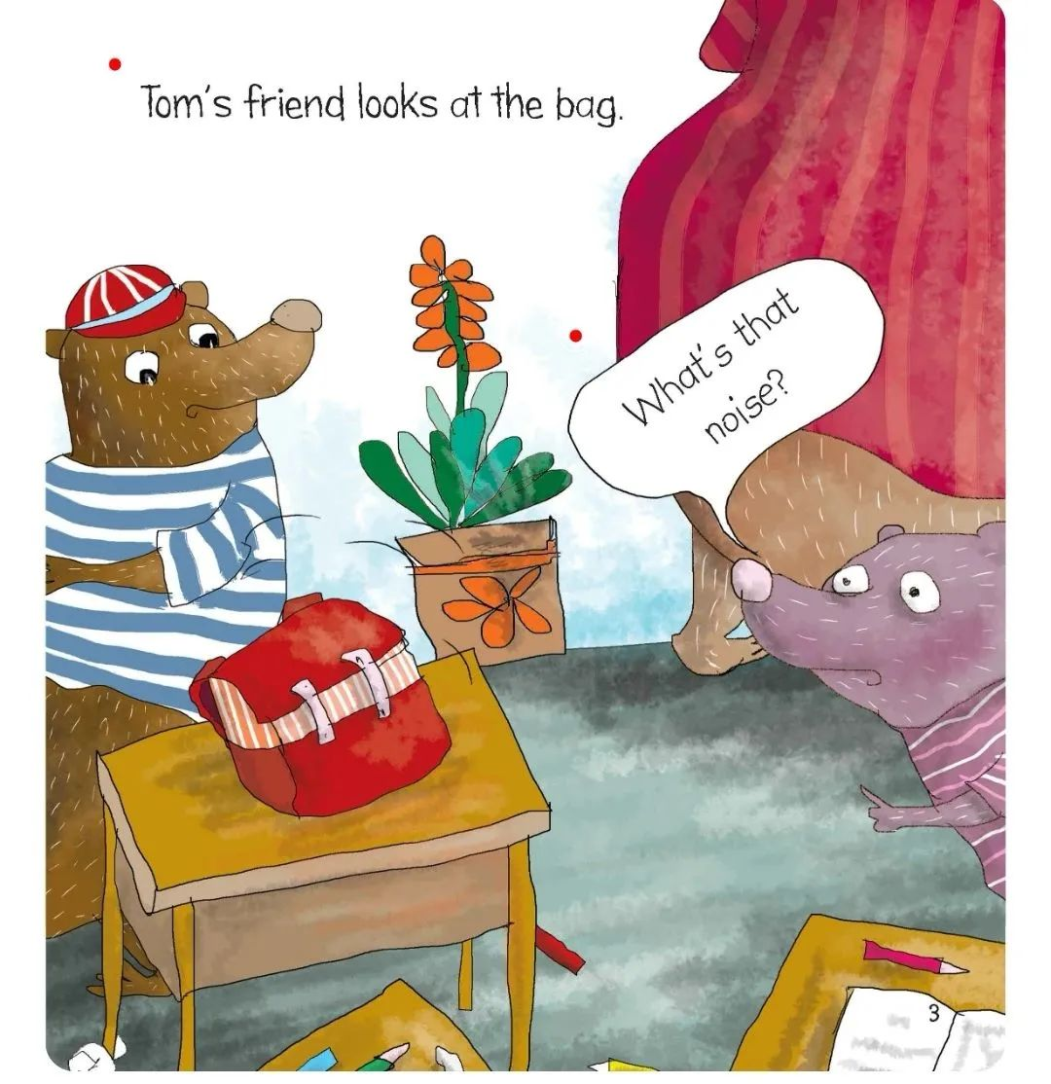

遮挡朋友的话，让学生猜测，再出示声音和问题，揭露故事矛盾 What’s that noise？ 学生再猜，学生自读Page (3-5) 回答 What’s that noise？设置环节：老师带领同学们试验一下文具用品是否能发出noise，与书中的noise比对一一排除，设疑。设置read in ways/ ask and answer环节，让学生多读多感受。

1. Page6

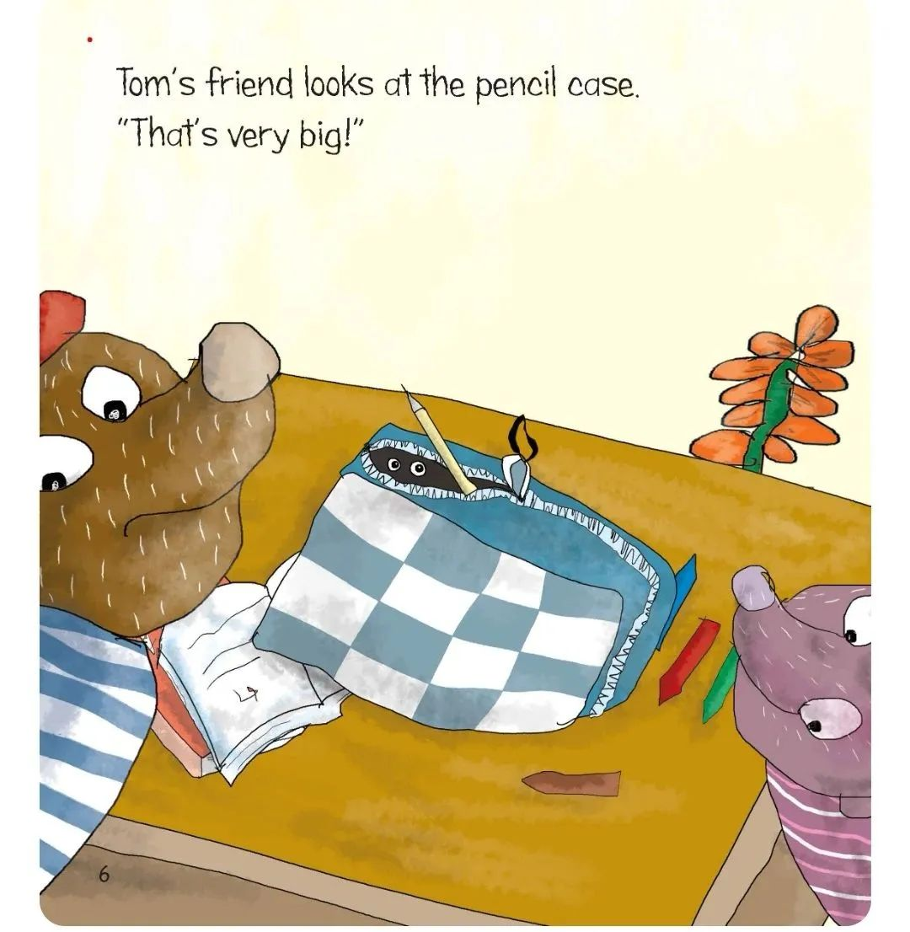出示page6，学生观察，能看到有双眼睛，学生猜，说心情，自读page（7-10）things in a pencil case，解惑。What’s that noise? How？ 设置act out 环节让学生多读多感受。

1. Page11 What’s that noise? Why? How?

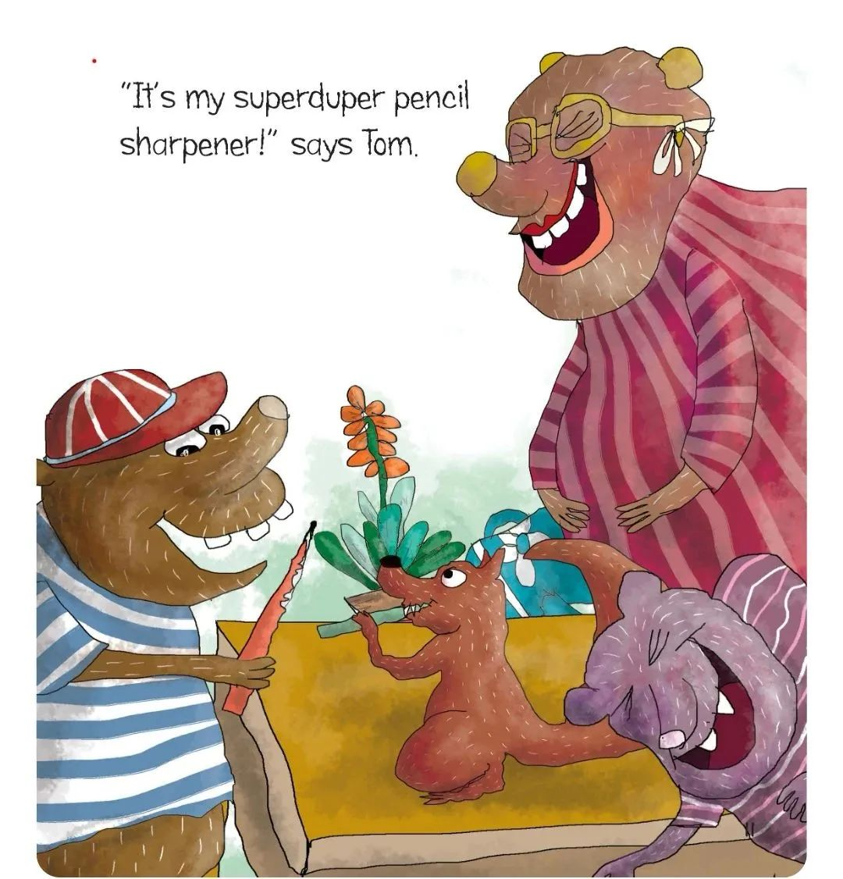细节：Tom 是在路上碰到squirrel的，是不是突发奇想放进书包的呢？这点很有趣的。

1. 完成 标题 My_________ schoolbag.

*Post-reading*

Finish the reading worksheet. / Book recommendation.