六年级上册 Unit 2 What a day!
第1课时 教案
教学内容:Story time
教学目标:
1. 学生能初步能理解并且会听、会说、会读和会拼写单词及词组：cloudy, rainy, sunny, windy 和会运用句型：It was sunny / cloudy / windy / rainy.和I/ We/ He/ She brought/ saw/ flew…
2. 学生能初步听懂并且会说、会读单词show, interesting, weather, high, honey, ant, bee, cloud, sky, rain。
3. 学生能初步感知动词过去式的不规则变化及读音。
4. 学生能初步感知天气表达的句型。
5. 学生能够对英语书写日记格式有一定的了解。

教学重点和难点
教学重点：1. 学生能初步能理解并且会听、会说、会读和会拼写单词及词组：cloudy, rainy, sunny, windy 和会运用句型：It was sunny / cloudy / windy / rainy. 和I/ We/ He/ She brought/ saw/ flew…
2. 学生能初步听懂并且会说、会读单词show, interesting, weather, high, honey, ant, bee, cloud, sky, rain。
教学难点：1. 学生对本课重点词汇的听、说、读、写。
2. 学生对本课天气表达的句型的掌握。
3. 学生对动词过去式的不规则变化的认读。
教学准备
PPT课件，
教学过程
Step1 Song time
T: Hello, boys and girls.
S: Hello, Miss He.
T: Nice to meet you.
S: Nice to meet you, too.
T: I like singing very much. Do you like singing?
S: Yes, I do.
T: Let’s learn to sing a new song, OK?
S: Great!
T: Let’s enjoy the song《How is the weather?》. (播放歌曲一遍)
First, listen and watch carefully. You may follow it if you want.
S: Enjoy the song and try to follow it.
T: How is the weather in the song?
It’s cloudy/ rainy.
S: Learn the new words. Read & spell them.
T: How is the weather today?
S: It’s…
（根据当天的天气情况回答，适时地学习sunny, windy等天气词汇。）
Step2 Leading
T: Well, boys and girls. Would you like to know something about me?
1. T: Two days ago, I was in Shanghai.
Do you know Shanghai? It’s a big and beautiful city.
But now I am in Suzhou. It’s beautiful, too.
Review : was（am的过去式）以及ago
2. T: Would you like to know more about me?
Look at the screen, you can choose one part to guess what I like.
（T出示Food, Animals, Hobbies三个话题）
S: (guess) Do you like...?/ You like..., I think./ You like..., right?
T: Bingo! I like... / Yes, you’re right.
在Food话题中引出本课相关单词dumplings, honey
在Animals话题中引出本课相关单词parrot
在Hobbies话题中引出I like writing diaries very much.
Teach: diary—diaries
Step3 Story time
1. Learn how to write a diary
T: (Show a picture of Yang Ling) This is Yang Ling. She likes writing diaries, too.
（出示日记抬头部分）
T: This is a diary of hers. What day is it today?
S: It’s Sunday.
T: What date is it today? It’s the 20th of September.
（渗透英文日记的书写格式）
2. Skipping reading略读
A．T: Look at the pictures in the diary. What can you see in the picture?
(1) S: I can see some children in the park. (T: Who are they?)
S: They’re Su Hai, Mike, Liu Tao and Yang Ling.
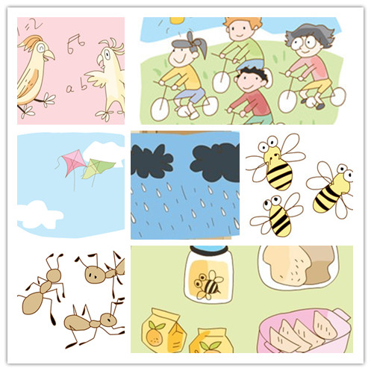
(2) S: We can see some parrots in the park.
(3) S: We can see some kites.
(T: Yes, there’re some kites in the sky.)
(4) S: We can see some bread, dumplings, honey…
(T: Good job! And we can see some drinks, right?)
(5) S: We can see some ants and bees too.
(6) S: We can see some clouds. (T: Right! There’re some black clouds in the sky.)
B. Look and match

T: Look at the pictures, match the pictures and the sentences.

a. They saw some interesting parrots in the park.

b. They were hungry and wet.
c. The children went to the park by bike.

d. They flew kites in the park.


e. They saw ants and bees on their lunch.

f. The weather became windy and cloudy.
g. It rained.
S: Look and match
（在此过程中教授动词过去式的特殊变化形式：
go→went see→saw become→became fly→flew are→were）
S: Read the sentences in the right orders.
3. Extensive reading泛读
T: Well, children. Here’re some sentences about the diary.
Open your books and read the diary by yourselves.
And then judge the sentences. (T/F)
S: Read the diary and judge the sentences.
① It rained all day on 20th September. ( F )
② The children saw a parrot show. ( T )
③ They flew kites in the park. ( T )
④ They brought lunch to the park. ( T )
⑤ They were hungry because they did not have lunch. ( T )
Teach: a parrot show; bring→brought
4. Intensive reading精读（找出表达天气变化的句子，再过渡到事件变化的句子）
(1) T: What was the weather like in the morning?
S: It was sunny in the morning.
T: What did they do?
S: The children went to the park by bike.
T: What did they do in the park?
S: There was a parrot show in the park. They saw some interesting parrots.
(2) T: How was the weather like then?
S: The weather became windy and cloudy.
T: What did they do?
S: They flew kites high in the sky.
(T: It was windy, so they flew kites high in the sky, right?)
(3) T: What was the weather like in the afternoon?
S: There were black clouds in the sky. It rained.
T: How were the children?
S: They were hungry and wet.
(4) T: Why were the children hungry? Did they have lunch? (S: No.)
T: What did they bring?
S: They brought some dumplings, some bread and honey and some drinks.
But there were some ants and bees on the bread and honey.
T: So they could not eat their lunch.
Teach: can→could
5. Reading time
(1) S: Read after PPT.
(2) S: Read the story together.
(3) S: Read the story in parts.
6. T: What do you think of her day? Happy? Interesting? Terrible? Bad?
Lead into the title——What a day!
（What a day! 可以应用在很多的场景中，它的意思包括“多么糟糕的一天！”“多么忙碌的一天！”“多么美好的一天！”等。）
S: Read the title together.
7. Retell the diary
S: Look at the pictures and retell the story.
It was  in the morning. Yang Ling and her friends went to the park by bike 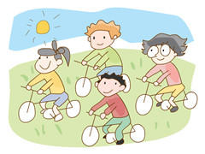. In the park, there was a 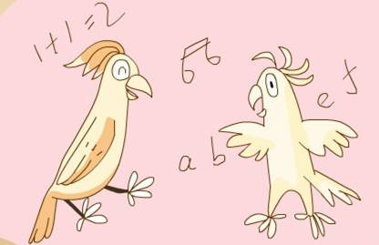 show. There were some interesting . Then the weather became  and . The children flew . They brought some food and drinks 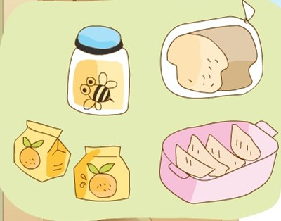 to the park. They did not eat their lunch, because they saw some  and  on the bread and honey. In the afternoon, there were some 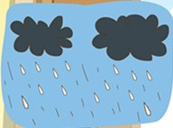 in the sky. It rained. They were hungry and wet.

Step4: Homework
1. Listen and read ’Story time’ three times.
2. Try to retell the diary according to Yang Ling’s pictures.
3. Copy the weather words and the verbs of past tense.
4. Collect more words about weather.

Board writing 板书设计

Unit 2 What a day!
Sunday, 20th September

It wassunny. go→went fly→flew

cloudy. see→saw are→were

windy. become→became bring→brought

rainy.

