备课日期 年 月 日 | 上课日期 年 月 日
课题： Unit 3 Holiday fun 第三课时 ( Cartoon time, Sound time and Culture time )
一、教学目标（知识与技能、过程与方法、情感态度与价值观三类目标）
1．能听懂、会读、会说单词、词组：“Easter, summer holiday ，Christmas holiday, fashion show, excited ,wore ,wonderful, heavy rain”并理解单词的意思。
2.学生能理解Cartoon Time的故事大意，能在教师的引导和帮助下复述对话。
3.了解英国学生的放假情况。体会中西方在放假上的文化差异。
4. 能初步运用本课所学的词汇过去式和日常用语来询问有关节日做了哪些事。
5. 能正确使用降调来朗读句子。
6. 通过本课时的学习，激发学生对美好景物的向往，感受愉快假期活动的乐趣。
二、教学重点、难点

1.学生能理解Cartoon Time的故事大意，能在教师的引导和帮助下选择不对的人物进行复述。
2.了解英国学生的放假情况，体会中西方在放假上的文化差异。
3. 能初步运用本课所学的词汇过去式和日常用语来询问有关节日做了哪些事，并尝试写作

三、教学准备
教学图片和卡片，多媒体（PPT）
Good!
Great fun!
四、板书设计
Unit 3 Holiday fun
Wonderful!
Cool!
Interesting!

Unit3Holiday fun寨桥小学 黄芳

五、教学过程  Step 1: Warming up.  1. Greetings.  2. Free talk  Enjoy some pictures  T: Look at these pictures ,Guess where were the students?  T: What did they do ?  T: Do you know what holiday was it?  引出 Dragon Boat Festival 让学生说一说上个端午节做了什么？  T: What did you do last National Day ?  Ss:…  3. Revision  复习Story time 让学生用自己的语言复述课文  T: Do you remember our friends Liu Tao’s and Mike ’s holidays, too. Do you know where did they go for the National Day holiday? And what did they do during the holiday?  Ss:回忆课文内容，用自己的话说一说。  Step 2: Sound time  - 听录音 ，完成对话  T：Look ， Mike is on the farm. He is so excited ,he is shouting .Listen to the tape ,fill in the blanks.  - 出示小诗，让学生自己体验一下韵脚  T： Please read these words me tree me sea ,what can you find ?  Ss : There is “i:”  3.T指出i:就是本首诗的韵脚，并指导学生用正确的语调朗读小诗。  4.讲解降调和连读，指导读，请学生个别读。全班齐读。  Step 3 Cartoon time  - 引出fashion show ,学习新单词。  T：（回到主画面）Mike was happy on the farm. Look at the picture .Do you know Miss Xu’s National Day holiday?  S1 : You went shopping .  T: Right .And I watched a fashion show . Learn : fashion show  - 出示 Bobby 、Sam 图 T： Bobby and Sam were at the fashion show .  Look, What did they wear?  Ss: They wore … Learn : wore  T: They were so excited . 学习单词excited  - 带问题看动画 How was Bobby and Sam’s holiday?  T：Did the show go well ?  听录音回答 It was wonderful at first .but then there was heavy rain .  学习单词 wonderful  学习词组heavy rain 用图比较 heavy rain 和little rain  引导学生思考 How did Bobby and Sam feel?  Ss: Bobby felt sad/ disappointed. Sam felt sorry.  尝试用Bobby 和Sam 的语气读一读  - Read after the tape  - Read in roles .  - Try to repeat!  让学生选择一个人物，根据所给词，尝试复述课文。  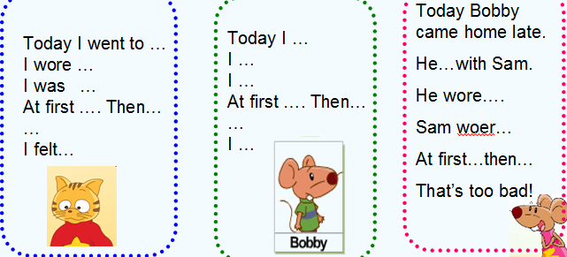  Step4: Culture time  - 教师出示Easter，summer holiday, Christmas holiday的图片，让学生读一读并讨论summer holiday, Christmas holiday这两个节日的文化背景知识。  2.让学生自己读一读Culture time的句子 ，找出第三个重要的学校假期  the Easter holiday 学习有关这个节日的一些内容  3. Learn more main school holidays in the US and in China  Step5: Consolidation  谈论自己经历的难忘假期，说一说，写一写。  Step6 :Homework  1. 背诵Cartoon time 中的四会词汇，熟读三会词汇。  2. 跟录音熟读Cartoon time,并在小组中分角色表演。  3. 预习Checkout time。 | 补充或修改

