译林版《英语》三下Unit 3 Is this your pencil? (Story time)
“我要展示”课例研修
卢家巷实验学校 张青宇
研修主题
“双减”背景下小学英语情境化作业的设计与实施研究
研修专题
“双减”背景下小学英语单元第一课时情境化作业课堂学练结合探究
教学目标
- 能通过复习、猜谜、儿歌等形式聚类学习文具类词汇，并尝试用简单的英语表达自己喜爱的文具。
- 通过呈现Mike在同学的帮助下寻找到自己铅笔的对话情境，理解并学习核心句型Is this/that your...？并学会正确应答。初步掌握一般疑问句的句型结构。
- 通过跟读、标调、朗读、表演等方式，培养学生良好的语音语调和听读习惯。
- 通过创设情境，询问物品的归属，在这过程中进一步培养学生互帮互助的良好品质。5．通过文本的学习以及对情境的理解，引导学生养成学会管理自己物品的习惯。
教学重点
1. 能通过复习、猜谜、儿歌等形式聚类学习文具类词汇，并尝试用简单的英语表达自己喜爱的文具。
2. 通过呈现Mike在同学的帮助下寻找到自己铅笔的对话情境，理解并学习核心句型Is this/that your...？并学会正确应答。初步掌握一般疑问句的句型结构。
教学难点
1. 通过创设情境，询问物品的归属，在这过程中进一步培养学生互帮互助的良好品质。
2. 通过文本的学习以及对情境的理解，引导学生养成学会管理自己物品的习惯。
教学准备
PPT多媒体课件，板贴图片，......

教学过程
Before class—Enjoy a song What’s this?
Stage 1 Pre-reading
Step 1 Let’s play!
T: Pay attention to the rules:
If you see a phrase, read it and do it.
If you see a tiger, shout “Ahh”!
【设计意图：通过歌曲、游戏激发学生学习英语的兴趣，同时复习旧知，为学习新知做好准备。】
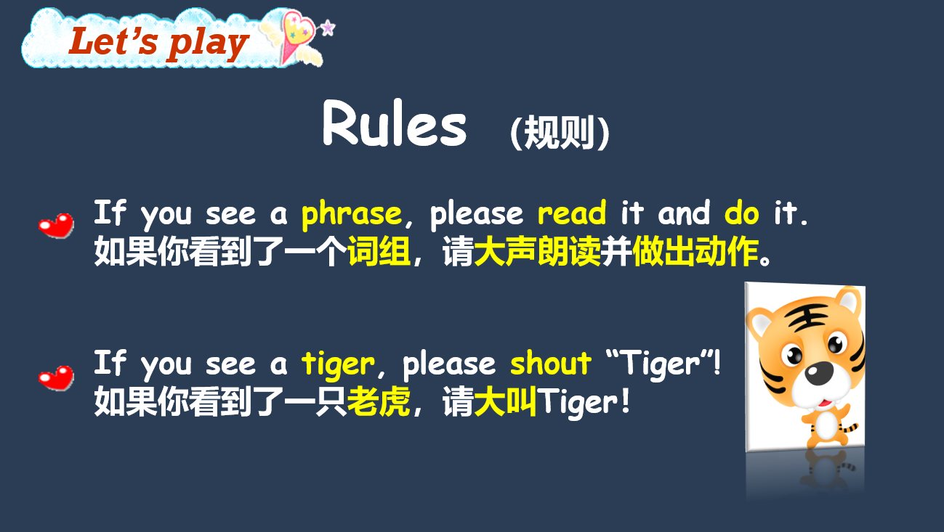
Step 2 Guessing game
(1) Yellow box—clothes (旨在新授Is this a …?)
T: There are so many beautiful clothes. What are the presents? Let’s guess.
S: A T-shirt./…
T: You can come here and guess like this, “Is this a …?”
(引导学生来到投影仪前进行猜测，并出示新授句型Is this a …?)
S: Is this a … ?
(前两幅引导学生用新授句型一起猜测，最后的一幅图转为同桌合作进行猜测。)
(2) Green box (旨在新授Yes, it is./No, it isn’t.)
T: Can you guess?
S: Is that a …?
T: Yes or no? If you think it is, you can say “Yes, it is.” But if you don’t think so, you can say “No, it isn’t.”
S: Is that a pen?
T: Yes, it is. It’s a pen. (新授pen，同法教学pencil )
T: The last picture, please guess with your partners.
S1: Is that a …?
S2: Yes, it is./No, it isn’t.
T: (教学pencil case。)
【设计意图：通过“猜猜礼品盒里的小礼物”这一活动设计，以旧引新，由扶到放，逐步学习本课教学重点，即文具类单词pen, pencil, pencil case和一般疑问句的问答。】
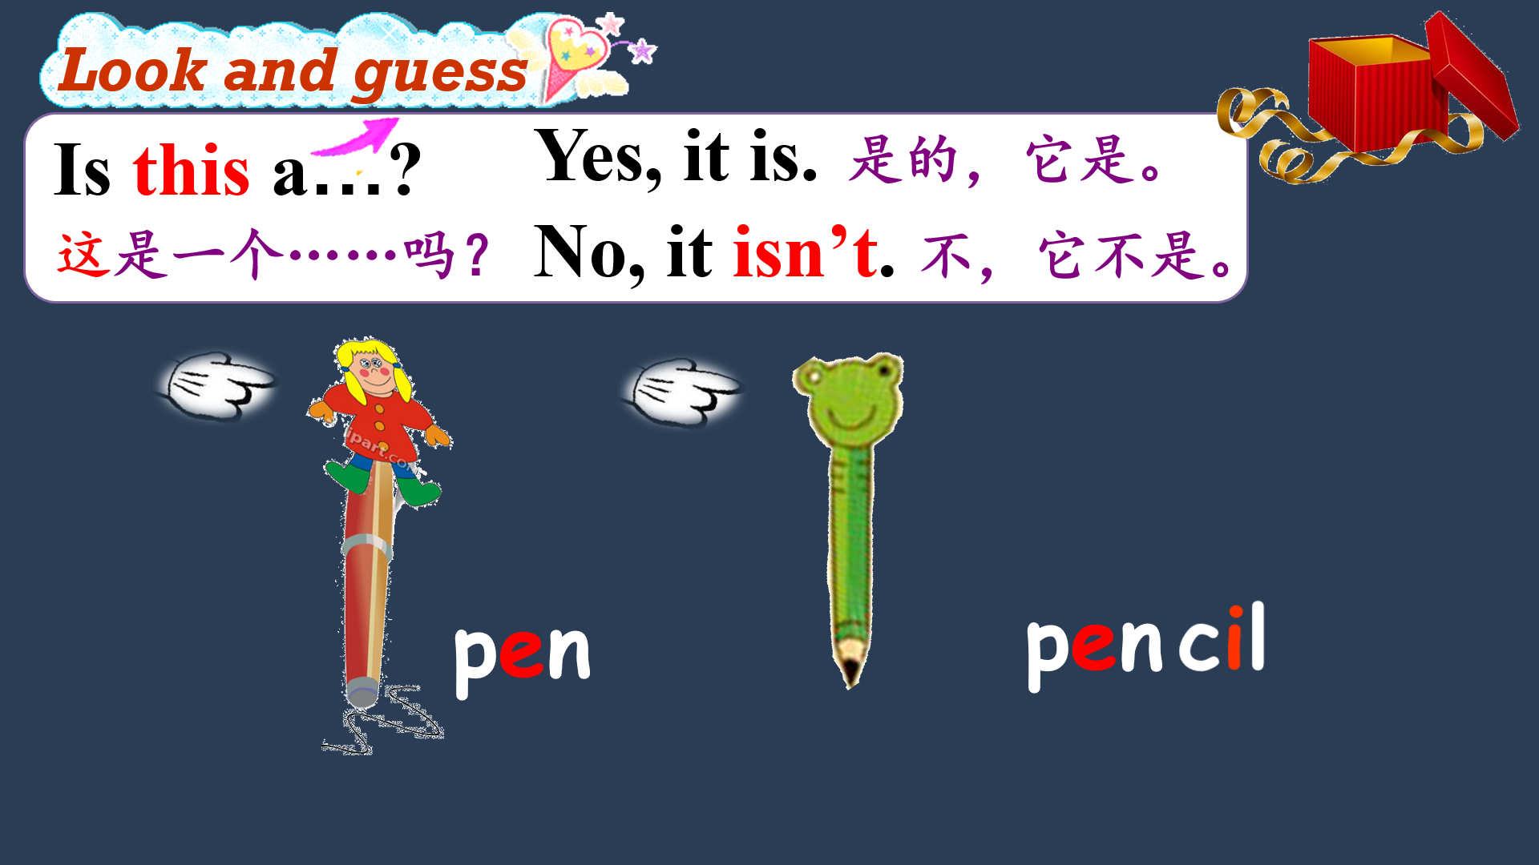
Stage 2 While-reading
Step 1 Watch and choose
What is the story about?
A: The pencil is lost. (丢失)
B: The pencil is broken. (弄坏)
C: The pencil is stolen. (偷掉)
S: A.
T: Is this Mike’s pencil? (出示第一幅图片)
S: No, it isn’t.
T: So Mike says: This isn’t my pencil. (教师指导朗读)
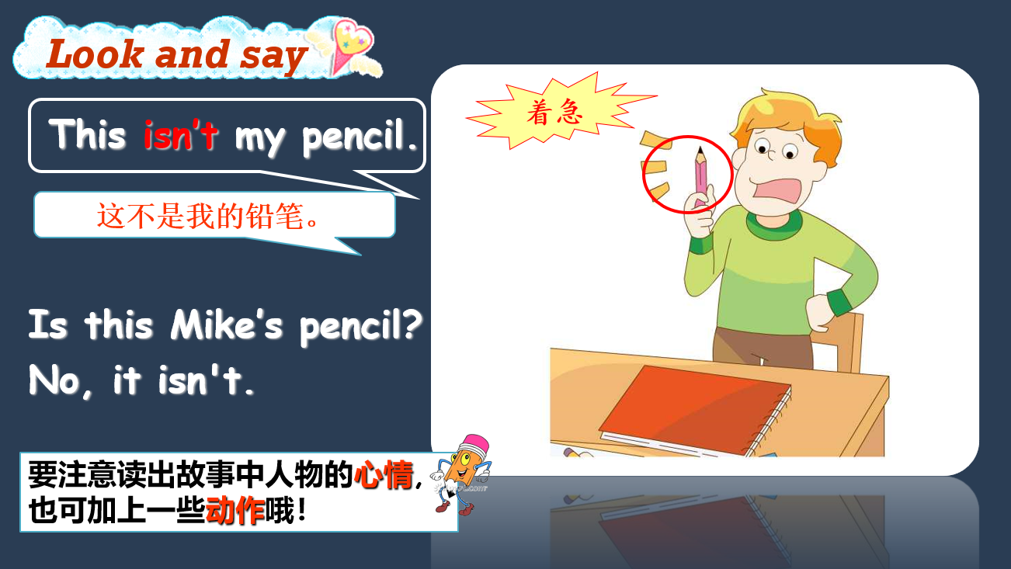
Step 2 Read and find
T: Who helps Mike?
S: Liu Tao and Yang Ling.
T: How do they help Mike? Find the sentence and underline.
S: Is this your pencil?/Is that your pencil?
T: (新授Is this/that your pencil?)
T: Neither is Mike’s pencil. Where is the pencil? (出示最后一幅图片)
S: Oh, that’s my pencil.
T: (Teach that’s = that is )
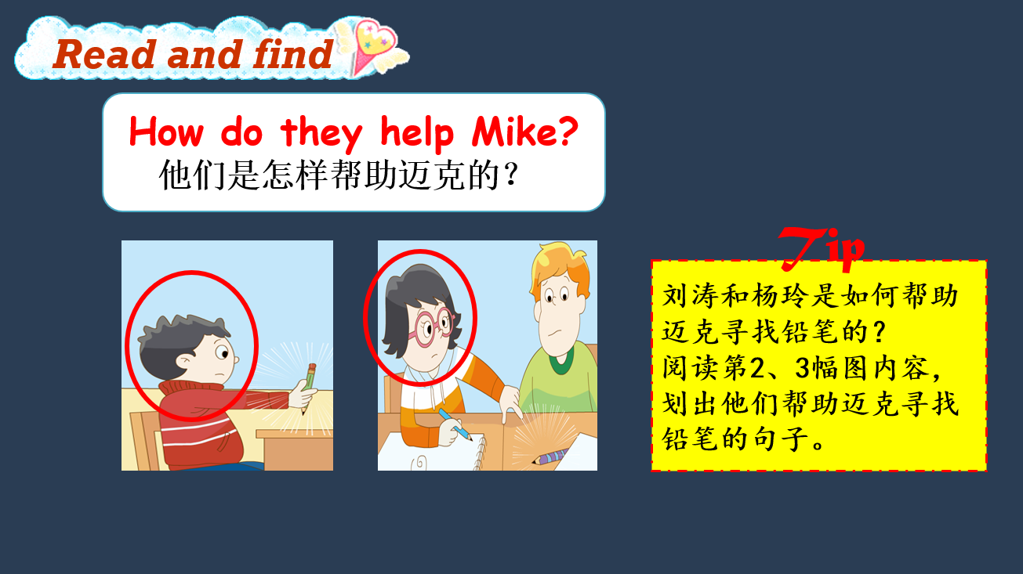
Step 3 Let’s read
a. Read after the computer.
b. Read after the teacher.
c. Read together.
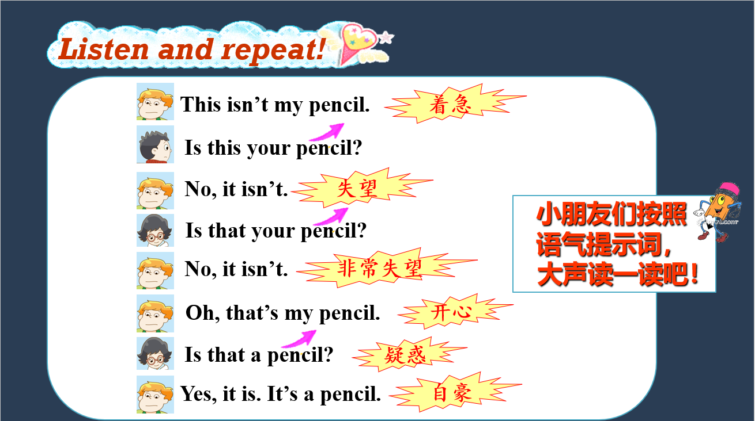
Step 4 Let’s order
出示Story time的图片，打乱顺序，通过重新排序，带着学生说说这个故事。
【设计意图：在故事学习环节，通过对故事的听、猜、读，引导学生在故事情境中帮助Mike寻找丢失的铅笔。这里分三个层次展开，第一层次是先整体理解故事的主题“Mike的铅笔丢失了”；第二个层次是帮助Mike寻找丢失的铅笔；第三个层次是找到铅笔后Mike说了些什么。最后通过对故事的排序，引导学生对故事的整体理解和细节把握。对故事的教学，由整体进入到分块理解再到整体复述，通过不同层次的听、猜、读、说，学生不断地学习新知识。】
Stage 3 Post-reading
Step 1 Let’s talk
T: Mike can’t find his stationery. Let’s help him. (出示两幅图片pen和pencil case )
T: I am Mike. Who can help me?
S: I can.
T: This isn’t my pen.
S: Is this your pen?
T: No, it isn’t.
S: Is that your pen?
T: No, it isn’t. Oh, that’s my pen. (学生两人小组，模仿对话)
Step 2 Let’s think
T: What do you think of Yang Ling and Mike?
S: They are helpful.
T: What do you want to say to Mike?
S: Mike is careless. He lost his pen. We must take good care of our things.
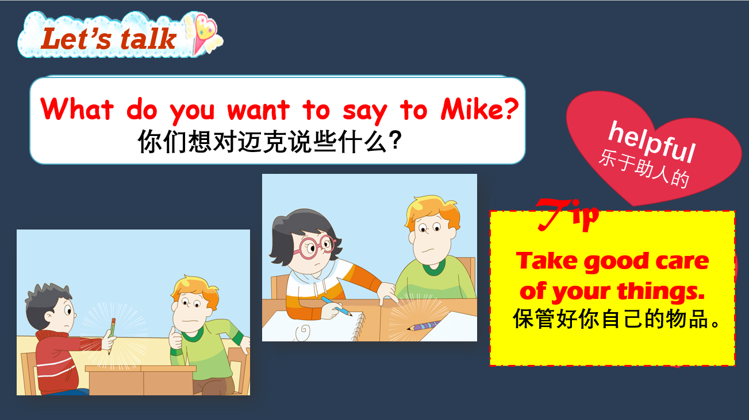
【设计意图：通过再次帮助Mike寻找丢失的钢笔，引导学生在实际情境中运用新句型，并适时进行相关的学习习惯教育——我们应该保管好自己的文具。】
Step 3 Homework
There are many lost stationeries on the classroom platform. Please use the sentence patterns learned in this lesson to help them find their owners.
教室的讲台上有许多同学们丢失的文具，请你运用本节课学习的句型，帮助它们找到自己的主人吧！

板书设计
Unit 3 Is this your pencil ?
pen Is this/that a …? Yes, it is.
pencil Is this/that your…? No, it isn’t.
pencil case

