**钟子莲老师《Unit8 Happy New Year!第一课时》公开课材料**

1. 安排表

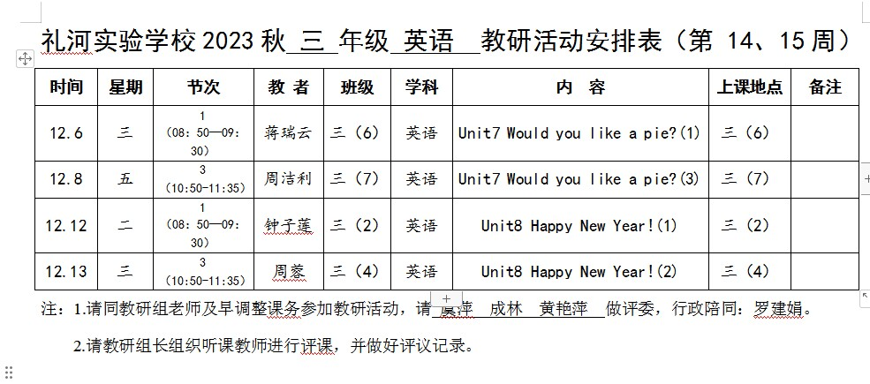

1. 签到表

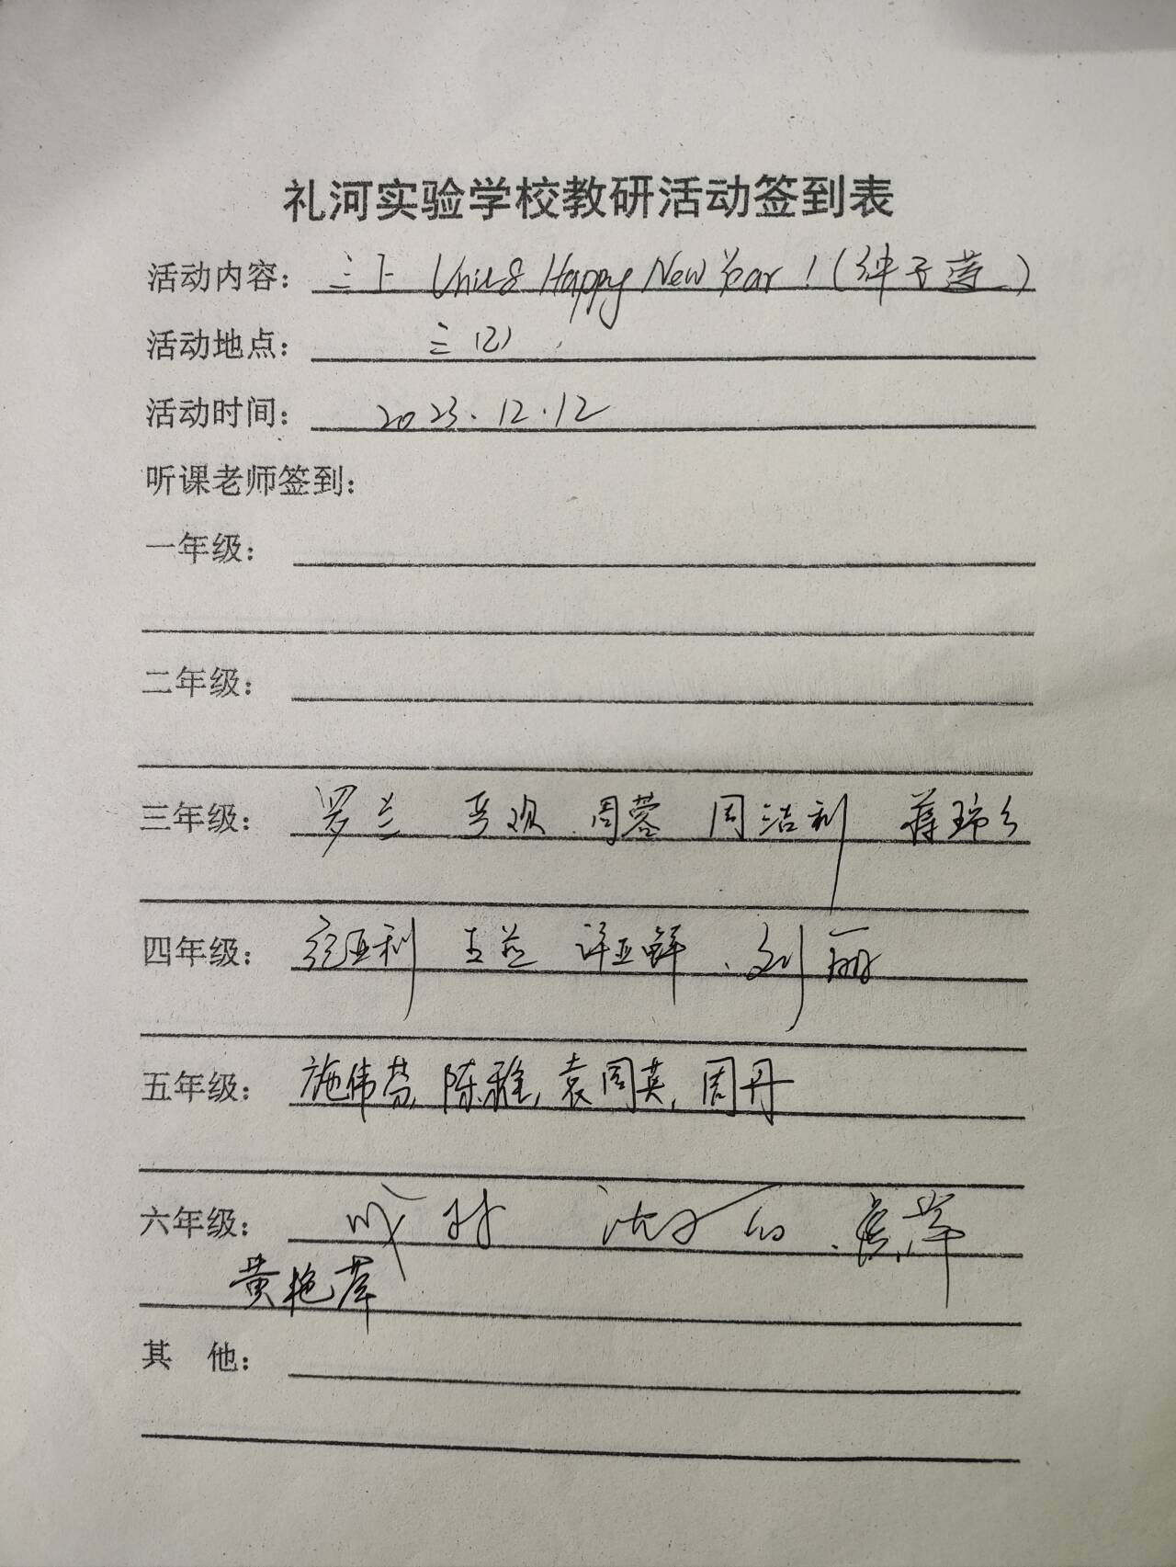

1. 教案

**三年级上册 第八单元**

**第1课时 教案**

**Teaching contents 教学内容**

Story time & Song time

**Teaching aims and learning objectives 教学目标**

1. 能听懂、会读、会说uncle, doll, ball, robot, CD, car, for。

2. 能听懂、会读、会说日常用语Happy New Year!、This is for you.、What’s this/that?、It’s a …。

3. 能正确地理解并朗读对话内容，并表演对话。

4. 能初步运用本课所学的词汇和日常用语互道节日祝福，互送礼物。

5. 能正确演唱歌曲。

**Focus of the lesson and predicted area of difficulty 教学重点和难点**

教学重点：能正确地理解并朗读对话内容，在教师的引导和帮助下表演。

教学难点：能初步运用本课所学的词汇和日常用语互道节日祝福，互送礼物。

**Teaching procedures 教学过程**

*Step 1 Greeting & Warm up*

1. Greeting

T: Hello, boys and girls.

S: Hello, …

T: Nice to meet you.

S: Nice to meet you, too.

2. Sing a song

T: Do you like music?

S: Yes.

T: Me too. Let’s listen to the music. Guess! What holiday is it? (播放音乐)

S: New Year!

T: Yes, it’s New Year’s Day. It’s on January the first. What can we say on New Year’s Day?

S: Happy New Year!

T: Can you sing the song *Happy New Year*?

S: Yes.

T: Let’s sing with the music. OK? (老师带着学生边拍节奏边跟唱)

T: This time, let’s try to sing and add some gestures together.

(再次播放歌曲，学生加上动作一起唱)

【设计意图：让学生感受元旦的节日氛围，在课堂开始时带动学生的学习热情，也为下一步的学习进行铺垫。】

*Step 2 Presentation*

1. Learn the new words

(教师准备两个礼物包，将doll、ball、CD、 toy car，robot分别放在里面。近处的包里有CD、doll；远处的包里放ball、toy car、robot)

T: New Year’s Day is coming soon. I have some presents in my bags. And that’s for my baby. This is for me. What’s for me? Let me open it. Look, what’s this?

(板书句子)

S: It’s a CD.

T: Yes, It’s a CD. I like listening to the CD. (板书单词，读一遍)

You know this is for me. And that’s for my baby. What’s that?

(板书：What’s that?)

S: It’s …

T: (从包里拿出一个玩具机器人) Let’s see. It’s a robot. (领读并板书单词)

(同法教授doll, robot, ball, toy car)

T: What would you like as a present? (根据学生的反馈扩展一些教新词)

T: Who would like to come here, choose a present and ask “What’s this/that?”

S1: (从包里拿出一个玩具) What’s this/that?

S: It’s …

2. Play a game

T: Let’s play a game.

(如果看到英语或图片，请大声读出来，如果看到炸弹，一起说“Bomb”)

S: OK!

【设计意图：用礼物袋激发学生学习新词的兴趣，以游戏形式巩固单词，并渗透句型What’s this that?、It’s …。】

*Step 3 Story time*

1. Listen and answer.

T: (播放门铃声) Who’s coming?

T: Yes, Uncle John brings some presents. (领读人名)

What presents are they? Please listen carefully. (播放课文录音)

S: A doll, a ball and a robot.

T: Do you like these presents?

S: Yes.

T: Are the presents for you?

S: No, they aren’t.

T: Who are the presents for?

S: They’re for Helen, Mike and Tim.

T: You’re right.

【设计意图：通过听课文录音的方式，帮助学生整体感知课文，了解大概内容。】

2. Watch and match.

T: What’s for Helen? What’s for Mike? What’s for Tim? Please watch the cartoon. (播放动画)

T: Can you tell me: Who are they for?

What’s that?

S: It’s a doll. It’s for Helen.

T: Good job. Now please talk about the presents in pairs like this.

S1: What’s that?

S2: It’s … (物品) It’s for … (人名)

【设计意图：观看动画，引导学生关注课文中的细节信息。】

3. Read and talk

T: Good. Now open your books. Please read their dialogue and find: How to give a present? How to accept the present?

S: This is for …

It’s for … (领读、板书句型)

Thank you.

How nice!

T: If you are Mike/Helen/Tim, what will you give to Uncle John? Now I’m Uncle John.

S: This … is for you.

T: Thank you. I like … Do you know how the Western people accept the present?

S: 他们通常会当面拆开，并表示感谢和赞赏。

【设计意图：精读课文，引导学生发现并实际运用语言；文化渗透，让学生了解中西方文化的差异。】

4. Read the story

T: Yes, but we are different. Anyway, to accept the presents is very happy, right?

S: Yes!

T: Let’s read happily, OK? First, let’s listen and follow. Pay attention to your pronunciation and intonation.

S: (学生逐句跟读对话)

T: OK. Now let’s read the story together.

S: (学生齐读，教师根据语音语调再给予细致指导)

【设计意图：引导学生用正确的语音语调朗读课文。】

5. Act the dialogue

T: You did a good job. Let’s act the dialogue in groups of 3.

(教师将学生分为三人小组分角色表演对话，要求学生注意模仿人物的语音语调以及神态和动作)

【设计意图：通过表演，复习和巩固课文学习。】

*Step 4 Talking time*

T: New Year is coming, what will you do for your father and mother and what will you say to them? 新年即将来临，你会对爸爸妈妈做什么，说什么？

T: Please act in groups. Here are some useful expressions for you.

*Happy New Year！*

*This is for you! Thank you!*

*What’s this/that? It’s a …*

*What colour is it? It’s …*

*How nice! It’s nice! It’s great! Great!*

【设计意图：换位思考，鼓励学生在新的情境中运用所学语言。】

**Homework 家庭作业**

1. 听磁带，读故事5遍。

2. 制作一张新年贺卡，送给家人或朋友。

**Teaching aids 教学准备（含板书设计）**

教学准备：书P50-51单词实物、两个礼物袋

板书设计：

**Unit 8 Happy New Year**

doll

ball

CD

car

robot

It’s …

Thank you.

How nice!

…

What’s this/that?

This is for you.

It’s for you.

…

1. 评议表

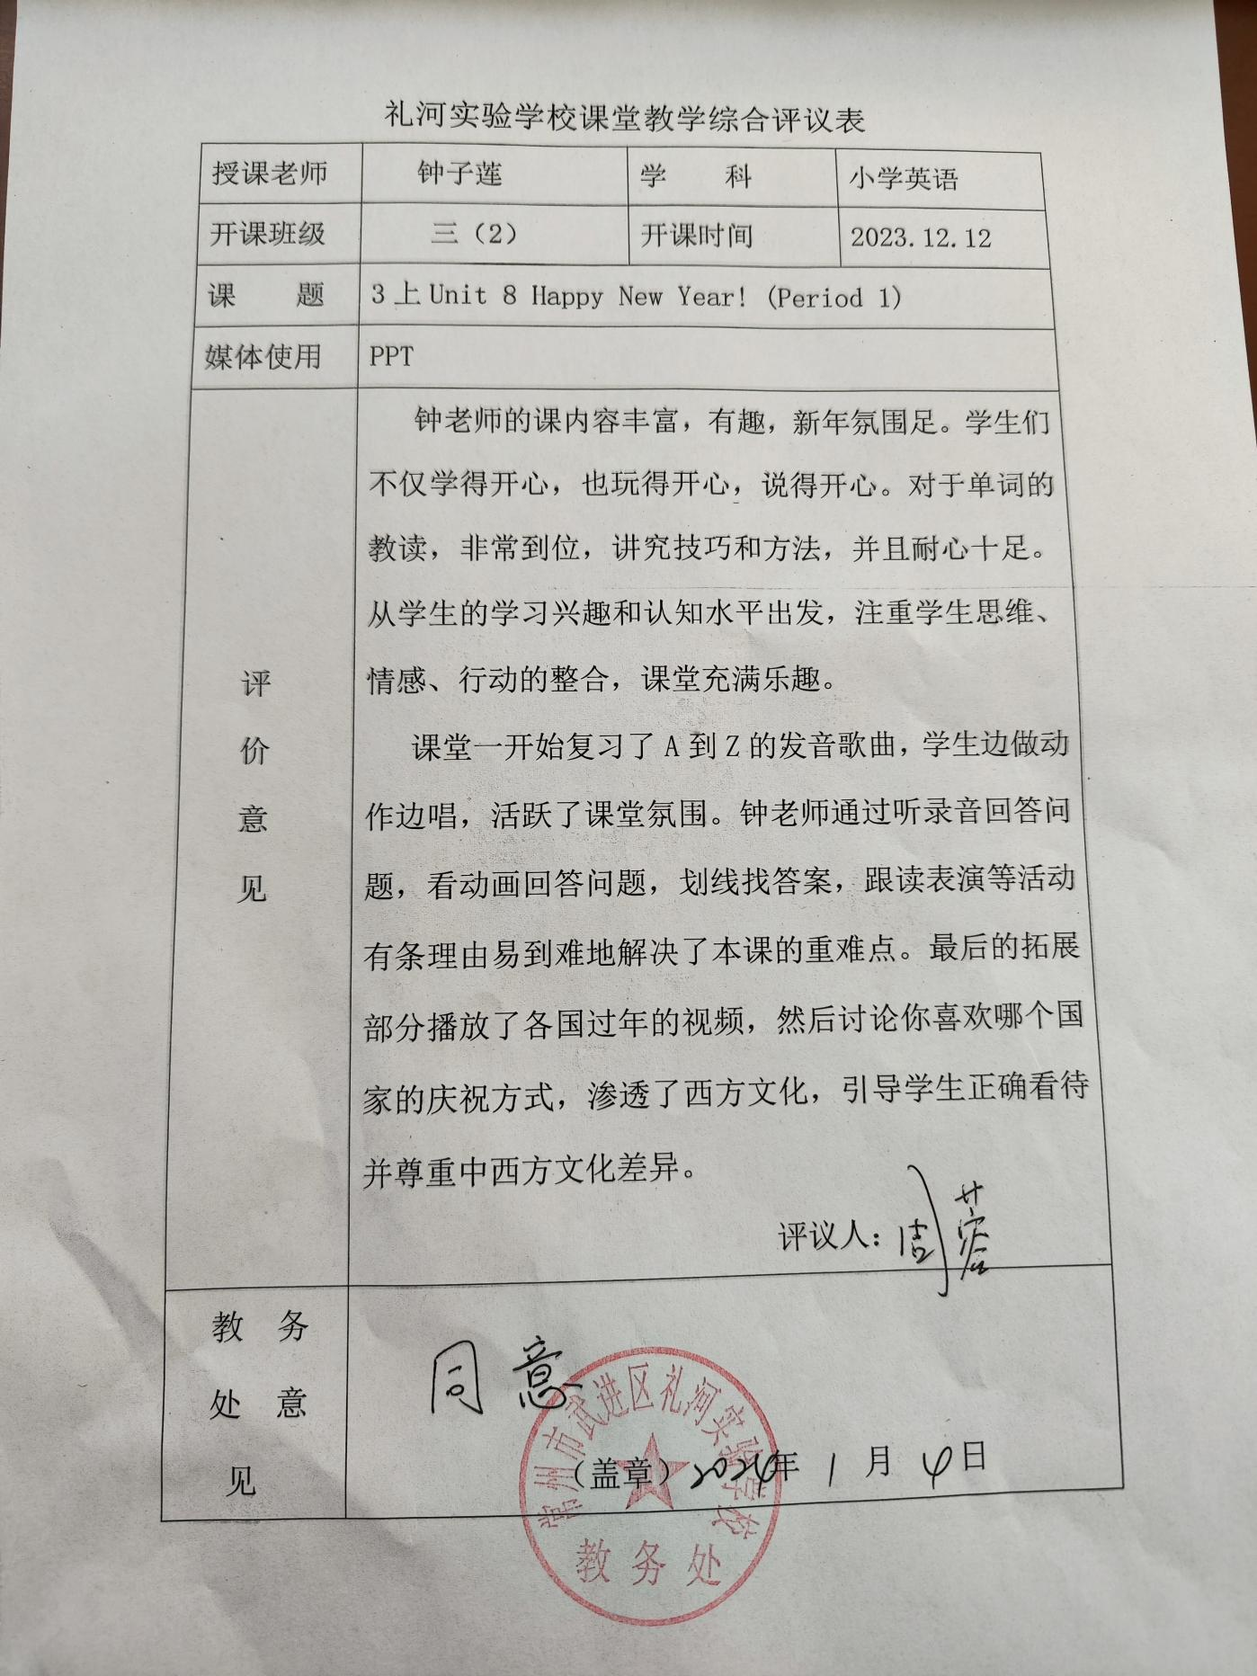

1. 照片



