周蓉老师英语学科《Unit8 Happy New Year》公开课材料
- 安排表
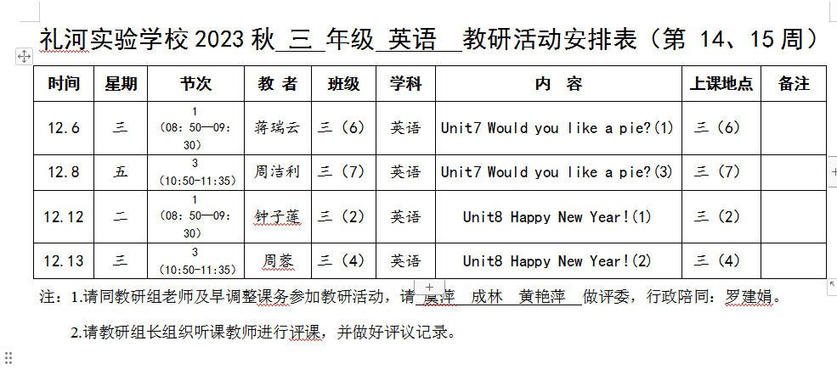
- 签到表
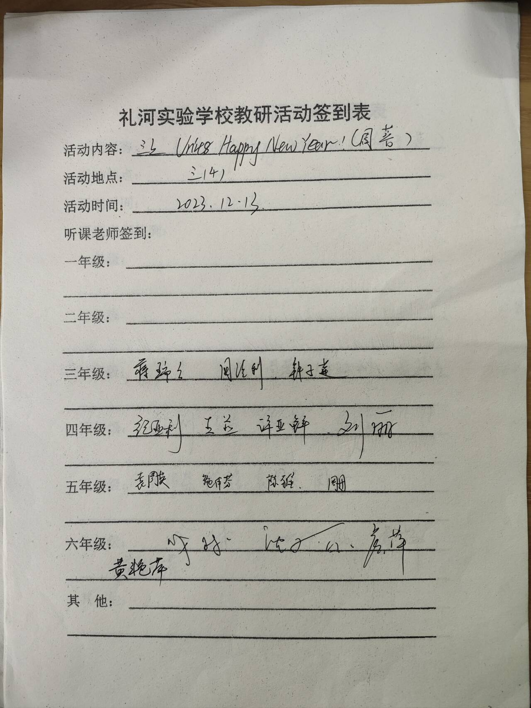
- 教案
Unit8 Happy New Year (Fun&Cartoon time)
- Lead in
- Greetings
T: Good morning/Good afternoon, boys and girls!
Ss: Good morning/Good afternoon, Miss Wu!
T: Nice to see you!
Ss: Nice to see you too.
T: Shall we start our lesson, OK?
Ss: OK.
T: Hi,...Would you like a cake? (教师手里拿实物询问)
S1: Yes, please.
T: Here you are.
S1: Thank you, Miss Wu.
T: You are welcome. Hello,...
S2: Hello, Miss Wu.
T: Would you like a pie?
S2: No, thank you.
T: What about a ball?
S2: Yes, please.
T: It’s for you.
S2: Thank you, Miss Wu.
T: Good girl/boy, sit down please.
(教师与多位学生用以前所学知识对话)
- Play a game
T: Boys and girls, this lesson we will still learn Unit8...
Ss: Happy New Year.
T: Yes. New Year is coming. In New Year, children usually like playing games. Do you like games?
Ss: Yes.
T: So now let’s play a game. We can get many red packets in New Year, right?
Ss: Yes.
T: Now, let’s read the letters on the coins first, then try to say the words, OK?
Ss: OK.
T: Can you read the letters?
Ss: h t w a
T: Oh, what’s this?
S1: It’s a ball.
T: Great! (下面的单词都用此游戏带学生复习)
Review words: ball/cake/doll/robot/car/CD/hot dog
- Review the story time
T: In New Year, people will give presents to their family and presents too, right?
Ss: Yes.
T: In story of Unit8, Uncle John gives some presents to his family too. Do you remember who get Uncle John’s presents?
Ss: Mike, Helen and Tim.
T: You are so clever! In picture one, how do they greet with each other at New Year? What do Mike and Helen say to Uncle John?
Ss: Happy New Year!
T: And Uncle John says...
Ss: Happy New Year!
T: Great! Let’s say “Happy New Year” to them.
Ss:...
T: Oh, wait... what are their presents? Do you still remember?
Ss:...
T: Good job! Let’s dub for the story time, OK?
Ss: OK.

- Fun time
- Listen and judge
T: Boys and girls, Miss Wu has some presents for you too. (给学生准备一些小礼物) If you can win, you can get it. Now, let’s see the rules.
Game Rules:
- If you think it is right，please say “Oh! Yeah!Yeah!Yeah!”
- If you think it is wrong, please say “Oh! No! No! No!”

- Guess and act
T: Look! The children are playing a game too. Actually they are playing a game with some cards, right?
Ss:...
T: Oh, what’s this in his card? Can you guess? Maybe it’s a/an...
Ss: It’s a/an...(学生猜一猜物品)
T: Now, let’s see, what’s this? (学生看图片回答)
Ss: It’s a ball.
T: Great!
- Play and say
T: Do you want to play the game again?
Ss: Yes.
T: Miss Wu has many cards too. Who can play once with me first?
Ss:...
T: ...What’s this?
S1: It’s a/an...
T: No.
S2: It’s a/an...
T: Yes. It’s for you.
Ss: Thank you!
(学生与老师一起玩卡片猜一猜游戏)
T: Now who wants to have cards and ask like me?
Ss:...
(学生与学生之间问答，回答正确地同学也可以获得卡片，回答错误的同学则由下一个同学继续猜)
Learning tips:
- 当我们想要询问卡片上是什么时，可以这样问：

- 当别人问你卡片上时什么时，可以这样回答：

- 当猜测正确或错误时，可以这样回应：

④ 当赠送给对方某个东西时，可以这样说：

- Cartoon time
- Guess and learn
T: Listen! Someone is laughing. Who is he? Look! Do you know them? Who can you see? I can see...
Ss: I can see Bobby, Sam, Willy.
T: Great! They are our old friends, right? We have a new friend today. Look at this little monkey. He is Tom. Please follow me :Tom.
Ss:...
T: Let’s greet Tom, OK?
Ss: Hi, Tom./Hello! Tom. ?Good morning, Tom./Good afternoon, Tom./Nice to see you, Tom.
T: Tom is also happy to see you too. Tom, Sam and Willy give presents to Booby. Why? Can you try to guess?
Ss:...
T: Wow! You are so great! You can see a hat on Bobby’s head. So today is Bobby’s...
Ss: 生日
T: Yes, we can say “Today is Bobby’s birthday”. Here’s a new word for you, please follow me: birthday. (教读单词，划分音节)
- Listen and say
T: So today is Bobby’s birthday. What should they say to Bobby? Let’s listen! (音频播放: Happy birthday, Bobby）
Ss:...
T: What do they say?
Ss: Happy birthday, Bobby.
Learning tip:
当家人、朋友过生日时，我们可以对他/她说: “Happy birthday!”或者 “Happy birthday to you!”
T: Let’s say “Happy birthday” to Bobby!
Ss:...
- Watch, choose and say
T: Boys and girls, look at Bobby, how does he feel now?
Ss: 开心的
T: Yes, Bobby is so happy. Why is he happy?
Ss:...
T: Yes, you are so clever! Because he gets many presents from his friends, right?
Ss: Yes.
T: So what presents does Bobby get from his friends? What’s this? What’s that? Can you guess?
Ss: It’s a/an...
T: Maybe you are right. So now let’s watch the cartoon and try to choose the present you see in the cartoon, OK?
Ss:...
T: What present can you see in the cartoon?
Ss: A car.
T: Who gives the car to Bobby?
Ss: It’s Tom.
T: Does Bobby like the car?
Ss: Yes.
T: How do you know that? What does Bobby say?
Ss: How nice!
T: Great! When you get a present, don’t forget to say...
Ss: Thank you!
Learning tip: 当你收到对方的礼物时，你应该说： “Thank you!/Thanks!”表示感谢。
T: Let’s help Tom give the present for Bobby.
Ss:...
Tom: This car is for you.
- Look and say
T: Boys and girls, Booby likes Tom’s birthday present very much, right?
Ss: Yes.
T: At first, how does Bobby feel?
Ss: 激动的、兴奋的、开心的
T: Yes, but look at this picture, is Bobby happy now?
Ss: No.
T: Yes, he is so afraid. Why? What’s this?
Ss: 玩具娃娃
T: It’s a clown. (新授: clown) Please follow me: clown
Ss:...
T: Oh...Bobby says...
Ss: Ah!
T: What does Sam say to Bobby? Can you guess?
Ss:...
Tom: This clown is for you./Happy birthday!
- Listen and imitate
T: Boys and girls, do you like the story?
Ss: Yes.
T: Let’s listen to the tape and try to imitate. Don’t forget to add some actions, OK?
Ss: OK.
- Act out the cartoon time
T: It’s time for you to act out the story. Let’s try to act!
Ss:...
- Think and say
T: Well, Bobby gets two presents from Tom and Sam. Wait...who doesn’t give the present?
Ss: Willy.
T: Yes. What’s Willy’s present? Can you guess? It’s a/an...
Ss:...
T: Now I want you to work in pairs. Try to act out Willy and Bobby. Who can try?
Ss:...
Willy: Happy birthday!... This is for you.
Bobby: Thank you! What’s this?/What’s that?
Willy: It’s a/an...
Bobby: How nice! Thank you!/Thanks!

- Homework
- Read and recite Cartoon time.
(读一读，并复述卡通时间)
- Act out the story time with your classmates.
(与你的同学们表演故事)
- Play the cards guessing game with your friends after class.
(和你的朋友课下玩一玩猜卡片的游戏)

- 评议表
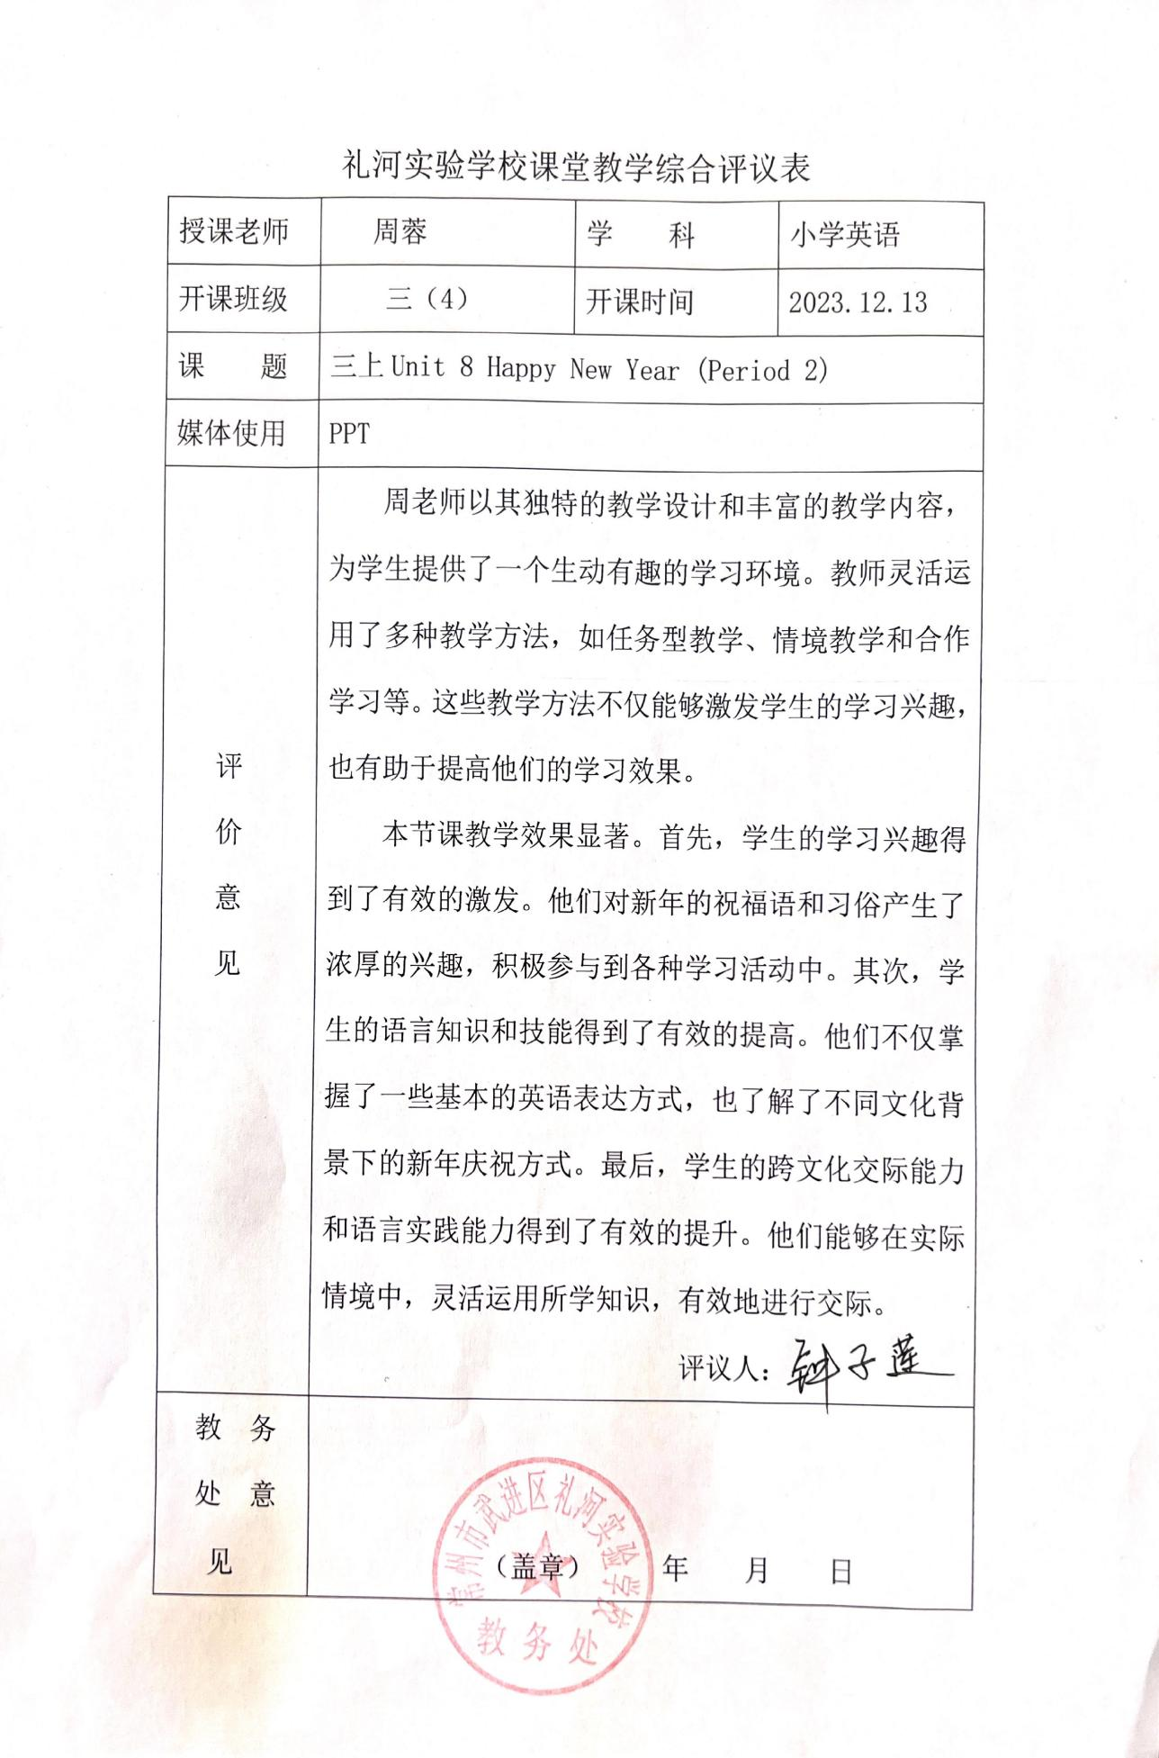
- 照片
