**20231205| 小一班**

Daily life

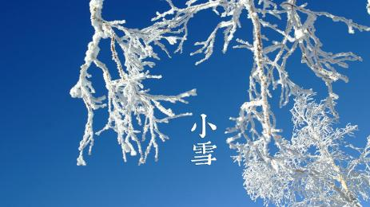

**「来园情况」**

今日星期二，共有16人来园，6人请假。

**「日常生活观察」**

|  |  |  |  |  |  |  |  |  |
| --- | --- | --- | --- | --- | --- | --- | --- | --- |
| **序号** | **姓名** | **入园情绪** | **早点** | **午餐** | | | **午睡** | **午点** |
| **饭** | **菜** | **汤** |
| 1 | 韩昕怡 | √ | √ | √ | √ | √ | √ | √ |
| 2 | 韩昕悦 | √ | √ | √ | √ | √ | √ | √ |
| 3 | 吴清墨 | √ | √ | √ | √ | √ | √ | √ |
| 4 | 陆晟涵 | √ | √ | √ | √ | √ | √ | √ |
| 5 | 杨雨涵 | 请假 |  |  |  |  |  |  |
| 6 | 张梅伊 | √ | √ | √ | √ | √ | √ | √ |
| 7 | 吴沐檀 | 请假 |  |  |  |  |  |  |
| 8 | 曹果 | 请假 |  |  |  |  |  |  |
| 9 | 曹煜琪 | 请假 |  |  |  |  |  |  |
| 10 | 蒋安乐 | √ | √ | √ | √ | √ | √ | √ |
| 11 | 韩书华 | 请假 |  |  |  |  |  |  |
| 12 | 顾言希 | √ | √ | √ | √ | √ | √ | √ |
| 13 | 贾钧尧 | √ | √ | √ | √ | √ | √ | √ |
| 14 | 杨宸 | √ | √ | √ | √ | √ | √ | √ |
| 15 | 张予安 | √ | √ | √ | √ | √ | √ | √ |
| 16 | 高瑞泽 | √ | √ | √ | √ | √ | √ | √ |
| 17 | 张路翔 | 请假 |  |  |  |  |  |  |
| 18 | 谢咏呈 | √ | √ | √ | √ | √ | √ | √ |
| 19 | 汤凌宇 | √ | √ | √ | √ | √ | √ | √ |
| 20 | 韩以轩 | √ | √ | √ | √ | √ | √ | √ |
| 21 | 冯煦晨 | √ | √ | √ | √ | √ | √ | √ |
| 22 | 郑哲皓 | √ | √ | √ | √ | √ | √ | √ |

**「集体活动」**

音乐：《我的身体会唱歌》是通过语言提示，融合节奏训练来吸引幼儿，从而培养幼儿的节奏感以及快速反应的能力的一节音乐活动。根据奥尔夫教学法中以自然的本性为出发点、必须自己动手（脚）去练习并以节奏为基石的观点，本次活动将引导幼儿尝试用自己的身体来发出声音，体验“身体唱歌”的乐趣。

|  |  |  |
| --- | --- | --- |
| **IMG_8965** | **IMG_8964** | **IMG_8963** |

**「户外游戏」**

|  |  |  |
| --- | --- | --- |
| **IMG_8966** | **IMG_8967** | **IMG_8969** |
| **IMG_8976** | **IMG_8981** | **IMG_8984** |