**20231226| 小一班**

Daily life

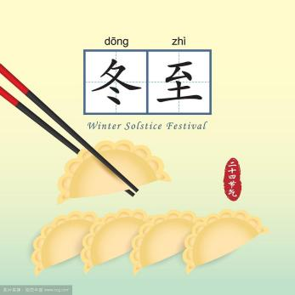

**「来园情况」**

今日星期二，共有17人来园，5人请假。

**「日常生活观察」**

|  |  |  |  |  |  |  |  |  |
| --- | --- | --- | --- | --- | --- | --- | --- | --- |
| **序号** | **姓名** | **入园情绪** | **早点** | **午餐** | | | **午睡** | **午点** |
| **饭** | **菜** | **汤** |
| 1 | 韩昕怡 | √ | √ | √ | √ | √ | √ | √ |
| 2 | 韩昕悦 | √ | √ | √ | √ | √ | √ | √ |
| 3 | 吴清墨 | 请假 |  |  |  |  |  |  |
| 4 | 陆晟涵 | √ | √ | √ | √ | √ | √ | √ |
| 5 | 杨雨涵 | √ | √ | √ | √ | √ | √ | √ |
| 6 | 张梅伊 | √ | √ | √ | √ | √ | √ | √ |
| 7 | 吴沐檀 | 请假 |  |  |  |  |  |  |
| 8 | 曹果 | 请假 |  |  |  |  |  |  |
| 9 | 曹煜琪 | 请假 |  |  |  |  |  |  |
| 10 | 蒋安乐 | √ | √ | √ | √ | √ | √ | √ |
| 11 | 韩书华 | √ | √ | √ | √ | √ | √ | √ |
| 12 | 顾言希 | √ | √ | √ | √ | √ | √ | √ |
| 13 | 贾钧尧 | √ | √ | √ | √ | √ | √ | √ |
| 14 | 杨宸 | √ | √ | √ | √ | √ | √ | √ |
| 15 | 张予安 | √ | √ | √ | √ | √ | √ | √ |
| 16 | 高瑞泽 | √ | √ | √ | √ | √ | √ | √ |
| 17 | 张路翔 | 请假 |  |  |  |  |  |  |
| 18 | 谢咏呈 | √ | √ | √ | √ | √ | √ | √ |
| 19 | 汤凌宇 | √ | √ | √ | √ | √ | √ | √ |
| 20 | 韩以轩 | √ | √ | √ | √ | √ | √ | √ |
| 21 | 冯煦晨 | √ | √ | √ | √ | √ | √ | √ |
| 22 | 郑哲皓 | √ | √ | √ | √ | √ | √ | √ |

**【半日活动：冬季运动会“我跑、我酷”】**

|  |  |  |
| --- | --- | --- |
| **IMG_9778** | **IMG_9795** | **IMG_9825** |
| **IMG_9799** | **IMG_9935(20231226-232339)** | **IMG_9938(20231226-232339)** |
| **IMG_9939(20231226-232339)** | **IMG_0279** | **IMG_9900** |

今天我们开展了冬季运动会，我们现在前操场做了热身运动，然后搬着小椅子按班级坐好。老师给我们示范了游戏的玩法，主持人沈老师宣布运动会正式开始。一部分小朋友们先进行比赛，我们剩下的小朋友给他们喊加油，为他们欢呼。小朋友们都很厉害，都完成了比赛。