**Good expressions in writing教案**

常州市武进区雪堰初级中学 钱芳

Teaching aims:

At the end of the class, Ss will be able to:

1. Master the ways of good expressions in writing
2. Apprciate some good expressions in sample writing
3. Learn to express in different and andvanced ways to make writing more perfect

Teaching procedures:

Step 1: （欣赏范文）

假如你是 Sigmund Friend ，有一位叫李涵的九年级学生向你求助，面对中考，他压力比较大，想找周围的人倾诉，但有各种担心。请根据来信内容，用英文写一封回信，帮助李涵解决问题。

Firstly, whenever you have any problem ,teachers will always be ready to help you.They have so much experience that they know how to help you relax. What’s more,they will not only offer you some useful advice but also help improve your study.

Secondly, why not share your worries with your parents? Your parents are the people who love you best in the world. There’s no doubt that they will encourage you and cheer you up.

Finally, it’s a good choice to share your stress with friends as well. Keeping it to yourself will make it worse. I do believe that students of your age understand your stress best, and they will be patient enough to listen to you .

Skill 1: have a clear structure

Skill 2: use right tenses and subjects

Skill 3: use proper linking words

Skill 4: select useful&various expressions

Step 2: （学会多样表达）

1. Some exercises.

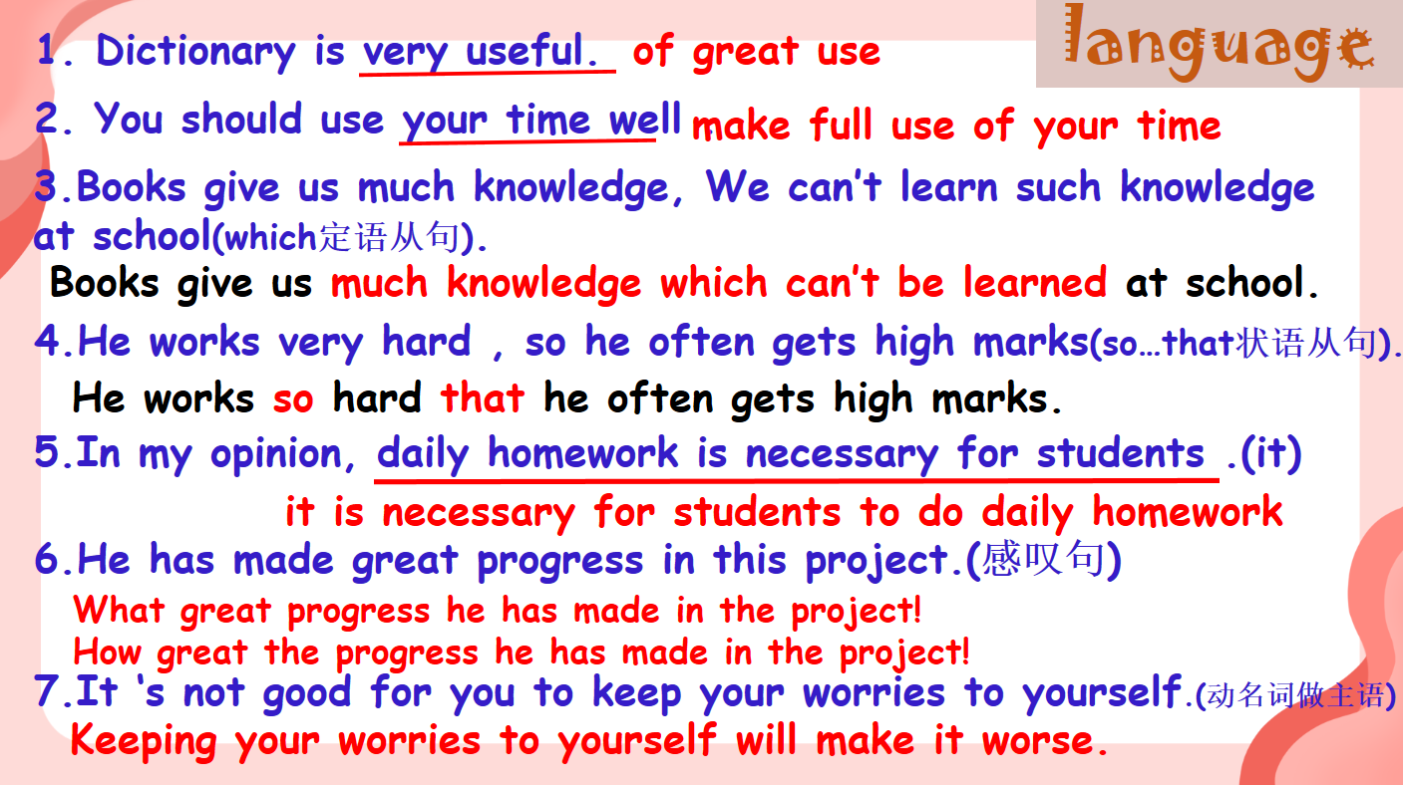

1. Ways to polish a passage by taking para3 as an example.

Step 3: （小组合作进行修改）

1. Show some versions written by Ss.

Example 1: Here are some methods to solve these problems. First, we can do some sports when something worries us. Second, you can have something to look forward to. Third, it's necessary to talk to our teachers or parents. Last but not the least, doing some reading will help us relax after a busy day.

Example 2: Firstly, reading more makes you feel relaxed. As we all know, reading makes a full man. It not only makes you happy but also opens up a whole new world to you. Secondly, you can do some outdoor activities like riding and running.They help you strong. What's more, asking your parents for help is also a good choice. Why not have a talk with them?

Step 4: （进行真题训练）

1. Study

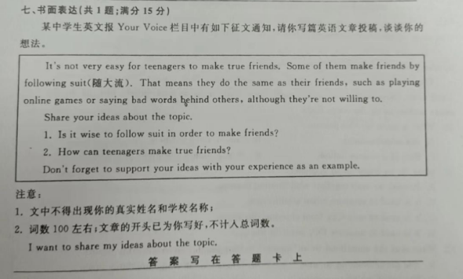

1. Tense & subject
2. Key points
3. Beginning

1. As for me, it's not wise...

2. I hold the belief that it's not wise...

3. There's no doubt that it's not wise...

4. I don't think it's wise...

5. From my point of view, we are supposed to avoid following suit to make friends.

2. brainstorming

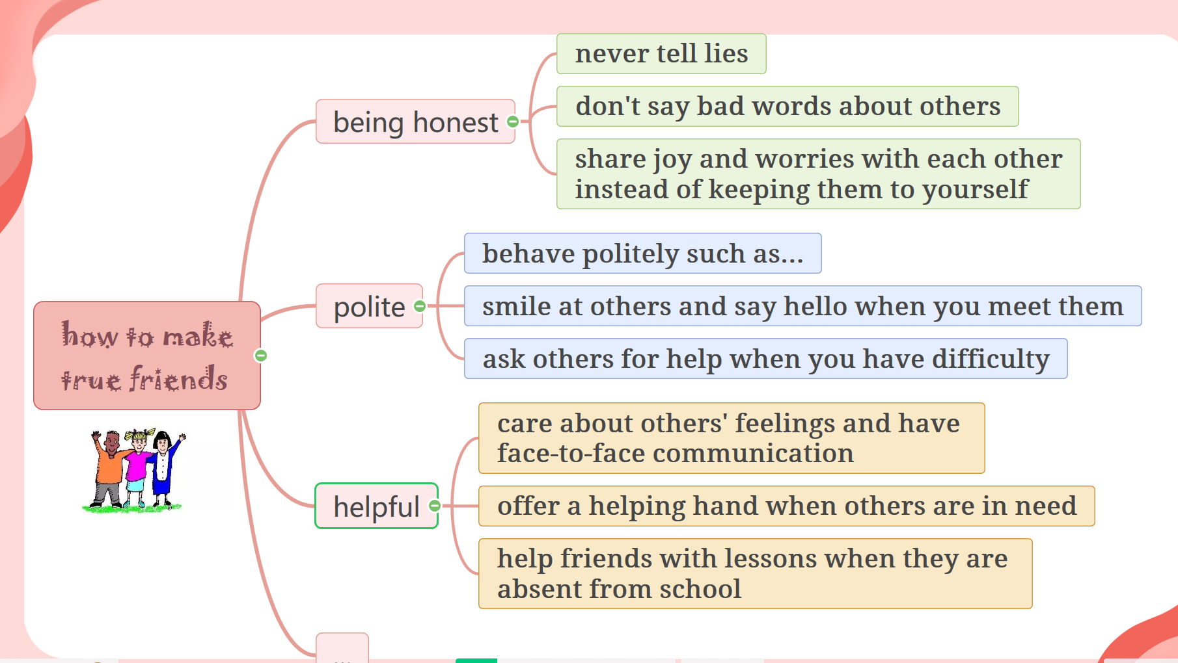

3.show writing standards

Step 5: （进行总结归纳）

Step 4: （重新打磨习作）