**9A U4 Reading教案**

**常州市武进区雪堰初级中学 钱芳 2022.10**

**Step 1. Lead in**

Recently, there has been a piece of good news. The Chinese Women Basketball went into the final of the World Cup. Watch a short video.

**Step 2. Predict**

Looking at the title, what do you want to know? Make a prediction.

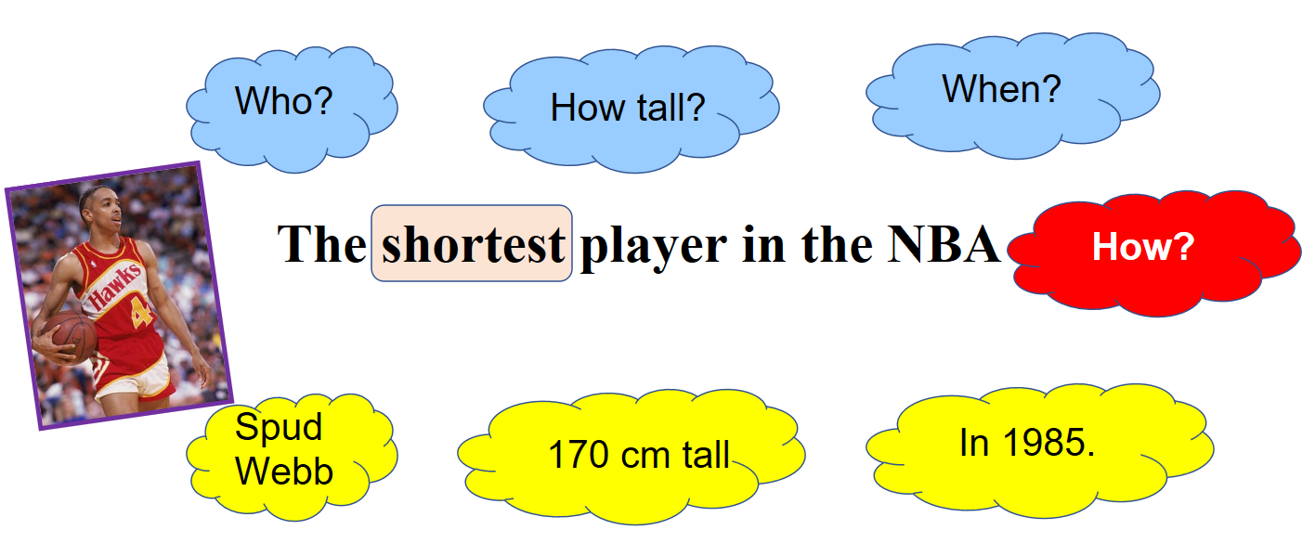

**Step 3. Pre-reading**

1. How is this passage organized?
2. Find out four stages of Spud Webb’s career（职业生涯的四个阶段）

1: _________________________________________(para _________)

2: _________________________________________(para _________)

3: _________________________________________(para _________)

4: _________________________________________(para _________)

**Step 4. While-Reading**

1. Read para1 and find two adjectives that impress you most.

Can we leave out the word ‘big’?

Can you think of other words to replace the word "big"?

1. Read para 2 and finish the mindmap

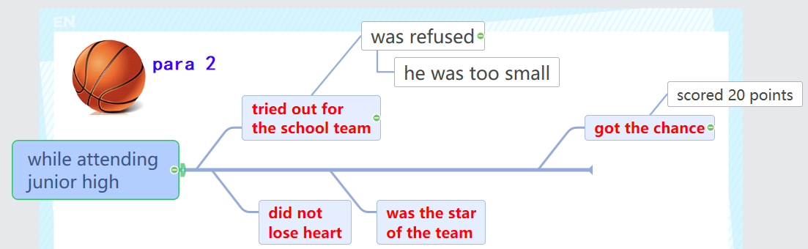

Some people thought Spud Webb was lucky because the chance was waiting for him.Do you agree with it? Why or why not?

1. Read para 3 and finish the flowchart

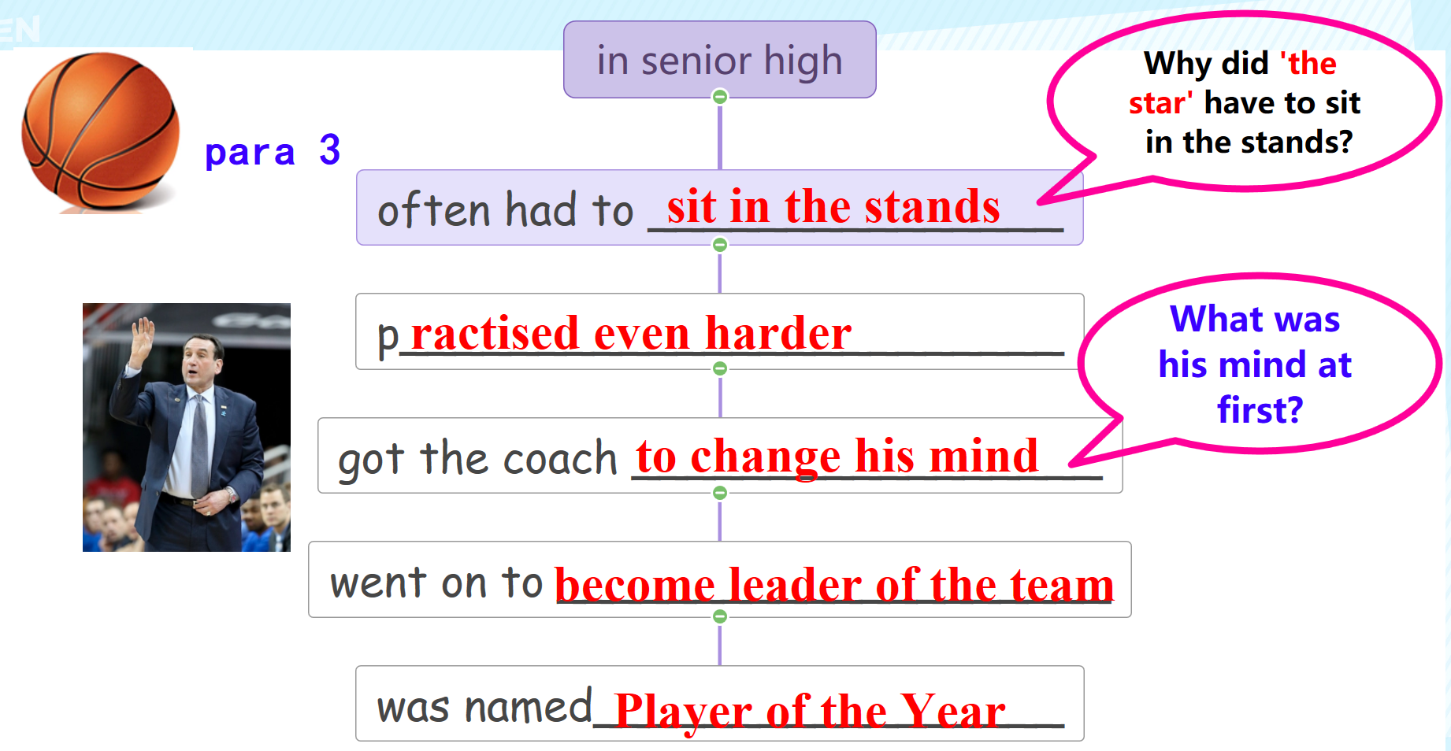

1. Read para 4 and complete the table.

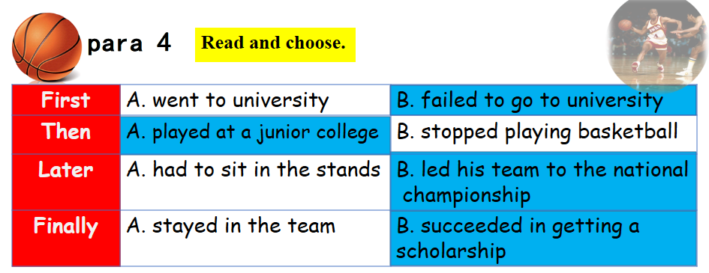

This brought him to the attention of North Carolina State University. What does ‘this’ refer to?

Make up sentences with ‘ succeed in doing’.

Was he a great player at university? Did he succeed in joining the NBA?

1. Read para 5 and match the sentences.

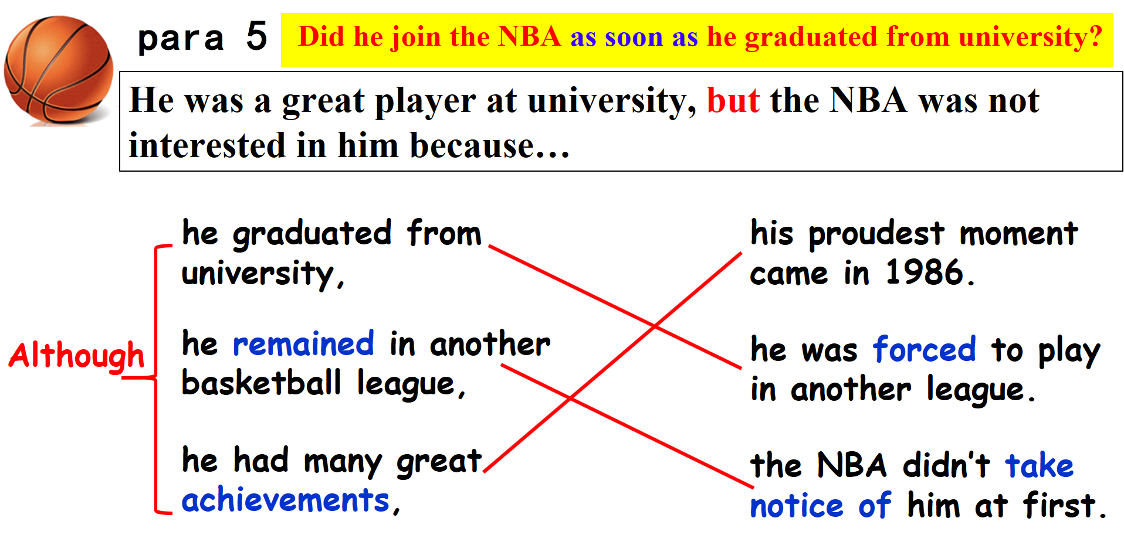

How many times was he refused in all ?

Why does the writer talk about his 'small' again and again?

1. What did he prove?

Spud Webb proved that size and body type do not matter. What really matters?

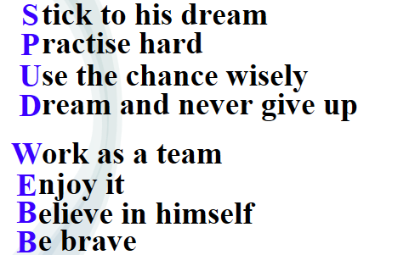

**Step 5. Post-Reading**

1. The title is ‘Never give up’. Can you come up with similar titles?
2. The title of Unit 4 is ‘growing up’. Why is this article put in this unit?
3. To Spud Webb, growing up was _____________, because _______________________________.

4. Growing up can be hard. Some students have teenage problems. Can you use Spud Webb’s story to cheer them up?

1. Although James works hard, he gets low marks in English. He doesn’t know how to deal with it. He wants to give up.
2. Mary’s parents are strict with her in everything. She feels much too stressed. What’s worse, she doesn’t know what her dream is.

