**20231127| 小一班**

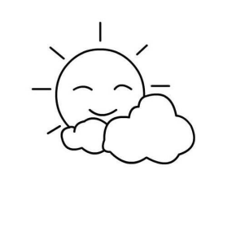

Daily life

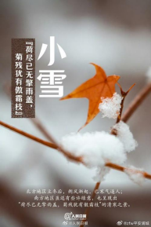

**「来园情况」**

今日星期一，共有14人来园，8人请假。

**「日常生活观察」**

|  |  |  |  |  |  |  |  |  |
| --- | --- | --- | --- | --- | --- | --- | --- | --- |
| **序号** | **姓名** | **入园情绪** | **早点** | **午餐** | | | **午睡** | **午点** |
| **饭** | **菜** | **汤** |
| 1 | 韩昕怡 | 请假 |  |  |  |  |  |  |
| 2 | 韩昕悦 | √ | √ | √ | √ | √ | √ | √ |
| 3 | 吴清墨 | 请假 |  |  |  |  |  |  |
| 4 | 陆晟涵 | √ | √ | √ | ⭕ | √ | √ | √ |
| 5 | 杨雨涵 | 请假 |  |  |  |  |  |  |
| 6 | 张梅伊 | √ | √ | √ | √ | √ | √ | √ |
| 7 | 吴沐檀 | 请假 |  |  |  |  |  |  |
| 8 | 曹果 | √ | √ | √ | √ | √ | √ | √ |
| 9 | 曹煜琪 | 请假 |  |  |  |  |  |  |
| 10 | 蒋安乐 | √ | √ | √ | √ | √ | √ | √ |
| 11 | 韩书华 | 请假 |  |  |  |  |  |  |
| 12 | 顾言希 | √ | √ | √ | √ | √ | √ | √ |
| 13 | 贾钧尧 | √ | √ | √ | √ | √ | √ | √ |
| 14 | 杨宸 | √ | √ | ⭕ | √ | √ | √ | √ |
| 15 | 张予安 | √ | √ | √ | √ | √ | √ | √ |
| 16 | 高瑞泽 | √ | √ | √ | √ | √ | √ | √ |
| 17 | 张路翔 | 请假 |  |  |  |  |  |  |
| 18 | 谢咏呈 | √ | √ | √ | √ | √ | √ | √ |
| 19 | 汤凌宇 | √ | √ | √ | ⭕ | √ | √ | √ |
| 20 | 韩以轩 | √ | √ | √ | √ | √ | √ | √ |
| 21 | 冯煦晨 | 请假 |  |  |  |  |  |  |
| 22 | 郑哲皓 | √ | √ |  |  |  |  |  |

**「区域游戏」**

小朋友们自主选择玩具进行游戏。

|  |  |  |
| --- | --- | --- |
| IMG_2395 | IMG_2391 | IMG_2393 |
| IMG_2394 | IMG_2392 |  |

**「社会：爱唱歌的大恐龙」**

这是一节关于文明礼仪的社会活动。通过讲述大恐龙由于嗓门大而被大家讨厌，在小女孩的提醒下改正错误的故事，引导幼儿在愉悦的体验中了解声音大的危害，进而学会控制声音的音量，在与同伴相处中不影响他人，做一个有礼貌的好宝宝。

|  |  |  |
| --- | --- | --- |
| IMG_2398 | IMG_2397 | IMG_2399 |

**「户外活动」**

|  |  |  |
| --- | --- | --- |
| IMG_2420(1) | IMG_2417(2) | IMG_2413 |
| IMG_2416(1) | IMG_2412 | IMG_2414(1) |