**20231114| 小一班**

Daily life

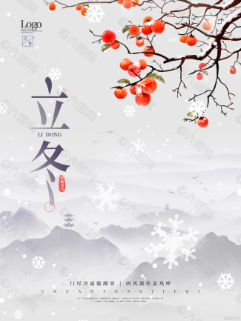

**「来园情况」**

今日星期二，共有14人来园，8人请假。

**「日常生活观察」**

|  |  |  |  |  |  |  |  |  |
| --- | --- | --- | --- | --- | --- | --- | --- | --- |
| **序号** | **姓名** | **入园情绪** | **早点** | **午餐** | | | **午睡** | **午点** |
| **饭** | **菜** | **汤** |
| 1 | 韩昕怡 | √ | √ | √ | √ | √ | √ | √ |
| 2 | 韩昕悦 | √ | √ | √ | √ | √ | √ | √ |
| 3 | 吴清墨 | 请假 |  |  |  |  |  |  |
| 4 | 陆晟涵 | √ | √ | √ | √ | √ | √ | √ |
| 5 | 杨雨涵 | 请假 |  |  |  |  |  |  |
| 6 | 张梅伊 | √ | √ | √ | √ | √ | √ | √ |
| 7 | 吴沐檀 | 请假 |  |  |  |  |  |  |
| 8 | 曹果 | 请假 |  |  |  |  |  |  |
| 9 | 曹煜琪 | 请假 |  |  |  |  |  |  |
| 10 | 蒋安乐 | √ | √ | √ | √ | √ | √ | √ |
| 11 | 韩书华 | √ | √ | √ | √ | √ | √ | √ |
| 12 | 顾言希 | √ | √ | √ | √ | √ | √ | √ |
| 13 | 贾钧尧 | 请假 |  |  |  |  |  |  |
| 14 | 杨宸 | √ | √ | √ | √ | √ | √ | √ |
| 15 | 张予安 | √ | √ | √ | √ | √ | √ | √ |
| 16 | 高瑞泽 | √ | √ | √ | √ | √ | √ | √ |
| 17 | 张路翔 | 请假 |  |  |  |  |  |  |
| 18 | 谢咏呈 | √ | √ | √ | √ | √ | √ | √ |
| 19 | 汤凌宇 | √ | √ | √ | √ | √ | √ | √ |
| 20 | 韩以轩 | √ | √ | √ | √ | √ | √ | √ |
| 21 | 冯煦晨 | 请假 |  |  |  |  |  |  |
| 22 | 郑哲皓 | √ | √ | √ | √ | √ | √ | √ |

**「集体活动」**

数学《打电话》感知物体的数量及其数字，对应关系是小班学习数学的重要阶段，而小班的孩子是以具体形象思维为主的，数字1、2、3是一个抽象的概念符号，要引导幼儿将数字点卡与物体数量联系起来。活动采用打电话的情境破译电话号码，利用游戏的形式感知数量并认识数字点卡。

|  |  |  |
| --- | --- | --- |
| 376173efe99935021ec05f9d92f8b417 | bd997f8842ba678c90b3943488fdeb55 | 373d6fb2bdac295a68bb378c0a12873f |
| IMG_8309 | IMG_8310 | IMG_8311 |